# Workflow

* ~~Git~~
  + ~~Branches~~
    - ~~Main~~
    - ~~(Optional) Dev~~
    - ~~Feature~~

1. ~~Auth => Together~~
2. ~~Chat...~~

# Functionality

* ~~Design~~ 
  + ~~Material Design~~
  + ~~Material Icons~~
  + (Optional) Tailwind CSS
  + ~~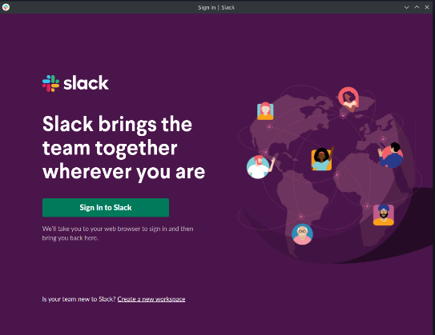Mockup 1:1 Slack~~
    - ~~Theme dark~~
    - (Optional) Light theme
* ~~Logo~~
* ~~Login~~
  + ~~Create account (Firestore)~~
    - ~~Form validation (Onsubmit)~~
      * ~~Display Name~~
      * ~~Email~~
      * ~~Password (Min length, strong pw)~~
    - ~~User feedback = Popups (Snack bar/Dialog)~~
  + ~~Firebase Auth~~
    - ~~(Optional) Email verifier~~
  + ~~Guest login (Redirect to Chat)~~
    - ~~Name (required)~~
    - Name always shown on messages with => (Guest)
  + ~~Footer (Imprint/Legal Notice)~~
    - (Optional) GitHub
* ~~Chat~~
  + ~~Header~~
    - ~~Burger (Toggle Nav)~~
    - ~~Search bar~~
      * Filter messages for all channels
    - ~~User profile~~
      * ~~Avatar (Name + profile image)~~
      * ~~Account~~
        + ~~Edit details~~

~~Name~~

~~Profile picture (Upload)~~

* + - * + ~~Delete account~~
      * ~~Logout => Login page~~
    - (Optional) Support
  + ~~Nav (Left)~~
    - ~~Channels (Dropdown)~~
      * ~~Add channel~~
      * Menu icon
        + Edit channel
        + Delete channel
    - ~~Direct message (Dropdown)~~
  + ~~Home = # welcome channel (HARDCODED)~~
    - ~~Custom welcome message/information for user~~
* Chat function
  + Post message
    - (Optional) upload files (img, etc)
    - (Optional) format message (Like word) => Library
  + Edit message
    - Only the user who created the message
    - Dialog if user is not authorized
  + Delete message
    - Only the user who created the message
    - Dialog if user is not authorized
  + (Optional) Show thread