NVIDIA Corporation (NASDAQ: NVDA)
Q2 FY2027 Earnings Update: Clean beat, $108B guide; margins plateau as the Rubin ramp begins
Report date: 2026-10-13 | Quarter: Q2 FY2027 (13 weeks ended 2026-07-26) | Reported: 2026-08-26 (after market close); Form 10-Q filed 2026-08-26
Rating: MAINTAIN BUY | Price (close 2026-10-13): $228.42 | 12-month price target: $320 (introduced; implies +40.1% upside) | Market cap: ~$5.5 trillion (24.3bn diluted shares)
Q2 FY27 results: BEAT | Reported | Consensus | Variance
Revenue (USD m) | 96,221 | 92,200 | +4,021 (+4.4%)
Non-GAAP diluted EPS (USD) | 2.22 | 2.10 | +0.12 (+5.7%)
GAAP diluted EPS (USD) | 2.46 | n/a | Includes $7.8bn equity gains
Data Center revenue (USD m) | 89,023 | 85,800 | +3,223 (+3.8%)
GAAP gross margin | 75.0% | ~75.0% (guide) | In line
Q3 FY27 revenue guide (USD m) | 108,000 ±2% | 104,200 | +3,800 (+3.6%)
Source: NVIDIA Q2 FY27 earnings release (2026-08-26) and Form 10-Q; consensus per earnings release; Form 10-Q; XTB consensus compilation (2026-08-26)

Key takeaways
■ Thirteenth consecutive revenue beat, driven by Data Center. Revenue of $96,221m (+105.9% YoY, +17.9% QoQ) beat consensus of $92,200m by 4.4% and came in roughly $5bn above the ~$91bn implied midpoint of management's own guide. Data Center was $89,023m (+116.6% YoY), 92.5% of revenue, with AI Clouds, Industrial & Enterprise (+138.1% YoY) now growing faster than Hyperscale (+101.5% YoY).
■ Margins held at the 75% plateau; guide steps down 100bp. GAAP gross margin was 75.0% (+260bp YoY, flat QoQ) and GAAP operating margin reached a record 66.2%. The Q3 guide of 74.0% ±50bp is the first guided sequential gross-margin decline of this cycle, reflecting Vera Rubin ramp costs and memory pricing. This, not the top line, drove the post-print volatility.
■ Guide well ahead of the Street; China still excluded. Q3 revenue guidance of $108.0bn ±2% is 3.6% above the $104.2bn consensus and implies +12.2% QoQ, with zero Data Center compute revenue from China assumed. Management framed FY2028 revenue growth at roughly 70%, against investor expectations of about 44%.
■ Cash conversion weakened as working capital ballooned. Operating cash flow was only $24,077m (25.0% of revenue) and free cash flow $21,400m as receivables rose to ~$63bn and inventory to ~$32bn, while purchase/supply commitments more than doubled to $279bn. We view this as a ramp-timing effect, but it is the main quality-of-earnings watch item.
■ Maintain BUY; $320 price target. We raise FY27E non-GAAP EPS to $9.36 (from $8.72) and FY28E to $14.68 (from $12.90). At $228.42 the stock trades on 15.6x FY28E EPS. Our $320 target applies 22x to FY28E EPS. Thesis impact: positive.

Updated estimates
USD m unless stated | FY27E old | FY27E new | Change | FY28E old | FY28E new | Change
Revenue | 381,815 | 409,836 | +7.3% | 560,000 | 635,000 | +13.4%
Revenue growth YoY | 76.8% | 89.8% | +13.0pp | 46.7% | 54.9% | +8.2pp
Gross margin (non-GAAP) | 74.7% | 74.3% | -0.4pp | 73.5% | 73.0% | -0.5pp
Non-GAAP operating income | 251,593 | 270,009 | +7.3% | 371,600 | 421,550 | +13.4%
Non-GAAP EPS (USD) | 8.72 | 9.36 | +7.3% | 12.90 | 14.68 | +13.8%
P/E at $228.42 (x) | 26.2 | 24.4 |  | 17.7 | 15.6
Source: Analyst estimates. FY26 revenue base 215,938 (company data, model knowledge). 'Old' = pre-print baseline built on the Q2 guide and Street consensus (no prior published note). FY ends late January. Q2 FY27 release

1. Which quarter, and when
NVIDIA's fiscal year ends on the last Sunday of January. The most recently reported quarter as of 2026-10-13 is the second quarter of fiscal 2027, the 13 weeks ended 2026-07-26. Results were released after the close on Wednesday 2026-08-26, and the Form 10-Q (accession 0001045810-26-000075) was filed with the SEC the same afternoon. The next print (Q3 FY27, quarter ending around 2026-10-25) is expected in the second half of November 2026, so this note remains the current read on the business.

2. Revenue: broad-based Data Center strength
Total revenue of $96,221m rose 105.9% YoY and 17.9% QoQ, a $14,606m sequential increase, the largest absolute quarter-on-quarter dollar gain in the company's history. The beat versus consensus ($92,200m) was $4,021m (4.4%), and the beat against the company's own guide midpoint of roughly $91bn was about 5.7%. The magnitude of the beat is in line with recent quarters, a sign that management continues to guide conservatively against a supply-constrained backdrop rather than demand uncertainty.
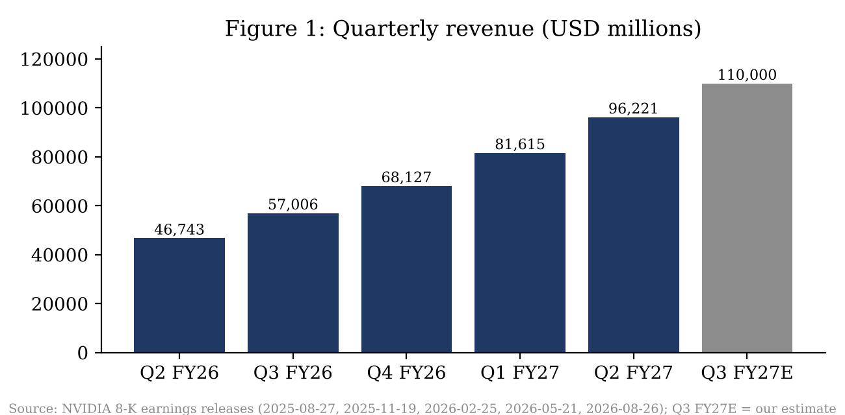
Source: Company earnings releases; Q2 FY27 release; Q4 FY26 release (8-K)
Reporting change. Starting in Q1 FY27, NVIDIA reports revenue by two market platforms: Data Center and Edge Computing. The old Gaming, Professional Visualization, Automotive and OEM & Other lines no longer exist as separate disclosures. Edge Computing covers PCs and game consoles (GeForce), workstations, automotive, robotics and AI-RAN base stations. Gaming revenue is therefore not separately reported for Q2 FY27. The legal reportable segments remain Compute & Networking and Graphics.
USD m | Q2 FY26 | Q3 FY26 | Q4 FY26 | Q1 FY27 | Q2 FY27 | YoY | QoQ
Total revenue | 46,743 | 57,006 | 68,127 | 81,615 | 96,221 | +105.9% | +17.9%
Data Center | 41,096 | 51,215* | 62,337* | 75,246 | 89,023 | +116.6% | +18.3%
Hyperscale | 24,168 | n/d | n/d | 43,050 | 48,710 | +101.5% | +13.1%
AI Clouds, Industrial & Enterprise | 16,928 | n/d | n/d | 32,196 | 40,313 | +138.1% | +25.2%
Edge Computing (incl. Gaming) | 5,647 | 5,791* | 5,790* | 6,369 | 7,198 | +27.5% | +13.0%
Segment: Compute & Networking | 41,331 |  |  |  | 88,299 | +113.6%
Segment: Graphics | 5,412 |  |  |  | 7,922 | +46.4%
Source: Form 10-Q filed 2026-08-26 and earnings releases. *Estimated: Q3 FY26 from legacy Data Center disclosure; Q4 FY26 Edge back-solved from the reported +10% QoQ in Q1 FY27. n/d = not disclosed. 10-Q text; segment change coverage
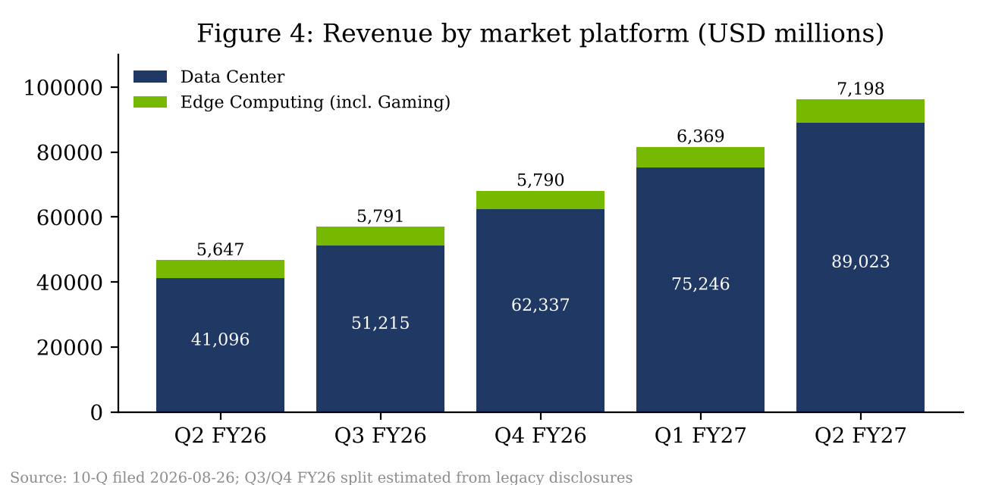
Source: Form 10-Q; analyst estimates for restated FY26 quarters Form 10-Q
Data Center ($89,023m, +116.6% YoY, +18.3% QoQ) beat the ~$85,800m consensus by 3.8%. Within it, the AI Clouds, Industrial & Enterprise bucket (neoclouds, sovereign AI, enterprise) grew 25.2% sequentially to $40,313m and now represents 45.3% of Data Center, up from 41.2% a year ago. Hyperscale grew 13.1% QoQ to $48,710m. The diversification away from the four large cloud providers is constructive for durability, though it raises counterparty-credit questions given that management paused a revenue-sharing financing program for smaller AI cloud operators during the quarter. Three direct customers accounted for 44% of total revenue.
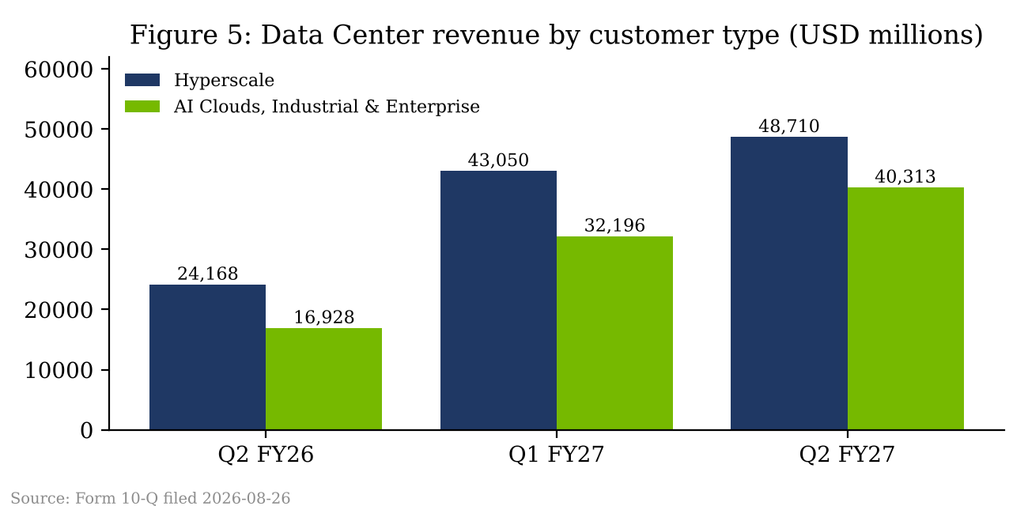
Source: Form 10-Q filed 2026-08-26 Form 10-Q
Networking is no longer broken out in the press release or 10-Q for Q2. In Q1 FY27 networking was $14.8bn (+199% YoY); we estimate Q2 networking at roughly $17bn, consistent with NVLink-rack attach for GB300 and early Rubin systems. This figure is our estimate and is unverified.
Edge Computing, which now houses Gaming, grew 27.5% YoY and 13.0% QoQ to $7,198m. The Graphics reportable segment (mostly GeForce, workstation and consoles) was $7,922m, up 46.4% YoY, with a 49.2% segment operating margin. We infer that Gaming remained the largest single piece of Edge Computing, but the company no longer quantifies it, so any Gaming figure for Q2 FY27 would be an estimate. Our working assumption is roughly $4.5bn to $5.0bn.
Geography. Revenue billed to US-headquartered customers was $60,074m (62.4%), Taiwan $26,985m (28.0%, mostly ODM/system builders), China including Hong Kong $7,880m (8.2%) and other $1,282m. The China figure is notably higher than the prior-year $3,985m and appears to reflect Edge and non-compute products plus some H20/H200-class shipments before the guide's China-zero assumption. A $0.4bn charge related to excess H200 inventory and purchase obligations was taken in the quarter.
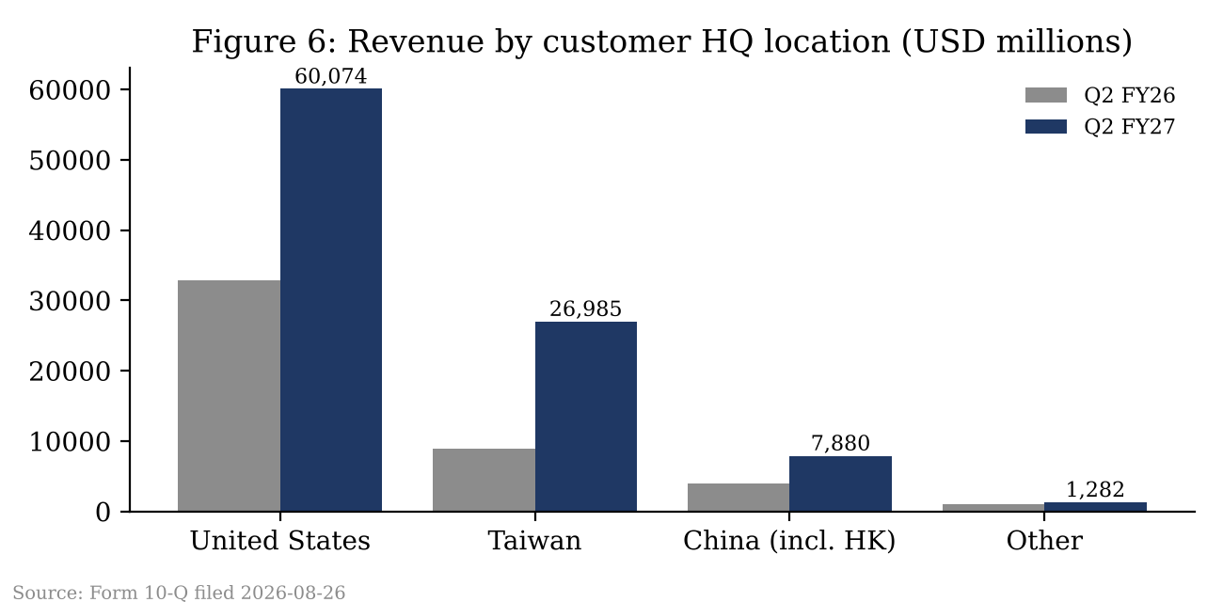
Source: Form 10-Q filed 2026-08-26 (customer headquarters basis) Form 10-Q

3. Margins: five-quarter trend
 | Q2 FY26 | Q3 FY26 | Q4 FY26 | Q1 FY27 | Q2 FY27 | YoY chg
Revenue (USD m) | 46,743 | 57,006 | 68,127 | 81,615 | 96,221 | +105.9%
GAAP gross margin | 72.4% | 73.4% | 75.0% | 74.9% | 75.0% | +2.6pp
Non-GAAP gross margin | 72.5% | n/a | n/a | 75.0% | 75.0% | +2.5pp
GAAP opex (USD m) | 5,413 | 5,839 | 6,794 | 7,621 | 8,408 | +55.3%
GAAP opex / revenue | 11.6% | 10.2% | 10.0% | 9.3% | 8.7% | -2.9pp
GAAP operating income (USD m) | 28,440 | 36,010 | 44,299 | 53,536 | 63,734 | +124.1%
GAAP operating margin | 60.8% | 63.2% | 65.0% | 65.6% | 66.2% | +5.4pp
GAAP net income (USD m) | 26,422 | 31,910 | 42,960 | 58,321 | 59,688 | +125.9%
GAAP net margin | 56.5% | 56.0% | 63.1% | 71.5% | 62.0% | +5.5pp
GAAP diluted EPS (USD) | 1.08 | 1.30 | 1.76 | 2.39 | 2.46 | +127.8%
Source: Company earnings releases; margins calculated by analyst. Non-GAAP restated to include SBC from Q1 FY27; restated Q3/Q4 FY26 non-GAAP not shown. Q2 FY27 release tables; Q4 FY26 release
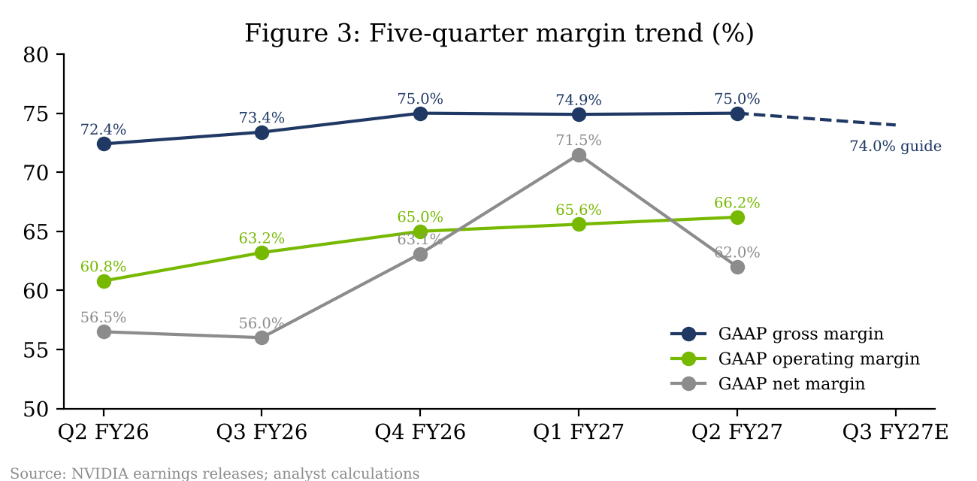
Source: Company releases; analyst calculations Q2 FY27 release
Gross margin has now sat at 75% for three quarters, after recovering from the Blackwell transition trough (72.4% in Q2 FY26). The Q3 guide of 74.0% ±50bp signals the next transition: early Vera Rubin volume carries higher initial cost, and HBM4 and LPDDR memory pricing has risen sharply. The $279bn of supply commitments (versus $119bn a quarter earlier), mainly memory, shows NVIDIA is locking in capacity at higher prices. We model 74.0% in Q3, 73.5% in Q4 and 73.0% for FY28, which leaves room for a recovery once Rubin yields mature.
Operating leverage remains extraordinary. GAAP opex grew 10.3% QoQ to $8,408m (R&D $7,054m; SG&A $1,354m) while revenue grew 17.9%, so GAAP operating margin reached a record 66.2%. GAAP operating income was $63,734m, up 124.1% YoY. Note that, beginning in Q1 FY27, NVIDIA's non-GAAP measures no longer exclude stock-based compensation, so GAAP and non-GAAP operating income ($63,956m) are now nearly identical.
Below the line. GAAP net income of $59,688m (GAAP diluted EPS $2.46) was inflated by about $7.8bn of net gains on equity securities (strategic stakes in AI model and cloud companies). Non-GAAP net income, which excludes those gains, was $53,954m, or $2.22 per share, the figure consensus is struck against. Diluted weighted shares fell to 24,285m from 24,391m in Q1 and 24,532m a year ago.
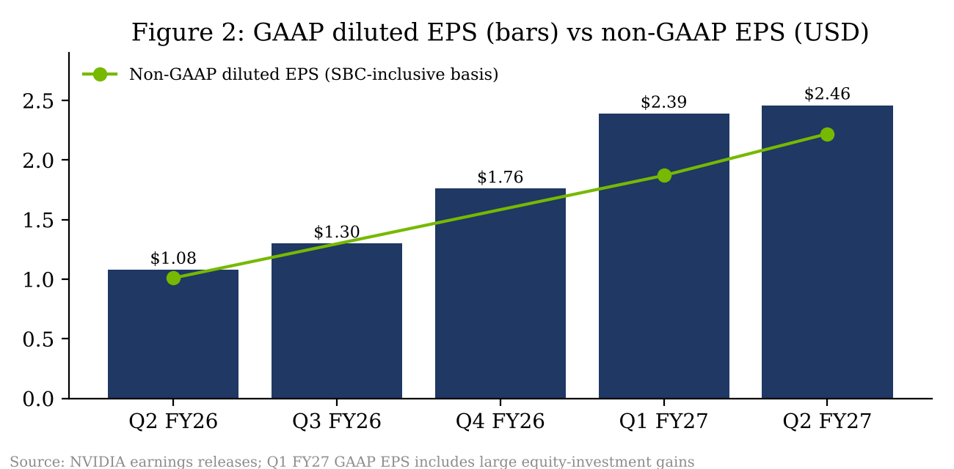
Source: Company releases Q2 FY27 release tables

4. Cash flow and capital returns
Operating cash flow was $24,077m in Q2 versus $50,344m in Q1, taking the first half to $74,421m. Capex (property, equipment and intangibles) was $2,677m, giving free cash flow of $21,400m, a 22.2% FCF margin against a 62.0% GAAP net margin. The shortfall reflects a working-capital build: accounts receivable rose to about $63.1bn (from $38.5bn) and inventory to about $31.6bn (from $21.4bn), consistent with back-end-loaded shipments of rack-scale systems and pre-buys for Rubin. Long-term debt rose to about $32.4bn from $7.5bn, per third-party balance-sheet summaries that we could not reconcile to the 10-Q directly.
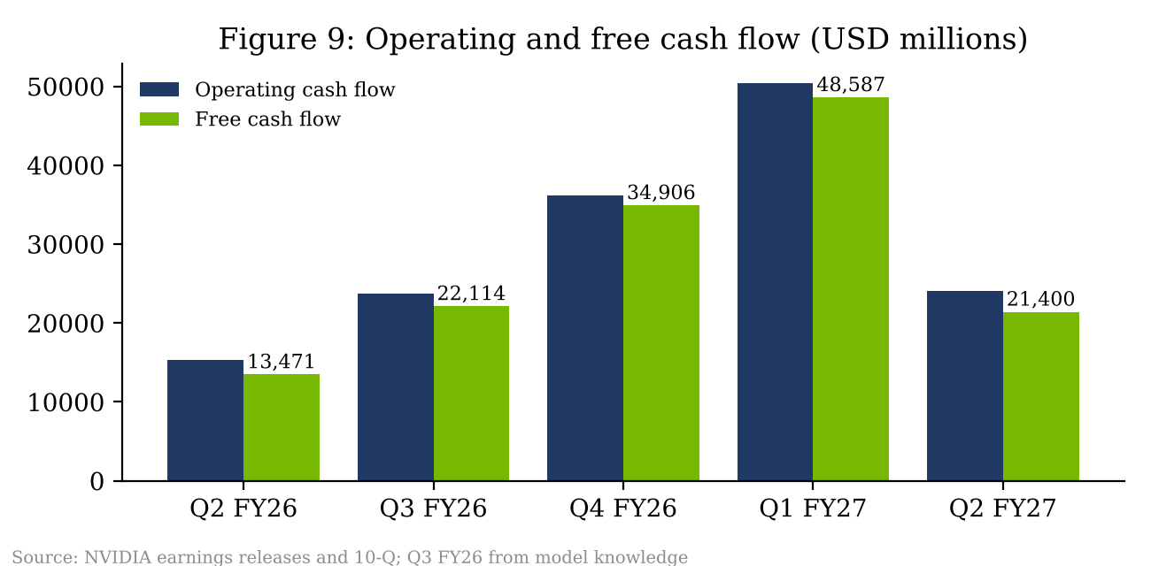
Source: Company releases and 10-Q; Q3 FY26 OCF/capex from model knowledge Q2 FY27 release; 10-Q
NVIDIA returned about $26.0bn in Q2: $19.7bn of buybacks (94m shares) plus dividends, now $0.25 per quarter. About $99bn of repurchase authorization remains. Even with weaker conversion this quarter, the H1 FCF of about $70bn comfortably funds returns.

5. Guidance versus consensus
Q3 FY27 outlook | Guidance | Consensus | Variance
Revenue (USD m) | 108,000 ±2% (105,840-110,160) | 104,200 | +3,800 (+3.6%)
Gross margin (GAAP and non-GAAP) | 74.0% ±50bp | ~75% | about -100bp
GAAP opex (USD m) | ~9,200 | n/a
Non-GAAP opex (USD m) | ~9,000 | n/a
FY27 tax rate | 16.0%-18.0%
China DC compute | Excluded
Source: Q2 FY27 earnings release; consensus per release; XTB; Parameter.io (~$103.9bn)
The revenue guide implies +12.2% QoQ at the midpoint, a deceleration from +17.9% in Q2. Our view is that this is a supply-gated number, not a demand signal: CFO Colette Kress said customer forecasts imply demand could double next year, but NVIDIA is planning for roughly 70% growth because of component supply. The guide also excludes China. At the guided 74.0% gross margin and $9.0bn of non-GAAP opex, Q3 non-GAAP operating income would be about $70.9bn at the midpoint. We model Q3 revenue at $110,000m (+1.6% above the midpoint, in line with NVIDIA's habit of landing at or above the top of the range) and non-GAAP EPS of $2.50.

6. Stock reaction
NVDA closed at $209.76 on 2026-08-26 ahead of the print. Shares fell almost 2% immediately after the release on the gross-margin guide, then recovered to about +4% after hours as the call progressed. On 2026-08-27 (the first full session after the report) the stock closed at about $227.98, up 8.7% and adding roughly $300bn of market value, one of the largest single-day dollar gains on record, helped by an announced AWS agreement for 2 million additional GPUs. The move then partially reversed on 2026-08-28 (close $217.55, -4.6%) as investors refocused on margins, decelerating sequential growth and China. The stock subsequently reached a 20-week high of $235.93 on 2026-10-02 and closed at $228.42 on 2026-10-13, up 8.9% from the pre-print close.
Source: Price data: 24/7 Wall St (2026-08-27); TS2 (2026-08-28); Parameter.io; Trading Economics (2026-10-13)
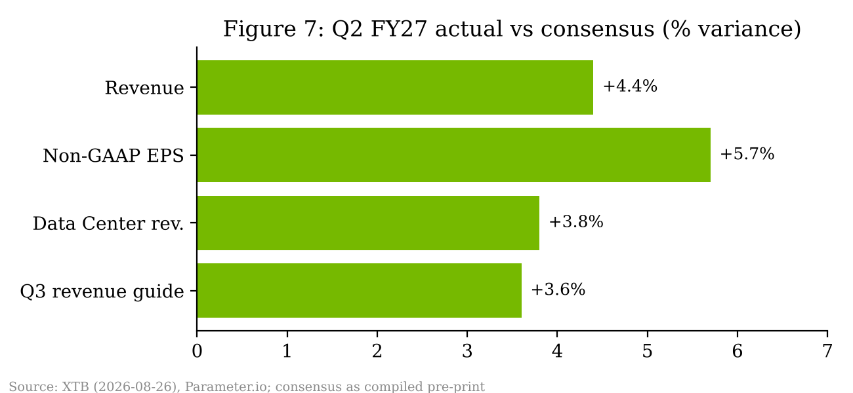
Source: Consensus as compiled by XTB; Parameter.io

7. Updated estimates
USD m | Q1 FY27A | Q2 FY27A | Q3 FY27E | Q4 FY27E | FY27E | FY28E
Revenue | 81,615 | 96,221 | 110,000 | 122,000 | 409,836 | 635,000
QoQ / YoY growth | +19.8% QoQ | +17.9% QoQ | +14.3% QoQ | +10.9% QoQ | +89.8% YoY | +54.9% YoY
Non-GAAP gross margin | 75.0% | 75.0% | 74.0% | 73.5% | 74.3% | 73.0%
Non-GAAP opex | 7,449 | 8,232 | 9,000 | 9,800 | 34,481 | 42,000
Non-GAAP operating income | 53,783 | 63,956 | 72,400 | 79,870 | 270,009 | 421,550
Non-GAAP diluted EPS (USD) | 1.87 | 2.22 | 2.50 | 2.77 | 9.36 | 14.68
Diluted shares (m) | 24,391 | 24,285 | 24,200 | 24,150 | 24,257 | 24,000
Source: Q1-Q2 actuals per company releases; Q3 FY27E onward analyst estimates. Assumes 17% tax, $0.5-0.6bn quarterly non-operating income ex-equity gains. Q2 FY27 release tables
What changed. Our FY27E revenue rises 7.3% to $409,836m, entirely because the Q2 beat and Q3 guide sit well above our pre-print baseline. FY28E revenue rises to $635,000m (+54.9% YoY). We deliberately stay below management's ~70% growth framing because (1) the supply commitments imply component cost inflation that may be partly passed through but could also cap units, (2) China remains at zero, and (3) the neocloud cohort's financing has become tighter. Gross margin is trimmed 50bp in FY28E to 73.0% to reflect memory costs. FY28E non-GAAP EPS rises 13.8% to $14.68.
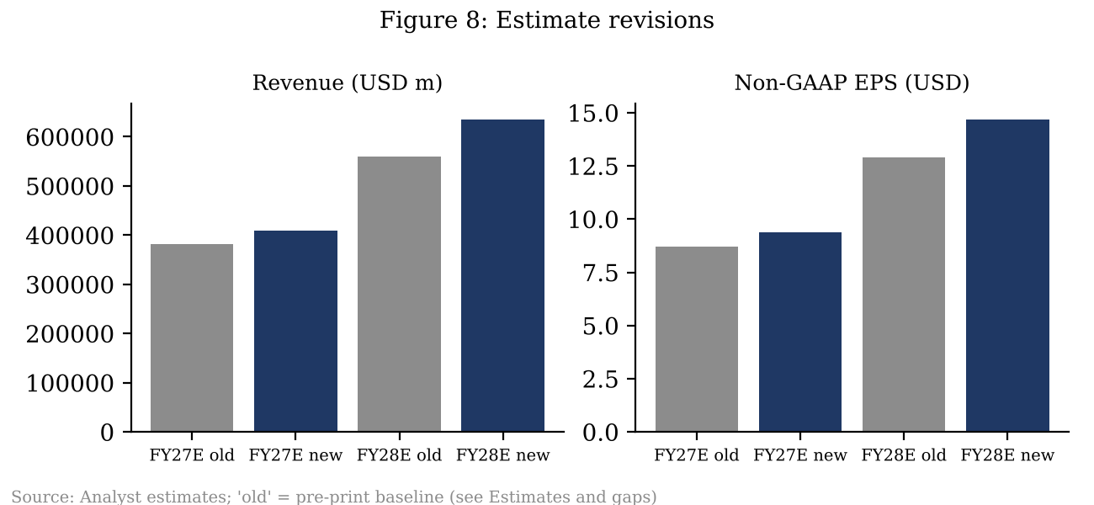
Source: Analyst estimates Q2 FY27 release

8. Thesis impact: positive
Our BUY thesis rests on three pillars: (1) NVIDIA is the system-level standard for AI training and inference, with networking and software extending the moat beyond the GPU; (2) AI infrastructure spending broadens from hyperscalers to sovereigns, neoclouds and enterprise; and (3) operating leverage keeps operating margins above 60% through product transitions. Q2 strengthened all three.
■ Pillar 1 intact. Data Center growth re-accelerated to 116.6% YoY, networking attach is rising, and the AWS 2-million-GPU agreement plus a reported $150-200bn Ohio campus opportunity extend visibility into 2027-2028.
■ Pillar 2 strengthened. AI Clouds, Industrial & Enterprise grew 138.1% YoY and is approaching parity with Hyperscale. Neocloud partners are expected to reach about 8 GW of installed capacity by year-end.
■ Pillar 3 holding, with a caveat. Operating margin hit 66.2%, but the 74% gross-margin guide and memory-driven commitments mean margin expansion has likely peaked for this cycle. We model gently declining gross margin through FY28 and still see operating margin above 64%.

What changed
New: management's FY28 growth framing (~70%), a doubling of supply commitments to $279bn, a step-down in gross-margin guidance, a sharp working-capital build and the move to two market platforms, which removes Gaming visibility. Unchanged: China excluded from guidance; capital return pace (~$26bn per quarter).

Key risks
- Margin compression beyond our 73% FY28 assumption if memory costs cannot be passed through.
- Customer concentration: three direct customers were 44% of revenue; neocloud credit risk after the financing pause.
- Receivables and inventory build could foreshadow digestion if hyperscaler capex growth slows in CY2027.
- Export controls: China upside is excluded, but further restrictions on other regions are a tail risk.
- Supply chain: CoWoS, HBM4 and power availability gate shipments regardless of demand.

Upcoming catalysts
- Q3 FY27 results, expected in the second half of November 2026.
- Vera Rubin volume ramp and NVL144 rack shipments through 2H CY2026.
- Any change in US export licensing for China data center compute.
- GTC DC / hyperscaler CY2027 capex guidance in late-2026 and early-2027 earnings.

9. Valuation and price target
We set a 12-month price target of $320, based on 22x our FY28E non-GAAP EPS of $14.68 ($323, rounded down). 22x is a discount to NVIDIA's three-year average forward P/E (low-30s) and reflects the plateau in gross margin and higher working-capital intensity, but it is a premium to the semiconductor group for roughly 55% growth. At $228.42 the stock trades at 24.4x FY27E and 15.6x FY28E EPS, which we think understates the earnings power implied by the $279bn of commitments. Our target sits close to the FactSet median target of $316.60 (57 Buy, 7 Overweight, 2 Hold, 1 Sell as of 2026-08-28).
Scenario | FY28E revenue (USD m) | FY28E EPS (USD) | Multiple | Value (USD) | vs price
Bear: digestion, GM 70% | 500,000 | 10.80 | 17.5x | 190 | -16.8%
Base | 635,000 | 14.68 | 22.0x | 320 | +40.1%
Bull: mgmt ~70% growth, GM 74% | 697,000 | 16.80 | 24.5x | 410 | +79.5%
Source: Analyst estimates; price per Trading Economics, close 2026-10-13
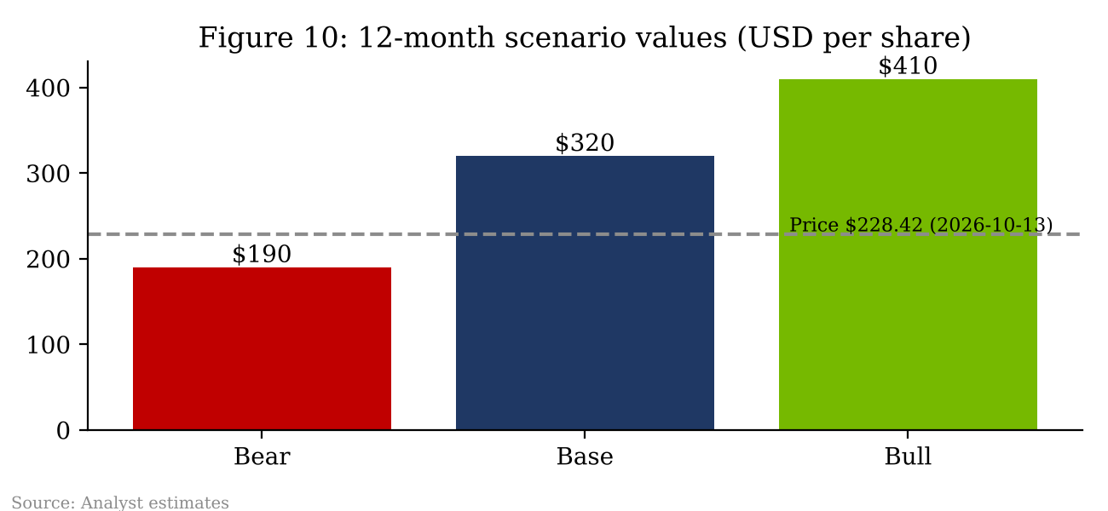
Source: Analyst estimates Trading Economics
Conclusion. Q2 FY27 was a clean beat with a strong guide; the debate has shifted from demand to margins and cash conversion. We think both are explainable by the Rubin transition and the supply pre-buys, and we would use margin-driven weakness to add. Maintain BUY, $320 target.

Sources and references
- NVIDIA Q2 FY27 earnings release (2026-08-26), text via StorageNewsletter
- NVIDIA Q2 FY27 earnings release with financial tables (PDF copy)
- Form 10-Q for quarter ended 2026-07-26, filed 2026-08-26 (SEC EDGAR)
- Form 10-Q text (OpenCapital mirror, accession 0001045810-26-000075)
- NVIDIA Q4 FY26 earnings release, Form 8-K (2026-02-25)
- XTB: consensus and stock reaction (2026-08-26)
- Parameter.io: consensus, closing price 2026-08-26 and after-hours move
- 24/7 Wall St: 2026-08-27 price move
- TS2: 2026-08-28 move and FactSet ratings/targets
- Trading Economics: NVDA price, 2026-10-13
- Digital Citizen: Edge Computing segment change (2026-05-21)
- Pulse 2.0: Q2 FY27 income statement summary
Earnings call transcript (2026-08-26) was not retrieved directly; management commentary is as reported by the outlets above. Consensus figures are third-party compilations, not Bloomberg/FactSet terminal pulls. This report is for informational purposes and is not investment advice.

