EQUITY RESEARCH | EARNINGS UPDATE | 2026-10-13

NVIDIA Corp. (NVDA): Q2 FY27 - Clean Beat, Bigger Guide; Cash Conversion Is the Watch Item
Rating: BUY | Price target: USD 306 (12-month) | Price (2026-10-13 close): USD 228.52 | Upside: 33.9% | Market cap: USD 5,518,073M
Quarter covered: Q2 fiscal 2027 (13 weeks ended 2026-07-26), reported after market close on 2026-08-26; Form 10-Q filed the same day. This is the most recent reported quarter as of 2026-10-13; Q3 FY27 (ending late October 2026) has not yet been reported.

Key takeaways
- Revenue beat by USD 4,051M (4.4%): USD 96,221M vs. USD 92,170M consensus, +105.9% YoY and +17.9% QoQ, and 5.7% above the USD 91,000M guide midpoint.
- EPS beat: non-GAAP diluted EPS USD 2.22 vs. USD 2.10 consensus (+5.7%). GAAP diluted EPS USD 2.46 (+127.8% YoY) is flattered by USD 7,773M of other income, mostly gains on equity holdings.
- Data Center USD 89,023M (+116.6% YoY) beat consensus by USD 3,943M (4.6%). Hyperscale USD 48,710M; AI Clouds, Industrial & Enterprise (ACIE) USD 40,313M (+138.1% YoY), now 45.3% of Data Center.
- Q3 FY27 guide of USD 108,000M +/-2% is 3.7% above the ~USD 104,190M consensus. The 74.0% gross margin guide was below the ~74.8% Street expectation; that is the main debate.
- Cash flow is the soft spot. Operating cash flow fell to USD 24,077M (from USD 50,344M in Q1) as receivables rose USD 22,349M to USD 63,059M. DSO went from 45 to 60 days.
- Thesis impact: POSITIVE. FY27E revenue rises to USD 407,800M and FY28E to USD 560,000M. We set a USD 306 price target (25x FY28E non-GAAP EPS of USD 12.25). BUY.

Results snapshot
Metric (USD M unless noted) | Q2 FY27 actual | Consensus / guide | Variance | Q2 FY26 | YoY
Revenue | 96,221 | 92,170 | +4.4% | 46,743 | +105.9%
Data Center revenue | 89,023 | 85,080 | +4.6% | 41,096 | +116.6%
Gross margin (GAAP) | 75.0% | n/a | n/a | 72.4% | +2.6 pts
Operating income (GAAP) | 63,734 | n/a | n/a | 28,440 | +124.1%
Operating margin (GAAP) | 66.2% | n/a | n/a | 60.8% | +5.4 pts
Diluted EPS, non-GAAP (USD) | 2.22 | 2.10 | +5.7% | 1.05* | +111.4%
Diluted EPS, GAAP (USD) | 2.46 | n/a | n/a | 1.08 | +127.8%
Q3 FY27 revenue guide (midpoint) | 108,000 | 104,190 | +3.7% | 57,006 (Q3 FY26) | +89.5%
Source: Q2 FY27 earnings release (2026-08-26); Form 10-Q filed 2026-08-26; consensus per LSEG/Street as reported by INDmoney (2026-08-27). *Q2 FY26 non-GAAP EPS restated to include SBC. Earnings release Form 10-Q Consensus (INDmoney)

1. Detailed results

Top line: the beat came from Data Center, and ACIE grew fastest
NVIDIA reported Q2 FY27 revenue of USD 96,221M, up 105.9% YoY from USD 46,743M and up 17.9% QoQ from USD 81,615M. The quarter beat the USD 91,000M +/-2% guide by USD 5,221M and LSEG consensus by USD 4,051M. The sequential increase of USD 14,606M is the largest absolute QoQ increase in the last five quarters. Data Center contributed USD 13,777M of it, so the beat was almost entirely Data Center. Management said Vera Rubin began production shipments during the quarter, with purchase orders from every major hyperscaler. The Rubin ramp therefore lands mostly in Q3, and the Blackwell family carried Q2.
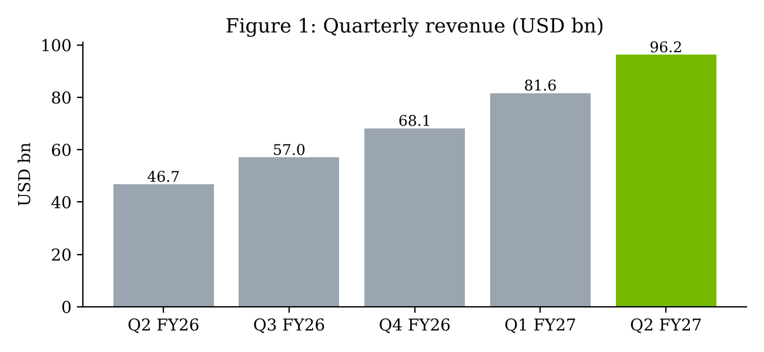
Figure 1. Revenue roughly doubled YoY to USD 96,221M. Source: NVIDIA 10-Q filed 2026-08-26 and prior filings (SEC XBRL via stock-data get_financials). 10-Q
On segment reporting: from FY27 NVIDIA presents revenue by two market platforms, Data Center (split into Hyperscale and ACIE) and Edge Computing. Edge Computing covers consumer PC/gaming GPUs, Blackwell workstations, automotive and robotics. Gaming, Professional Visualization and Automotive are no longer disclosed separately, so a Gaming line for Q2 FY27 is not available. Edge Computing is the closest comparable. The 10-Q's reportable segments are still Compute & Networking (USD 88,299M revenue; USD 62,696M operating income) and Graphics (USD 7,922M; USD 3,899M). Graphics revenue grew 46.4% YoY.
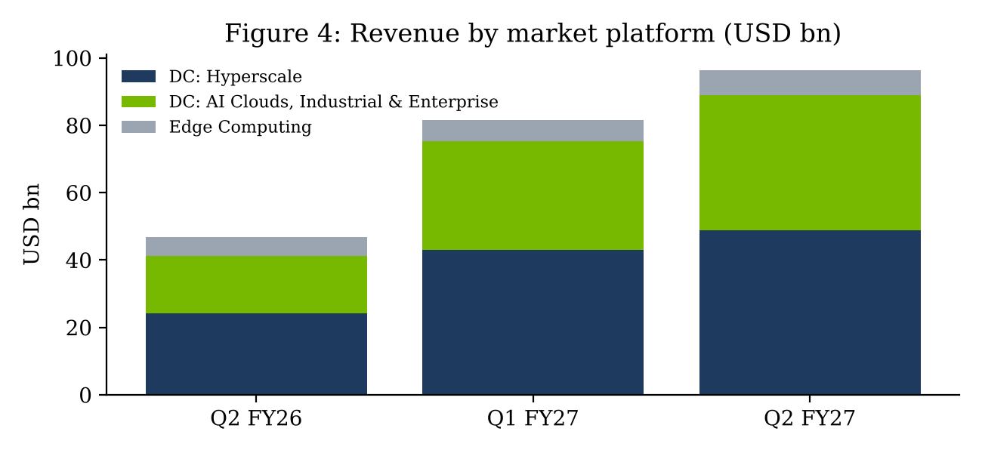
Figure 4. Data Center USD 89,023M (+116.6% YoY); Edge Computing (gaming/PC, workstations, auto, robotics) USD 7,198M (+27.5%). Source: 10-Q filed 2026-08-26. 10-Q
Market platform (USD M) | Q2 FY27 | Q1 FY27 | Q2 FY26 | QoQ | YoY | % of rev.
Data Center | 89,023 | 75,246 | 41,096 | +18.3% | +116.6% | 92.5%
Hyperscale | 48,710 | 43,050 | 24,168 | +13.1% | +101.5% | 50.6%
AI Clouds, Industrial & Enterprise | 40,313 | 32,196 | 16,928 | +25.2% | +138.1% | 41.9%
Edge Computing (gaming/PC, workstation, auto, robotics) | 7,198 | 6,369 | 5,647 | +13.0% | +27.5% | 7.5%
Total | 96,221 | 81,615 | 46,743 | +17.9% | +105.9% | 100.0%
Source: Form 10-Q for the quarter ended 2026-07-26, filed 2026-08-26 (revenue by market platform). Form 10-Q
The ACIE line, which covers neoclouds, sovereigns, industrial and enterprise buyers, grew 25.2% QoQ against 13.1% for Hyperscale. That spreads demand away from the largest cloud buyers, and in our view it is the most important mix change in the print. Neither the 10-Q nor the release splits Data Center into compute and networking, so we do not show networking separately this quarter.

Why results beat
- Supply (our interpretation): component supply was better than the guide implied, which let Blackwell-family shipments run ahead of plan. Management still describes NVIDIA as supply-constrained through the year.
- Customer breadth: ACIE beat Hyperscale growth by 12 pts QoQ, so the beat did not depend on a single hyperscaler pulling orders forward.
- No China: the guide assumed zero Data Center compute revenue from China. The upside was ex-China.
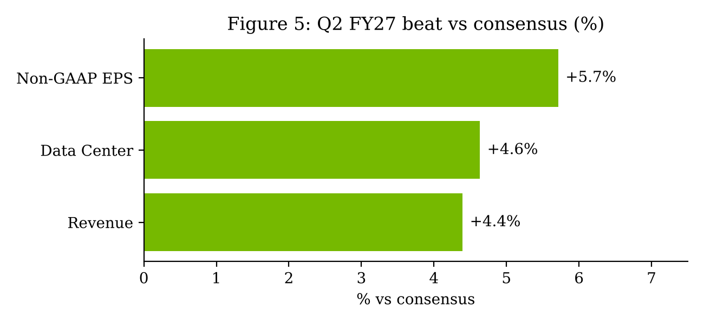
Figure 5. Consensus: revenue USD 92,170M, Data Center USD 85,080M, non-GAAP EPS USD 2.10 (LSEG/Street, as reported by INDmoney 2026-08-27). INDmoney

2. Margins, cash flow and guidance

Margins: gross margin flat at 75%, operating leverage intact
GAAP gross margin was 75.0%. It was 72.4% in Q2 FY26, 73.4% in Q3 FY26, 75.0% in Q4 FY26 and 74.9% in Q1 FY27, so it has stayed at about 75% for three quarters while revenue grew 41%. Operating expenses rose 10.3% QoQ to USD 8,408M, slower than revenue, and GAAP operating margin reached a record 66.2%, up 5.4 pts YoY and 0.6 pts QoQ. GAAP net margin fell to 62.0% from 71.5% in Q1 because Q1 contained an unusually large equity-investment gain. Non-GAAP net income of USD 53,954M (56.1% margin) is the cleaner measure of earnings power. From Q1 FY27, non-GAAP results include stock-based compensation, which lowers reported non-GAAP EPS against the old definition.
GAAP (USD M / %) | Q2 FY26 | Q3 FY26 | Q4 FY26 | Q1 FY27 | Q2 FY27
Revenue | 46,743 | 57,006 | 68,127 | 81,615 | 96,221
Gross margin | 72.4% | 73.4% | 75.0% | 74.9% | 75.0%
Operating expenses | 5,413 | 5,839 | 6,794 | 7,621 | 8,408
Operating income | 28,440 | 36,010 | 44,299 | 53,536 | 63,734
Operating margin | 60.8% | 63.2% | 65.0% | 65.6% | 66.2%
Net margin | 56.5% | 56.0% | 63.1% | 71.5% | 62.0%
Diluted EPS (USD) | 1.08 | 1.30 | 1.76 | 2.39 | 2.46
Operating cash flow | 15,365 | 23,751 | 36,188 | 50,344 | 24,077
Source: SEC XBRL quarterly data via stock-data get_financials (Q4 values derived as FY minus 9M); Q4 FY26 release (2026-02-25); Q2 FY27 release (2026-08-26). Q4 FY26 release Q2 FY27 release
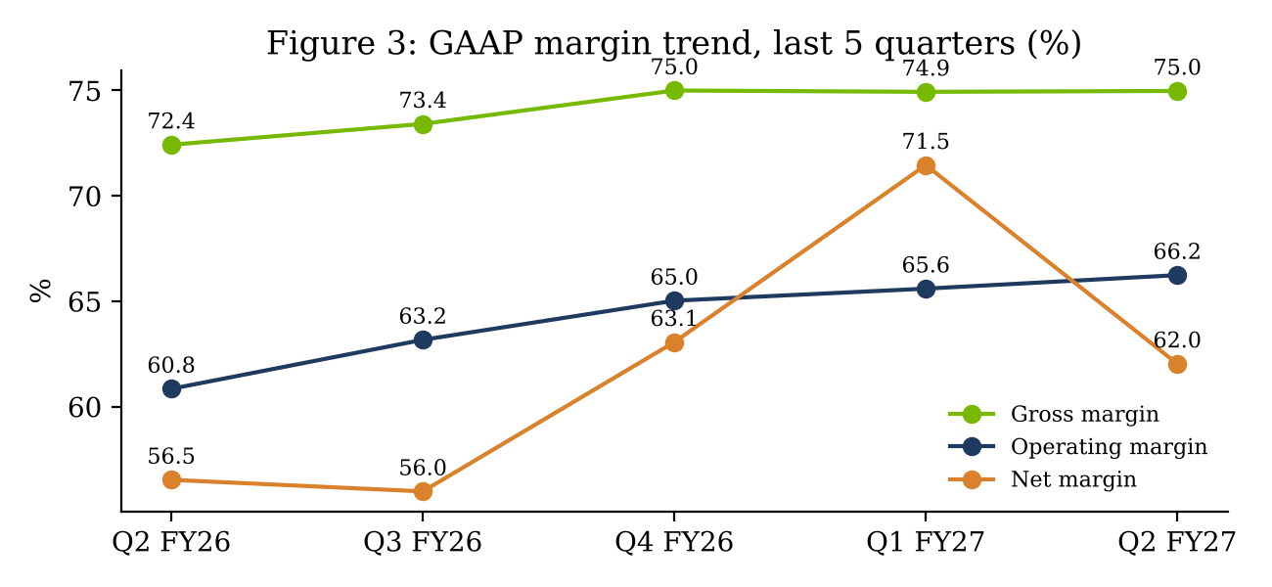
Figure 3. Gross margin held at 75.0%; operating margin up 5.4 pts YoY to 66.2%. Source: SEC XBRL (stock-data get_financials); company releases.

Earnings: GAAP vs non-GAAP divergence
GAAP diluted EPS was USD 2.46, up 127.8% YoY, on GAAP net income of USD 59,688M and 24,285M diluted shares. Non-GAAP diluted EPS was USD 2.22 on non-GAAP net income of USD 53,954M. The USD 5,734M gap comes mainly from USD 7,773M of GAAP other income, largely unrealized gains on NVIDIA's growing portfolio of marketable equity securities (USD 42,783M at quarter end against USD 12,886M at 2026-01-25), partly offset by tax effects and acquisition-related items. From Q1 FY27 NVIDIA's non-GAAP measures include stock-based compensation (USD 2,026M in Q2), so the non-GAAP figure is now a stricter measure than in earlier years. On the restated basis non-GAAP EPS grew 111.4% YoY and 18.7% QoQ, roughly in line with revenue. The diluted share count fell 1.0% YoY to 24,285M, helped by USD 19,732M of repurchases in the quarter. The GAAP effective tax rate was 16.5% (USD 11,819M on pre-tax income of USD 71,507M), within the new 16-18% FY27 range, below the 17-19% range guided in February 2026.
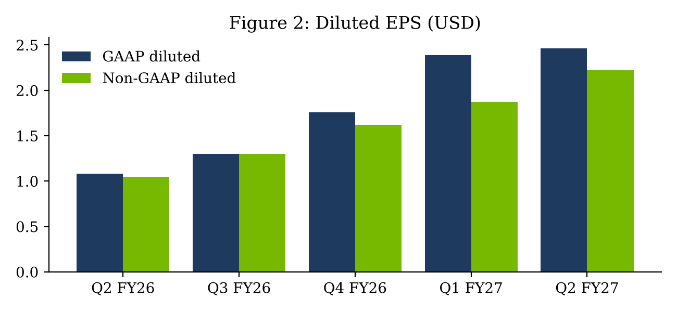
Figure 2. GAAP EPS of USD 2.46 includes USD 7,773M of other income (largely equity-security gains); non-GAAP EPS of USD 2.22 now includes SBC (Q2 FY26 restated to USD 1.05). Source: Q2 FY27 release 2026-08-26; Q4 FY26 release 2026-02-25.

Cash flow: receivables absorbed half the quarter's cash generation
Operating cash flow was USD 24,077M, 40.3% of GAAP net income against 86.3% in Q1. Capex was USD 2,677M, and company-defined free cash flow was USD 21,341M. Accounts receivable rose USD 22,349M QoQ to USD 63,059M and inventory rose USD 5,778M to USD 31,575M. We read this as quarter-end-weighted Rubin and Blackwell shipments rather than a credit problem: customer advances in deferred revenue also rose to about USD 2.8bn. Even so, DSO of 60 days against 45 in Q1 and 54 a year ago means Q3 collections need to come through. NVIDIA returned about USD 26,000M in Q2 (USD 19,732M of buybacks and USD 6,047M of dividends after raising the quarterly dividend to USD 0.25) and has about USD 99,000M of repurchase authorization left. Long-term debt rose to USD 32,366M from USD 7,470M after a bond issue.
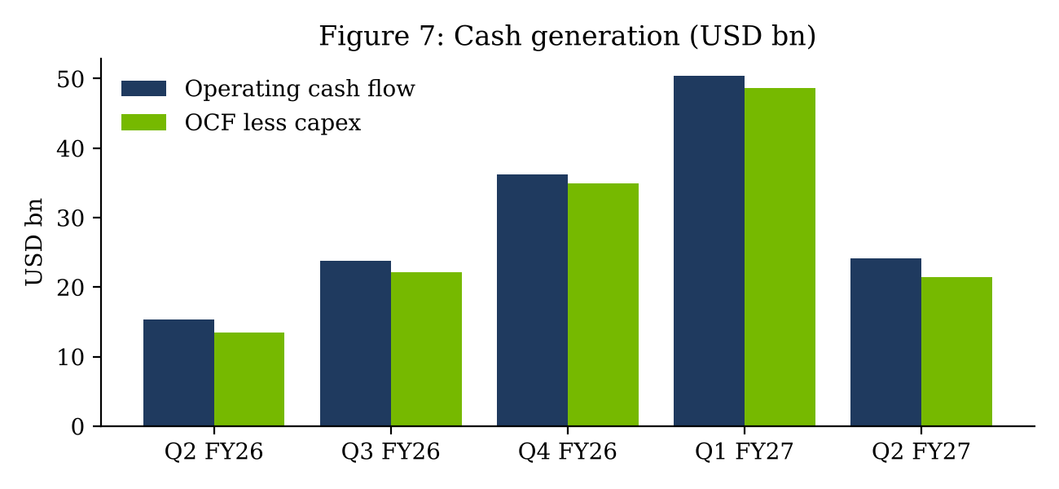
Figure 7. Q2 OCF fell to USD 24,077M as receivables rose USD 22,349M. Source: SEC XBRL (quarterly derived from YTD) via stock-data; Q2 FY27 release.
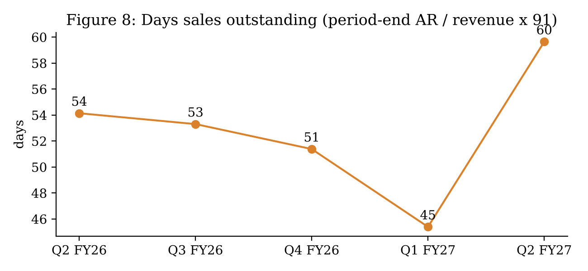
Figure 8. Receivables USD 63,059M at 2026-07-26 vs USD 40,710M at 2026-04-26. Source: 10-Q balance sheets via stock-data get_financials; our calculation.

Guidance: revenue ahead, gross margin a little light
Q3 FY27 guidance: revenue USD 108,000M +/-2% (USD 105,840M to USD 110,160M), +12.2% QoQ and +89.5% YoY, still assuming no China Data Center compute. GAAP and non-GAAP gross margin of 74.0% +/-50 bps. Opex of about USD 9,200M GAAP and USD 9,000M non-GAAP. FY27 tax rate of 16-18%. Revenue guidance is 3.7% above the ~USD 104,190M LSEG consensus. The roughly 100 bp step-down in gross margin, which management linked mainly to higher memory costs during the Rubin ramp, explains why the stock dipped after hours before the call. One third-party summary (TIKR) reports management saying gross margin could bottom around 71-72% in Q4 FY27. We could not confirm that from primary sources, so we model 72.5% for Q4 as a middle case.
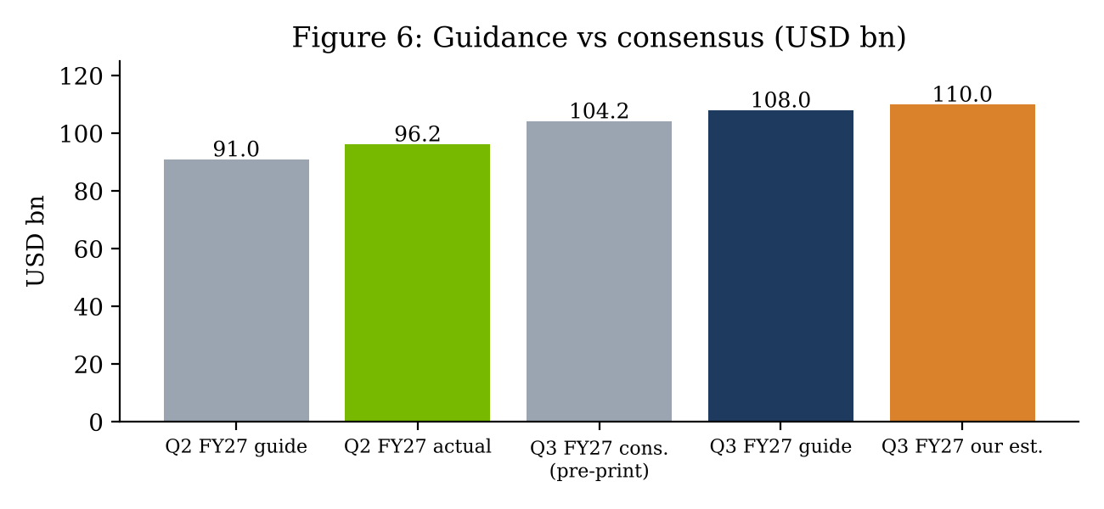
Figure 6. Q3 FY27 guide USD 108,000M +/-2% vs LSEG consensus ~USD 104,190M. Sources: investingLive preview (Q2 guide), Q2 FY27 release 2026-08-26, INDmoney (LSEG via Reuters); our estimate. Q2 guide Q3 consensus

3. Stock reaction and thesis update

Stock reaction
NVDA closed at USD 209.66 on 2026-08-26 before the release and at USD 227.98 on 2026-08-27, a gain of 8.7%. Per Bloomberg-sourced reports, that was its biggest one-day gain since April 2025, adding roughly USD 442bn of market value. Part of the move reversed the next day (2026-08-28 close USD 217.55, -4.6%). The stock then recovered to a high close of USD 239.24 on 2026-10-06 and closed at USD 228.52 on 2026-10-13, 9.0% above the pre-print close.
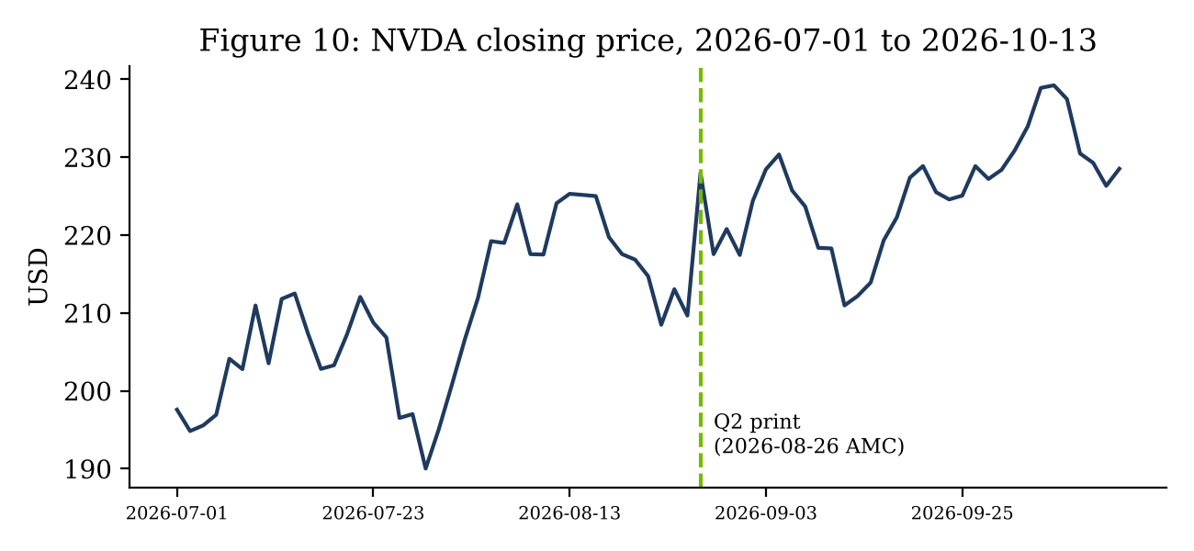
Figure 10. Close 2026-08-26 USD 209.66; 2026-08-27 USD 227.98 (+8.7%); 2026-10-13 USD 228.52. Source: stock-data get_price_history (Yahoo Finance). The Edge / Bloomberg

What changed in our thesis
- Demand breadth, stronger: ACIE now accounts for 45.3% of Data Center revenue. That reduces hyperscaler-concentration risk and supports durable growth into FY28.
- Product cadence, on track: Rubin production shipments began in Q2. Management expects about 20% of Q3 Data Center revenue from Rubin (call commentary as reported by TIKR), which reduces transition risk.
- Margins, slightly weaker: memory inflation takes roughly 100-250 bps off gross margin over the next two quarters. Operating leverage offsets most of this at the EPS level.
- Earnings quality, weaker: GAAP EPS is increasingly driven by equity-investment gains, and cash conversion fell. We value the stock on non-GAAP EPS and will watch DSO.

Key risks
- Gross margin stays below 72% for longer if HBM and other memory pricing keeps rising.
- Receivables stay elevated, which would suggest extended terms for financially weaker AI-cloud customers.
- Export-control changes: any re-entry to China is upside, but further restrictions on other regions are a risk.
- Hyperscaler capex digestion in calendar 2027, and the pace of competing custom ASICs.

Questions for the Q3 FY27 print
- Rubin mix: does Rubin reach the roughly 20% of Data Center revenue management indicated, and does it carry a lower initial gross margin than mature Blackwell?
- Gross-margin floor: is 74.0% the low point, or does memory cost inflation push Q4 toward the low 70s, as one third-party summary suggests?
- Collections: does DSO move back toward 45-50 days? If receivables keep growing faster than revenue, we would re-examine customer credit quality, especially among AI-cloud customers in ACIE.
- Opex: the USD 9,000M non-GAAP opex guide implies 9.3% QoQ growth. Faster growth would point to more aggressive hiring and R&D for the next architecture.
- Capital allocation: with USD 99,000M of authorization left and new long-term debt, how much of the buyback pace continues, and what is the balance-sheet policy for the equity portfolio?

Catalysts
- Q3 FY27 results (expected around late November 2026): Rubin mix, gross margin against the 74.0% guide, and whether DSO normalizes.
- Hyperscaler calendar Q3 2026 capex updates (late October 2026).

4. Estimates and valuation

Updated estimates
For Q3 FY27 we model revenue of USD 110,000M, 1.9% above the guide midpoint and a smaller beat than this quarter's 5.7%, with 74.0% gross margin and USD 9,000M of non-GAAP opex. Non-GAAP EPS is USD 2.50. For Q4 FY27 we model USD 120,000M of revenue at 72.5% gross margin, for non-GAAP EPS of USD 2.67. FY27E revenue is USD 407,800M and non-GAAP EPS USD 9.26. FY28E revenue is USD 560,000M (+37.3%) and non-GAAP EPS USD 12.25, assuming a 63% non-GAAP operating margin, a 17% tax rate and 24,000M diluted shares.
Estimate | Pre-print baseline | New | Change
Q3 FY27 revenue (USD M) | 104,190 | 110,000 | +5.6%
Q3 FY27 non-GAAP EPS (USD) | 2.35 | 2.50 | +6.4%
FY27 revenue (USD M) | 393,800 | 407,800 | +3.6%
FY27 non-GAAP EPS (USD) | 8.85 | 9.26 | +4.6%
FY28 revenue (USD M) | 520,000 | 560,000 | +7.7%
FY28 non-GAAP EPS (USD) | 11.40 | 12.25 | +7.5%
Price target (USD) | n/a | 306 | n/a
Source: Our estimates. The pre-print baseline is our assumed starting model (Q1 actuals, Q2 guide, LSEG Q3 consensus, our Q4/FY28 assumptions); it is not a previously published figure.
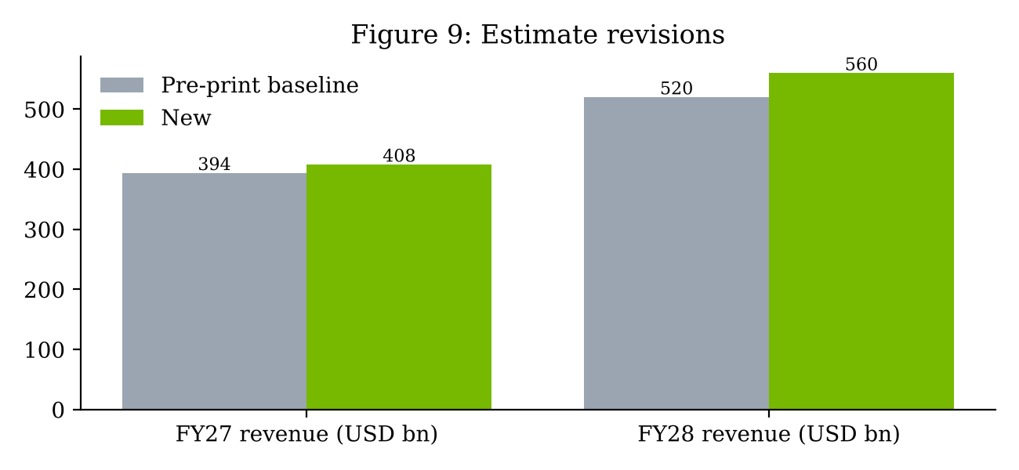
Figure 9. Pre-print baseline is our assumed starting model (guide plus consensus), not a published figure; New is our post-print model.

Valuation and price target
Our USD 306 price target is 25.0x FY28E non-GAAP EPS of USD 12.25 (USD 306.25, rounded down). That is a modest premium to large-cap semiconductor peers, which we think is justified by close to 40% growth and a 60%-plus operating margin. At USD 228.52 the stock trades at 18.7x FY28E and 24.7x FY27E non-GAAP EPS. Bear case: 20x on FY28E EPS of USD 10.50 (gross margin stays at 71%, revenue USD 500,000M) = USD 210. Bull case: 30x on FY28E EPS of USD 13.50 = USD 405.
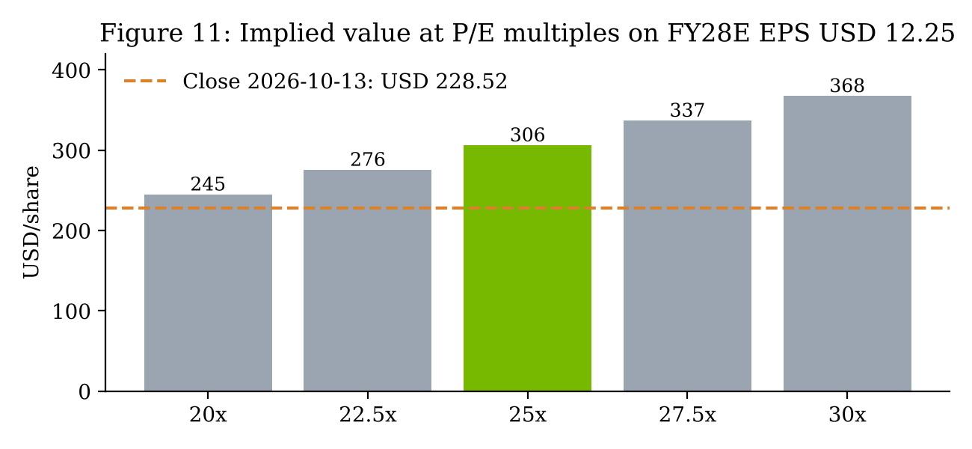
Figure 11. Our price target applies 25.0x to FY28E non-GAAP EPS. Source: our estimates.

Investment recommendation
We rate NVDA BUY with a USD 306 price target. Q2 FY27 beat on revenue, Data Center and EPS, and guidance is above the Street. Memory-driven gross-margin pressure and weaker cash conversion are real but, in our view, manageable and do not change the growth trajectory.

Sources & references
- NVIDIA, 'NVIDIA Announces Financial Results for Second Quarter Fiscal 2027' (2026-08-26), syndicated release text
- NVIDIA Form 10-Q for the quarter ended 2026-07-26 (filed 2026-08-26), SEC EDGAR, accession 0001045810-26-000075
- NVIDIA Q4 FY26 earnings release, Form 8-K exhibit (2026-02-25), SEC EDGAR
- INDmoney, NVDA Q2 earnings analysis (2026-08-27): consensus revenue, EPS, Data Center; Q3 LSEG consensus
- TIKR, 'Nvidia's Q2 earnings beat by 6%: the margin guide tells a different story' (call commentary)
- investingLive, Q2 FY27 preview (2026-08-26): Q2 guide of USD 91.0bn; pre-print consensus
- The Edge Malaysia / Bloomberg (2026-08-27): +8.7% move, about USD 442bn of market value added
- Pulse 2.0 (2026-08-26): Q3 outlook and capital-return summary
Market data: stock-data connector (Yahoo Finance), get_quote and get_price_history, fetched 2026-10-14 04:06 UTC (2026-10-13 close). Financials: stock-data get_financials (SEC XBRL) and get_filings (EDGAR). The earnings-call transcript was not retrieved directly; call commentary comes from third-party summaries.
Prepared with AI assistance from public sources. Not investment advice. The rating, estimates and price target are illustrative analyst views.

