US Mega-Cap Tech Platforms: Sector Overview
Prices as of 2026-10-13 close. Financials: last reported fiscal year per company. USD millions unless stated.

1. Summary
- Six US platforms (NVIDIA, Apple, Alphabet, Microsoft, Amazon, Meta) carry a combined market cap of about USD 23.6 trillion as of 2026-10-13. Each one is worth more than every other US-listed company outside the group.
- In their last fiscal years they booked USD 2,284,640m of revenue and USD 710,989m of GAAP operating income, a 31.1% blended margin. Capex totalled USD 430,125m, about 18.8% of revenue.
- The AI capex cycle is accelerating. The latest 2026 guidance from the four hyperscalers adds up to about USD 730bn, up from about USD 411bn of reported capex last fiscal year. The question is no longer whether demand exists, since cloud backlogs and NVIDIA's growth show that it does. The question is whether returns on capital will hold as depreciation catches up.
- Rates rose and multiples held. The 10-year Treasury yield rose about 115bp in a year (4.05% to about 5.2%), yet XLK returned 41.7% against 20.4% for the S&P 500. Earnings growth, not multiple expansion, carried the group, so a further rise in rates is now the main risk to valuations.
- Positioning: overweight the companies that sell AI capacity and already show monetization (NVIDIA, Alphabet, Microsoft). Stay neutral on Amazon, where AWS is reaccelerating but free cash flow is under pressure, and on Meta, where capex is heavy relative to revenue and the payback is indirect. Underweight Apple on valuation: it trades at 37x forward earnings while growing revenue in the single digits.

2. Market structure
The group spans four overlapping profit pools. Each company leads at least one and competes in at least two.
- Cloud infrastructure. This is a three-player oligopoly: AWS, Azure and Google Cloud hold roughly two-thirds of the global market (model knowledge). AWS made USD 128,700m of net sales in 2025, Azure has passed a USD 100bn annual run rate, and Google Cloud grew 82% year on year in Q2 2026 to USD 24,800m, with a USD 514bn backlog (secondary source). The barriers to entry are capital (each player spends USD 100bn+ a year), custom silicon, and enterprise relationships.
- Digital advertising. This is a duopoly at the top. Alphabet (Search and YouTube) and Meta together take roughly half of global digital ad spend outside China, with Amazon as a fast-growing third (model knowledge). AI ad ranking and targeting are the clearest AI payback so far: Meta revenue grew 22.2% in 2025.
- Devices and operating systems. Apple's installed base of more than 2.3bn active devices (model knowledge) supports a high-margin services business. The hardware is mature, and growth now depends on the upgrade cycle and on services pricing, which faces regulatory pressure (App Store rulings in the EU and US, and the remedies in the DOJ search case).
- Semiconductors for AI. NVIDIA holds an estimated 80%+ share of merchant AI accelerators (model knowledge). Its moat is the CUDA software stack, NVLink networking and system-level integration. Custom ASICs from the hyperscalers (TPU, Trainium, MTIA, Maia) are the main long-term threat to its share.
- Value chain. Value pools at the two ends of the chain: compute (NVIDIA at a 60%+ operating margin) and the application and ad layers. The cloud-infrastructure middle carries the capital intensity.

3. The six largest companies
Ticker | Mkt cap | Revenue | Growth % | Op. margin % | Capex | Capex/rev % | EV/Sales | Fwd P/E
NVDA | 5,518,000 | 215,938 | 65.5 | 60.4 | 6,042 | 2.8 | 18.1x | 18.9x
AAPL | 4,980,000 | 416,161 | 6.4 | 32.0 | 12,715 | 3.1 | 10.5x | 37.0x
GOOGL | 4,330,000 | 402,836 | 15.1 | 32.0 | 91,400 | 22.7 | 9.4x | 26.3x
MSFT | 4,035,000 | 331,839 | 17.8 | 46.8 | 115,948 | 34.9 | 12.3x | 27.5x
AMZN | 2,789,000 | 716,900 | 12.4 | 11.2 | 131,800 | 18.4 | 3.8x | 27.6x
META | 1,942,000 | 200,966 | 22.2 | 41.4 | 72,220 | 35.9 | 8.6x | 23.7x
Figures are for the last reported fiscal year, in USD millions. Market cap is as of the 2026-10-13 close. EV/Sales is trailing twelve months, and forward P/E comes from stockanalysis.com.
- NVIDIA. FY2026 revenue was USD 215,938m (+65.5%) at a 60.4% GAAP operating margin. Growth is accelerating: Q2 FY2027 revenue was USD 96,221m (+106% year on year), Data Center revenue was USD 89.0bn, and Q3 guidance is USD 108bn ±2%. Capex is only 2.8% of revenue, so NVIDIA receives the cycle's spending rather than funding it. At 18.9x it has the lowest forward P/E of the six.
- Apple. FY2025 revenue was USD 416,161m (+6.4%) at a 32.0% operating margin, and capex was only USD 12,715m (3.1% of revenue). Apple is the low-capex, partner-led AI player, and it trades at 37.0x forward earnings, the highest in the group, for the lowest growth.
- Alphabet. FY2025 revenue was USD 402,836m (+15.1%) at a 32.0% margin. Capex was about USD 91.4bn, and 2026 guidance has been raised to USD 195-205bn. Cloud growth of 82% and resilient Search make it the clearest example of AI capex paying back.
- Microsoft. FY2026 (to June) revenue was USD 331,839m (+17.8%) at a 46.8% margin. Capex was USD 115,948m (34.9% of revenue), and Azure grew 43% in fiscal Q4. The capex intensity weighs on free cash flow, and FY2027 margins will show how much of the depreciation step-up can be absorbed.
- Amazon. 2025 net sales were USD 716.9bn (+12.4%) at an 11.2% margin, the lowest in the group because of the retail mix. Capex was USD 131.8bn, the largest in the group, and the 2026 plan is about USD 220bn. AWS growth reaccelerated to 28% in Q1 2026, but free cash flow has compressed sharply.
- Meta. 2025 revenue was USD 200,966m (+22.2%) at a 41.4% margin. Capex was USD 72.2bn (35.9% of revenue, the highest intensity in the group), and the 2026 guide is USD 130-145bn. Meta earns its AI return indirectly, through ad pricing and engagement, which makes the payback harder to audit.
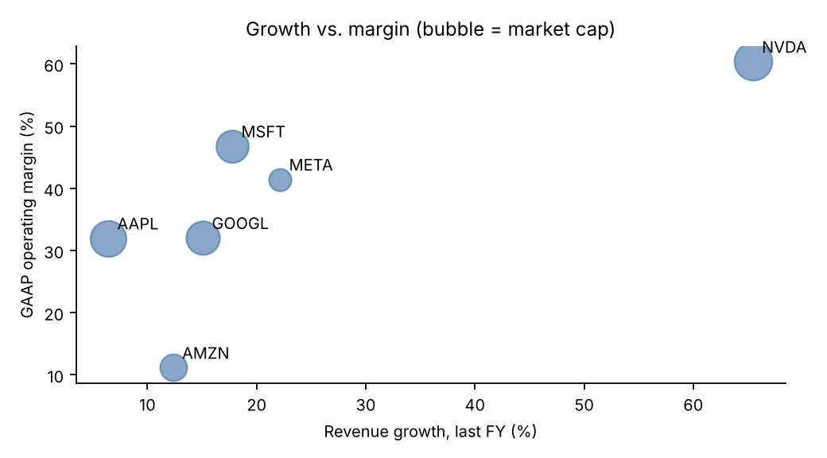

4. Growth and margin profiles
- Three groups emerge: hyper-growth at very high margins (NVIDIA), high-teens to twenties growth at 32-47% margins (Microsoft, Meta, Alphabet), and low-to-mid growth (Amazon at 12.4%, Apple at 6.4%).
- Margins have so far absorbed the capex. Microsoft's margin rose from 45.6% to 46.8%, and Alphabet's held at about 32%. Meta's slipped from 42.2% to 41.4%.
- Depreciation is the variable to watch. Servers depreciate over 5-6 years, so the 2025-26 capex wave lifts depreciation steeply in 2026-28.

5. Valuation vs. history
- Today: the median trailing EV/Sales of the six is 10.0x (range 3.8x for Amazon to 18.1x for NVIDIA). Forward P/E runs from 18.9x (NVIDIA) to 37.0x (Apple), with a median of about 26.9x.
- Against history (approximate five-year average forward P/E, model knowledge): Apple's 37x is well above its roughly 27x average. Microsoft's 27.5x is slightly below its roughly 30x average. Alphabet's 26.3x and Meta's 23.7x are above their roughly 21x averages. Amazon's 27.6x is well below its roughly 45x average. NVIDIA's 18.9x is far below its roughly 38x average.
- The group trades at a modest premium to the S&P 500 forward P/E. The premium is narrower than in 2020-21 even though the group's growth is faster.

6. The AI capex cycle and the payback debate
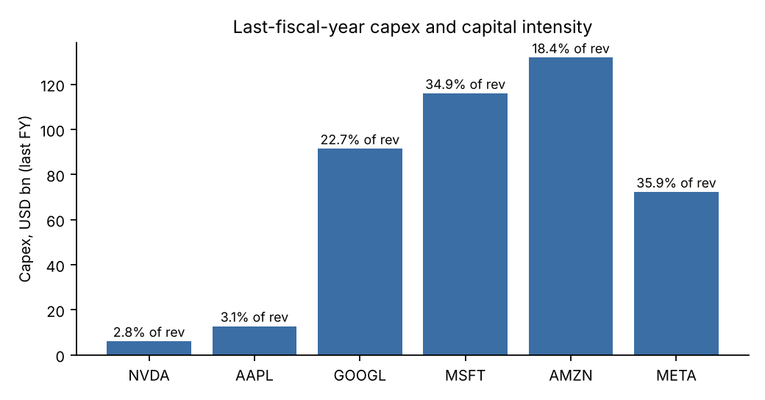
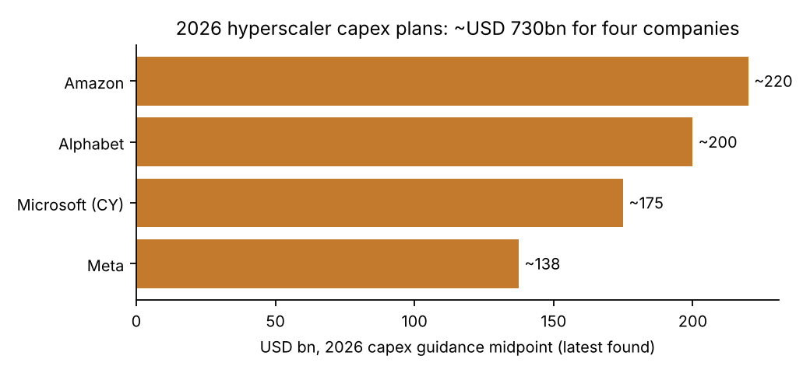
- Scale: the four hyperscalers reported about USD 411bn of capex in their last fiscal years and guide to about USD 730bn for 2026, roughly 1.8x. The guides were raised at both the April and the July 2026 earnings reports.
- Bull case: demand is visible (growing cloud backlogs, accelerating cloud growth, and NVIDIA guiding above USD 100bn a quarter). Payback can be measured in advertising and cloud. The spending is funded from operating cash flow.
- Bear case: capex at 35% of revenue is utility-like intensity, and free cash flow conversion is falling. GPU depreciation lives may be too long. Revenue is concentrated in a few AI labs, partly funded by the hyperscalers themselves. Power and grid are constrained. Rates above 5% raise the hurdle rate.
- Our view: returns are positive for the capacity sellers (NVIDIA, Azure, GCP and AWS). The application layer is the least proven. Watch, in order: cloud growth relative to capex growth, depreciation as a share of revenue, and the free cash flow yield.

7. How rates have affected multiples
- The 10-year Treasury yield rose from about 4.05% to 5.21% over the year. Under textbook duration, that should have cut long-duration growth multiples by roughly 15-20% (our estimate).
- That did not happen at the group level. XLK returned 41.7% against 20.4% for the S&P 500, and NVIDIA's multiple compressed to about 19x forward as its earnings outgrew its share price. Earnings revisions outweighed the higher discount rate.
- The equity risk premium is thin: a median forward earnings yield of about 3.7% sits below the 5.2% risk-free rate. A slowdown in revisions would expose the group to a rate-driven derating, most of all Apple and the names whose free cash flow is depressed by capex.

8. Investment implications
- Overweight NVIDIA, Alphabet and Microsoft: they combine visible AI monetization with multiples at or below their history.
- Neutral on Amazon (free cash flow squeezed by about USD 220bn of capex) and Meta (the highest capex intensity, with indirect payback).
- Underweight Apple: 37x forward P/E for 6.4% growth.
- Catalysts: Q3 2026 hyperscaler earnings (late October; first indications of 2027 capex), Apple FY2026 results, NVIDIA Q3 FY2027 (late November), the 10-year yield above 5%, and rulings on search and App Store remedies.

9. Data notes
- Market data are as of 2026-10-13. Fiscal years are not aligned, and Apple's FY2026 results are not yet reported. Meta's capex includes finance-lease principal payments. The 2026 guidance figures come from secondary sources.

