US Mega-Cap Tech Platforms: Sector Overview
Cloud, digital advertising, devices and AI semiconductors | As of 2026-10-14 (prices: close 2026-10-13) | All money in USD millions unless stated

Key takeaways
- The six largest US tech platforms (NVIDIA, Apple, Alphabet, Microsoft, Amazon, Meta) are worth a combined USD 23,592,346 million, and earned USD 835,942 million of GAAP operating income over the trailing twelve months (TTM) on USD 2,551,425 million of revenue.
- Growth has gone up, not down: TTM revenue growth is 14.2% to 83.4% for all six, and five of six grew faster in the latest quarter than in their last full fiscal year. Ads (Alphabet +24.2%, Meta +28.0% year over year in the June 2026 quarter) and cloud are both speeding up.
- The AI capex cycle is the main story. Last-fiscal-year capex for the six was USD 427,662 million, up from USD 250,024 million the year before. The four hyperscalers (Alphabet, Microsoft, Amazon, Meta) spent USD 510,703 million over the TTM, and their latest quarter annualises to about USD 660,200 million.
- Free cash flow is being used up. Combined hyperscaler FCF fell from about USD 231,325 million (prior fiscal year) to about USD 149,611 million (TTM). Amazon and Alphabet reported negative FCF in their latest quarter, and debt has risen steeply: Alphabet long-term debt went from USD 21,607 million to USD 98,165 million in three quarters.
- Valuations are near the top of their 5-year range even though rates are higher. The aggregate market cap / trailing operating income is 28.2x, against 20.3x at the 2022 trough and 30.9x at the 2021 peak, while the 10-year Treasury yield is 5.24% (versus 1.52% at end-2021). The equity risk premium is now thin, which makes the group sensitive to further rate rises.
- Positioning (our view): favour "arms dealers" and platforms whose AI spend already shows up in revenue (NVIDIA, Alphabet, Microsoft). Be selective on the heaviest spenders relative to cash flow (Amazon, Meta). Apple is a lower-capex, rate-sensitive quality holding at a full multiple (32.3x EV/TTM EBIT).

1. Scope and universe
Universe: US-listed technology platform companies with more than USD 1 trillion market cap whose main businesses are cloud infrastructure, digital advertising, consumer devices or AI semiconductors. Ranked by market cap at 2026-10-13 close, the top six are NVIDIA (5.52T), Apple (4.98T), Alphabet (4.33T), Microsoft (4.04T), Amazon (2.79T) and Meta (1.94T). Broadcom (1.71T) and Tesla (1.48T) are ranked 7th and 8th and are excluded. Broadcom is discussed as an AI-semiconductor adjacency.

2. Market structure
The group is a set of overlapping oligopolies rather than one industry. Each company dominates at least one profit pool and competes in two or three others:
Profit pool | Leaders (of the six) | Structure | Key moat
Cloud infrastructure (IaaS/PaaS) | AWS, Azure, Google Cloud | 3-player oligopoly; Oracle and neoclouds (e.g., CoreWeave) gaining at the margin | Scale, capex intensity, enterprise lock-in
Digital advertising | Alphabet (Search, YouTube), Meta, Amazon (retail media) | Concentrated: three firms take the majority of US digital ad spend (estimate) | Logged-in user data, closed-loop measurement, AI targeting
Consumer devices / OS | Apple | Duopoly with Android (Alphabet) | Installed base, ecosystem, services attach
AI accelerators | NVIDIA (merchant), plus in-house silicon at Google (TPU), Amazon (Trainium), Microsoft (Maia), Meta (MTIA) | Near-monopoly in merchant GPUs; custom ASICs (Broadcom/Marvell-designed) are the main threat | CUDA software stack, NVLink/networking, supply allocation at TSMC
Productivity / enterprise software | Microsoft (and Alphabet Workspace) | Dominant incumbent | Distribution, Copilot bundling

Value chain. In the AI build-out, the profit pool sits mostly upstream today. NVIDIA earns a 65.2% TTM operating margin on hyperscaler capex, and those same customers are spending 25-38% of revenue on capex. The open question for the sector is whether value moves downstream (to cloud and application revenue) fast enough to justify that spend.
Barriers to entry are extreme. Annual capex at the hyperscalers is now larger than the market cap of most S&P 500 companies, and network effects (ads, app stores, developer ecosystems) are entrenched. The main regulatory risk is antitrust remedies, such as US v. Google (search and ad tech), FTC v. Meta and FTC v. Amazon, along with EU DMA enforcement. Their status is based on model knowledge and is not verified in this run.

3. Company comparison
Company | Mkt cap | LFY (end) | LFY revenue | LFY growth % | LFY GAAP op. margin % | LFY capex | TTM rev growth % | TTM op. margin %
NVIDIA (NVDA) | 5,518,073 | FY2026 (2026-01-25) | 215,938 | 65.5 | 60.4 | 6,042 | 83.4 | 65.2
Apple (AAPL) | 4,980,556 | FY2025 (2025-09-27) | 416,161 | 6.4 | 32.0 | 12,715 | 14.2 | 33.2
Alphabet (GOOGL) | 4,326,706 | FY2025 (2025-12-31) | 402,836 | 15.1 | 32.0 | 91,447 | 20.1 | 33.1
Microsoft (MSFT) | 4,035,413 | FY2026 (2026-06-30) | 331,839 | 17.8 | 46.8 | 115,948 | 17.8 | 46.8
Amazon (AMZN) | 2,789,125 | FY2025 (2025-12-31) | 716,924 | 12.4 | 11.2 | 131,819 | 15.8 | 12.1
Meta Platforms (META) | 1,942,473 | FY2025 (2025-12-31) | 200,966 | 22.2 | 41.4 | 69,691 | 27.7 | 38.1

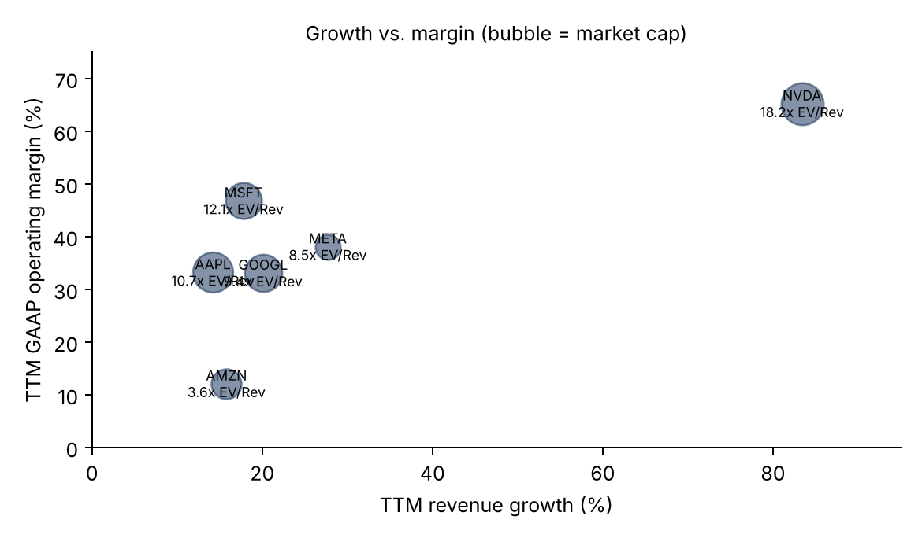
Company profiles
- NVIDIA: merchant AI accelerators and systems. Revenue was USD 96,221 million in the July 2026 quarter, up 105.9% year over year, so growth sped up again after FY2026 (+65.5%). It is the purest play on hyperscaler capex and also the most exposed if that capex slows. It is capital-light (capex 2.8% of revenue). Recent moves include a large debt raise (long-term debt rose from USD 7,470 million to USD 32,366 million in the July quarter) and a large dividend payment in the same quarter.
- Apple: devices plus high-margin services. TTM revenue growth reached 14.2% (June 2026 quarter +16.4% year over year), its best run in years, which points to an upgrade cycle. Capex is only 3.1% of revenue, so it is the least exposed to the AI-capex payback debate but the most exposed to multiple compression (32.3x EV/TTM EBIT).
- Alphabet: Search and YouTube ads plus Google Cloud and TPUs. TTM growth was 20.1% (June quarter +24.2%) with a 33.1% operating margin. Capex is rising fastest of the group: the June quarter was USD 44,924 million, or USD 179,696 million annualised. FCF turned negative in the June quarter. GAAP net income is inflated by large non-operating gains, with pretax income of USD 138,753 million against operating income of USD 40,770 million in the June quarter.
- Microsoft: Azure plus Microsoft 365/Copilot. FY2026 (ended 2026-06-30) revenue was USD 331,839 million (+17.8%) with a 46.8% operating margin, the highest of the hyperscalers. Capex doubled from USD 64,551 million to USD 115,948 million, and FCF fell to USD 66,987 million from USD 71,611 million.
- Amazon: AWS, retail, and advertising. It has the lowest margin (12.1% TTM) and the highest capex relative to cash flow: FY2025 capex was 94.5% of operating cash flow and TTM FCF was negative. GAAP results are boosted by non-operating gains (June quarter pretax income USD 80,857 million against operating income USD 27,461 million).
- Meta: social advertising. It is the fastest-growing ad platform (TTM +27.7%), but operating margin fell to 30.9% in the June 2026 quarter from 43.0% a year earlier because R&D (USD 21,656 million in the quarter) and depreciation are rising. FY2025 capex was 34.7% of revenue, the highest intensity in the group alongside Microsoft.

4. Growth and margin profiles
Three distinct profiles:
- Supplier super-cycle (NVIDIA): growth of 65-106%, with operating margin of 60%+. Margins are at a cyclical peak and are tied to customer capex.
- Hyperscaler platforms (Microsoft, Alphabet, Meta, Amazon): mid-teens to high-20s growth, now speeding up, but operating margins face depreciation pressure as each year of capex turns into a 5-6 year expense stream. Meta is already showing that compression.
- Device franchise (Apple): high-single to mid-teens growth, mid-30s margin, minimal capex. Its AI exposure comes through a product/upgrade cycle rather than infrastructure spend.

5. Valuation vs. history
Company | EV | Net cash (debt) | EV / LFY revenue | EV / TTM revenue | EV / TTM GAAP EBIT
NVDA | 5,528,996 | -10,923 | 25.6x | 18.2x | 28.0x
AAPL | 5,000,504 | -19,948 | 12.0x | 10.7x | 32.3x
GOOGL | 4,184,396 | 142,310 | 10.4x | 9.4x | 28.3x
MSFT | 3,998,864 | 36,549 | 12.1x | 12.1x | 25.8x
AMZN | 2,798,361 | -9,236 | 3.9x | 3.6x | 29.9x
META | 1,935,877 | 6,596 | 9.6x | 8.5x | 22.3x
Median |  |  | 11.2x | 10.1x | 28.2x

EV = market cap + reported debt minus cash and current marketable securities. Leases and non-current investments are excluded. NVIDIA marketable securities were not tagged in its latest filings, so its EV is slightly overstated. The median EV/TTM EBIT shown is the median of the six (28.0, 32.3, 28.3, 25.8, 29.9, 22.3 sorted gives 28.2).
Aggregate history (top six, using the constituents as they are today). Market cap / trailing operating income: 30.9x at 2021-12, 20.3x at 2022-12, 27.5x at 2023-12, 28.9x at 2024-12, 29.1x at 2025-12, and 28.2x now. Market cap / trailing revenue went from 7.6x (2021) to 4.3x (2022) to 9.0x (2025) and is 9.2x now. The revenue multiple is at a 5-year high because mix has shifted toward NVIDIA's 60%+ margins. On earnings the group is at the upper end of its range but not at its peak.

6. How rates have affected multiples
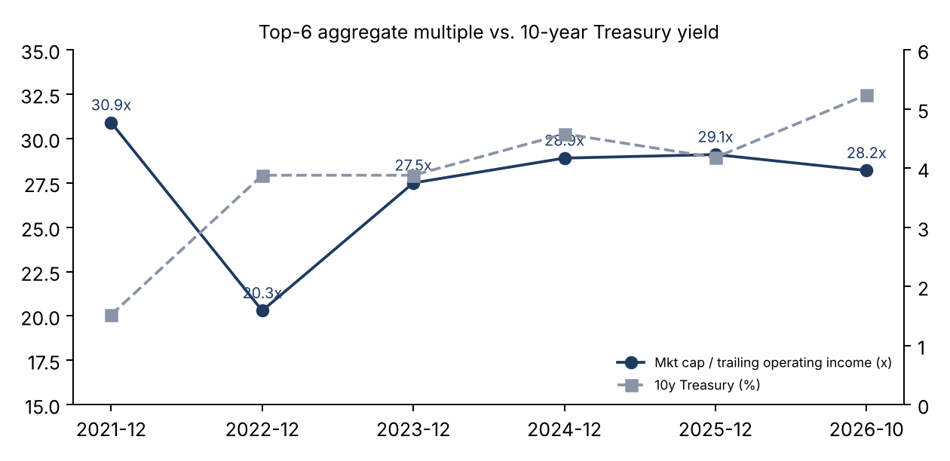
- 2022 shows the effect clearly: the 10-year yield rose from 1.52% to 3.88% and real 10-year yields went from about -1.0% to +1.6%. The group multiple fell by a third (30.9x to 20.3x) even though operating income was broadly stable outside Meta and Amazon.
- Since 2023 the link has weakened. Multiples re-rated to 27-29x while the 10-year rose to 4-5% and now 5.24%. AI-driven earnings revisions and scarcity value have outweighed discount-rate effects.
- The cushion is now thin. The aggregate EBIT yield (3.5%) is below the 10-year nominal yield (5.24%) and close to the 10-year real yield (2.93% at 2026-09-30, up from 1.93% a year earlier). In 2022 the EBIT yield was 4.9% against a 3.88% 10-year. The 10-year has risen about 110bp in a year (4.14% to 5.24%), with most of that since August 2026. If that rise continues, it is the most direct macro risk to the multiple.
- Duration differs by stock. Apple (lowest growth, highest EV/EBIT) and NVIDIA (long-duration expectations) are most rate-sensitive. Meta and Microsoft, on lower EV/EBIT, have more valuation support.

7. The AI capex cycle and the payback debate
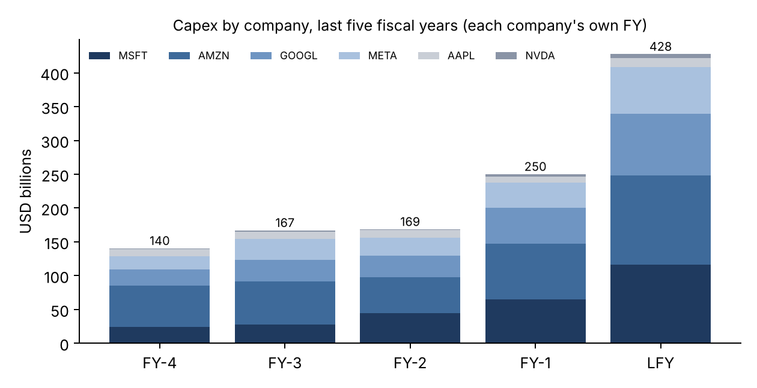
Scale. Combined last-fiscal-year capex of the six was USD 427,662 million, 71% higher than the prior year (USD 250,024 million) and 3.0x the level four fiscal years earlier (USD 140,330 million). For the four hyperscalers, capex as a share of operating cash flow went from 45.1% to 67.8% over five fiscal years. On the latest-quarter run-rate (USD 660,200 million annualised), it exceeds TTM operating income of USD 483,504 million.
Hyperscaler | TTM capex | Latest-Q capex annualised | TTM capex / TTM revenue % | LT debt, latest (3 Qs earlier)
Alphabet | 132,402 | 179,696 | 29.7 | 98,165 (21,607)
Microsoft | 115,948 | 143,208 | 34.9 | 31,067 (35,376)
Amazon | 173,028 | 216,832 | 22.3 | 128,894 (50,742)
Meta | 89,325 | 120,464 | 39.1 | 83,664 (28,834)
Total | 510,703 | 660,200

Bull case (payback is happening):
- Revenue is speeding up where the capex is going. The hyperscalers added about USD 279,668 million of TTM revenue year over year, and ad growth at Alphabet and Meta (24-28%) shows AI-driven targeting and ranking are paying off now, not just in the future.
- Demand is constrained by supply, not by customers: NVIDIA's July quarter grew 105.9%, which implies customers keep raising orders.
- Balance sheets can absorb it. The group still generated about USD 836 billion of TTM operating income, and the debt being raised is small relative to equity value.
Bear case (overbuild risk):
- Depreciation is coming. At a 6-year useful life, a USD 660 billion annual run-rate eventually means about USD 110 billion of annual depreciation, or roughly 23% of current hyperscaler operating income, before any revenue offset. Meta's margin drop (43.0% to 30.9% year over year in the June quarter) is an early sign.
- FCF conversion is collapsing. Hyperscaler FCF fell about 35% while operating income grew. Amazon and Alphabet were FCF-negative in the June quarter, and buybacks at Alphabet and Meta stopped (zero in the last two quarters).
- Circular demand. A large share of AI cloud revenue comes from model labs that are themselves funded by the hyperscalers (strategic stakes are behind the large non-operating gains at Alphabet and Amazon). That raises questions about the quality of the end demand.
- Useful-life risk. GPU generations now turn over roughly every year, which could shorten economic lives below the 5-6 years assumed in depreciation schedules.
Our framing: to earn a 10% pre-tax return on a USD 660 billion annual spend, the hyperscalers need about USD 66 billion of new incremental operating income each year from AI. Today's evidence (ad acceleration, cloud growth) suggests the 2024-2025 vintages are paying back. The 2026-2027 vintages, funded partly with debt, carry the risk.

8. Investment implications
Stance (our view) | Names | Rationale
Overweight | NVIDIA, Alphabet | NVIDIA: the clearest beneficiary while capex keeps rising; 28.0x EV/TTM EBIT is not extreme for 83% growth. Alphabet: accelerating ads plus cloud plus in-house TPUs, at 28.3x with large net cash (USD 142,310 million). Watch its FCF.
Market weight | Microsoft, Meta | Microsoft: highest margin and best enterprise monetisation, at 25.8x, but capex doubled and FCF is falling. Meta: cheapest (22.3x) and fastest ads growth, but margin compression and the highest capex intensity.
Underweight / selective | Amazon, Apple | Amazon: FCF-negative, 94.5% capex/OCF, 29.9x EV/EBIT on a 12% margin. Apple: strong upgrade cycle, but 32.3x EV/EBIT is the richest in the group and the most rate-sensitive.

Thematic expressions: (1) AI arms dealers over AI spenders while the capex run-rate is still rising; (2) "show-me" pairs, such as long the platforms whose AI revenue is already visible (Alphabet, Meta ads) against those still building (Amazon); (3) a rate hedge, since a sustained 10-year yield above 5% argues for trimming the highest EV/EBIT names.
Catalysts to watch: September-quarter earnings (late October 2026) and 2027 capex guidance; NVIDIA FY2027 Q3 results (around late November 2026); the direction of the 10-year after the September-October 2026 sell-off; antitrust remedy rulings; any hyperscaler capex cut or useful-life change (the most important bear signal); Apple FY2026 10-K.

Data notes
Financials come from SEC XBRL filings via the stock-data connector. Quarterly Q4 figures are derived (FY minus 9M). Prices and market caps are from Yahoo Finance as of the 2026-10-13 close. Treasury yields are from FRED (DGS10, DFII10). Fiscal years differ: NVIDIA FY ends in January, Apple in September, Microsoft in June, and the others in December. The historical aggregate multiples use approximate calendar alignment and split-adjusted share counts (Alphabet 2021 share count estimated). Regulatory status and the ad-market share statements are model knowledge and were not verified here. Sector overviews date quickly, so treat every figure as of the dates shown.

