EJKL Software 2.3
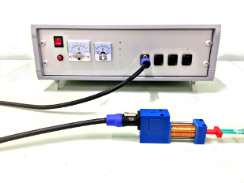
Table of Contents
1 GUI for the device control, a general overview 1
2 Connection with the arduino controller 3
3 General power settings 3
4 Main sequence panel 4
4.1 Table of events, general overview. 4
4.2 Table editing control 6
4.3 The current voltage of the capacitors 6
4.4 Trigger modes 7
5 Known issues 7
6 Example of a sequence. 7
7 Installation 8
7.1 Linux 8
7.2 Windows 10 (64bit) 9

GUI for the device control, a general overview
A user-friendly GUI application has been created that enables easy programming the sequence of events performed by the device. The program was created using the LabVIEW 2017 package and is delivered as a binary executable files for Linux and Windows operating systems. To use executable files on Linux you must install LabVIEW Runtime Engine 2017 and NI VISA drivers from National Instruments webpage: https://ni.com. It is not necessary to install LabVIEW Runtime separately on Windows, as the installation package includes all required libraries. Additionally, the source code (ejkl.llb) is also available for download, which can be used to modify the program if necessary. To modify the source code, you must have LabVIEW Development Package 2017 or later. The source code can also be modified in the LabVIEW Community Free Edition under the terms of the appropriate license.
After installation, the program can be started by clicking the icon created on the desktop, if it has been created (Windows), or by clicking the VI icon in the folder where the program was downloaded and unpacked (Linux). See installation details in section 7.
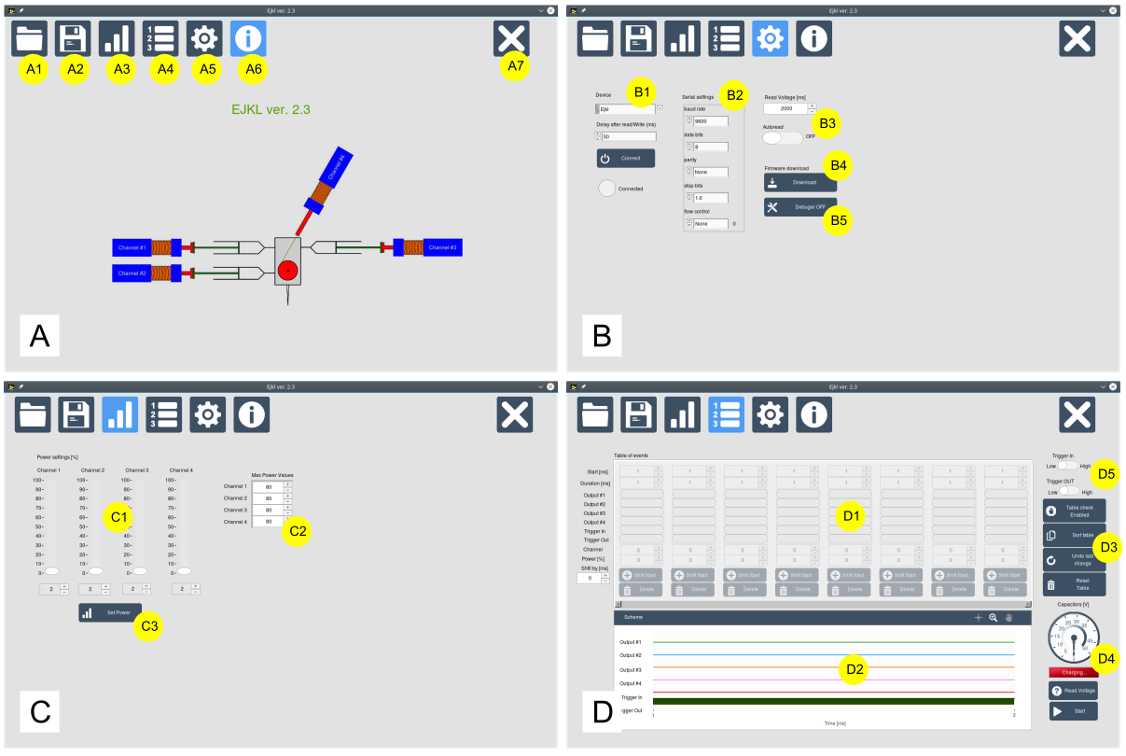
Fig. 1. Four basic screens of the program. The main screen (A) is the welcome window displayed when the program is started. The connection panel (B) allows you to control the connection to the Arduino controller. The power settings panel (C) allows you to define the output power for each channel. The main screen (D) is a table that allows you to program a specific sequence of events. Switching between screens is done by clicking on the menu icons (A1-A7).
The program is divided into 4 basic screens as shown in Fig. 1. The welcome screen (Fig. 1 A) is displayed after starting the program. The buttons numbered A1 - A7 represent the main menu of the program, allowing you to switch between screens and functions. The currently selected screen is marked with the light blue color of the icon. The first two buttons allow you to load an external file containing all settings and the table containing event sequence (A1) or to save an external file containing program settings and experiments (A2). Button A3 switches the screen to the power settings panel (Fig. 1 C). The A4 button opens the main panel where you can program your own sequence of events (Fig. 1 D). Button A5 switches to the panel of general settings and connection control (Fig. 1 B). The A6 button switches to the welcome screen, and the A7 exits the program.

Connection with the arduino controller
After starting the program, first establish a connection to the arduino controller. Open the "settings and connection" panel (A5 button) and the screen shown in Fig. 1 B will appear. To connect to the arduino controller, proceed as follows:

1) Select the serial port to which the Arduino controller is connected - select the appropriate port from the "Device" drop-down menu. The default device is named "Ejkl", but usually it needs to be matched with the serial port to which the usb cable is connected. Use the "refresh" option to renew the list of available serial devices after connecting the usb cable.

2) Serial port parameter settings can be adjusted in section B2, but the defaults should generally be fine and you do not need to change them. Default values are: baud rate = 9600, data bits = 8, parity = None, stop bits = 1.0, flow control = None

3) Set the read/write delay (ms) to avoid communication problems with arduino. The default value is 50 ms and may be increased in case of problems with the use of the program and/or communication with arduino. The default value should generally be fine.

4) Connect with the controller by pressing the "Connect" button. If the connection is successful, the LED below the Connect button turns green. Please note that the current version of the program does not check whether the connection is established with the arduino controller, but only whether the serial port has been opened. If an error screen appears after sending the command to arduino, press the "Disconnect" button, change the serial port (Device) and reconnect.

An additional option available on this panel in section B3 is "Autoread". It is set to "OFF" by default. When set to "ON", the current voltage of the capacitors will be read automatically and the millisecond delay between each reading can be adjusted with the "Read Voltage (ms)" control (default delay is 2000 ms which means that the voltage is read every 2 seconds).

The "Firmware download" button (B4) saves the arduino firmware source code (in ASCII format) which can be then compiled and loaded into a new arduino controller.

The "Debugger" button (B5) allows you to open additional menu items, useful for debugging the software and/or manual controlling the device. It is set "OFF" by default as incorrect use of the functions available there may damage the device. Do not switch it "ON" unless you are developing/modifying the software.

General power settings
Fig. 1 C shows the panel used for general power control. Each of the 4 channels can be set to a different output power. The sliders shown in section C1 allow you to change the value of the power output (as a percentage of the maximum power) for each channel separately. After setting the power to the desired values, press the "Set Power" button (C3) to send the settings. Note that the power on each channel can be changed dynamically at any time point in the sequence, and values set in the event table take precedence over the general power values set in this panel. This is discussed below.

The maximum absolute power for each channel can be defined in section C2 "Max Power Values" and may be slightly different for each unit of the device. It depends on the maximum PWM (Pulse-Width Modulation) at every channel and can be determined experimentally after assembly of the device. The default value here is 80 (which means 100% power). This value means that any value larger than 80 will not lead to an increase in the output power (maximum PWM is reached at 80). Value 0 means no power. Overall, this value should not be too small, and the default should work fine for most units.

Main sequence panel
Fig 1 D shows the main panel for creating and running sequences. This panel is divided into 4 general sections. The central part is the table of events (D1) in which the time sequence is created. A graphical representation of the time of events is shown in D2 section. The control of the table switches is in section D3. The current status of the capacitors is shown in section D4. Trigger In and Out modes are set in section D5.

Table of events, general overview.
The desired sequence of events can be programmed in the event table (D1). Fig. 2 shows an example of a single event that will be added to the sequence. The first line "Start [ms]" specifies the time point at which this particular event should occur. It specifies how many miliseconds after startup must elapse to trigger this event. In this example, the value "10" means that this event will be fired 10 ms after the sequence has started. The second line named "Duration" specifies how many milliseconds this event will be active for. In the example, the value "15" means that this event will be active for 15 ms. The next 4 lines named "Output #1", "Output #2", "Output #3", "Output #4" determine which channel will be activated. In this example, the power will be turned on for the channels 1 and 4. The next two lines named "Trigger In" and "Trigger Out" define the operation of the triggers. If the "Trigger In" option is enabled, the device will wait for the signal from an external device to reach the appropriate port. If the "Trigger Out" is turned on, the device will send the trigger signal to an external device at the specified time point. In this example, both triggers are disabled.

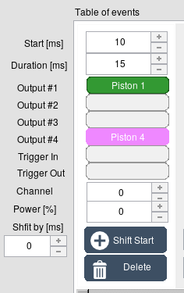
Fig. 2. A single entry in the table of events that specifies the starting point, duration and action type.
The following lines named "Channel" and "Power [%]" are used to set the output power to the value defined in the "Power [%]" control at the channel number defined in the "Channel" control. The "Channel" control can accept values from 1 to 4 depending on which channel you want to modify the power. A value "0" means that no power is modified at that particular time point. If the power is to be changed ("Channel" control is not 0), then Duration is automatically set to 1 ms and Output channels #1-#4 are turned off.

The next line named "Shift by [ms]" specifies the number of milliseconds the sequence will be shifted after pressing the "Shift Start" button. A positive value means a shift to a later time point, while a negative value means a shift to an earlier time point. This is useful if you have defined, for example, 10 events and you want to move all events from 4 to 10 forward to increase the delay between 3rd and 4th events with no need to manually modify the starting points for each event from 4 to 10. An example of the using the "Shift Start" button is shown in Fig. 3.

In the last line there is the "Delete" button, which allows you to delete selected event from the table.

Table editing control
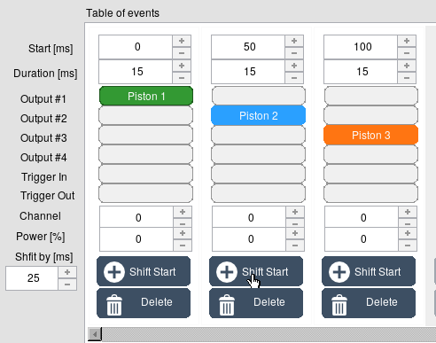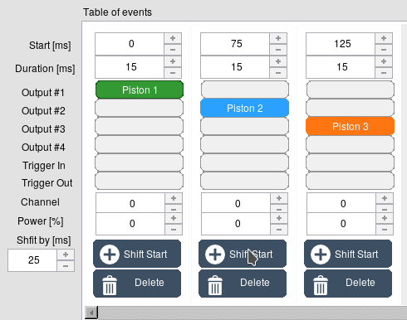A B

Fig. 3 An example of using the "Shift Start" button. A) There are 3 events, each 15 ms long and starting at 0 (channel #1), 50 (channel #2), 100 ms (channel 3). B) The staring points for channels #2 and channel #3 were shifted by 25 ms after setting the "Shift by [ms]" value to +25 and pressing the "Shift Start" button on the second event.
Section D3 (Fig. 1D) contains buttons that allow to change the table editing mode. The first button "Table check" enables or disables automatic table check. When this button is set to "ON" the table is automatically verified for overlapping events and is automatically sorted from the earliest to the latest events after every modification of the table.

"Sort table" button is used to put the sequence of events in the order from the earliest to the latest.

"Undo last change" button is self explanatory. It only allows to undo the last modification of the table.

"Reset the table" button clears all events in the table.

The current voltage of the capacitors
Section D4 allows you to monitor the voltage on the capacitors. If the "Autoread voltage" switch (B3) is set to "ON", the indicator is automatically refreshed to show the voltage. If the "Autoread" switch is set to "OFF", you can read the voltage by pressing the "Read voltage" button. The sequence can be started when the voltage is greater than 45 V. This fact is communicated by changing the LED status from red status (Charging...) to green (Voltage OK). If the program is not connected to the arduino controller, pressing the "Read voltage" button displays 50V, but it is not the actual value.

Trigger modes
There are two possible operating modes for Trigger In and Trigger Out, which can be defined by the switches in section D5. You can change the way triggers are sent or received by the device.
The "Trigger IN" switch can be set to "Low" or "High". When set to "Low", the trigger will activate the sequence when the input voltage changes from 5 to 0 V. When set to "High", the trigger will activate the sequence when the voltage raises from 0 to 5 V.

When the "Trigger OUT" switch is set to "Low", the device sends a trigger signal by changing the output voltage from 5 to 0 V. This means that the voltage is 0 only when a trigger out event occurs during the sequence. If the trigger out is not used, the output is at a constant voltage of 5 V. Conversely, when the "Trigger OUT" switch is set to "High", the device will sent a trigger signal by changing the voltage from 0 to 5 V when the corresponding event occurs during the sequence execution.

Known issues
Sometimes, usually on Windows OS, after connection to a different serial port than the arduino controller is actually connected the program shows that the connection is established. However, any use of controls leads to an error. In such cases it is necessary to disconnect from the serial port and switch to another serial port to which arduino is connected.

Example of a sequence.
Below is a simple example of sequence for mixing two solutions that are subsequently pushed into a third syringe, followed by pushing the solution back to the first two syringes.
The sequence in the table of events is shown in Fig. 4. The first event occurs 1 ms after the sequence has started and it sets the trigger out signal from 0 to 5 V for 5 ms. Then, the second event (6 ms after start) and third event (7 ms after start) set the output power of channel #1 and #2 to 80% and 15% of the maximum power, respectively. After 10 ms since the sequence has started the power is applied to channel #1 for 20 ms. Ten milliseconds after applying the pulse at channel #1, the power is applied to channel #2 for 15 ms to slow down the moving piston 1. When channel #2 is switched of the power for this channel is set to 60% (at 75 ms after start) and then channel #2 is activated for 10 ms to move the piston #2 to its initial position. The move showing this process can be downloaded from the file repository.

The file "example.ejkl" contains this example sequence that can be loaded into the program.
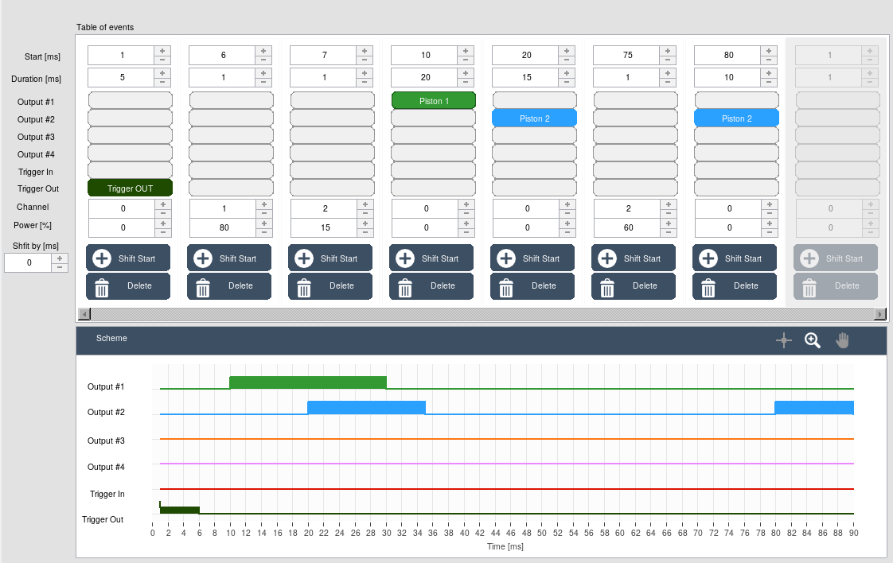
Fig. 4. An example of a simple mixing of two solutions in two syringes.

Installation

Linux
To run the program on Linux, you need to install Labview Runtime Engine 2017 64 bit. You can download it from the link: Labview Runtime 2017 Linux 64bit. You will also need NI VISA drivers installed and configured on your system. It can be found at ni visa linux. These links were active in December 2021, but there is no guarantee that it will not be moved elsewhere in the future. In this case, please find the appropriate links in https://www.ni.com.

A supported Linux distribution is openSUSE (Ejkl was tested on version 15.1, 15.2 and 15.3) but this program should work on any modern Linux distribution as long as it is 64 bit. In DEB-based package managers, RPM must be converted to DEB package using alien with "-d" and "--scripts" options:

# alien -d --scripts labview*.rpm

Windows 10 (64bit)
The easiest way to install Ejkl software in Windows is to use the Setup.exe file which is located in the Ejkl-Win64-installer.zip archive. It contains all necessary libraries and drivers required to run the program. To install Ejkl, please follow the steps below:

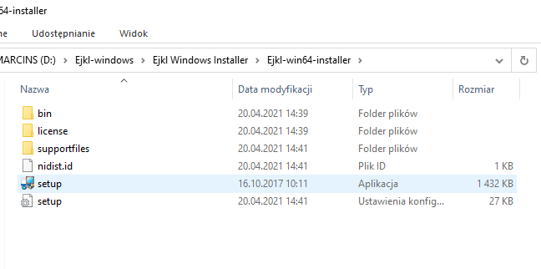
1. Unzip the downloaded Ejkl-Win64-installer.zip file and go to the folder with unpacked files. Run Setup.exe.

2. Select the folder where the program will be installed. The defaults are fine and it is recommended that you leave them unchanged. Click "Next".
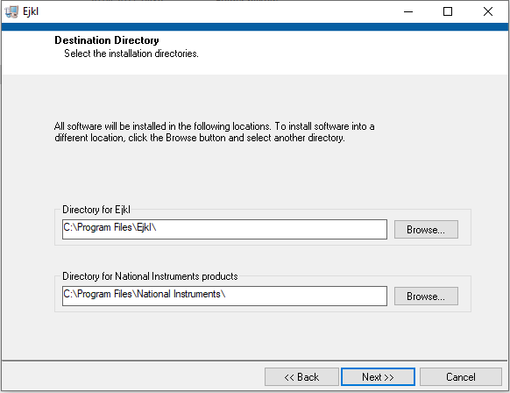
3. In the next window, you must accept the NI licenses for VISA and LabVIEW Runtime.

4. In the next window, Disable Windows Fast Startup keep the default values and press the "Next" button to install the files. This will take approximately 5 minutes.

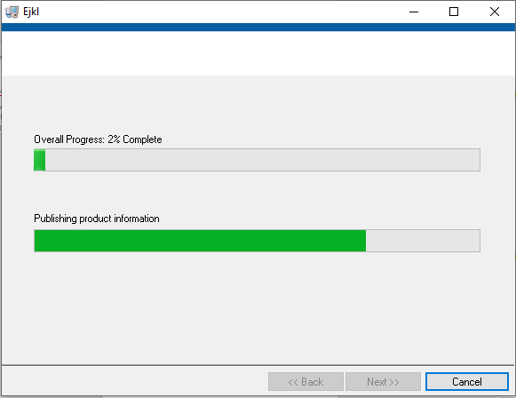
5. When finished, restart your system.

6. Find the Ejkl program in the main Windows menu.
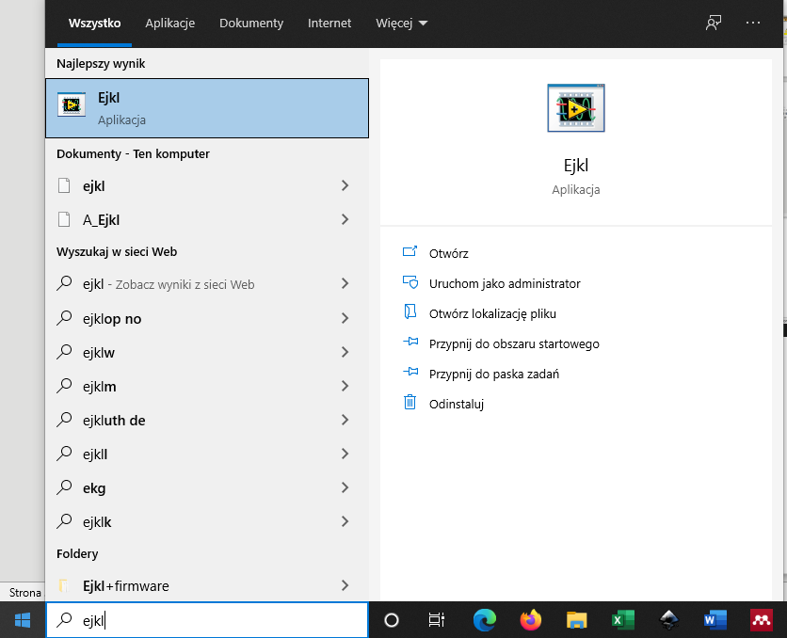
7. After starting the program, connect the USB cable to any free port. Then go to the connection panel (B). Click the "Device" button (B1) and select "Refresh". The list should show the serial port to which the device is connected. In this example, it is COM3.
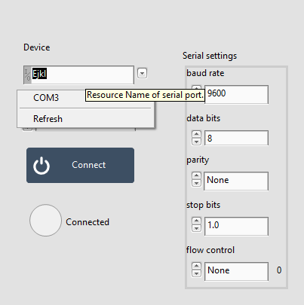
8. Select that port and press the "Connect" button and that's it. Everything should now work.

