„Alloy structures calculation” (ASC) software manual

prepared by Łukasz Frąckowiak

Table of Contents

Indroduction 2

Section 1 - Concentration fit 3

Section 2 – Concentration distribution 5

Section 3 – Sputtering rates 6

Section 4 – Sputtering calibration 7

Section 5 – Numerical distribution 9

Few words from the author 12

# Indroduction

The ASC software can calculate, predict, and calibrate alloy samples with a gradient of concentration along one edge. The model included in the software was published in Ł. Frąckowiak et al.’s “Magnetic Properties of Co-Tb Alloy Films and Tb/Co Multilayers as a Function of Concentration and Thickness” in the Journal of Magnetism and Magnetic Materials 544 (2022) 168682. This article contains an example of a TbCo alloy, but the software is capable of calculating alloy samples with various elements.

For numerical model we use setup presented below

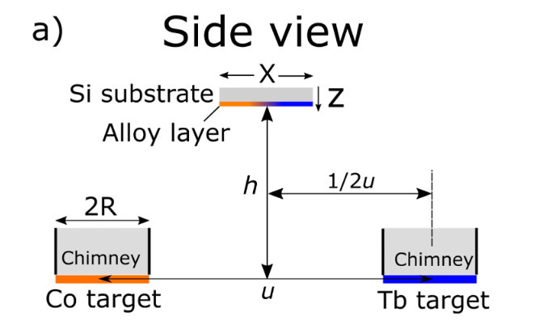

In manual h will be called as A-K height and for center of sample is located in 0 mm.

ASC software contains 5 different features : “Concentration fit”, “Concentration distribution”, “Sputtering rates”, “Sputtering calibration” and, “Numerical distribution”. Each part will be discussed in separate section of this manual.

Short about numerical model

IMPORTANT!!

Before you start using ASC software you need to include file with molecular volume values for elements you want to calculate alloys. Name of file need to be “molecular_database.xlsx” and it should look like this

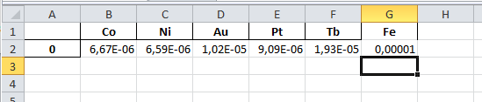

If you want add new elements just add new column with name of element and value of molecular volume.

# Section 1 - Concentration fit

Concentration fit determine concentration value in the center of the alloy sample from x-ray microanalysis measurement. Provided experimental data are fitted to numerical model.

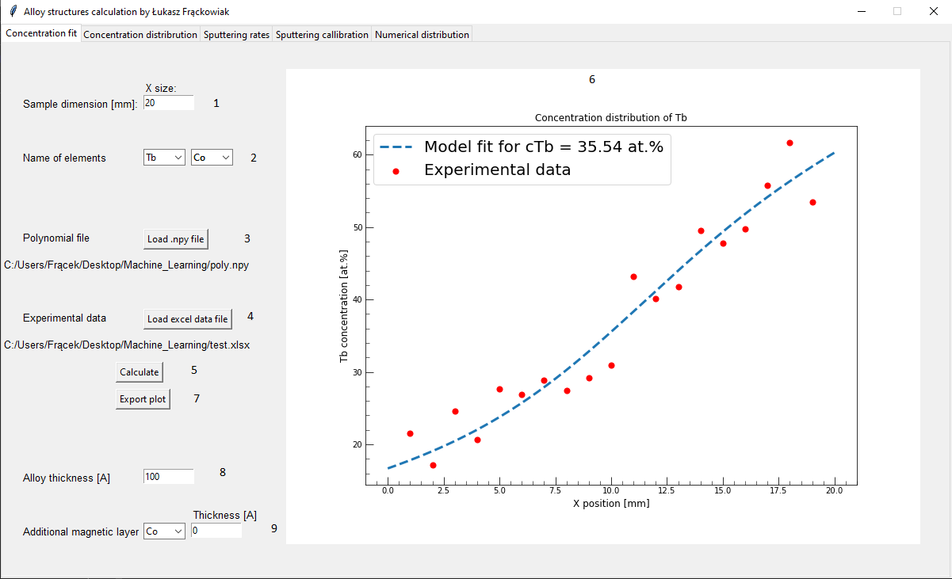

1. 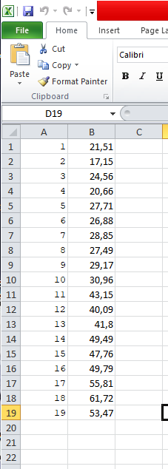Sample dimension (X size) – Here you need to provide the value of the sample dimension along the concentration gradient. The Y size is not important here because the concentration does not change in that direction. We assume a constant value of concentration along the Y axis.
2. Name of elements – You need to choose alloy elements from the list. If the list does not contain an element, please update the file “molecular_database.xlsx”. Note that the first element given will be considered the “main” element, and the calculation will focus on this.
3. Polynomial file – You need to load a .npy file that contains information about the polynomial equation used to fit numerical data. For each value of A-K height, you need to provide a separate file. This polynomial file is created in the “Numerical distribution” tab (Section 6). After a successful load, the file path will appear.
4. Experimental data – Here you need to provide an Excel file with data of the concentration of a specific element as a function of position on the sample. An example of data is shown on the right. The first column contains information about the position on the sample (measured from the sample edge) and the second column contains the value of the concentration of the element chosen as first in point 2. Again, after a successful file loading, the file path will appear.
5. Calculate – If all the previous points are filled, just press this button.
6. Figure – After a successful calculation, the software will create figures with the experimental data points and with the best fit to the numerical model. In the legend you can find the value of concentration in the center of the sample.
7. Export plot – Here you can export the created figure to a PDF file.

Last two points are optional and do not need to be changed. These two last parameters can be used when you want to calculate the distribution concentration in the alloy layer, however, the sample contains an additional layer that cannot be excluded during EDS measurements. For example, you create a sample buffer/Co-1nm/TbCo – 10nm/protective layer, and during the EDS measurement, you cannot exclude the bottom Co layer from the measurement. However, with the information given in points 8 and 9, you can include this layer during fitting, and in this way you will get information about the alloy layer separated from the additional layer.Alloy thickness – you can provide here information about total alloy thickness

1. Alloy thickness – provide thickness of alloy layer.
2. Additional magnetic layer – here you can provide information about additional homogenous layer.

# Section 2 – Concentration distribution

Concentration distribution feature allows to predict distribution of elements on the sample surface.

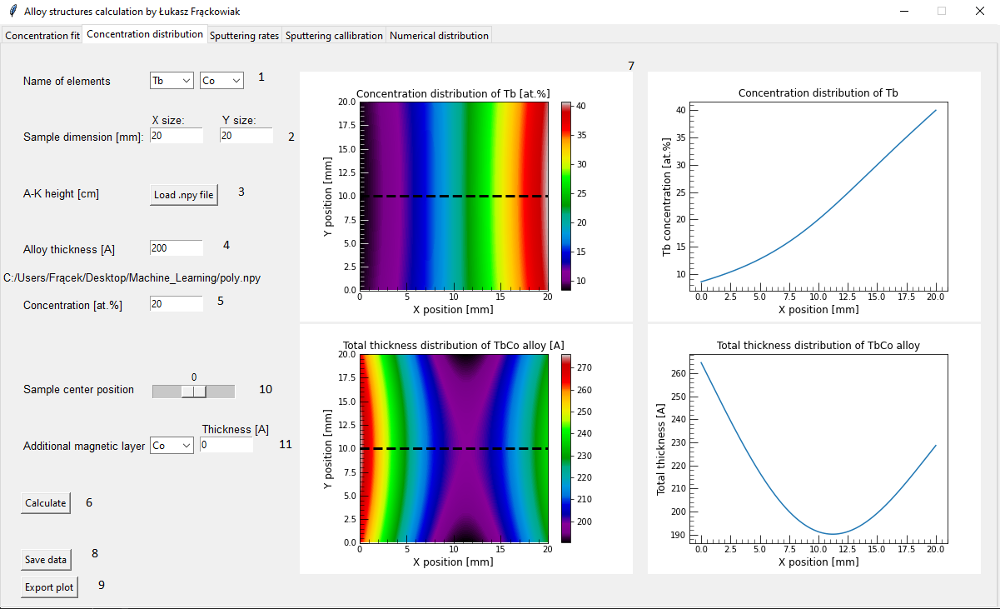

1. Name of elements - you need to choose alloy elements from the list. If list do not contain element please update file “molecular_database.xlsx”. Please note here, the first element given will be count as “main” i.e. calculation will be focus for this element
2. Sample dimension - here you need to provide value of sample dimension in both direction.
3. A-K height - here you need to load .npy file that contain information about polynomial equation used to fit numerical data. For each value of A-K height you need to give separate file. This polynomial file are created in the “Numerical distribution” tab (Section 6). After successful load file path will appear.
4. Alloy thickness – provide information about total alloy thickness
5. Concentration – provide information about atomic concentration in the middle of sample. You can get this information from EDS measurements and usining Concentration fit feature (Section 1)
6. Calculate – if all previous points are filled you calculate distribution of concentration
7. Figures – 2 maps of concentration and total thickness distribution. 2 cross section of characteristic at positions marked as dashed line in map figures
8. Save data – export calculated maps into xlsx file that contain distribution data about concentration, total thickness, thickness of 1st element and thickness of 2nd element
9. Export plot – export ganarated figures into pdf file

Last two paramaeters are optional and you don’t need to change during standard calclulation.

1. Sample center position – in indroduction was mentioned that sample center is in position 0mm, by changing this position you can move sample closer/further to specific target.
2. Additional magnetic layer – similar to point 9 in Section 1. Here you can provide information of additional layer added to system.

# Section 3 – Sputtering rates

Sputtering rates provide information about what supply power you need to set to get alloy sample of desire properties.

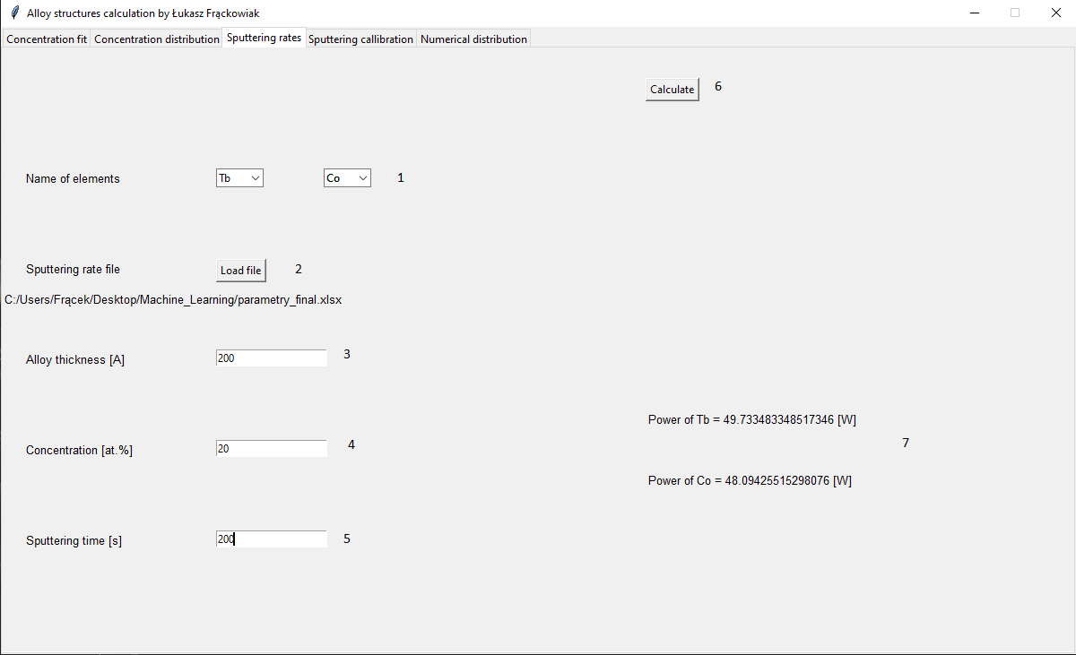

1. Name of elements – as before provide name of elements that you are using
2. 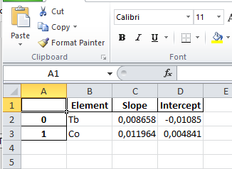Sputtering rate file – in excel file you need to provide parameters as slope and intercept of the function sputtering rate [A/s] vs power supply [W]. File should look like that (right image).

If you want to add new element just add new row or create this file using “Sputtering calibration” feature (Section 4)

1. Alloy thickness – total alloy thickness in the middle of sample
2. Concentration – atomic concentration in the middle of sample (this is value for the 1st element that you chose in point 1)
3. Sputtering time – magnetron co-sputtering deposition time to create desire sample. Note that this parameters has the highest impact on result, so by decreasing/increasing time you can reduce/increase value of power supply
4. Calculate – button to calculate
5. Result – result of what power supply for given element you need to set to get desire sample. Please note that during setting power in real machine you can set only integer value i.e. if you get in result 50.1 W in machine you set 50 W.

# Section 4 – Sputtering calibration

Feature that help calibrate sputtering rates of element in magnetron sputtering device. Calibration is done in few steps.

1st method

You create two thick alloy samples with cross done by marker on substrate. Each sample should have various power supply during deposition (e.g. in one sample u using for element 1 -20W and element 2-40W and in second sample you reverse this). In the lift-of-process you remove material above line. Using profilometer you measure total thickness of alloy. In the next step you measure by EDS concentrations distribution along axis with gradient. By using “Concentration fit” feature (Section 1) you can determine value of concentration in the middle of sample. In the last step you provide all information in empty places (point 1).

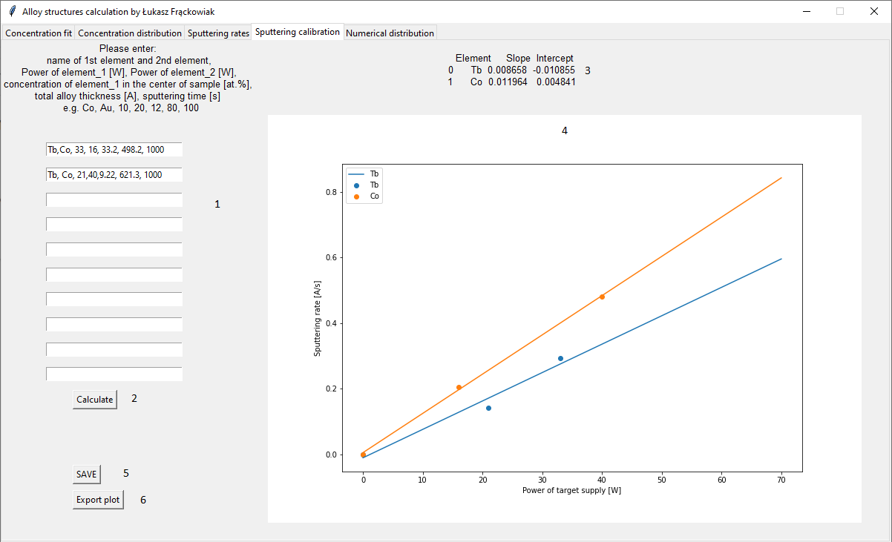

2nd method

You create 4 samples (2 for each element) with cross done by marker on substrate. During deposition of those sample substrate must be locatated between two targets (alloy sputtering position). Each sample should have various power supply during deposition. In the lift-of-process you remove material above line. Using profilometer you measure total thickness of alloy. In the last step you type information to the empty places (point 1). Please note that you need to type alloy structure, so to go around this you type element what you measured and element that you did not measure, next you need to set power of supply of 1st element and random value for imaginary element, next you set concentration in the middle equal to 100. By doing that you will correctly provide information to calculate thickness. Example below

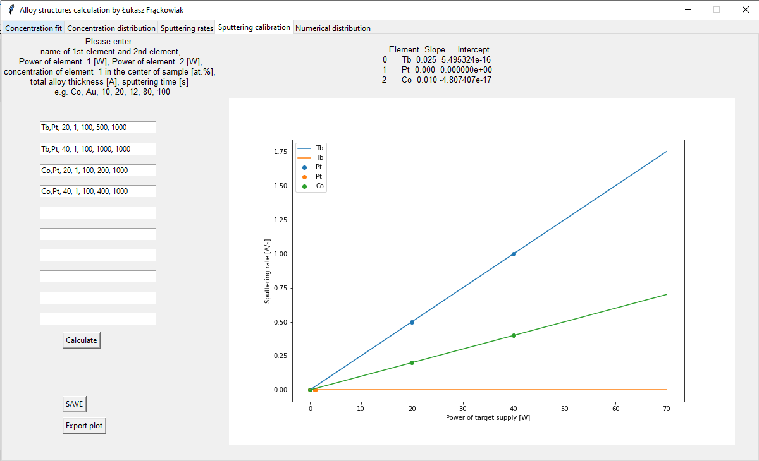

1. Provide information of sample : name of 1st and 2nd elements, power supply for 1st and 2nd elements, concentration of 1st element, total allot thickness and sputtering time.
2. Calculate – just button to press
3. Result – as result you will get table of sputtering function for each element. In method 2 you can see that imaginary element has slope and intercept equal to 0
4. Figure –you can see linear regression for given data
5. Save – export result table into excel file. File this can be later used in “Sputtering rates” feature (Section 4)
6. Export plot – export plot to pdf file

# Section 5 – Numerical distribution

Numerical distribution feature creates polynomial equation file (.npy) used in “Concentration fit” and “Concentration distribution”. .npy file is based on fitting high degree of polynomial to the numerical model. This feature calculates G parameter which is the “deposition profile by unit area” that describes the distribution of deposited material as a function of position on the substrate. More information you can find in published article.

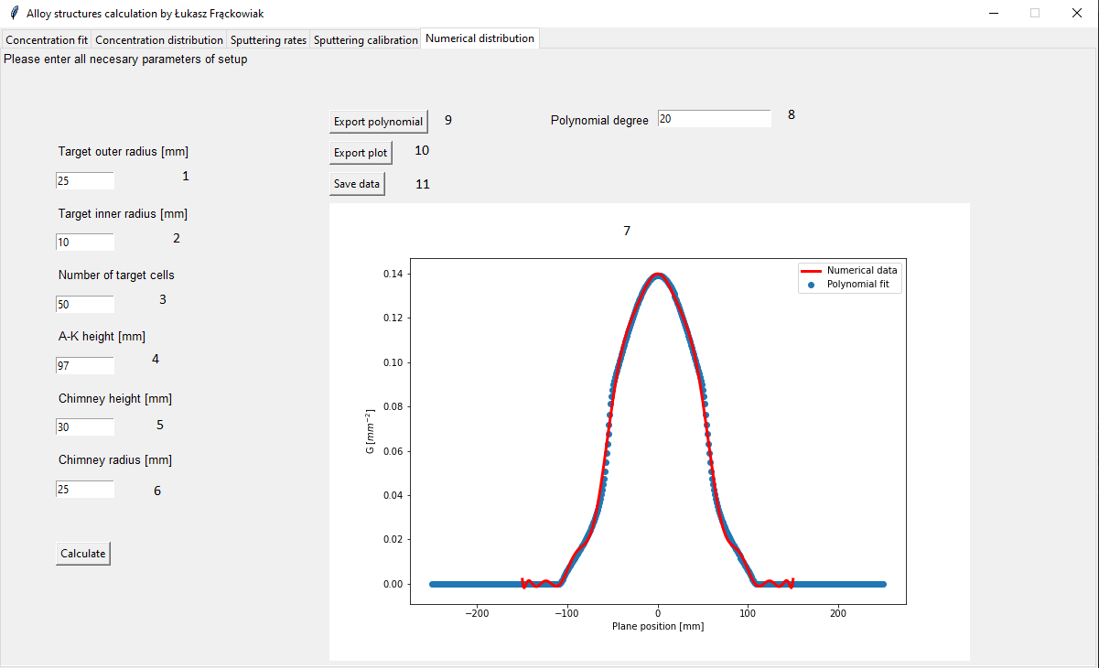

1. Target outer dimension
2. Target inner dimension

Both points represent target dimension. The easiest way to show dimension is to check image below

In magnetron sources, permanent magnets located below a target create a magnetic field, which is responsible for heterogeneous sputtering of the target. To account this effect in numerical analysis, we can calculate an annulus target with an inner radius R1 (point 2) and an outer radius R2 (point 1). For disc shape target with radius R just type in Inner radius value of 0 and in outer 25mm.

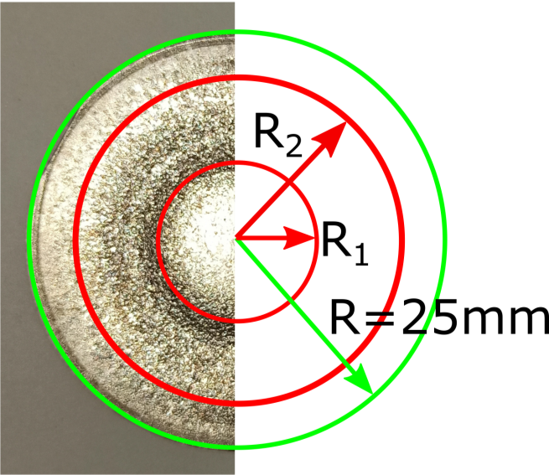

Overall target shapes for A-K around 10 cm do not impact distribution at all.

1. Number of target cells – type for how many squares we divide our target. Number represent cells in direction i.e. total cells is 50 (for default value) x 50 = 2500 cells
2. A-K height – just height h on the image in the Introduction. The most important here is difference between real value and value set on the magnetron scale. Difference is 3mm, meaning that 10 cm on the magnetron scale in real value is 97mm, similar to 15 cm in real is 147 mm. During order sample you need to provide magnetron scale value which is usually value of 10 or 15 cm. Maximum value on the scale is 17 cm.
3. Chimney height
4. Chimney radius

Target chimneys prevent part of the sputtered material from reaching the substrate. Therefore, some parts of the target do not contribute to the deposition in given segments of the substrate and should be excluded in calculations.

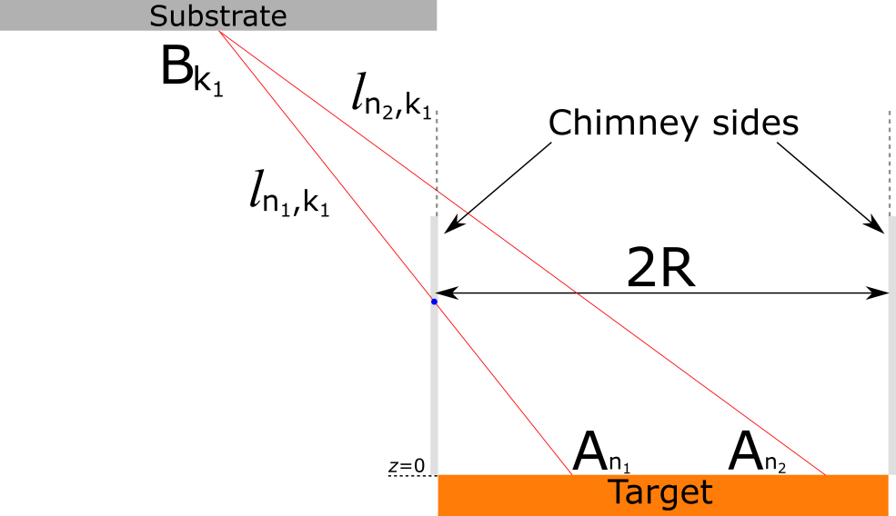

Default values of chimney parameters is set to real values in our magnetron sputtering setup, so you do not need to change this value.

1. After pressing calculate button you will get figure of G parameter distribution (calculated from model and parameters you provided). Calculation is made in the range of -250 mm to +250mm from the center of target. Red line represent polynomial fit in the range from -150mm to +150mm. Polynomial degree can be change in point 8
2. Polynomial degree – as default is set to value 40. Ranges of fit cannot be change from user interface (if needed maybe in future I will add this parameter). Please note that for G = 0 polynomial fit takes form of some wavy curve which far away from truth. So during calculation in this ranges you need to be caution. In standard calculation it will not affect result, however when you start changing e.g. position of the sample center it can impact result.
3. Export polynomial – the most important result file (.npy) used in calculation of distributions for other software features. This creates NumPy file (Python library) that contains fitting equation. Please note equation can predict value over the ranges that was fitted, however the value won’t be true.
4. Export plot – just export plot to PDF file.
5. Save data – it will produce excel file with numerical calculation of G distribution.

# Few words from the author

Source code is wrote in Python and you can find it on my github <https://github.com/LukaszFrackowiak/PhD_work/tree/main/Alloy_calculation>

In the future, if you will need any changes to the software you can write to me an e-mail ([l.frackowiak@tlen.pl](mailto:l.frackowiak@tlen.pl)) and I will do my best to implement it.