1. r is the rate/ratio of buses. The mean rate.
2. the random variables become exponentially less as the wait time continues since it is exponential (exponential is heavily skewed!).
3. a. pexp(15, rate=1)

[1] 0.9999997

b. pexp(25, rate=1)

[1] 1

c. pexp(20, rate=1)-pexp(10, rate=1)

1. a. hist(rexp(100, 20), main = "Wait Times Waiting for a Bus every 20 minutes, 100 times", xlab = "Time", ylab = "Probability")

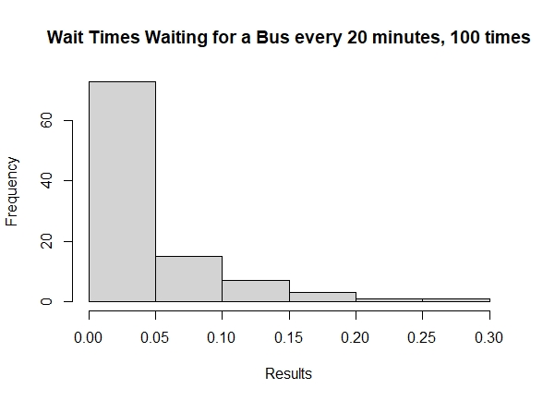

b. hist(rexp(1000, 20), main = "Wait Times Waiting for a Bus every 20 minutes, 1000 times", xlab = "Time", ylab = "Probability")

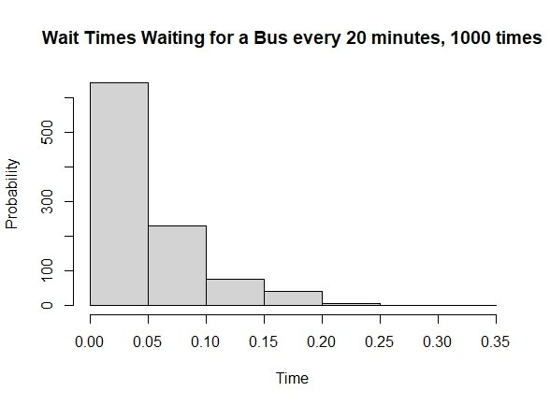

c. hist(rexp(10000, 20), main = "Wait Times Waiting for a Bus every 20 minutes, 10000 times", xlab = "Time", ylab = "Probability")

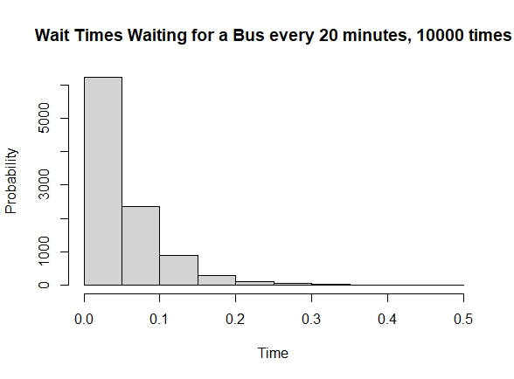

the results look exponential because of the radical dip over time. And with more time calculated the more accurate it gets.

1. a. 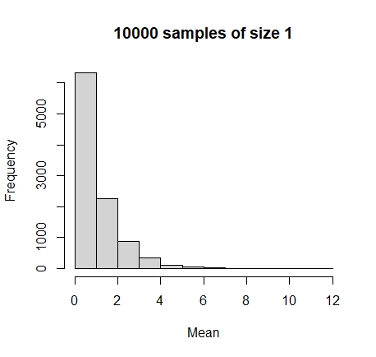

1. qqnorm(rnorm(ratGroupA$Wt))

qqnorm(rnorm(ratGroupB$Wt))

qqnorm(rnorm(ratGroupJ$Wt))

qqnorm(rnorm(ratGroupI$Wt))

I think the qq plot for I looks the most normal excluding the first and last plots. Otherwise, pretty consistent.