1. pie(percents, homeType, col = c("#FF3300", "#FFFF00", "#66FF00", "#FFCCFF", "#0000FF"), main = title)

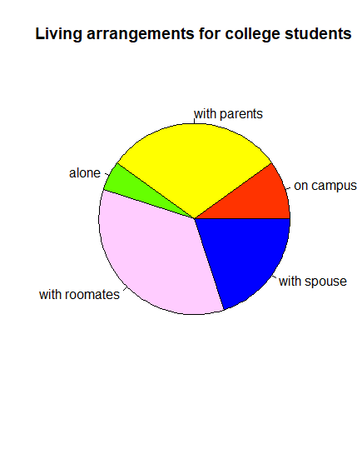

1. pie(tab, lbls, col = c("#FFC0CB", "#99CCCC"), main = writingHandsTitle)

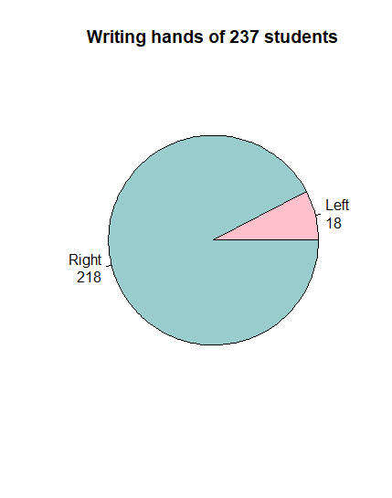

1. barplot(tab, horiz = TRUE, main = writingHandsTitle)

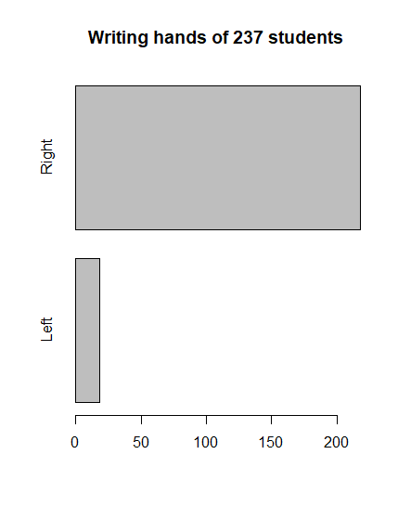

1. stem(survey$Height, scale = 2)
2. An immediate difference between the men’s & women’s height datasets are that the men’s height clusters where the women’s maximum height is (180cm). Another difference I would like to point out is that each dataset has one big cluster where the I presume the median is for each respective dataset.
3. men=filter(survey, survey$Sex == "Male")

women=filter(survey, survey$Sex == "Female")

menAges=men$Age

womenAges=women$Age

ageClass=seq(10, 80, by=10)

menAges.cut=cut(menAges, ageClass, right=FALSE)

menAges.freq=table(menAges.cut)

cbind(menAges.freq)

womenAges.cut=cut(womenAges, ageClass, right=FALSE)

womenAges.freq=table(womenAges.cut)

cbind(womenAges.freq)

From my frequency tables of men & women’s ages, it looks that the age distribution between these two datasets is almost the same. The distribution for both frequency tables shows a huge majority of ages between 10 to 30.

1. hist(numHeight, main = "Heights of 237 students", xlab = "Heights (cm)", col = "#FFFFFF", breaks = seq(150, 205, by=2.5))

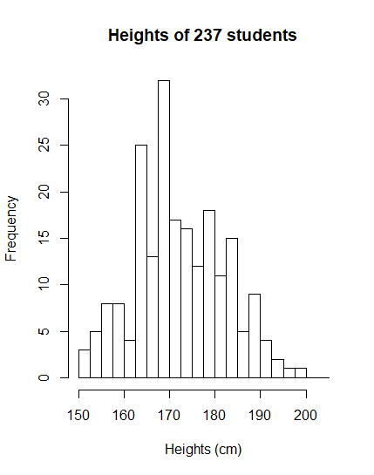

(I hope its ok if its taller than what is shown in lab, idk how to change that and could not find anything on it)

1. plot(breaks, freqs, type = "b", main = "Ogive of 209 student heights", xlab = "student heights in cm", ylab = "number of students")

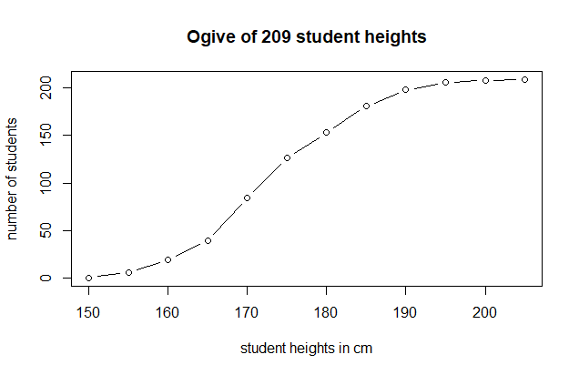

1. xyplot(survey$Wr.Hnd ~ survey$Height, ylab = "Student Writing Hand Size", xlab = "Student Height", main = "Relation Between Student Writing Hand and Height")

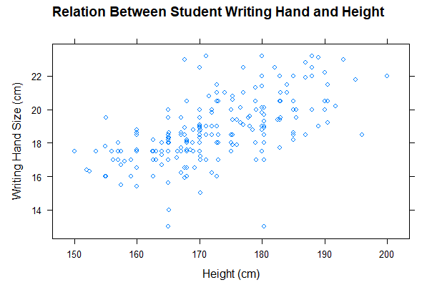

1. xyplot(survey$Wr.Hnd ~ survey$NW.Hnd, ylab = "Student Writing Hand Size", xlab = "Span of Non-writing Hand", main = "Relation Between Student Writing Hand and Non-writing Hand")

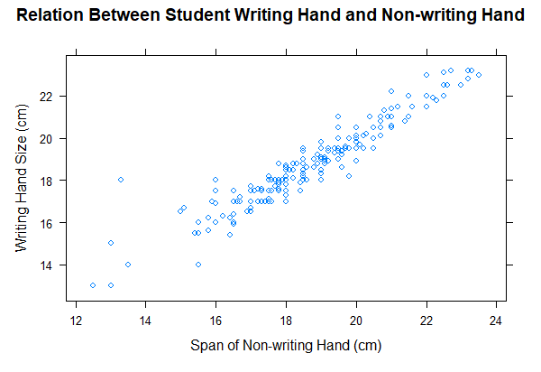

xyplot(survey$Height ~ survey$Pulse, ylab = "Height (cm)", xlab = "Pulse Rate (beat per min)", main = "Relation Between Student Height and Pulse Rate")

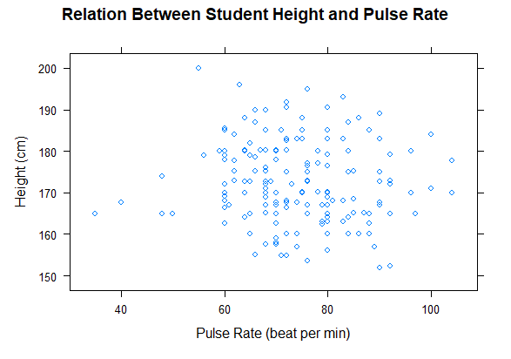

Regarding how the graphs compare to each other, the height/pulse and the writing hand size/height graphs show the data of their variables spread apart. Writing hand size/span graph on the other hand, shows the data is far more clustered together. And both variables of the graph elevate with each other, I believe that is a positive correlation between writing hand size and span of non-writing hand. On another glance, the writing hand size/height graph may also exhibit a positive correlation as well, just more subtly. I do not like comparing graphs to other graphs, but I suppose that height, writing hand size, and span of non-writing hand would all have a positive correlation together. the argument of the pulse rate being positively correlating with the prior-mentioned variables is not as convincing since the graph does not show a clear positive correlation between the pulse rate and height; therefore, probably not a positive correlation with writing hand size and non-writing hand span either.