**Quiz 1X**

**Graphical Descriptive Statistics**

1. The axial load of a solid material is the amount of force that can be applied along the long axis before the object bends or breaks. The axial loads of 50 aluminum cans are represented in the ogive below.

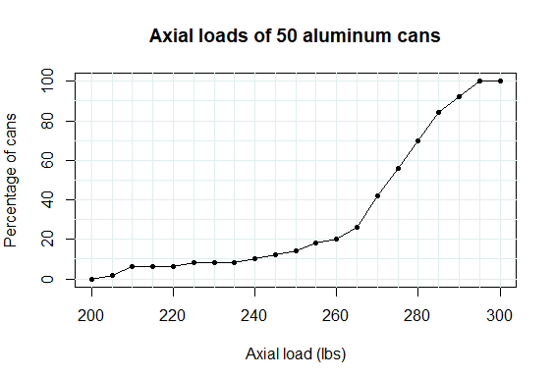

1. [2] Approximately what proportion of aluminum cans have axial loads between 230 lbs and 280 lbs? Explain briefly. You may mark up the ogive if you want.

Looks like 18% to 70% cans are between 230 & 280 lbs. Therefore 70% – 18% = ~52% of cans are in that axial load range. I looked at the axial load points at 230 & 280 lbs and deduced their correlated can percentage on the ogive.

1. [2] Complete the following sentence:   
     
   Approximately 30% of aluminum cans have axial loads exceeding ________ lbs.

Explain briefly how you got your answer. You may mark up the ogive if you want.

Approximately 30% of aluminum cans have axial loads exceeding **280** lbs. Since the statement states “exceeding” I would need to look for a percentage range of 70% to 100%, which is 100% – 70% = 30%. It could not be 0% - 30% since those loads would not be exceeding anything. Nor can it be in the middle since there would be some percentage of data exceeding the 30% somewhere within the data. 70% on the ogive is equal to axial load of 280 lbs; therefore, that is where approximately 30% of cans have axial loads exceeding 280 lbs.

1. [1] The lengths of 30 rats, in inches, are represented in the stemplot below.

The decimal point is at the |

8 | 391

10 | 590249

12 | 019159

14 | 35727

16 | 12488089

18 | 2

20 | 1

How many rats are between 13 inches and 15 inches in length?

Lengths: 13.1, 13.5, 13.9, 14.3, 14.5, 14.7

6 rats are between 13 & 15 inches in length (exact data shown above).