1. aceProbs=c(dhyper(0, 4, 48, 8), dhyper(1, 4, 48, 8), dhyper(2, 4, 48, 8), dhyper(3, 4, 48, 8), dhyper(4, 4, 48, 8))

aceProbTable=table(aceProbs)

View(aceProbTable)

barplot(aceProbs, names.arg = c(0, 1, 2, 3, 4), ylab = "Probability", xlab = "Aces drawn", main = "Probability of Aces Drawn From Deck w/o Replacement")

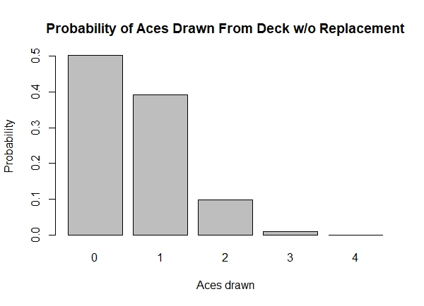

1. a. 

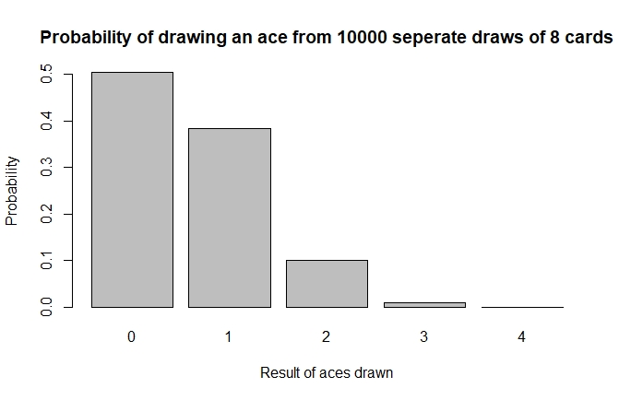

b. 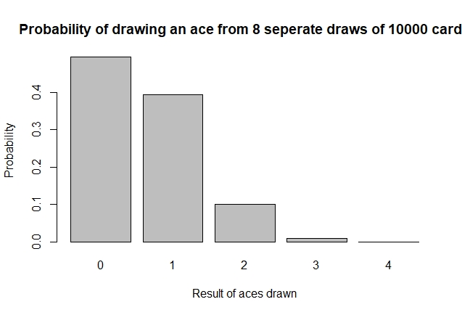

1. The 2 graphs above are almost identical. The mere number of samples insures one gets very close to the actual probabilities
2. O_O
   1. dhyper(100, 333, 666, 300)

[1] 0.05834763

* 1. phyper(100, 333, 666, 300)

[1] 0.5340624

* 1. phyper(99, 333, 666, 300)

0.4721148

* 1. 1 – phyper(109, 333, 666, 300)

[1] 0.08253631

* 1. phyper(110, 333, 666, 300)-phyper(89, 333, 666, 300)