1. a. nrow(filter(crabs, crabs$RW > 12))

[1] 119

1. quantile(crabs$RW, 0.8)

80%

14.82

1. boxplot(crabs$RW)

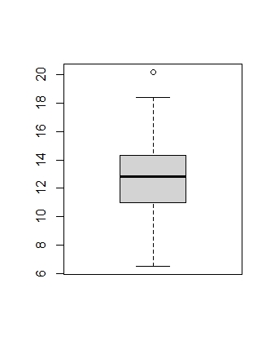there is 1 piece of data that is unusually high denoted by the clear circle on top of the fence.

1. blueCrabs=filter(crabs, crabs$sp == "B")

orangeCrabs=filter(crabs, crabs$sp == "O")

1. t.test(orangeCrabs$RW, conf.level = 0.9)

One Sample t-test

data: orangeCrabs$RW

t = 52.001, df = 99, p-value < 2.2e-16

alternative hypothesis: true mean is not equal to 0

90 percent confidence interval:

13.11638 13.98162

sample estimates:

mean of x

13.549

We are 90% sure that the mean of the orange crab species rear width is between 13.11638mm and 13.98162mm.

t.test(blueCrabs$RW, conf.level = 0.9)

One Sample t-test

data: blueCrabs$RW

t = 52.332, df = 99, p-value < 2.2e-16

alternative hypothesis: true mean is not equal to 0

90 percent confidence interval:

11.54955 12.30645

sample estimates:

mean of x

11.928

We are 90% sure that the mean of the blue crab species rear width is between 11.54955mm and 12.30645mm.

The orange crab species seems to have the average wider rear width (between 13.11638mm and 13.98162mm) than the blue crab species (between 11.54955mm and 12.30645mm).

1. pexp(7, 1/5)-pexp(3, 1/5)