Game Design Document

Fill up the following document

1. Write the title of your project.

Space Shooter Game

1. What is the goal of the game?

To get higher score by destroying flying asteroids and avoiding the asteroids

1. Write a brief story of your game.

The robot is at his home planet but asteroids are about to destroy it. So he has to destroy the asteroids in space before they reach the planet

1. Which are the playing characters of this game?

* Playing characters are the ones who respond to the user based on the input from the user.
* Cars, monkeys, dinos, wizards, etc., are the playing characters in the game.

|  |  |  |
| --- | --- | --- |
| Number | Character Name | What can this character do? |
| 1 | robot | Move up and down, shoot lasers (PC) |
| 2 |  |  |
| 3 |  |  |
| 4 |  |  |
| 5 |  |  |
| 6 |  |  |
| 7 |  |  |
| 8 |  |  |

1. Which are the Non-Playing Characters of this game?

* Non-Playing characters are the ones that don't have an action or behavior when the user interacts with the game.
* Hurdles, stones, bananas, coins, etc., are non-playing characters in the game.

|  |  |  |
| --- | --- | --- |
| Number | Character Name | What can this character do? |
| 1 | rocks | Fly sideways towards the robot(NPC) |
| 2 |  |  |
| 3 |  |  |
| 4 |  |  |
| 5 |  |  |
| 6 |  |  |
| 7 |  |  |
| 8 |  |  |

Draw your imagination of this game. What does this game look like?

* Draw the game either on your computer or on paper.
* Add images of the game scenes to show each of the playing and non-playing characters at least once.

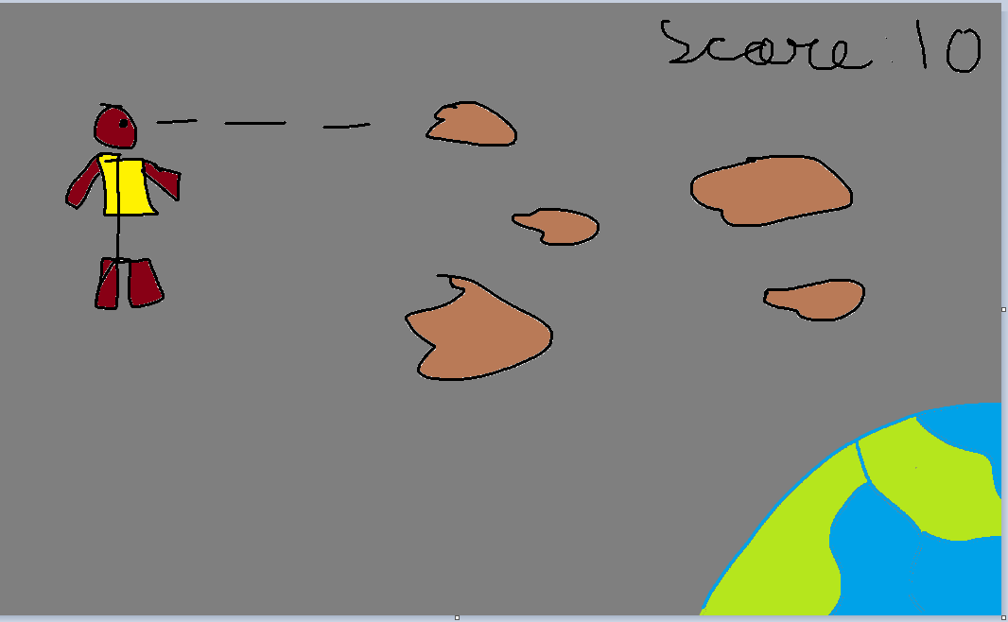

How do you plan to make your game engaging?

The game will be adaptive, the rock speed wil increase as you play longer and longer, and the game will look attractive and polished.