Luke Canfield

GitHub Username: LukeCanfield13

Purdue ID: 0032342067

Instructor: Chris Brinton

Problem 1 Write-Up

Estimated Functions

$$\hat{y_{1}}=21.99190792x+92.70531403$$

$$\hat{y_{2}}=-1.15834068x^{2}+22.60822925x+100.79905593$$

$$\hat{y_{3}}=1.66680649x^{3}-1.19334469x^{2}+ 0.39581103x+100.43721865$$

$$\hat{y_{4}}=-.0143365571x^{4}+1.66770942x^{3}-.905694362x^{2}+.339499592x+ 99.7620446$$

$$\hat{y_{5}}=-.0231737037x^{5}-.0196196620x^{4}+2.27429003x^{3}-.864397166x^{2}-2.65996605x+99.4138526$$

Data Visualization

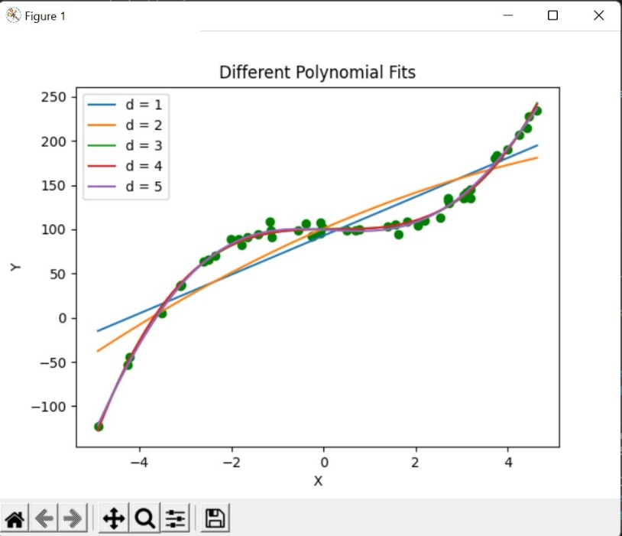

The data appears to follow a fifth order polynomial the best. The fourth and fifth order polynomial almost appear identical but we know that theoretically that a higher order polynomial will have a smaller error. If we measure a new data point x = 2 the corresponding predicted value using the fifth order polynomial would by $\hat{y_{5}\left(2\right)=}$ 107.775179