ECE 49595 Assignment 3

Tree Drawn from Car Dataset

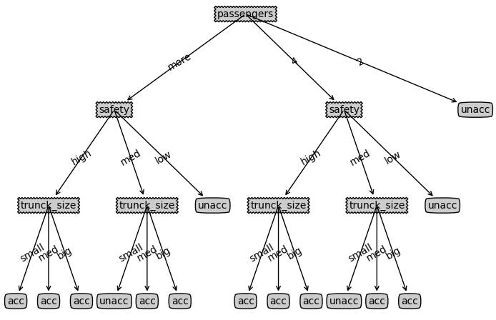

chooseBestFeature Code

def gini(labels):

    _, count = np.unique(labels, return_counts=True)

    probs = count / len(labels)

    gini_idx = 1 - np.sum(probs ** 2)

    return gini_idx

def chooseBestFeature(dataSet):

    '''

    choose best feature to split based on Gini index

    Parameters

    -----------------

    dataSet: 2-D list

        [n_sampels, m_features + 1]

        the last column is class label

    Returns

    ------------------

    bestFeatId: int

        index of the best feature

    '''

    best_gain = 0

    bestFeatId = -1

    num_features = len(dataSet[0]) - 1

    total_samples = len(dataSet)

    for ID in range(num_features):

        gini_idx = gini([x[-1] for x in dataSet])

        unique_vals = set([x[ID] for x in dataSet])

        for val in unique_vals:

            subset = [x for x in dataSet if x[ID] == val]

            gini_idx_subset = gini([x[-1] for x in subset])

            gain = gini_idx - (len(subset) / total_samples) * gini_idx_subset

            if gain > best_gain:

                best_gain = gain

                bestFeatId = ID

    return bestFeatId

stopCriteria Code

def stopCriteria(dataSet):

    '''

    Criteria to stop splitting:

    1) if all the classe labels are the same, then return the class label;

    2) if there are no more features to split, then return the majority label of the subset.

    Parameters

    -----------------

    dataSet: 2-D list

        [n_sampels, m_features + 1]

        the last column is class label

    Returns

    ------------------

    assignedLabel: string

        if satisfying stop criteria, assignedLabel is the assigned class label;

        else, assignedLabel is None

    '''

    assignedLabel = None

    labels = [x[-1] for x in dataSet]

    unique_labels = np.unique(labels)

    if len(unique_labels) == 1:

        assignedLabel = unique_labels[0]

    elif len(dataSet[0]) == 1:

        assignedLabel = max(set(labels), key=labels.count)

    return assignedLabel