# CA 1 – Design Doc

# 3D Game Engine Development

# Luke Courtney

## Overview

This game was created as part of CA 1 for 3D Game Engine Development. The objective of this assessment was to create a game under the theme of *“Start from nothing”*. In it, you control a ball in a dark, maze-like environment. Due to the oppressive darkness and lack of visibility, you must rely on the light from a flashlight to find your way around. From the darkness comes an endless wave of enemies, that when they see you will attempt to chase and kill you. If you get hit three times, its game over. These enemies can be killed using the light from the flashlight. This flashlight however has a limited amount of battery, and drains over time. As you progress through the game, the rate at which it drains also increases. Randomly spawning pickups can be found throughout the level can be found and used to replenish health and flashlight battery. Over time the enemies will appear more frequently, as well as in more powerful forms. Your objective is to survive as long as possible in this environment.

The game takes place in a pitch-black environment designed to be disorienting and maze-like. The darkness in combination with the mix of wide open areas and narrow spaces make it difficult to keep track of where you are and where you have been. This creates a tense atmosphere as you try to figure out the layout of the level, and remember where you’ve been already.

The game features a single mode. Starting as soon as the player hits start on the main menu, the goal is to survive as long as possible. The game starts off slowly, with enemies spawning every 10 seconds randomly across the map. The difficulty soon increases however in a number of ways.

* Enemies spawn more frequently
* Special enemy types spawn
* The players flashlight battery drains faster
* Health packs and batteries appear less often
* As the player is chased by more enemies, the camera zooms in and a faster heartbeat sound can be heard

As these difficulties build, the player also unlocks a number of upgrades that can be used in order to tip the scales in their favour. These include:

* Dash ability
* Area-of-Effect damage ability
* Ping ability that highlights enemies
* Teleport ability that teleports player to a random point on the map

These abilities are unlocked through defeating enemies, starting with the dash ability at 5 kills, and working up to the teleport ability much later in the game. Each ability has a different cooldown. The dash ability can be used every 5 seconds. for example, but the teleport ability takes a total of 5 minutes to recharge after use.

Figure - Player with 3 lives and all abilities ready

The game contains minimal on-screen text or UI elements, instead opting to display relevant information to the player in-world. For example, the players current health is displayed as a series of rings of light around the player, and the status of the players abilities are shown by a set of coloured lights behind them.

Figure - Main Menu

When the player launches the game, they will be brought to the main menu. From here they have the options of starting the game, viewing their scores, and quitting the game. The menu can be navigated using the *W* and *S*  keys, and selections can be made using the *Enter* key. The current selection is indicated by the two white spheres with lights. The menu is accompanied by custom menu music made in FLStudio. The same music can be heard when the player is killed.

## Development

(14 scripts in game mode, 19 total)

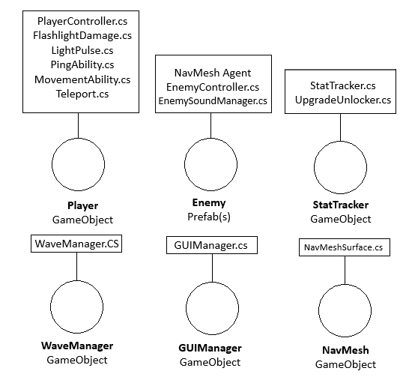

Figure - GameObject Diagram