**Design Document & Technical Review**

*Luke Courtney, Ishka Yao, Adam Sheedy & Cillian Murphy*

**Design Document**

**Assets**

An asset in game development is essentially any resources that are used to develop a video game. There are many different types of assets such as graphics, sound , textures and many more. Assets are important since they make the game visually and audibly appealing, this will attract more players to want to engage in your game. For our project we will mainly be using the sound and graphics assets.

**Graphics**

Graphics are very important in games design as it can completely alter the appearance of your game from something basic to something phenomenal. In our game “Submarine Mayhem” our graphics will be hand drawn and altered to fit in the game perfectly. The graphics will mainly be going on sprites, background, menu and obstacles. This asset will be stored in a graphics folder.

Figure 1:Graphics

**Sound**

The sound asset proves vital to making your game more realistic, for example if a game character goes in the water, you would want a splash sound as it is more realistic and can make the game more engaging to play. In our game our sound would be generated in ‘Bfxr’ this is a helpful tool in making sound effects which can then be imported into our game. We will have a sound folder to store all our generated audio.

Figure 2:Bfxr

**Use Case Diagram**

Figure - Use Case Diagram

The use case diagram shown above gives an overview of the basic operations available to the player upon launching the game. When the game starts, the player will be on the main menu. From there, they will have four options. These include:

* Start Game
* View High Scores
* View Instructions
* Quit game

The first of these options, *Start Game*, will cause the game to begin, and allow the player to start controlling the player submarine, and pilot it through the underwater cave in which the game takes place. From here they will have the options to move through the level, shoot enemies, collect powerups and return to the menu.

The second option available to the user from the main menu is the *View High Scores* option. This will display a list of previous scores obtained in the game, sorted from highest to lowest. The player will then be given an option to return to the main menu.

Option three on the main menu is the *View Instructions* selection. This will display a brief description of the game, and an overview of the controls and objectives.

Finally, the fourth item on the main menu of the game is simply the *Quit Game* option. This will stop the game from running and close the window.

**Sequence Diagram**

Figure - Sequence Diagram

This diagram shows the core game loop and certain aspects of the game and their relation to each other. This shows the player starts the game and loads the level. It shows how the player can shoot the enemies and the enemies can shoot back as well as what happens when either the player or the enemies die. This diagram shows what happens when the player completes a level and shows that the player can die by running out of oxygen.

**Technical Review**

**SFML**

Figure - SFML Logo

As part of the project, we will be working with the SFML C++ Library. SFML, which stands for “Simple and Fast Multimedia Library”, is a library that can be used in the development of games and other multimedia applications. SFML is a multi-platform library. This means that it can be compiled and run on most major operating systems without much if any additional work.

We have chosen to use the SFML library in our project as it is relatively simple to use, and we have past experience in using it, with such projects as Zombie, and Timber in previous semesters. As we are already familiar with SFML, it should save us from the challenge of learning a new library and using it to create a game. SFML is also multi-language, but we will be using it in C++ as out previous experience with SFML has been in C++.

SFML covers all of the needs we could have for a library. The five modules of SFML are system, window, graphics, audio and network. Of these, we will primarily be using the graphics and audio components. As our project will be created using the frame of a previous project, we will not have to spend as much time setting up the window component of the project, as it will already have been created.

SFML is well documented, and a number of books and other resources have been written on the topic. This will be a significant help with regards to development using SFML. A number of these resources are linked on the [SFML website](https://www.sfml-dev.org/learn.php), and many more can be found online on various forums and websites.

**Class Diagram**

A class diagram shows the classes of a project their attributes, methods and the relationships of each classes. The diagram provides a basic notation for other structure diagrams prescribed by UML.

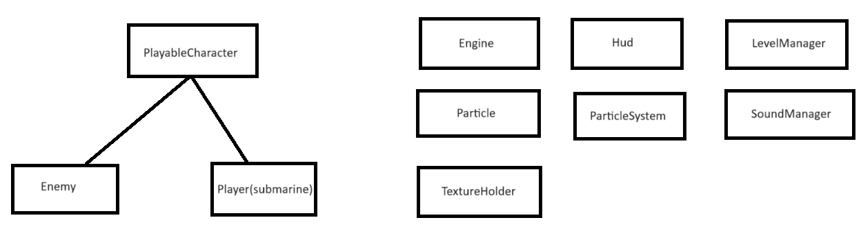

Figure 6:Submarine-Mayhem class diagram

This diagram is the class diagram of the team project Submarine-Mayhem.

* The PlayableCharacter holds the characters positions, spawns them in and sprite.
* The Enemy and Player are connected to PlayableCharacter so they can use those methods, they also have their own inputs to handle movement and jumping.
* The Engine holds the method to spawn in the shaders, background, textures it runs the game. The Hud is use to load text in the main menu or in the paused menu.
* The LevelManager loads a new level from a text file, count the number of rows in the file and store the integers in an array to find the appropriate sprite for that number.
* The Particle class moves the particles and the ParticleSystem creates the particles into the level.
* The SoundManager associates the sounds to a buffer, the sound can be heard from a certain distance from the Player.
* The TextureHolder holds the textures for the game and uses a key-value-pair to search for the file that has the textures.

**References**

*Simple and fast multimedia library* (no date) *SFML*. Available at: https://www.sfml-dev.org/index.php (Accessed: 12 October 2023).

*Learn (SFML)*. Available at: https://www.sfml-dev.org/learn.php (Accessed: 12 October 2023).