2-Problem Definition and Background

The objective of our project “Submarine Mayhem” is to create a platform-based survival game with the given theme ‘Start from nothing’. Our game reflects the theme as you start of as a basic submarine with nothing, as you progress through the level defeating enemies you will be able to collect upgrades to enhance the submarine. The goal we want to achieve by the end is to have a working game that fits the requirements and to have completed all documentation/presentation to a high standard. As a team we have highlighted key tasks we need to complete for our game such as:

**-Health System:** This will be an oxygen tank that will decreases over time or if an enemy hit it.

**-Enemies:** The enemies will be around the map preventing the submarine from moving forward unless defeated, a boss enemy will drop a pickup.

**-Pickups/Upgrades:** The pickups can either be spawned on the map or drop upon defeating a boss, some pickups will allow an upgrade to your submarine such as increase in oxygen, speed boost etc.

**-Shooting:** We want both our submarine and the enemy submarine to shoot at each other.

**-HUD Elements:** To make the game more organised there will be different states of the game like menu/paused. A scoring system will also be added to make the game more interesting.

**-Levels:** The levels should have a different layout this is to be edited in the level.txt files.

Some problems we may face is being stuck on time or a confusion among team members on what is to be completed. To combat this, we have created a timeline to be organised and to set a standard on what is to be completed by the end of a certain date.

**Timeline**

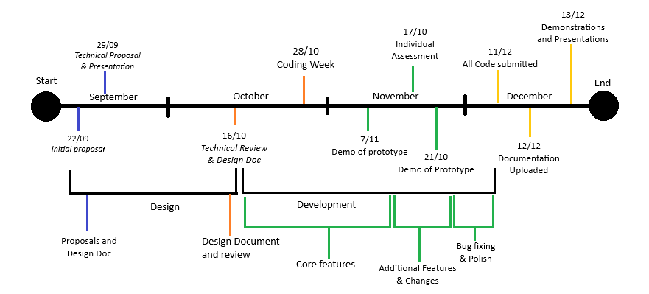

Figure :Timeline

**September:** From the beginning of September our group all agreed upon the idea to do a survival platform game using “Thomas was late” as a template. This will be the beginning of designing our project “Submarine Mayhem”, carrying this plan forward we submitted the “Initial proposal”, “Design document”, “Technical proposal” and our first “Presentation”.

**October:** In October we created a more solidified “Technical review & design document”, this document provides a more in depth look on how we will implement and design our project. In coding week, we worked on campus and online and had set a goal to have a working game prototype with no errors.

**November:** Our goal for November is to complete the final steps for the game such as polishing the code, bug fixing, & implementing additional features and changes for our game. We will also have demoed our game and finished the “Individual assessment”.

**December:** Finally in December everything should be complete, and the code and final documentation will be uploaded. We will do a final presentation to discuss our project in more detail.

As a team we will have a meeting every Tuesday to discuss our tasks and objectives for the week. In the meeting the members will divide the tasks and set a deadline for the tasks to be completed by, we will also try to solve any issues and help each other if anyone is facing a problem. Outside of the meeting we have created a GitHub Repository to manage our work and a Discord group chat to discuss issues and updates outside of college. In our team we want to ensure that we stay organised and dedicate our time into completing the project, we have various ways to keep track of the deadline this includes a weekly meeting, timeline, GitHub and a Discord group chat.