**Year 1 Production log**

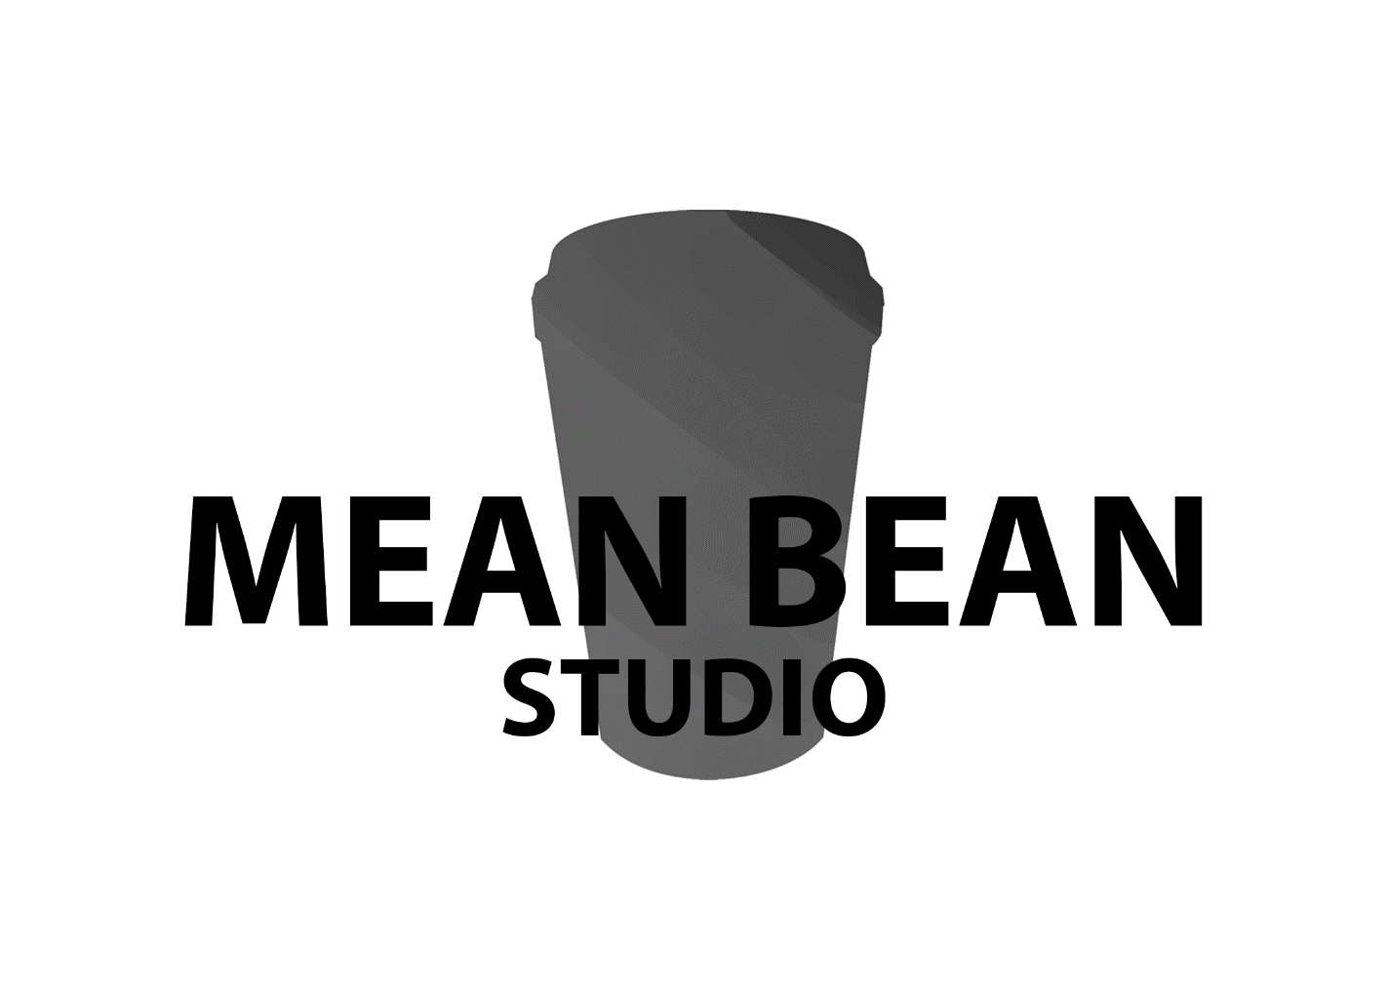

**Instructions**

* Production log to be updated each week of Production (6 weeks).
* All work deliverables must be agreed upon by the team as a whole. This is to highlight individual contributions and to ensure each team member is accountable for their deliverables throughout production.
* Please email your production log to your production manager (teacher) every Monday after your initial daily meeting.
* Completed work/deliverables to be sighted and approved by your production manager (teacher) weekly.
* Use the production log to record production manager (teacher) feedback you receive each week during your stand-ups and your response to it.

Contents

# Week 1: 21 – 22 October

# Week 2: 28 – 30 October

# Week 3: 4 – 5 November

# Week 4: 11 – 13 November

# Week 5: 18 – 19 November

# Week 6: 25 – 27 November

# Week 1

## Date: 21 – 22 October

|  |  |  |
| --- | --- | --- |
| **Team member** | **Deliverables / contribution planned for week** | **Incomplete deliverables** |
| Aiden | Environmental block-outs & painting | After some consideration and time spent reviewing progress I have come to the conclusion that doing paint overs for all 32 assets will be completely impracticable and unnecessary. I will be moving on with the project and begin production of the assets with all passed though the art-style to ensure continuity. |
| Domenic | Character sculpting and painting | Didn’t finish One character |
| Luke | Obstacle finalisation, prototyping and finalising pickups | Didn’t finish the pickup prototyping. |
| Will | Map generation, pickup prototyping, | Didn’t finish the pickup prototyping. |
| Tarek | Obstacle block-out |  |
| Pasquel | Pickups (coffee beans and score), refine movement |  |

1. Were all deliverables completed for the week?

Yes  No

1. If not, how will the team compensate for this moving forward?

We overestimated what we could do in the time we had. We’ll have to move some of the tasks to next week. We’ll have to take time from other tasks or even work more in the back half of the week.

1. What feedback did your team receive this week?

Few changes to our trello board.

Add a bug log, find them fast

We should add time estimations to each task.

1. How did you implement the feedback?

After considering the feedback provided we implemented a

# Week 2

## Date: 28 – 30 October

|  |  |  |
| --- | --- | --- |
| **Team member** | **Deliverables / contribution planned for week** | **Incomplete deliverables** |
| Tarek | Rigging both character and starting animation for main character Beanbo |  |
| Aiden | Sculpting assets and pushing all art assets to the alpha asset pack. Testing art features and expanding knowledge of key requirements for aesthetically pleasing assets. |  |
| Domenic | Sculpting and basic texturing of both the characters in the game. |  |
| Will | Prototype pickups, merging scripts and obstacle spawning. |  |
| Pasqual | Prototype pickups, bean pickups, score, Player UI and starting work on Beanbo’s ultimate |  |
| Luke | Blocking out the Ui (menu & pause Menu, concepting for player Ui). Working with programmers for the spawning of obstacles. |  |

1. Were all deliverables completed for the week?

Yes  No

1. If not, how will the team compensate for this moving forward?
2. What feedback did your team receive this week?
3. How did you implement the feedback?

# Week 3

## Date: 4 – 5 November

|  |  |  |
| --- | --- | --- |
| **Team member** | **Deliverables / contribution planned for week** | **Incomplete deliverables** |
|  |  |  |
|  |  |  |
|  |  |  |
|  |  |  |
|  |  |  |
|  |  |  |

1. Were all deliverables completed for the week?

Yes  No

1. If not, how will the team compensate for this moving forward?
2. What feedback did your team receive this week?
3. How did you implement the feedback?

# Week 4

## Date: 11 – 13 November

|  |  |  |
| --- | --- | --- |
| **Team member** | **Deliverables / contribution planned for week** | **Incomplete deliverables** |
|  |  |  |
|  |  |  |
|  |  |  |
|  |  |  |
|  |  |  |
|  |  |  |

1. Were all deliverables completed for the week?

Yes  No

1. If not, how will the team compensate for this moving forward?
2. What feedback did your team receive this week?
3. How did you implement the feedback?

# Week 5

## Date: 18 – 19 November

|  |  |  |
| --- | --- | --- |
| **Team member** | **Deliverables / contribution planned for week** | **Incomplete deliverables** |
|  |  |  |
|  |  |  |
|  |  |  |
|  |  |  |
|  |  |  |
|  |  |  |

1. Were all deliverables completed for the week?

Yes  No

1. If not, how will the team compensate for this moving forward?
2. What feedback did your team receive this week?
3. How did you implement the feedback?

# Week 6

## Date: 25 – 27 November

|  |  |  |
| --- | --- | --- |
| **Team member** | **Deliverables / contribution planned for week** | **Incomplete deliverables** |
|  |  |  |
|  |  |  |
|  |  |  |
|  |  |  |
|  |  |  |
|  |  |  |

1. Were all deliverables completed for the week?

Yes  No

1. If not, how will the team compensate for this moving forward?
2. What feedback did your team receive this week?
3. How did you implement the feedback?