Progress Report – License Plate Sequence Extraction

by: Lauren, Luke, and Kayhan

We have been able to compile our solution to implement the correlation coefficient method. We are having issues regarding how our program is using the calculated correlation coefficients to determine the correct symbol being analyzed on the image of the license plate. That is, certain templates are returning a higher correlation value than they should ( as in those characters being represented by said templates are not in the image) and the result of this is an incorrect alpha numeric sequence being returned.

We have only rough pseudo code for the Hough Transform in place. We are focusing on completing the correlation coefficient method before moving onto the Hough. After fixing our current problems in the correlation coefficient method, we will need to add the features that will display the corresponding information to the screen.

Below is a snip-it of the values being produced by the correlation coefficient. We can demonstrate our current solution on Monday to show our progress thus far.

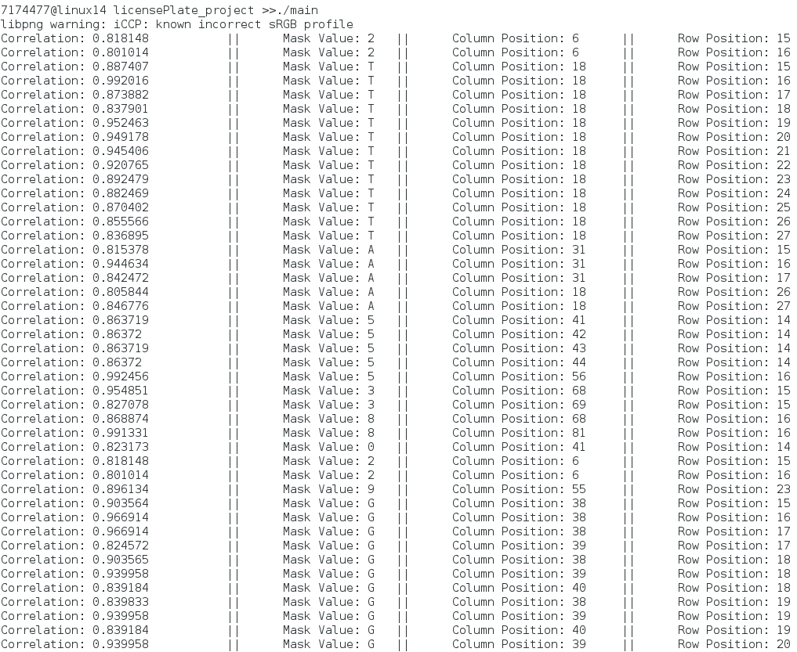

The expected license plate sequence should be: “2TA 538”. We are receiving high correlated values from templates representing characters not actually in the image as you can see from the mask values after the “8”. The reason we receive the mask values in proper sequence is because we are testing those specific mask values first, according to the image of the plate used.