**2. Quick Start**

This section introduces the **Mango Cryptographic Workbench** — a hands-on interface where you can manually build and test cryptographic sequences using Mango's atomic transforms. While later chapters dive into automated sequence discovery and tuning, this chapter focuses on the *manual* process to help you understand how the system works from the ground up.

**2.1 Launching Mango**

To begin, navigate to the Workbench's output directory and launch the executable:

cd Workbench/bin

Mango.exe

**2.2 Building a Transform Sequence**

Once Mango is running, you’ll see an interactive command prompt. Begin constructing a transform sequence by entering numbers between **1 and 40** — each number corresponds to a specific transform.

**Example:**

9

18

23

4

This builds a four-transform sequence composed of transforms 9, 18, 23, and 4. Mango will resolve and display the corresponding names:

SubBytesXorMaskFwdTx -> ShuffleNibblesFwdTx -> SlidingMaskOverlayTx -> ShuffleBitsFwdTx

**2.3 Executing Your Sequence**

Once your sequence is defined, you can execute it against the current input data by entering:

run sequence

Mango will process the input and display a detailed breakdown of cryptographic metrics — including entropy, avalanche performance, key sensitivity, and more.

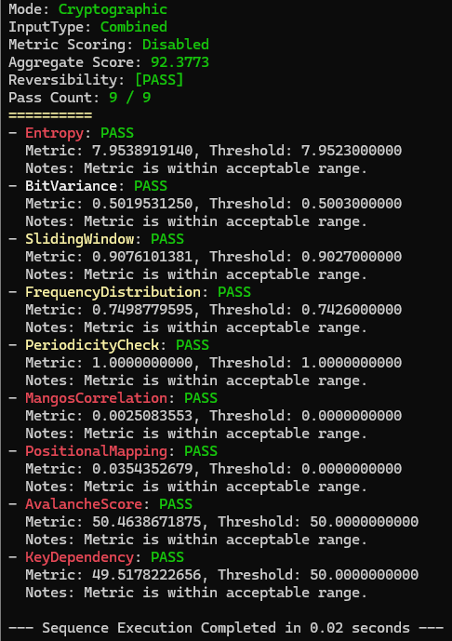

**2.4 Other Useful Commands**

While exploring, the following commands may come in handy:

* clear sequence — Clears your current sequence.
* set InputType <type> — Sets the input data classification. Options are: Combined, Random, Sequence, or Natural.
* help — Displays all available commands.
* list — Displays your current configuration, including active sequence and input type.

**2.5 Comparing Mango to AES**

After crafting a sequence you're satisfied with, you can benchmark it against AES using:

run comparative analysis

This command evaluates your custom sequence against AES across Mango’s full suite of metrics. It provides a side-by-side comparison, highlighting strengths or weaknesses of your sequence relative to a widely accepted encryption standard.

⚠️ **Note:** While manual exploration is a valuable learning tool, the combinatorial space of transform sequences is far too vast for trial-and-error to uncover truly optimal configurations. Mango’s automation engine — *Munge* — handles this heavy lifting and will be covered in upcoming chapters.