**Project Guide**

**Developing Environment：**

Windows 10 x64

Visual Studio 2017

**Install Nunit:**

1. Go to Tools => Extensions and Updates in Visual Studio 2017

Install NUnit 3 Test Adapter

Nunit VS Templates

Test Generator NUnit extension

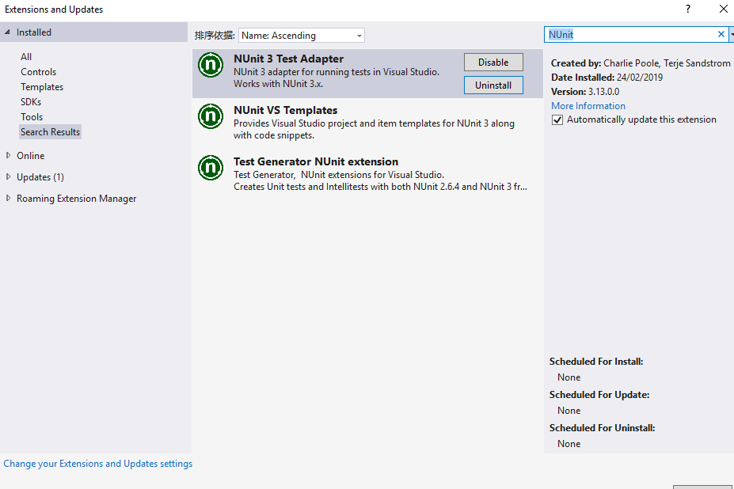

1. Install NUnit, NUnitTestAdapter.WithFramework package for ConvertDollarService.UnitTests project
2. Restore NuGet package on ConvertDollarService project after you open the solution in Visual Studio 2017

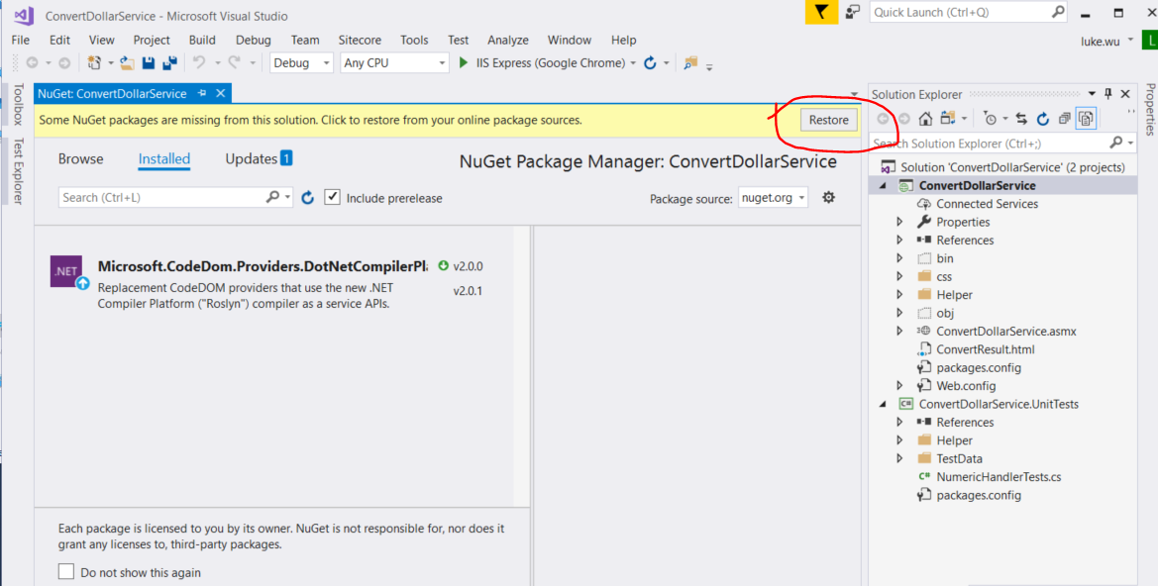

**Operation process:**

1. Set project web url to http://localhost:27882/

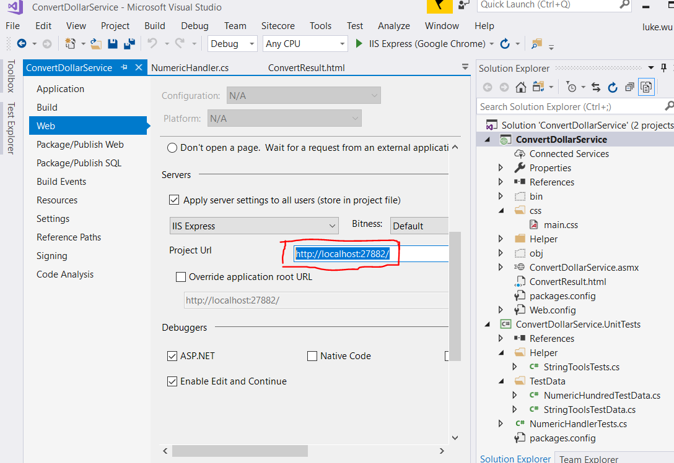

1. Set ConvertDollarService as startup project and set ConvertResult.html file as start page

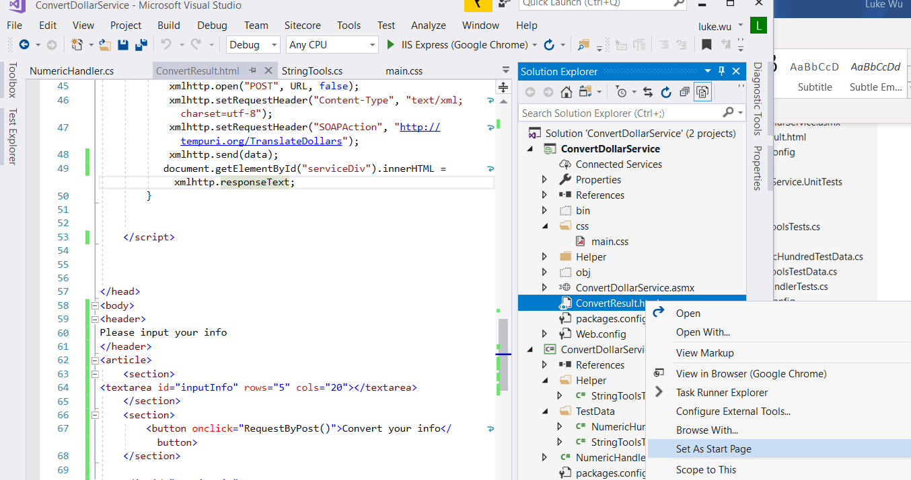

1. Run the project and you can view it in web browser

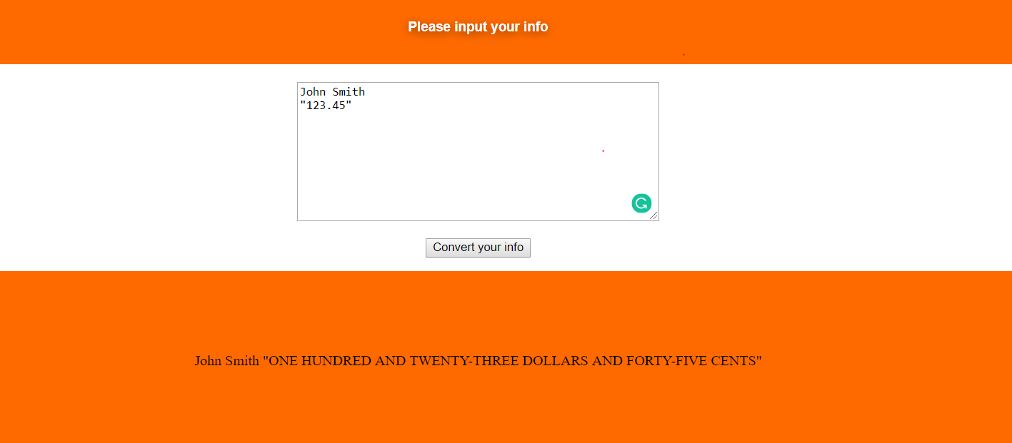

**Project Unit Test (NUnit):**

Please run unit test in ConvertDollarService.UnitTests project, it tests StringTools and NumericHandler. I did not unit test webservices directly since it invokes the method of NumericHandler class. So, the unit test code coverage is not 100%

It will show the Code Coverage is 90.10%.