# Closing Kit

## **COVER**

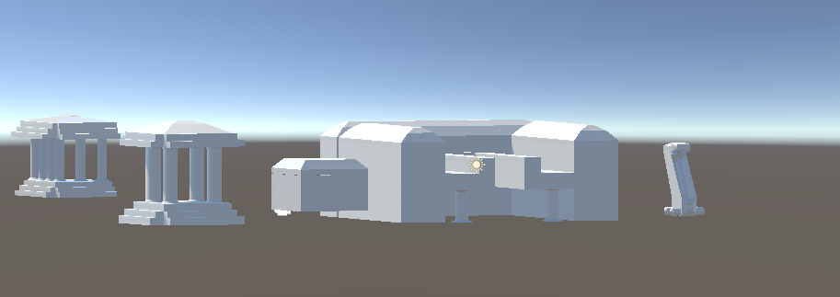

# **Populous 2 War against the Gods**

Document version number 1

Written by Luke Mears

Point of contact st2017899

Date of publishing 04/1/2024

Version number 1

**Closing Kit Outline**

Contents

Closing Kit 1

**COVER** 1

**Populous 2 War against the Gods** 1

API Versions 2

Release Version 2

Instructions 2

Repository 2

Credits 2

Other IP 2

Issue List 2

API Versions— The only APIs that I will know is that was the software of 3Ds max and the game engine which was unity.

Release Version—this game is still in prototype and has no release date on it as well.

Instructions— the aim of the game would be that the player will need to get material to help them to defend them self and there items that they got from the

Repository— A link to the code repository in a suitable VCS (e.g. a git repository on Bitbucket).

Credits— Luke Mears is the only person that will be credited for making the models and putting them into a game engine.

Other IP— the only other IP that was used was some YouTube videos to get the noises/ audio for the model, they will be link bellow.

<https://www.youtube.com/watch?v=e_X1wXwgwec&ab_channel=FreeSoundEffects>

<https://www.youtube.com/watch?v=mRw7IDFwY2I&ab_channel=HouseOfSoundEffects>

<https://www.youtube.com/watch?v=k1LgRjAf7nw&ab_channel=FreeSoundEffects>

Issue List— the only issue with this was that the textures would seem to be transferring over to the game engine and it was tried to get that all working but couldn’t