# Technical Design Document (TDD)

## **COVER**

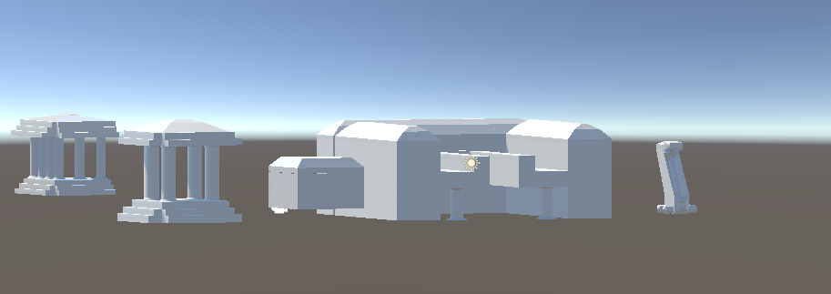

# **Populous 2 War against the Gods**

Document version number 1

Written by Luke Mears

Point of contact st2017899

Date of publishing 04/1/2024

Version number 1

Contents

Technical Design Document (TDD) 1

**COVER** 1

**Populous 2** 1

Development Requirements 2

Development 2

Game Engine 2

API Versions 2

2D/3D Software 2

Project Management 2

Source Control 2

Sound Software 2

Asset Specifications 2

Project Structure 2

File Naming Convention 2

Level / World Details 2

Development Plan 2

Playtesting 3

Development Requirements— The only software that would be required are a 3D modelling software and a game engine to put the models into to show them off.

Development— the development of the models were taken through many months and weeks using the software from the university and the software at home. This will allow the developer to be able to develop the models to the highest quality

Game Engine— the game engine that was used was the unity game engine. The vision of this game is the is vision 3.5.2 , the reason why this was chosen because the user was more confinable using unity than unreal engine.

2D/3D Software— The software that was used for making the 3D models was 3Ds max with the vision of the software being 2024, the reason why this was the software that was chosen because it is industry standards of the gaming world.

Project Management— The software that was used was Microsoft excel, with this it was easy for the game developer to get a time scale done for the project and be able to get the done to a high enough standers and be able to complete with plenty time to spare.

Source Control— there was no client software that was use to make this project reality.

Sound Software— the sound software that was used was the software Audacity, the reason why this software was chosen was that it was the best and easiest one to get the audio right for the different models.

Asset Specifications— with the assets that was chosen to make I thought that the

Project Structure— it is in one gig folder that will have the links

File Naming Convention—Convention for naming code and asset files.



This this the main file of the 3Ds max

This is the files inside the file that can allow the game developer to find what they wanted to get at

Theses are the files that didn’t get any sorting to them, with a bit of hindsight these files would be put into different folders to allow them to be sorted easier to find.

Level / World Details— with the assets they will allow them to give life to the game, with the first asset terrain it is the place where all of the other game will be put down. The second biggest model will be the main temple this is where you can upgrade you land to get more resources, with the other models then they will be the same size as each other except the robot NPC which will be smaller to allow it to interact with the other models.

Development Plan—Outline of the production plan from pre-production to delivery.

|  |  |  |  |
| --- | --- | --- | --- |
| Milestones | Date | Deliverable | Approval |
| Pre-Production End | 04/01/2024 | TDD  Prototypes | Yes |
| Milestone 1 | 04/01/2024 | Prototype  Unity | Yes |
| Milestone n | 04/01/2024 | Prototype | Yes |
| Alpha | 04/01/2024 | Unity  Prototype | Yes |
| Beta | 04/01/2024 | Unity  Prototype | Yes |
| Final | 04/01/2024 | Unity | Yes |
| Pitch and Play | 04/01/2024 | Unity | Yes |

Playtesting— the testing on this game will require the play tester will need to control the NPC and the environment to help the NPC to make better building to help them out against the Gods.