**Gapology: How Winning Leaders Close Performance Gaps, 5th Anniversary Edition by Brian Brockhoff and Mark Thienest**

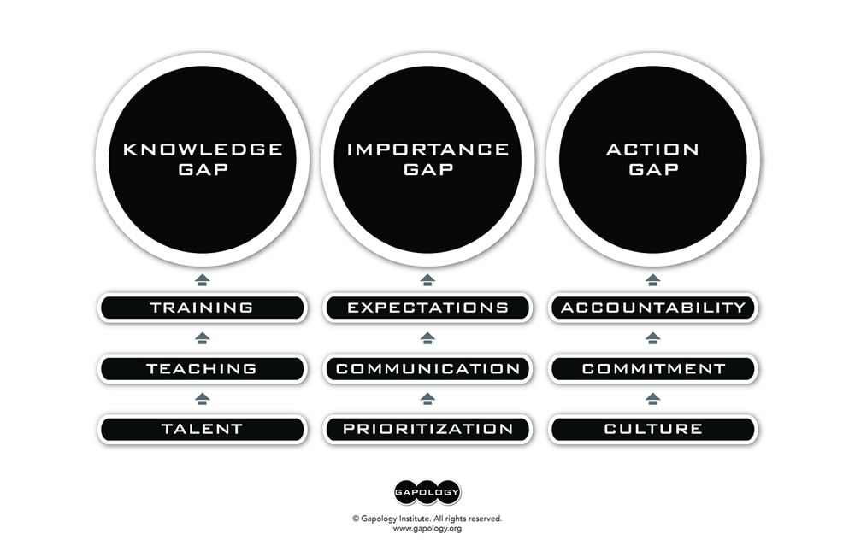

**Identifying Performance Gaps: The Nine Evaluation Points**

**1. Knowledge Gap**

A Knowledge Gap arises when employees lack the necessary information, skills, or understanding to perform their roles effectively. Evaluating this gap involves three critical components:

* **Talent**: Are we recruiting the right talent?  
  Recruiting individuals with the appropriate skills and capabilities is the first step in bridging the Knowledge Gap. Assess whether your recruitment strategies align with the requirements for success in your organization.
* **Onboarding**: Are we onboarding them effectively?  
  An effective onboarding process ensures that new employees are smoothly integrated into the company culture while gaining a clear understanding of their roles and responsibilities. Evaluate whether your onboarding practices effectively communicate essential knowledge and expectations.
* **Teaching and Training**: Do I prioritize ongoing development opportunities for my team?  
  Continuous learning is vital for keeping employees updated on industry trends and emerging technologies, as well as nurturing their personal and professional growth. By incorporating coaching, mentoring, and professional skills development, you can enhance critical abilities such as communication, leadership, and problem-solving. These efforts extend beyond standard job-specific training, creating a workforce that adapts quickly to change. Regular development programs foster a culture of growth and ensure that employees remain confident and prepared to tackle future challenges.

The adaptability of the Gapology Framework across various organizational contexts underscores its effectiveness.

**2. Importance Gap**

An Importance Gap occurs when there is a disconnect between an employee’s perception of their work’s significance and the organization’s priorities. Consider these evaluation points:

When leaders adopt the Gapology Framework, they foster a culture of continuous improvement and accountability.

* **Prioritization**: Am I prioritizing my “asks” correctly?  
  Ensure that employees’ tasks and projects align with the organization’s strategic objectives. Proper prioritization helps focus efforts on what is most impactful.
* **Communication**: Am I communicating effectively?  
  Clear and consistent communication is crucial for ensuring that employees understand their role in achieving company goals. Evaluate whether your communication channels and methods effectively convey priorities.
* **Expectations**: Do I set clear expectations?  
  Clearly defined expectations help employees understand what is required of them and how their contributions impact the organization. Regularly review and communicate these expectations to prevent misunderstandings.

The practical applications of the Gapology Framework are extensive, benefiting teams across diverse industries.

**3. Action Gap**

An Action Gap occurs when there is a disconnect between employee intentions and their actual actions. Addressing this gap involves fostering a supportive environment and ensuring accountability:

Leaders who implement the Gapology Framework can better align team efforts with overarching business goals.

* **Culture Building**: Have I created a thriving culture?  
  A positive work culture encourages openness, collaboration, and innovation. Assess whether your organizational culture supports employee engagement and motivation.
* **Commitment**: Have I secured their commitment?  
  Gaining employee commitment to organizational goals requires fostering a sense of ownership and purpose. Evaluate whether employees are genuinely engaged in their roles.
* **Accountability**: Do I hold them accountable?  
  Accountability ensures that employees take responsibility for their actions and outcomes. Establish clear performance metrics and conduct regular reviews to reinforce accountability.