NERYVA
FLEXCORE
Open-Source DER Orchestration & VPP Coordination Engine
SYSTEM DESIGN SPECIFICATION
  - A modular, constraint-aware platform for modelling, scheduling, coordinating, and verifying distributed energy resource portfolios.

DOCUMENT CONTROL | VALUE
Document version | 1.0
Date | 04 November 2026
Status | Engineering design baseline - review required before implementation
Product scope | Open-source VPP orchestration core with distribution-aware DER coordination
Audience | Power-system engineers, software engineers, researchers, integrators, security and operations reviewers
Safety classification | Simulation-first design; not certified for direct grid control or market operation

IMPORTANT OPERATING BOUNDARY
FlexCore is a supervisory orchestration and research platform. It does not replace protective relays, inverter firmware, battery-management systems, certified site controllers, utility ADMS/SCADA, or market-operator systems. No field-control capability is implied by this document.

Prepared for Neryva. This specification defines a proposed open-source engineering baseline. It is not a statement of completed implementation, certification, market qualification, or operational deployment.

Document control and navigation
Item | Description
Purpose | Provide a self-contained technical design baseline for Neryva FlexCore.
Normative language | “MUST” indicates a mandatory design requirement. “SHOULD” indicates a strong recommendation. “MAY” indicates an optional capability.
Evidence labels | Design decision = selected architecture. Research hypothesis = unproven method. External requirement = must be confirmed against the relevant standard, tariff, contract, and jurisdiction.
Versioning | Changes to sign conventions, command semantics, domain schema, safety gates, and protocol profiles require a documented design decision and migration plan.
Review status | Engineering baseline only. Power-system, cybersecurity, regulatory, and hardware specialists must review applicable deployments.

Contents
- 1. Executive summary
- 2. Product definition, scope and boundaries
- 3. Operating model and primary use cases
- 4. Architecture principles and logical architecture
- 5. Component design
- 6. Domain model and data contracts
- 7. Deterministic scheduling and network-feasibility mathematics
- 8. Research and advanced optimization modules
- 9. Command lifecycle and runtime assurance
- 10. Interoperability and market integration
- 11. Simulation, co-simulation and benchmark design
- 12. Cybersecurity, safety and operational resilience
- 13. Deployment, observability and operations
- 14. API and event contract examples
- 15. Verification and acceptance criteria
- 16. Implementation roadmap
- 17. Risks, assumptions and unresolved decisions
- 18. Glossary
- 19. References
HOW TO USE THIS DOCUMENT
Treat Sections 1–6 and 9–15 as the product/system design baseline. Section 7 defines the mathematical baseline. Section 8 is a research roadmap and must not be treated as production control authority. Section 16 is a proposed sequence, not a delivery commitment.

1. Executive summary
Neryva FlexCore is an open-source orchestration engine for aggregating and coordinating distributed energy resources (DERs) across one or more sites. Its initial target is a virtual power plant (VPP) operator or DER aggregator that needs a consistent asset model, telemetry view, portfolio scheduler, distribution-network feasibility checks, dispatch workflow, protocol adapters, and auditable operating history.
FlexCore is designed around a deterministic operational core. It ingests time-stamped measurements and asset capabilities, builds a current portfolio and network state, schedules resources against commitments and constraints, validates proposed setpoints against resource and network limits, applies authorization policy, and sends approved commands through site or device adapters. Measured response is then reconciled against the target.
Advanced methods - graph neural networks (GNNs), distributed model predictive control (DMPC) using methods such as ADMM, and multi-agent reinforcement learning (MARL) - are isolated research extensions. They may propose initializations, schedules, or candidate actions. They MUST NOT bypass deterministic capability checks, network validation, command authorization, or local equipment protection.
The first release is simulation-first. It should demonstrate portfolio scheduling and dispatch assurance against reproducible feeder and asset scenarios. Field write capability, wholesale market participation, grid-forming control, frequency response, and utility-grade DERMS functions are later integration and qualification activities, not assumed features of the initial release.
CORE PRODUCT THESIS
Build a dependable orchestration and verification spine first. Add learned optimization only where reproducible benchmarks show a measurable benefit without weakening constraint enforcement or operational assurance.

2. Product definition, scope and boundaries

2.1 Product definition
FlexCore is a modular, open-source DER orchestration and VPP coordination engine. It provides fleet-level modelling, telemetry normalization, aggregation of operational flexibility, rolling-horizon scheduling, network-aware feasibility checks, command lifecycle management, interoperability adapters, audit, and simulation.

2.2 Target users and roles
Role | Primary needs | FlexCore responsibilities
VPP / DER aggregator operator | Portfolio capacity, commitments, dispatch, availability, performance and exceptions. | Asset aggregation, schedule generation, dispatch monitoring, portfolio-level audit.
Microgrid / site operator | Site import/export limits, local operating constraints, resilience and schedules. | Site capability envelope, telemetry exchange, schedule coordination.
Distribution utility / DSO engineer | Feeder loading, voltage limits, topology, DER visibility and coordination. | Network model interface, requested flexibility, constraint checks and auditable exchanges.
Market integration engineer | Market-specific bids, schedules, telemetry and performance data. | Adapter boundary and canonical internal market/event model.
DER OEM / integrator | Device capabilities, supported protocols, commissioning and local protection. | Versioned adapters and capability profiles; no bypass of OEM protection.
Researcher / developer | Reproducible models, scenario data, baselines and evaluation. | Simulation harness, plugin contracts, documented metrics and open test cases.

2.3 In-scope capabilities
- Canonical DER, site, feeder, portfolio, telemetry, capability and dispatch data models.
- Telemetry ingestion, timestamp and unit normalization, quality assessment, stale-data detection and provenance.
- Asset-level constraints and aggregate flexibility envelopes for batteries, PV, wind, EV charging and controllable loads.
- Rolling-horizon scheduling for energy, flexibility commitments, reserve margins and resource limitations.
- Distribution-aware optimization using supported network models and independent AC power-flow verification.
- Command proposal, validation, feasibility, authorization, issuance, acknowledgement, tracking, completion and exception handling.
- Adapters for selected market and device protocols, with jurisdiction-specific mappings.
- Simulation, replay, scenario generation, fault injection, benchmark reporting and research-plugin isolation.
- Operator cockpit, audit trail, metrics, alerting and configuration management.

2.4 Explicit non-goals for the initial release
- Replacing ISO/RTO market platforms, utility ADMS/SCADA, protection systems, BMS, inverter firmware, or certified site EMS controllers.
- Claiming FERC Order 2222 compliance, IEEE 1547/1547.1 compliance, CSIP certification, OCPP certification, NERC CIP compliance, or IEC 62443 certification.
- Autonomous sub-second primary frequency control, synthetic inertia delivery, protection coordination, or relay operation.
- Guaranteeing global optimality of nonconvex AC-OPF, nonconvex ADMM, or learned control policies.
- Direct field dispatch before the relevant device, utility, cyber, safety, market, and commissioning requirements have been validated.
- Providing a universal wholesale market gateway through OpenADR.

2.5 DERMS and VPP distinction
A VPP aggregates DERs into a portfolio that can provide market or grid services. A DERMS coordinates DERs with distribution-system conditions and utility operating needs. The products overlap but are not equivalent. FlexCore begins with VPP portfolio orchestration and distribution-aware coordination. A utility-facing DERMS deployment requires additional network models, operational workflows, utility integration, cybersecurity, and acceptance requirements.

3. Operating model and primary use cases

3.1 Operational time horizons
Horizon | Typical decision | FlexCore responsibility
Planning / day-ahead | Portfolio availability, forecasted capability, energy and reserve commitments. | Create and version a feasible schedule from forecast and asset constraints.
Intraday / rolling horizon | Update schedule after forecast, telemetry, price, commitment or availability changes. | Recompute affected decisions; preserve ramp, SOC and commitment continuity.
Dispatch / event response | Respond to market, aggregator or utility request. | Validate target against asset and network constraints; authorize and track commands.
Site-local fast control | Inverter, BMS, EVSE or industrial controller response. | Remain above local controller; delegate the fast inner loop to qualified equipment/site controllers.

Exact intervals are configurable and depend on market rules, service type, communications, equipment, and site design. FlexCore MUST NOT hard-code a universal 1-second, 5-second, or 15-minute control cadence as applicable to every resource or grid service.

3.2 Primary use cases

UC-01: Portfolio schedule creation
Given the current asset registry, forecasts, commitments, tariffs or market inputs, and network limits, generate a rolling-horizon schedule. Every schedule is versioned and records its inputs, model version, objective, solver status, and validation evidence.

UC-02: Intraday re-optimization
When new telemetry, forecasts, market instructions, or asset availability arrive, update the schedule over the remaining horizon. Respect already-issued commitments and ramp constraints. Supersede old commands explicitly; do not silently overwrite active dispatch state.

UC-03: Distribution-aware flexibility request
A utility or feeder operator sends a bounded flexibility request. FlexCore estimates available portfolio response, checks network constraints using the approved network model, and returns a feasible offer or a reasoned rejection/limit. The exchange uses a specific utility/market adapter, not an assumed universal interface.

UC-04: Dispatch execution and tracking
An approved target is translated to asset-level setpoints, dispatched through site/device adapters, acknowledged, and measured. Partial fleet response is represented explicitly. Missing or discrepant telemetry raises an exception and can trigger an asset-specific fallback policy.

UC-05: Contingency and outage scenario
The operator simulates loss of a resource, feeder limit, communication link, topology change, or forecast error. FlexCore evaluates the portfolio response and documents limits. A scenario result is not a live contingency clearance unless the deployment has the required validated network model and operational process.

UC-06: Research-plugin evaluation
A GNN, DMPC worker, or MARL policy is run against a frozen scenario and baseline. Outputs are compared with deterministic results and are logged without control authority. A plugin can be promoted only through documented review and testing.

4. Architecture principles and logical architecture
- Deterministic core first: learned models are optional and cannot be the sole enforcement mechanism for physical constraints.
- Hard constraints are not soft penalties: physical operating limits, equipment bounds, and required safety conditions are enforced as constraints or via explicit rejection.
- Control-plane/data-plane separation: fleet configuration and scheduling are distinct from telemetry ingestion and command transport.
- Edge autonomy: site controllers and equipment retain local protection and fast control; loss of FlexCore connectivity must not disable local safety functions.
- Protocol isolation: each external market/device protocol maps to a versioned internal domain model through an adapter.
- Explicit uncertainty: forecast confidence, measurement quality, model assumptions, topology revision, and solver status accompany decisions.
- Fail closed for command authorization: unknown, stale, invalid, unverified, or unauthorized conditions block a new dispatch command.
- Observable and replayable: every schedule and command is reconstructable from timestamped inputs, configuration, model version, and event history.
- Incremental deployment: simulation, read-only, operator-approved dispatch, and limited automation are distinct deployment modes.
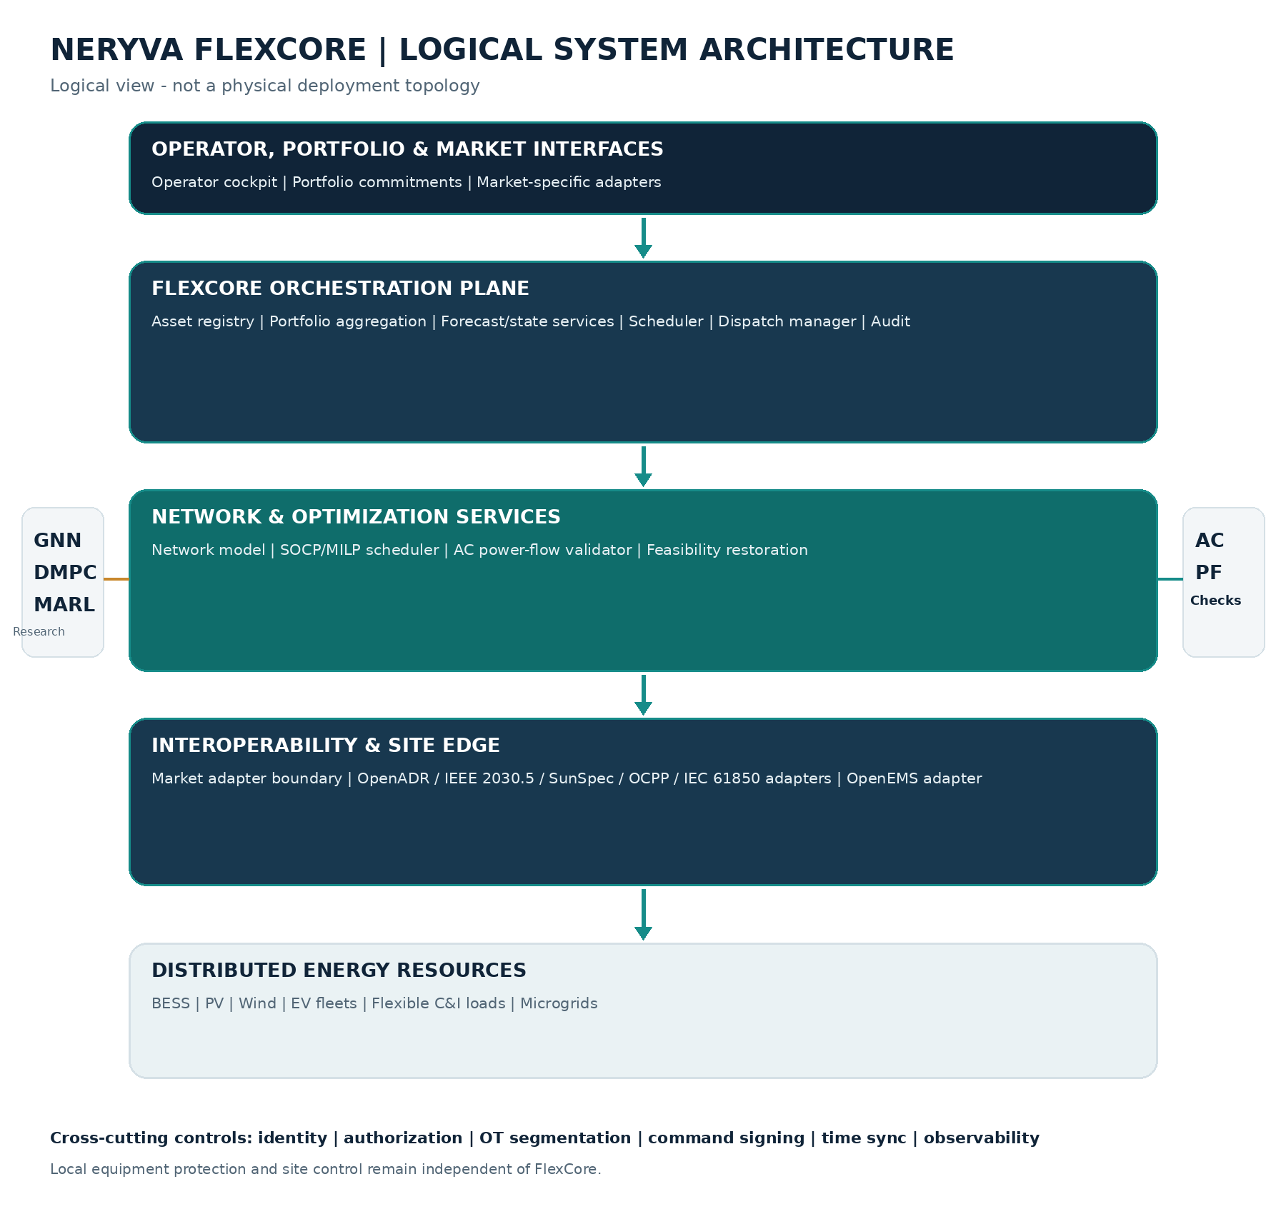
Figure 1. FlexCore logical architecture. Research services are advisory and feed the core through validated interfaces.

4.1 Deployment modes
Mode | Behaviour | Allowed writes
Simulation | All data and devices are simulated; scenarios can inject failures. | Simulator only.
Read-only integration | Real telemetry and metadata are ingested; calculations are run in advisory mode. | No device writes.
Operator-approved dispatch | Commands are proposed, validated, and require authorized human approval. | Only approved commands through commissioned adapters.
Bounded automation | Pre-approved dispatch classes can execute under a deployment-specific operating envelope. | Only explicitly authorized assets, ranges, services and time windows.

5. Component design

5.1 Asset and portfolio registry
Stores canonical identity and configuration for assets, sites, feeders, points of interconnection (POIs/PCCs), portfolios, device adapters, capability profiles, certificates, contracts, and commissioning evidence. Every configuration is versioned. A schedule or command references the exact configuration revision used.

5.2 Telemetry ingestion and state service
Accepts protocol-specific messages and converts them to canonical measurements. Each measurement carries event time, receive time, unit, quality flag, source, sequence/quality metadata, and asset/point identity. State services calculate freshness, availability, derived operating state, and data-quality indicators. Where measurement visibility and network observability are sufficient, an optional state-estimation service may estimate unmeasured states and report residuals/uncertainty; it must not label an unobservable estimate as measured truth. Out-of-order data is handled using event-time policy; duplicate events are idempotently recognized.

5.3 Forecast and availability service
Provides forecasts for PV/wind output, load, EV availability, ambient conditions, market prices, and asset outage/availability as applicable. The service records forecast issue time, valid time, horizon, model/version, source, quantiles or scenarios, and uncertainty. Forecasts are inputs, not ground truth.

5.4 Flexibility and capability aggregation
Computes feasible ranges and time-coupled constraints for individual resources and aggregates them into portfolio envelopes. Aggregation must preserve constraints that materially affect delivery: SOC coupling, ramp limits, availability windows, energy budgets, reactive capability, minimum up/down times, comfort/process limits, and network location.

5.5 Scheduling and optimization service
Builds the rolling-horizon decision problem. The deterministic baseline supports linear/MILP and convex relaxations where justified. It records all objective components, constraints, solver version, tolerances, termination reason, and resulting feasible/relaxed solution status. It does not present an approximate solution as AC-feasible until verification passes.

5.6 Network model and validation service
Maintains the approved network topology and electrical parameters, associates DERs with buses/phases and POIs, executes supported AC power-flow verification, checks voltage/thermal/transformer/PCC/DER constraints, and produces a validation report. Topology and model-data revisions are first-class inputs. AC power-flow convergence alone is not sufficient: all required limits must be explicitly checked.

5.7 Dispatch manager and command lifecycle
Creates command intents from an approved schedule, checks resource and policy bounds, applies approval, signs commands, sends through adapters, tracks acknowledgements and measured response, and handles rejection, cancellation, expiry, partial execution, and fallback. It enforces idempotency and sequence/fencing controls.

5.8 Protocol and site adapters
Adapters translate canonical FlexCore events and commands to the exact protocol profile and version supported by a deployment. Adapters are isolated from optimization logic and must expose transport-level and application-level outcomes separately.

5.9 Operator cockpit and audit
Presents fleet availability, commitments, current schedule, network constraints, exceptions, command state, data quality, solver evidence, approvals, and audit history. It must expose why a decision was accepted, limited, rejected, or superseded.

5.10 Research plugin runtime
Runs GNN, DMPC, MARL and other research components in isolated processes or jobs with versioned contracts. Plugin outputs are typed candidate artifacts. The core validates the result, checks freshness and model identity, and independently enforces constraints. A research process does not hold device credentials.

5.11 Logical control-plane and data-plane separation
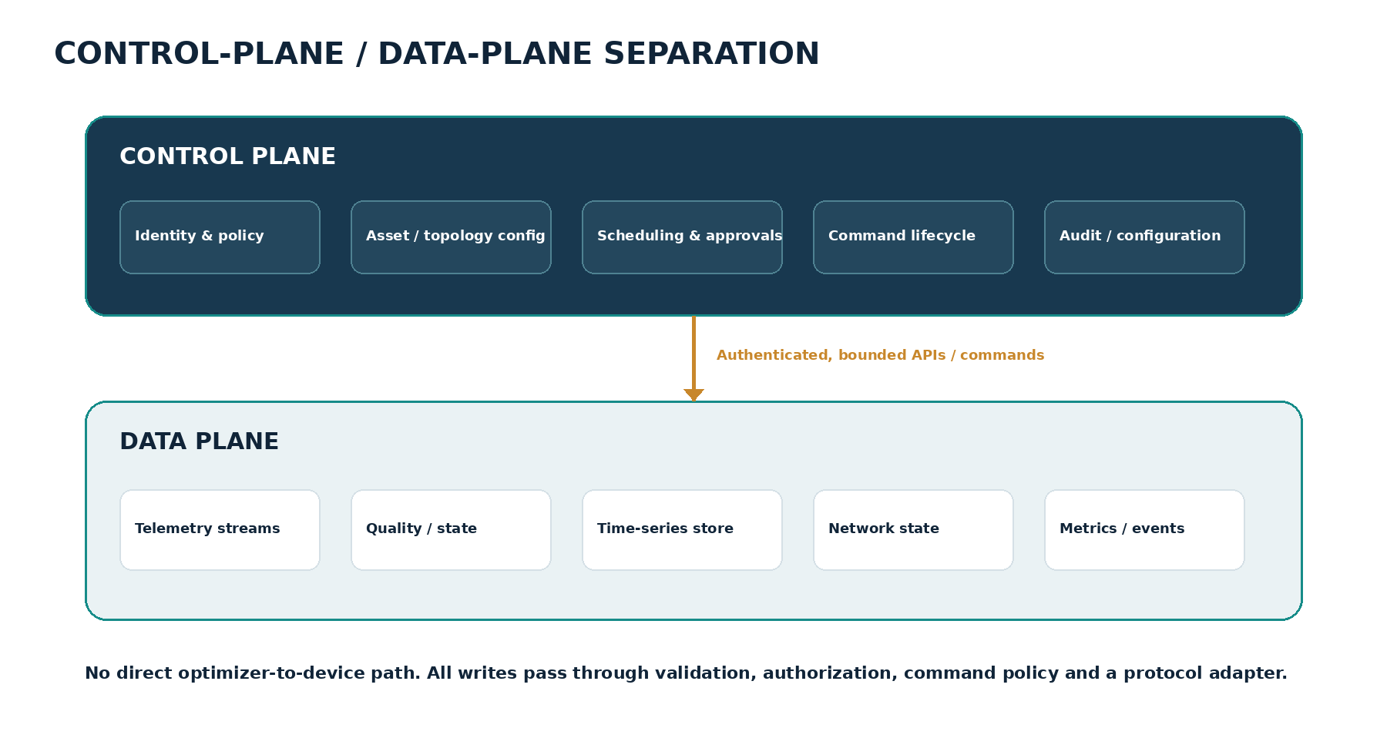
Figure 2. The control plane authorizes and governs actions; the data plane collects measurements and operational state. Device writes are mediated through the dispatch manager and adapter boundary.

6. Domain model and data contracts

6.1 Canonical entities
Entity | Key fields / relationships
Portfolio | portfolio_id, owner/operator, market area, commitment, sites, assets, operating policy.
Site | site_id, site controller, PCC, network node, timezone, local policy, communications state.
DER asset | asset_id, type, rated capability, operating envelope, location, protocol, model revision, protection/commissioning profile.
Electrical node / branch | network_id, bus/node, phase, line/transformer parameters, limits, topology version.
Measurement | asset/point, event time, receive time, value, unit, quality, source, sequence and provenance.
Forecast | target variable, issue time, valid time, horizon, scenarios/quantiles, source, model version.
Schedule | schedule_id, portfolio, horizon, resolution, asset targets, objective, solver and validation evidence.
Dispatch command | command_id, asset, target, validity interval, schedule revision, approval, signature, command state.
Execution result | acknowledgement, measured response, tracking error, timestamps, exception and final status.
Audit event | actor, action, object/revision, timestamp, reason, result, correlation ID, integrity metadata.

6.2 Units and sign conventions
MANDATORY CONVENTION
FlexCore uses SI-compatible engineering units internally and stores a unit with every external measurement. No implicit unit conversions are allowed at protocol boundaries. The convention below defines positive active power at the POI as export from the site/portfolio to the grid.

Quantity | Internal convention
Active power P | MW. Positive = injection/export to grid at the POI. Consumption is negative net injection.
Reactive power Q | MVAr. Positive/negative direction is explicitly configured to match the network model and device convention; never inferred from sign alone.
Energy E | MWh.
Voltage | kV at nominal base in network model; per-unit in solver representation.
Current | A or per-unit on explicit base.
Time | UTC epoch/time plus original timezone metadata where relevant. Simulation time is separate from wall-clock time.
State of charge | Fraction in [0,1] or percent, but one representation is selected per API and stated explicitly.

6.3 Asset capability representation
Asset models must describe more than nameplate MW. The capability contract includes operating mode, active/reactive power envelope, apparent-power rating, ramp limits, availability, duration/energy budget, state variables, minimum/maximum state, efficiency/losses, temperature or process limits where relevant, communication state, and vendor/commissioning provenance.
Asset class | Minimum model elements
Battery energy storage (BESS) | P charge/discharge limits, E capacity, SOC/E state, SOC bounds, efficiency, ramp, apparent power, Q envelope, availability, auxiliary load, warranty/degradation model where known.
Solar PV | Available P forecast, curtailment range, inverter P-Q envelope, ramp, voltage/reactive mode, irradiance/temperature provenance, availability.
Wind | Available P forecast, ramp, curtailment, Q capability and control mode, availability, turbine/farm aggregation assumptions.
EV charging fleet | Connection windows, departure energy target, charger limit, charging efficiency, bidirectional capability only where certified/configured, user/contract constraints.
Flexible C&I load | Baseline, controllable range, duration, rebound/recovery, ramp, process/comfort constraints, opt-out and availability.
Site/microgrid | PCC import/export limits, local generation/storage/load summary, islanding mode only if approved and locally controlled, site controller health.

6.4 Data quality and freshness
- Every measurement MUST carry a quality status: GOOD, SUSPECT, BAD, MISSING, ESTIMATED, or STALE (or a mapped equivalent with consistent semantics).
- Freshness limits are configurable by point type, service, protocol and operating mode. There is no universal stale timeout.
- Clock offset, event-time skew, duplicate sequence, missing intervals, impossible values, range checks and cross-sensor residuals are monitored.
- Bad or stale values are not silently replaced by zeros. Estimation/interpolation is explicit, tagged, bounded by policy, and disallowed for safety-critical authorization unless approved.
- Telemetry correction and late arrival must be append-only or versioned so historical decisions can be replayed using the data available at decision time.

7. Deterministic scheduling and network-feasibility mathematics

7.1 Formulation scope
The first deterministic scheduler is a rolling-horizon portfolio optimization model. It may use a linear/MILP or convex network approximation depending on the supported network model. The solver returns a candidate schedule. An independent nonlinear AC power-flow check evaluates the candidate at the relevant network operating point. If the check fails or the model is stale/incomplete, the candidate is not dispatchable.
The initial supported network scope should be stated explicitly for every release. A practical first benchmark is radial distribution feeders using a balanced branch-flow approximation, with a separate unbalanced three-phase validation track. Meshed transmission cases, dynamic stability, protection studies and large-scale N-1 analysis are separate capabilities.

7.2 BESS energy dynamics
Let P_ch and P_dis be nonnegative charging and discharging powers in MW, E_t be stored energy in MWh, and Δt be the interval duration in hours. The net BESS injection to the grid is P_dis - P_ch.
E(t+1) = E(t) + η_ch · P_ch(t) · Δt - [P_dis(t) / η_dis] · Δt - P_aux(t) · Δt
E_min ≤ E(t) ≤ E_max; 0 ≤ P_ch(t) ≤ P_ch_max; 0 ≤ P_dis(t) ≤ P_dis_max
If simultaneous charge/discharge is prohibited, use a binary operating-mode variable or an explicitly justified complementarity/convex-relaxation approach. With binary u(t) ∈ {0,1}:
P_ch(t) ≤ u(t) · P_ch_max; P_dis(t) ≤ [1 - u(t)] · P_dis_max
Including this binary operating decision makes the resulting problem a mixed-integer optimization problem (e.g., MISOCP if combined with a second-order cone relaxation), not a plain continuous SOCP. The timestep must be in hours and all power/energy units must be consistent. Optional self-discharge, degradation, thermal limits, auxiliary loads and reserve SOC must be added when supported by data.

7.3 Inverter P-Q capability
The apparent-power limit is a necessary but not sufficient description of an inverter capability envelope:
P(t)^2 + Q(t)^2 ≤ S_max^2
The full envelope is device- and mode-specific. Use vendor or commissioning-derived functions/polygons Q_min(P,V,mode) and Q_max(P,V,mode), active-power bounds, apparent-power rating, ramp limits and enabled control modes. Do not apply a power-factor-angle inequality that assumes P is nonnegative to a bidirectional inverter. IEEE 1547 performance requirements are interconnection requirements; they are not a universal device-level P-Q curve. Conformance testing is addressed separately by IEEE 1547.1. [R2, R3]

7.4 Other asset constraints
- PV: 0 ≤ P_PV(t) ≤ P_available(t), with curtailment represented explicitly; Q capability follows the inverter envelope.
- Wind: operating range and ramp/cut-out constraints; availability and forecast uncertainty are represented explicitly.
- EV fleets: charger availability windows, departure energy constraints, charging limits and V2X only for supported equipment and contracts.
- Flexible loads: baseline deviation, duration, rebound/recovery, comfort/process constraints and opt-out availability.
- All resources: ramp limits, minimum operating states, communication/telemetry validity, contractual availability and local operating policies.

7.5 Portfolio objective
A baseline objective may minimize the sum of energy procurement cost, resource degradation cost, load discomfort/process cost, renewable curtailment cost, commitment deviation, reserve shortfall and switching/operational costs over the scheduling horizon. Illustrative form:
min Σ_t [ C_energy(t) + C_degradation(t) + C_flex_discomfort(t) + C_curtailment(t) + C_commitment_deviation(t) + C_reserve_shortfall(t) ]
Physical limits, approved equipment envelopes, mandatory network constraints and command-policy limits are hard constraints, not merely penalties. Penalties are suitable for commercial objectives and explicitly designated soft constraints. Market interchange must be modelled at the actual POI/PCC, with consistent sign convention, losses and delivery-point mapping; it is not generally equal to a raw sum of bus injections.

7.6 Radial branch-flow SOCP relaxation
For a balanced radial feeder with branches directed from parent i to child j, let p_j and q_j denote net consumption at node j (positive for load, negative for generation). Let P_ij and Q_ij be branch flow toward child j, v_i = |V_i|² and l_ij = |I_ij|² in a consistent per-unit formulation. A simplified branch-flow model is:
P_ij = p_j + Σ_(j,k) P_jk + r_ij · l_ij
Q_ij = q_j + Σ_(j,k) Q_jk + x_ij · l_ij
v_j = v_i - 2(r_ij P_ij + x_ij Q_ij) + (r_ij² + x_ij²) · l_ij
P_ij² + Q_ij² ≤ v_i · l_ij
The final inequality is the conic relaxation of the branch-flow equality. The relaxed model may be solved as an SOCP under suitable assumptions. Exactness is not universal; it depends on topology, objective and operating constraints. The classical branch-flow literature gives specific sufficient conditions, not a blanket guarantee for all feeders. [R15]
The initial implementation must state whether it supports radial balanced networks only. Three-phase unbalanced feeders require phase-coupled models and appropriate tools; a single-phase scalar DistFlow model must not be presented as validating an unbalanced feeder.

7.7 AC power-flow verification
After the scheduler produces a candidate, freeze the candidate setpoints and update the relevant network injections. Run an AC power-flow solution using the approved network model. Check at minimum:
- Power-flow convergence and numerical status.
- Bus voltage magnitude limits for every modeled phase/bus.
- Line current/thermal limits, transformer loading and applicable emergency/normal ratings.
- Generator and inverter P-Q operating envelopes, tap/phase-shifter limits and reactive capability.
- POI/PCC import/export and transformer headroom constraints.
- Topology and network-model revision, measurement freshness and operating-state consistency.
CRITICAL DISTINCTION
AC power-flow verification is not AC-OPF, transient stability analysis, N-1 contingency analysis, protection coordination, or a formal guarantee under model uncertainty. A converged power flow can still violate voltage, thermal or equipment constraints. Each required limit must be checked explicitly.

If validation fails, FlexCore must not issue the candidate. It may re-optimize using tightened constraints, add corrective constraints/cuts, try a documented conservative schedule, or enter a deployment-specific fallback. If a validated candidate cannot be produced, the system reports no dispatch rather than assuming that the last setpoint remains safe.

7.8 SOCP relaxation diagnostics
For each branch, record the relaxation residual:
g_ij = v_i · l_ij - (P_ij² + Q_ij²) ≥ 0
A material positive gap can indicate that the conic relaxation is not tight. The acceptable normalized residual is a solver- and model-specific numerical tolerance defined in configuration and benchmark reports. This residual does not replace AC verification.

7.9 Uncertainty and reserves
The deterministic release uses explicit forecast point values plus configured reserve margins and stress scenarios. Later releases may introduce scenario-based stochastic scheduling, robust optimization or chance constraints. Probability guarantees require calibrated forecast distributions, explicit violation events, assumptions about dependence, and statistically adequate evaluation. They must not be inferred from a nominal forecast or a few simulation runs.

8. Research and advanced optimization modules
RESEARCH AUTHORITY BOUNDARY
The modules in this section are research candidates. They MUST NOT issue field commands directly. Their output is a candidate initialization, schedule, ranking or action that is independently checked by FlexCore core services.

8.1 GNN module: topology-aware OPF assistance
Purpose: improve solver initialization and screening, not replace physical equations or nonlinear verification. Candidate tasks are AC-OPF warm-start prediction, likely binding-constraint ranking, topology-change screening and contingency prioritization.
Interface | Definition
Input | Versioned graph: buses/nodes, branches, phase/topology, impedances, ratings, injections, generator/DER bounds, operating state and model revision.
Output | Candidate primal initialization and/or ranked constraint/contingency candidates, with model version, uncertainty/confidence and input fingerprint.
Baseline | Same nonlinear solver and same scenario without GNN initialization; additionally compare DC/linear/SOCP initialization where appropriate.
Acceptance metrics | End-to-end feasible solve time, convergence rate, constraint residual, objective gap, performance on unseen topology/operating regimes, calibration and failure rate.
Failure behaviour | Ignore stale/mismatched or low-confidence output; run the deterministic baseline. Never bypass solver or AC validation.

The neural model may be trained to predict a feasible-region candidate, but its output is not presumed feasible. The solver must still solve or verify the relevant constrained optimization problem. A solver initialization accelerator is evaluated on total end-to-end runtime, not neural inference latency alone.

8.2 DMPC / ADMM module: distributed portfolio coordination
Purpose: coordinate local sites or stakeholders that have local private constraints but share a feeder, substation, POI, reserve or market coupling constraint. Do not force independent sites to agree on identical power setpoints. They need to satisfy shared coupling constraints.
minimize Σ_k f_k(x_k) + g(z)
subject to Σ_k A_k x_k - z = 0; x_k ∈ X_k; z ∈ Z
A standard two-block ADMM formulation can use local x_k updates, a shared z update and dual-variable updates. Exact update form depends on the coupling structure. The common consensus update based on a simple average is valid only for a suitable consensus formulation, not for every feeder constraint.
Classical ADMM theory provides convergence results under convexity and related assumptions. For nonconvex AC-OPF or arbitrary nonconvex device constraints, convergence to a global optimum is not generally guaranteed. FlexCore must report primal/dual residuals, objective gap against a centralized benchmark, iteration count, runtime, communication failures and fallback behaviour. On non-convergence or communication partition, use the agreed centralized/locally safe operating policy rather than issuing incomplete consensus output. [R20]

8.3 MARL module: shadow-mode fleet coordination
Purpose: research adaptive coordination of heterogeneous flexible DER fleets where explicit optimization models may be expensive or incomplete. Initial setup is centralized training with decentralized execution (CTDE), with policy outputs represented as candidate changes to a deterministic schedule.
Element | Design
State | Resource availability, SOC/energy, local P/Q, forecasts, commitment, topology/constraint state and communication quality.
Action | Candidate change in active/reactive setpoint or resource allocation within a defined action space.
Reward | Commercial objective, tracking performance, degradation/discomfort, curtailment and constraint risk. Reward does not replace explicit constraints.
Safety layer | Independent capability, policy and network validation. A CBF may be evaluated only where a suitable dynamic model, relative-degree assumptions and discrete-time treatment are established.
Mode | Offline simulation, then shadow comparison only. No operational command authority in this release.
Metrics | Constraint violations, baseline regret, tracking performance, robustness under distribution shift, action smoothness, compute budget, uncertainty and fallback rate.

A generic vector inequality for a control barrier function is not a complete safety proof. For each scalar barrier h_j and a justified continuous-time control-affine model, a relative-degree-one condition has the form L_f h_j(x) + L_g h_j(x)u ≥ -α_j(h_j(x)). Power-network voltage and branch-current constraints often depend on algebraic network equations and hybrid equipment modes, so the state model, sensitivities, sampling, uncertainty and infeasibility handling must be explicitly derived. Safe RL is a research topic with unresolved deployment challenges in power systems. [R16]

8.4 Optional LLM/agent integration
LLM capabilities may support operator search, explanation of schedules, retrieval of approved manuals, summarization of market/utility documents, and generation of draft analysis reports. If a project such as Harvard SEAS PowerAgent/PowerMCP is evaluated, treat it as an external open-source ecosystem and optional tool interface. Review its current API, licence, supported engines and maintenance state. Do not imply Harvard endorsement or affiliation. The LLM must not receive direct device credentials or bypass deterministic command authorization. [R17]

9. Command lifecycle and runtime assurance
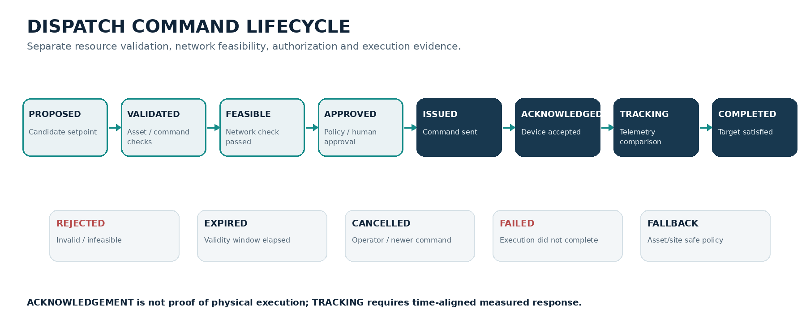
Figure 3. Command lifecycle. The acknowledgement and measured-response stages are deliberately separate.

9.1 State definitions
State | Entry condition and invariant
PROPOSED | A scheduler, approved operator or permitted service creates a candidate target. Includes asset, target, effective time, expiry, duration, source and model/schedule revision.
VALIDATED | Schema, units, asset identity, freshness, capability, ramp, SOC/energy, availability and policy checks pass.
FEASIBLE | Relevant network validation passes for the stated model revision and operating point, including all configured hard limits.
APPROVED | Required human/policy approval is recorded. Approval is separate from physical feasibility.
ISSUED | Command is signed and sent via the correct adapter with idempotency and sequence controls.
ACKNOWLEDGED | Application-level device/gateway acceptance is received. Transport receipt alone is insufficient.
TRACKING | Time-aligned telemetry is compared with command target and expected response.
COMPLETED | Defined tracking tolerance and completion condition are satisfied for the required duration.
REJECTED | A validation, feasibility or authorization gate fails.
EXPIRED | The command validity window ends before execution/acceptance.
CANCELLED / SUPERSEDED | An authorized cancellation or newer schedule revision invalidates the prior command.
FAILED | Execution, communications, acknowledgement or tracking failed.
FALLBACK | Deployment-specific safe policy is invoked by the site/asset owner or adapter workflow.

9.2 Command invariants
- Every command has a globally unique command_id, idempotency key, asset_id, target timestamp, validity interval, duration, sequence/version, schedule revision, reason and actor/service identity.
- P and Q target units and positive directions are explicit. No protocol adapter may silently reverse the canonical convention.
- Commands are time-bounded and replay-resistant. Expired, duplicate, out-of-order or stale commands are rejected or safely deduplicated.
- Only the dispatch manager may call a writable adapter. Schedulers, research plugins, LLMs and dashboards have no direct write path.
- Application-level acknowledgement, device execution and measured physical response are different evidence types.
- Partial fleet success is represented per asset. A portfolio-level ACK is not assumed from the first responding device.
- Authorization records the operator/policy, scope, approved limits, expiry and supporting validation report.
- Fallback is asset/site specific and is not assumed to be zero power or the last setpoint. Local protection and control remain authoritative.

9.3 Network validation and restoration
If the candidate fails AC power-flow verification, FlexCore blocks dispatch. Permitted responses include re-optimization with tightened limits, explicit corrective constraints, reduced portfolio commitment, an alternate schedule, or a no-dispatch outcome. A power-flow failure must not trigger an automatic return to a prior setpoint without re-evaluating that setpoint against current topology, telemetry and operating state.

9.4 Timing and acknowledgement policy
Timeouts are service-specific and configurable. They must be derived from the relevant market response time, protocol profile, network path, device behaviour, local site controller and service requirements. A generic 2-second acknowledgement timeout is not a universal rule. Each adapter publishes its transport, application acknowledgement and measured-response semantics.

10. Interoperability and market integration

10.1 Protocol and standard roles
Standard / project | Role in FlexCore | Important boundary
FERC Order 2222 | US regulatory framework for DER aggregation participation in organized wholesale markets. | Not a protocol or a single gateway. Tariff and RTO/ISO-specific rules govern eligibility, telemetry, metering, locational requirements, coordination and settlement. Outside-US deployments require local rules.
OpenADR 2.0 / 3.0 | Demand-response programme event and reporting communication (VTN/VEN roles). | Not a universal wholesale market bid/dispatch API. Implement only the profile and role required by the programme.
IEEE 2030.5 / CSIP | DER communication and smart-inverter control profile in applicable regions. | Profile-specific interoperability; certification and utility requirements remain deployment-specific.
IEEE 1547 / 1547.1 | DER interconnection/performance requirements and conformance test procedures. | 1547 is not an application protocol or battery BMS protection standard.
SunSpec Modbus | Common DER/inverter monitoring and control data models over supported Modbus transport. | Device model, register map, read/write permissions and secure OT network design must be validated per OEM.
OCPP 1.6 / 2.0.1 / 2.1 | EV charging station to charging-management system communication. | 2.1 adds ISO 15118-20, bidirectional charging/V2X and DER-related functionality. Deployed support varies by charger and CPO; version negotiation/adapters are required.
IEC 61850 | Substation automation and IED information exchange. | Not assumed for every DER device; engineering, data models, profiles and utility integration are deployment-specific. [R21]
OpenEMS | Site-level EMS / edge controller integration. | OpenEMS may execute local site control; FlexCore sends bounded schedules/capability requests and respects its local controller priority and timing.
HELICS | Co-simulation federation and time coordination. | Simulation integration only; not a field device protocol.

The references include official descriptions of these standards and projects. OpenADR defines VTN/VEN roles and provides separate 2.0 and 3.0 specifications [R4]. CUPID is an LF Energy open-source IEEE 2030.5 interoperability toolkit currently listed as Sandbox [R5]. OCPP 2.1 was released in 2025 and supports bidirectional/V2X functionality [R6].

10.2 Market adapter architecture
Create a market adapter per market operator/region and version. The adapter handles the external market data model, authentication, schedule/bid submission, dispatch notices, telemetry/reporting and settlement-related records as actually specified by the operator. A canonical internal commitment/dispatch model separates core scheduling from market-specific formats. Do not infer that OpenADR covers all of these functions.

10.3 Southbound device/site adapter architecture
Device and site adapters must declare supported protocol version, data models, measurement semantics, control functions, maximum update rates, acknowledgement semantics, command limits, certificate requirements and failure modes. Where OpenEMS is the site controller, use its supported integration interface and respect its controller priority system. Its documentation describes periodic controller cycles (typically one second) and a local scheduler that constrains external setpoints [R7]. This does not make OpenEMS a universal sub-second frequency-control system.

10.4 Interoperability conformance
- Maintain protocol-specific conformance fixtures and versioned test profiles.
- Test malformed, duplicate, delayed, replayed, unauthorized and partially acknowledged messages.
- Validate device-side capability mapping during commissioning; do not infer the same capability from a shared protocol alone.
- Keep market, device and site identifiers mapped through a reviewed asset identity registry.
- Record protocol version and adapter build in every dispatch and audit record.
- Do not claim certified interoperability until the relevant certification/utility test process has been completed.

11. Simulation, co-simulation and benchmark design
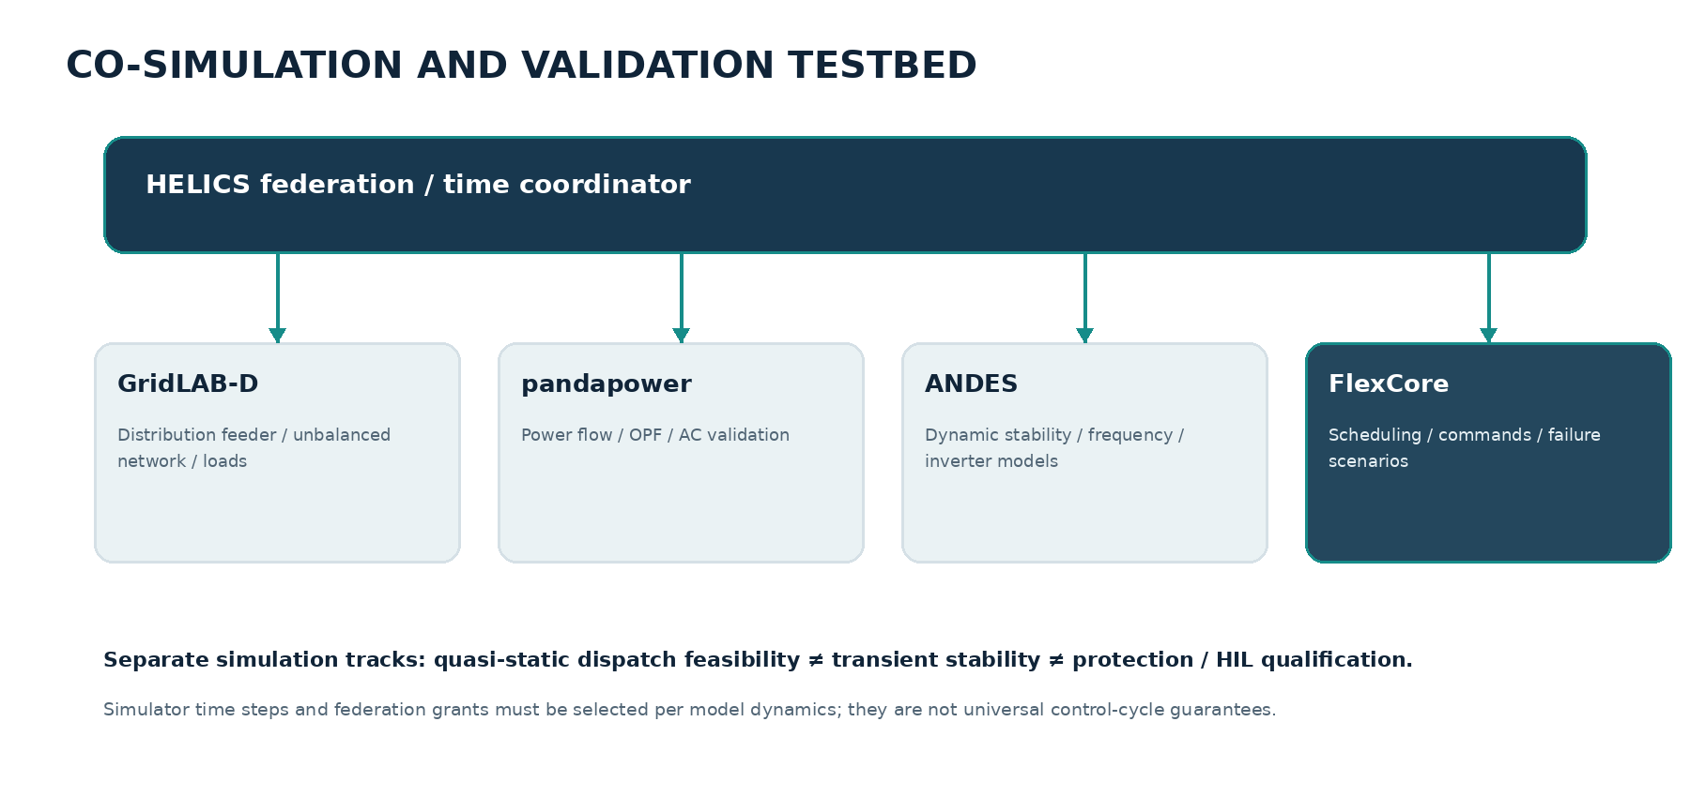
Figure 4. Proposed co-simulation federation. Each simulator is used for the physical phenomena it supports.

11.1 Simulator responsibilities
Tool | Use | Limit / caution
pandapower | AC/DC power flow, balanced and three-phase power flow, OPF and network diagnostics. | Static power flow does not establish transient stability or protection behaviour. [R8]
GridLAB-D | Distribution feeder and end-use/load modelling, distribution power flow and time-series simulation. | Choose appropriate solver/mode and timestep; quasi-static results are not a transient stability proof. [R9]
PyPSA | System-level planning and multi-period linear optimization of generation, storage and networks. | Use for appropriate planning/linear network tasks; do not assume its linear OPF is a full nonlinear AC-OPF validator. [R10]
HELICS | Federation coordination, event exchange and simulation-time synchronization. | Time grants and message timing must match each federate's modelling assumptions. [R11]
ANDES | Power-system power flow, transient stability/time-domain simulation, eigenvalue analysis and dynamic models. | Use for dynamic/frequency research, not as a replacement for device HIL or protection certification. [R12]
MATPOWER cases | Transmission-network benchmark cases such as case39/case118 where provenance and assumptions are documented. | Benchmark cases are not live utility models. Document modifications and data source. [R18]

11.2 Benchmark network families
Initial benchmark coverage should include distribution networks of increasing complexity, at least one unbalanced three-phase feeder, and transmission-network cases for research requiring transmission context. Candidate cases include IEEE 13-, 34- and 123-node distribution feeders and MATPOWER case39/case118. Each case must record provenance, topology, phase configuration, base values, solver assumptions, license/redistribution status and any modifications.

11.3 Scenario matrix
Scenario family | Perturbations | Primary evaluation
Normal operation | Typical load, DER availability, forecast and market profile. | Schedule quality, tracking, compute time.
High DER penetration | Reverse flows, voltage rise, reactive limits, curtailment. | Voltage/thermal constraints, usable flexibility.
Resource outage | Battery, PV, wind, EV fleet or C&I resource unavailable. | Rescheduling, commitment shortfall and fallback.
Network contingency | Branch/transformer limit change, topology switch or feeder constraint. | Revalidation, corrective schedule, blocked unsafe command.
Forecast error | Solar/load forecast bias, ramp events, correlated errors. | Robustness, reserve sufficiency and constraint violations.
Telemetry/data quality | Missing, stale, delayed, duplicate, noisy or spoof-like measurement. | Data-quality detection, degraded mode, no unsafe dispatch.
Communication fault | Latency, packet loss, partition, retry, replay, delayed ACK. | Command state correctness, idempotency and fallback.
Market/commitment event | Updated target, price, event or overlapping service. | Commitment feasibility, conflict and audit.
Dynamic stability | Inverter controls, low-inertia models, disturbances and frequency response. | Frequency/voltage dynamic response using dynamic simulator.

11.4 HELICS federation timing
HELICS coordinates simulation-time requests and message exchange between federates. It does not define a universal 100 ms or 1 s engineering cadence. Each federate uses its own valid integration step and advertises/publishes at appropriate synchronization points. The test plan records time-step, event ordering, latency model, synchronization configuration and coupling assumptions. [R11]

11.5 Dynamic studies and HIL boundary
Static AC power-flow validation, time-series distribution simulation, transient stability, electromagnetic transient studies, protection tests and hardware-in-the-loop are distinct validation activities. A dispatch benchmark using pandapower or GridLAB-D cannot substantiate claims about synthetic inertia, fast frequency response, grid-forming inverter dynamics or relay behaviour. Such claims require dynamic models and, before hardware/field claims, appropriate HIL and equipment testing. ANDES is a candidate open-source tool for time-domain and small-signal power-system analysis [R12].

12. Cybersecurity, safety and operational resilience

12.1 Security objectives
- Prevent unauthorized, malformed, replayed or stale commands from reaching a device/site adapter.
- Protect availability and integrity of telemetry, asset configuration, schedules, network models and audit evidence.
- Separate enterprise IT services, FlexCore control services, site OT networks and device networks using deployment-specific segmentation.
- Protect device and service identities, private keys, credentials, configuration, model artifacts and software supply chain.
- Preserve local protection, site autonomy and safe operation during cloud outage, network partition or control-plane failure.

12.2 Threat model
Threat | Example | Required mitigations
Unauthorized command | Compromised user or service issues a setpoint. | Strong identity, RBAC/ABAC, dual approval for sensitive actions, asset/portfolio scope, command signing and audit.
Replay / duplicate | Old command retransmitted or duplicated after retry. | Validity window, unique command ID, monotonic sequence/fencing token, idempotent adapter handling.
Telemetry manipulation | Forged or delayed telemetry changes state estimate or available capacity. | Mutual authentication, source identity, sequence/time checks, quality flags, cross-checks, plausibility and residual monitoring.
Credential compromise | Protocol credential or device key exposed. | Secret manager, certificate lifecycle, rotation, least privilege, no secrets in logs, revocation process.
Lateral movement | Compromised enterprise service reaches OT network. | Network segmentation, brokered gateways, allowlists, egress control, jump hosts, monitoring and deployment-specific OT security architecture.
Supply-chain attack | Compromised library, container, model or build pipeline. | Pinned dependencies, SBOM, signed artifacts, scanning, reproducible builds, review and controlled release.
LLM/tool misuse | Prompt injection or hallucination produces unsafe operational instruction. | LLM is advisory; schema/allowlist tool access; human review; deterministic validation; no direct device credentials.
Availability attack | Broker, API, DNS, time source or cloud service unavailable. | Local fallback, redundant services, bounded retries, durable queue, recovery tests and site autonomy.

12.3 Identity and access control
- Use mutually authenticated service-to-service channels for control-plane and adapter traffic where supported.
- Use human identity federation and MFA for operator access; privileged operations require stronger authorization.
- Enforce role- and attribute-based policy at portfolio, site, asset, command type, operating mode and time-window levels.
- Separate read telemetry, schedule proposal, approval, command issue, configuration administration and security administration permissions.
- Use dedicated workload identities and short-lived credentials where possible. Rotate and revoke device certificates and keys.
- Use signed command envelopes and verify signature, issuer, target, expiry, sequence and policy scope at the adapter/edge boundary.

12.4 OT segmentation and control boundary
FlexCore should be deployed outside the most critical local protection/control boundary. A site gateway mediates approved commands to local EMS/device networks. The edge/site system retains local constraints and fallback. Remote connectivity must not create a direct unrestricted path from an LLM, research plugin, public API or enterprise database to device control.

12.5 Security framework and compliance claims
Use NIST SP 800-82 Rev. 3 as an OT security baseline and the ISA/IEC 62443 family as a lifecycle and risk-based industrial-control security framework. NIST published an initial public draft of SP 800-82 Rev. 4 on 21 September 2026; as of the date of this document, it is a draft for comment, not a finalized replacement. [R13, R14] NERC CIP applicability depends on the relevant Bulk Electric System assets, entity registration and jurisdiction; it must not be claimed merely because software is used in energy operations. [R19]
A future customer deployment must perform a threat/risk assessment, zoning/conduit design, system categorization, access-control review, vulnerability/patch process, incident response, recovery test and supplier assessment. This document does not certify FlexCore against any cybersecurity standard.

12.6 Safety and operational assurance
The physical protection layer is independent and authoritative. FlexCore can limit requests and enforce software policy, but it cannot replace certified relay protection, BMS cell limits, inverter protection, emergency stop, local interlocks or utility-approved control functions. Asset-specific fallback behaviour must be agreed with the asset owner/OEM and validated during commissioning.

13. Deployment, observability and operations

13.1 Logical deployment zones
Zone | Services | Trust boundary
Enterprise access zone | Operator UI, API gateway, identity federation, reporting. | User-facing zone; no direct device access.
Control application zone | Asset registry, scheduling, dispatch manager, policy, audit. | Restricted services; commands require policy and validation.
Data zone | Telemetry broker, time-series data, metadata DB, object store. | Authenticated producers/consumers; integrity and retention controls.
Research/simulation zone | GNN/DMPC/MARL jobs, simulators, notebooks, evaluation. | No production credentials or direct OT connectivity.
Integration/DMZ zone | Market adapters, site gateways, protocol proxies. | Strict allowlists, mTLS, rate limits, command policy and monitoring.
Site OT zone | EMS, inverter, BMS, EVSE and industrial controller networks. | Owned by site/asset operator; local safety and protection authoritative.

13.2 Initial software architecture
Start with a modular codebase and explicit service boundaries rather than creating a large microservice fleet before requirements are measured. Keep protocol adapters, optimizer, network validator, telemetry, command manager and audit as independently testable modules. Introduce process/service separation when deployment, scale, fault isolation or language/toolchain requirements justify it.
Technology area | Candidate implementation | Decision guidance
Domain/core contracts | Rust types plus JSON Schema/Protobuf at external boundaries. | Use exact units, explicit enums, compatibility tests and schema versioning.
Optimization and simulation | Python ecosystem: pandapower, PyPSA, Pyomo/CVXPY and selected solvers. | Keep numerical engine behind versioned API; capture solver versions and tolerances.
Control services | Rust or a service framework selected by measured latency/reliability needs. | Start modular; avoid splitting research services prematurely.
Event transport | NATS JetStream, Kafka or equivalent durable message transport. | Choose after throughput, ordering, retention and operations requirements are quantified.
Metadata and audit | PostgreSQL or equivalent transactional store. | Transactional command state and append-only audit event model; retention and integrity policy.
Telemetry storage | Time-series database or partitioned analytical store. | Select based on sample volume, query pattern, retention and site count.
Scenario artifacts | Object storage for network models, forecasts, scenarios, reports and model artifacts. | Versioned, content-addressed and tied to run metadata.
Deployment | Docker Compose for local research; orchestrated deployment when needed. | Production high availability and OT segmentation must be designed for the target site.

13.3 State durability and high availability
- Persist schedule revisions, command state transitions, approvals, adapter outcomes and audit events before acknowledging durable acceptance.
- Use idempotent writes, outbox/inbox patterns or equivalent mechanisms to avoid lost or duplicate command events across DB/broker boundaries.
- Use leader leases/fencing tokens for active dispatch ownership; prevent split-brain controllers from issuing competing setpoints.
- Define recovery-point and recovery-time objectives with the operator; do not invent generic targets.
- On loss of central service, the site controller and device protection continue local operation. FlexCore suspends or bounds new dispatch according to the approved policy.
- Exercise failover, backup restoration, certificate rotation and communications partition scenarios in tests.

13.4 Observability
Signal | Examples
Operational metrics | Portfolio available MW/MVAr, committed vs available flexibility, schedule quality, command latency, tracking error.
Network metrics | Voltage range, line/transformer loading, constraint margins, model revision, validation failures.
Data quality | Freshness, missing interval, source, bad-data score, clock skew, out-of-order and duplicate counts.
Optimization metrics | Solver status, runtime, objective, gap, residuals, constraint slack, failed/rejected schedule count.
Command metrics | State age, issue/ack latency, partial fleet response, stale/duplicate rejection, fallback and cancellation.
Security metrics | Authentication failures, policy denials, signature failures, privileged changes, certificate expiry and adapter anomalies.

14. API and event contract examples
The following examples are illustrative contracts. They define the semantics to preserve, not a finalized OpenAPI document. Exact field naming, schema versioning and protocol payloads are implementation decisions subject to compatibility review.

14.1 Canonical telemetry event
{
"schema_version": "1.0",
"event_id": "evt-uuid",
"asset_id": "bess-site-a-01",
"point_id": "active_power",
"event_time": "2026-11-04T09:15:00Z",
"received_at": "2026-11-04T09:15:01.120Z",
"value": 2.4,
"unit": "MW",
"quality": "GOOD",
"source": {
"adapter": "openems-site-adapter",
"protocol": "site-api",
"protocol_version": "configured-version",
"device_sequence": 884120
},
"network_revision": "feeder-model-2026-11-04-r12"
}
Event time is the time the measurement represents; received_at is ingestion time. A quality flag and source provenance are mandatory. Event identity and device sequence support deduplication and ordering.

14.2 Candidate dispatch command
{
"schema_version": "1.0",
"command_id": "cmd-uuid",
"idempotency_key": "portfolio-42:asset-7:schedule-18:slot-37",
"asset_id": "bess-site-a-01",
"portfolio_id": "vpp-portfolio-42",
"target": {
"active_power_mw": 2.4,
"reactive_power_mvar": 0.15,
"positive_active_power": "export_to_grid"
},
"effective_from": "2026-11-04T09:15:00Z",
"expires_at": "2026-11-04T09:20:00Z",
"duration_seconds": 300,
"schedule_revision": "schedule-18",
"asset_config_revision": "asset-config-7-r4",
"network_revision": "feeder-model-r12",
"source": "deterministic-scheduler",
"reason": "approved-portfolio-dispatch",
"approval_reference": "approval-uuid",
"sequence": 991,
"signature_reference": "kms-key-version-reference"
}
The signature is generated and verified by the command security component; private key material is not embedded in the payload. The target is a proposed command until all gates pass. No example implies that this command is supported by every device or protocol.

14.3 Minimum API groups
API group | Representative operations
Assets | Create/update asset, configure capability, associate site/network node, retrieve configuration revision.
Telemetry | Ingest event, query current state, query history, retrieve quality/freshness.
Forecasts | Publish forecast, retrieve forecast by valid time and issue time, compare revisions.
Portfolios | Create portfolio, assign assets, set commitments, calculate flexibility envelope.
Schedules | Create schedule request, retrieve candidate, validate, approve, supersede, compare runs.
Network | Import/update network model, topology revision, run power flow, validate candidate, inspect constraints.
Dispatch | Propose, validate, authorize, issue, acknowledge, track, cancel, expire, fallback and query audit.
Research | Submit benchmark job, retrieve model/run metadata, compare baseline and candidate; no write authority.

15. Verification and acceptance criteria

15.1 Test layers
Layer | Required evidence
Unit | Sign conventions, unit conversion, asset envelopes, SOC dynamics, command states, idempotency, policy checks.
Property-based | Randomized valid/invalid assets, limits, state transitions, timestamps, schedule boundaries and serialization.
Solver regression | Frozen cases, expected objective/feasibility envelopes, solver version and tolerances.
Network integration | AC power flow with explicit voltage, current, transformer, PCC and generator/inverter checks.
Protocol conformance | Versioned test vectors, malformed payloads, protocol ACK/error, security and device capability mapping.
Fault injection | Stale/missing telemetry, message delay/loss, duplicates, out-of-order events, partition, broker failover and clock skew.
Co-simulation | Time synchronization, boundary consistency, scenario reproducibility and numerical stability.
Security | Threat-based tests, RBAC/ABAC, mTLS, certificate rotation, replay, signing, secrets and supply-chain checks.
HIL / field acceptance | Separate commissioning plan with OEM, utility, asset owner, protection, cyber and operating acceptance. Not part of initial simulation release.

15.2 Release gates
Gate | Acceptance condition
Data contract gate | All critical values have units, sign direction, timestamp semantics, quality and provenance. Invalid/stale data cannot silently pass.
Asset model gate | Capability boundary tests pass at and around each configured limit; SOC/energy and ramp constraints are time-consistent.
Optimization gate | Solver status, objective, infeasibility and relaxation residuals are recorded. Every candidate dispatch receives the required independent checks.
Network gate | No command is issued when the AC validation fails, is stale, incomplete, non-convergent or violates a configured hard limit.
Lifecycle gate | Duplicate, replayed, expired, out-of-order and unauthorized commands are handled idempotently and audibly.
Fault gate | Network partition, delayed telemetry and partial acknowledgement trigger defined degraded/fallback paths; local controllers remain functional.
Research gate | GNN/ADMM/MARL results are benchmarked against the deterministic baseline, versioned and isolated from command authority.
Deployment gate | Target-specific security, operations, hardware, market, regulatory and commissioning reviews are complete before enabling field writes.

15.3 Avoid arbitrary performance claims
Do not hard-code claims such as “100% safe across 1,000 random scenarios”, “ADMM converges within 30 iterations”, “GNN gives 5× speedup”, or “fallback always occurs within 2 seconds” before baselines and service requirements exist. These can become measured acceptance targets for a defined scenario suite. Report sample size, topology, scenario generator, hardware, solver/configuration, tolerance, observed failures and uncertainty. Zero observed failures in a finite test suite is evidence about that suite, not a universal safety proof.

16. Implementation roadmap
Phase | Deliverable | Exit evidence / dependency
0. Domain and requirements baseline | Canonical terminology, sign/unit conventions, asset and network scope, operating use cases, threat model, interface contracts. | Reviewed by power-systems and software engineering; no unresolved sign/unit ambiguity.
1. Simulation-first data foundation | Asset registry, capability model, telemetry schema, quality/freshness processing, topology versioning, scenario replay. | Contract/unit/property tests pass; repeatable synthetic feeder + asset scenarios.
2. Deterministic portfolio scheduler | BESS/PV/EV/C&I constraints, rolling-horizon scheduling, market commitment and PCC tracking. | Reproducible solver baselines and objective/constraint reports.
3. Network feasibility and dispatch assurance | AC validation, constraint report, command lifecycle, authorization, signing, audit, failure handling. | No candidate is issued when validation fails; replay/duplicate/stale command tests pass.
4. Co-simulation and protocol adapters | HELICS federation, distribution model, site/edge adapter, selected OpenADR/2030.5/OCPP/SunSpec profiles. | End-to-end simulation tests with correct protocol semantics and adapter conformance fixtures.
5. Distributed coordination | DMPC/ADMM workers with shared-constraint formulation and centralized fallback. | Convergence/residual and objective comparison against centralized baseline; communication-failure tests.
6. GNN research | Topology representation, OPF warm-start and contingency ranking. | Held-out topology tests; end-to-end validated runtime benefit without feasibility loss.
7. MARL research | CTDE fleet policy in offline simulator and shadow evaluator. | Comparative evaluation, distribution shift and failure testing; no field command authority.
8. HIL and controlled pilot readiness | Hardware integration, commissioning evidence, cyber/safety and market/utility acceptance. | Independent target-specific sign-off. Not implied by completion of software phases 1–7.

16.1 First public release definition
The first public FlexCore release should be a simulation-first VPP orchestration demonstrator with canonical asset/telemetry models, a deterministic multi-period scheduler, network-feasibility validation for a clearly bounded network class, command-state simulation, reproducible scenarios, tests, documentation and an operator view. It should not claim utility certification, market qualification, real-time autonomous grid control or validated synthetic-inertia delivery.

17. Risks, assumptions and unresolved decisions
Risk / decision | Why it matters | Required resolution
Initial target customer and jurisdiction | Market, telemetry, device and regulatory integration are region-specific. | Select one initial VPP/aggregator use case and jurisdiction before market adapter design.
Distribution network scope | Balanced radial, unbalanced radial and meshed systems require different models/solvers. | Define exact supported topology/phase class for each release.
DER asset focus | BESS, PV, EV and C&I loads have very different temporal and operational constraints. | Choose a first portfolio composition and capability contract.
Market participation model | Order 2222 and each RTO tariff impose market-specific requirements. | Map one operator's accepted tariff, roles, telemetry and settlement obligations.
Protocol profiles and certification | A protocol implementation does not imply device or utility certification. | Identify target utility/OEM profiles and conformance tests.
Network model ownership/quality | Incorrect impedance, topology, phase and ratings can invalidate a result. | Define model provenance, validation and update process with network owner.
AC validation fidelity | Static power flow cannot cover dynamic response/protection. | Separate static, dynamic, EMT/protection and HIL evidence.
Nonconvex optimization | SOCP exactness and ADMM convergence are conditional. | Record assumptions; use independent verification and fallback.
Cybersecurity and OT acceptance | Remote write control creates material cyber/operational risk. | Complete deployment-specific risk assessment, zones/conduits and certification/contract reviews.
Open-source licensing | Third-party protocols, data, models and dependencies have distinct licences/terms. | Perform licence and redistribution audit before release.
Research scope creep | GNN, DMPC and MARL could overwhelm the core product. | Keep advanced methods as optional modules with measurable hypotheses and gates.

17.1 Assumptions in this baseline
- Initial development is simulation-first and does not connect to live device control.
- The first deterministic scheduler supports a bounded set of asset types and network models; universal grid coverage is not assumed.
- Network models and asset capability data are supplied by the operator/integrator and require provenance and validation.
- Market adapter requirements will be selected after a jurisdiction and market operator are chosen.
- Open-source release scope and licence will be finalized after reviewing third-party dependencies and data rights.
- GNN, DMPC and MARL are optional research modules, not release blockers for the first working deterministic baseline.

17.2 Decisions required before implementation sprint
- Choose initial operating jurisdiction and target operator type (aggregator, microgrid operator, utility/DSO pilot, or market participant).
- Choose first portfolio composition and operational service (e.g., energy shifting, peak management, distribution flexibility, reserve or demand response).
- Choose initial network class and simulation toolchain for the first release.
- Finalize canonical sign conventions, base units, time resolution and quality semantics.
- Choose code licence, contribution policy, security disclosure process and third-party licence policy.
- Approve a hazard analysis and target deployment threat model before any field write feature is enabled.

18. Glossary
Term | Definition
AC-OPF | Alternating-current optimal power flow; a constrained optimization problem using nonlinear AC network equations.
AC power flow | Nonlinear steady-state network calculation for specified injections and controls; not itself an optimization or transient stability study.
ADMM | Alternating Direction Method of Multipliers; a distributed optimization method with standard convergence results under convex assumptions.
ADMS | Advanced Distribution Management System.
BESS | Battery Energy Storage System.
CBF | Control Barrier Function; a method for expressing forward-invariance conditions under stated model assumptions.
DER | Distributed Energy Resource.
DERMS | Distributed Energy Resource Management System.
DMPC | Distributed Model Predictive Control.
DSO | Distribution System Operator.
HELICS | Hierarchical Engine for Large-scale Infrastructure Co-Simulation.
HIL | Hardware-in-the-loop testing.
ISO/RTO | Independent System Operator / Regional Transmission Organization.
MARL | Multi-Agent Reinforcement Learning.
MISOCP | Mixed-Integer Second-Order Cone Program.
MPC | Model Predictive Control.
OT | Operational Technology.
PCC / POI | Point of Common Coupling / Point of Interconnection.
P-Q capability | Feasible active/reactive power operating envelope of a DER/inverter.
SOC | State of Charge.
SOCP | Second-Order Cone Program.
TSO | Transmission System Operator.
VPP | Virtual Power Plant.
VTN / VEN | Virtual Top Node / Virtual End Node in OpenADR.

19. References and external standards
The following public references support the design boundaries and tool selections. Standards and market tariffs are subject to revision. Implementers must verify the exact edition, profile, amendment, jurisdiction and customer requirements at design and commissioning time. Accessed 04 November 2026 unless a publication date is shown.
[1] Federal Energy Regulatory Commission, FERC Order No. 2222 Fact Sheet.. https://www.ferc.gov/media/ferc-order-no-2222-fact-sheet DER aggregation framework; locational, metering, telemetry and coordination considerations.
[2] IEEE Standards Committee 21, IEEE Std 1547-2018 overview.. https://sagroups.ieee.org/scc21/standards/1547rev/ DER interconnection and interoperability performance requirements.
[3] IEEE Standards Committee 21, IEEE Std 1547.1-2020 overview.. https://sagroups.ieee.org/scc21/standards/standards-1547-1/ Conformance test procedures for DER interconnection and interoperability.
[4] OpenADR Alliance, OpenADR 3.0 Introduction and Certification Program.. https://www.openadr.org/openadr-3-0 Normative OpenADR 3 API/specification and its role relative to 2.0a/b.
[5] LF Energy, CUPID project.. https://lfenergy.org/projects/cupid/ Open-source IEEE 2030.5 interoperability toolkit; current lifecycle status shown by LF Energy.
[6] Open Charge Alliance, OCPP Protocols and Downloads.. https://openchargealliance.org/protocols/ocpp-protocols/ OCPP 1.6, 2.0.1 and 2.1 status and protocol role; see also https://openchargealliance.org/ocpp-2-1-is-now-available/.
[7] OpenEMS, Edge Architecture and Core Concepts.. https://openems.github.io/openems.io/openems/latest/edge/architecture.html Site/edge controller execution, priority and external setpoint constraints.
[8] pandapower documentation, Power Flow.. https://pandapower.readthedocs.io/en/stable/powerflow/run.html Balanced AC, DC and asymmetric/three-phase power flow capabilities.
[9] GridLAB-D Documentation.. https://gridlab-d.readthedocs.io/en/docs/ Distribution-system simulation, DER, load and market modelling.
[10] PyPSA project.. https://github.com/PyPSA/PyPSA Open-source power-system analysis and optimization; model capabilities vary by version.
[11] HELICS documentation.. https://docs.helics.org/en/latest/ Cyber-physical energy co-simulation, federates and simulation-time synchronization.
[12] ANDES Documentation.. https://docs.andes.app/en/stable/ Open-source power-system power flow, transient stability and eigenvalue analysis.
[13] NIST SP 800-82 Rev. 3, Guide to Operational Technology Security.. https://csrc.nist.gov/pubs/sp/800/82/r3/final Published September 2023; NIST page notes initial public draft of Rev. 4 published September 2026.
[14] ISA, ISA/IEC 62443 Series of Standards.. https://www.isa.org/standards-and-publications/isa-standards/isa-iec-62443-series-of-standards Industrial automation and control systems cybersecurity lifecycle and requirements.
[15] M. Farivar and S. H. Low, Branch Flow Model: Relaxations and Convexification—Part II, IEEE Transactions on Power Systems, 2013.. https://ieeexplore.ieee.org/abstract/document/6507352 Branch-flow SOCP and exactness conditions; DOI: 10.1109/TPWRS.2013.2255318.
[16] Safe reinforcement learning for power system control: A review, Renewable and Sustainable Energy Reviews, 2025.. https://doi.org/10.1016/j.rser.2025.116022 Review of safety layers and integrated optimization approaches in power-system control.
[17] Harvard SEAS Power and AI Initiative, PowerAgent.. https://poweragent.seas.harvard.edu/ External open-source ecosystem for LLM-powered tools and agentic AI in power systems; optional integration only.
[18] MATPOWER, case39 and case118 transmission-network benchmark data.. https://github.com/MATPOWER/matpower/tree/master/data Benchmark case provenance and model modifications must be documented.
[19] North American Electric Reliability Corporation, Critical Infrastructure Protection (CIP) Standards.. https://www.nerc.com/standards/reliability-standards/cip NERC CIP requirements and effective status; applicability depends on BES scope and entity obligations.
[20] S. Boyd et al., Distributed Optimization and Statistical Learning via the Alternating Direction Method of Multipliers, Foundations and Trends in Machine Learning, 2011.. https://stanford.edu/~boyd/papers/admm_distr_stats.html Foundational ADMM reference and discussion of distributed convex optimization.
[21] IEC TR 61850-1-1:2026, Communication networks and systems for power utility automation - Introduction and overview.. https://webstore.iec.ch/en/publication/105222 Current IEC overview report for the IEC 61850 series, published February 2026.
DOCUMENT STATUS
This is a self-contained engineering design baseline for review and implementation planning. It does not represent an implemented system, field-tested control software, certified product, qualified market participant, or safety approval. Before any live write capability, the target operator, utility, OEMs, market rules, protection engineer and cybersecurity authority must approve the deployment-specific design and commissioning evidence.

