**Running the Reactive Agent:** The Krislet folder in the “State Agent” folder should replace the demo Krislet folder. The agent is executed identically to Krislet (i.e., “java Krislet”). An agent’s behaviors and next states can be changed without recompiling the code by editing AgentSpec.txt. The agent’s behavior cannot be changed mid-game by editing AgentSpec.txt, a new agent must be executed to observe the changes made to AgentSpec.txt.

**Environment Model:** For the agent, the ball is either “visible”, “directly in front”, or “not visible” and is either “far”, “close”, or “unknown” in terms of proximity to the agent. Likewise, the agent’s team goal and opponent’s team goal are either “visible” or “not visible”.

**Agent Specification Syntax:** An agent behavior is specified in the following form:

(<ball visibility>, <ball distance>, <team goal visibility>, <opponent goal visibility>) -> <action> X <state>

Where <ball visibility> $∈$ {Visible, NotVisible, DirectlyInFront}, <ball distance> $∈$ {Close, Far, Unknown}, <team goal visibility> $∈$ {Visible, NotVisible}, <opponent goal visibility> $∈$ {Visible, NotVisible}, <action> $∈$ { Turn, TurnToBall, TurnToMyGoal, TurnToOpponentGoal, TurnAround, KickForward, KickBehind, KickAtOpponentGoal, Dash}, and state $∈$ {BallInView, SearchingForBall} . If a behavior is not specified for a given environment the agent finds itself in, no action will be performed.

**Expected Action of the Provided Agent:** The agent specification provided in the submission is intended to behave similarly to Krislet. The agent will turn until it is in line with the ball, then dash towards the ball. When the agent is close enough, the agent will the kick the ball towards the net. This agent will also kick the ball backwards if it reaches the ball and can only see its own goal, and begins searching for the ball by doing a complete 180-degree spin as observations of the reactive agent showed this was most often where the ball was when an agent lost sight of it.

**State-Based Behavior:** The following figure is a state machine diagram of the provided agent specification. In order to reduce the number of transitions drawn, a – is used to denote that any value for that aspect of the environment will result in the same transition:

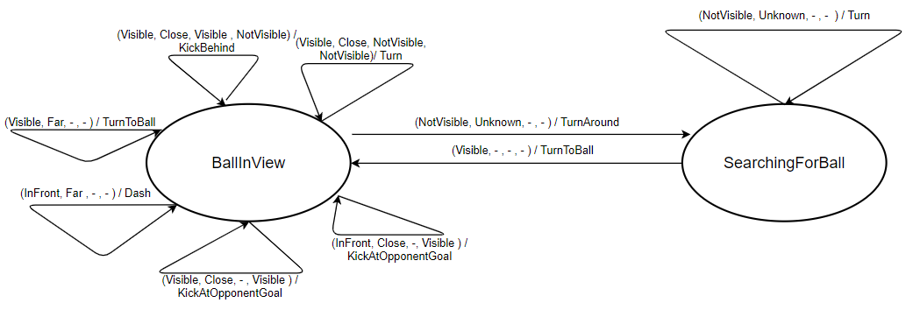

We can see that the behavior is in fact state-based by observing how the agent searches for the ball when it is no longer visible. In the BallInView state, an environment such as (NotVisible, Unknown, NotVisbile, NotVisible) maps to the TurnAround action. If the agent is still in this same environment state after this action is performed, it instead performs the Turn action.