Engineering Computations

Homework 10

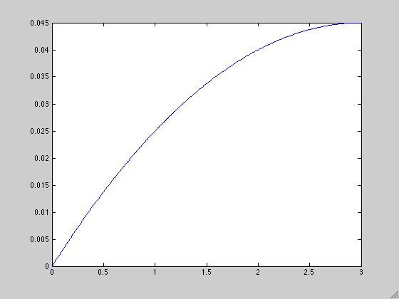Luke Bury LGB544

1)

clear

clc

clf

x=[0:.01:3];

u=@(x) (x.*(2*3-x))/200

plot(x,u(x))

2d)

clear

clc

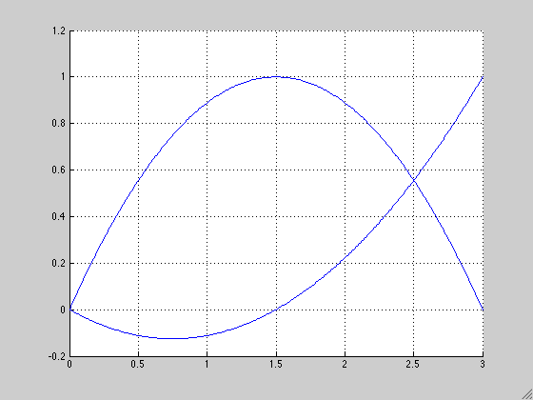clf

x=0:.01:3;

L2=-4/9*x.*(x-3);

L3=(1/9)*x.*(2*x-3);

hold on

plot(x,L2)

plot(x,L3)

grid on

hold off

figuregfh

s=[0:.01:3];

u=@(s) .022511*s.*(s+.66485)

plot(s,u(s))

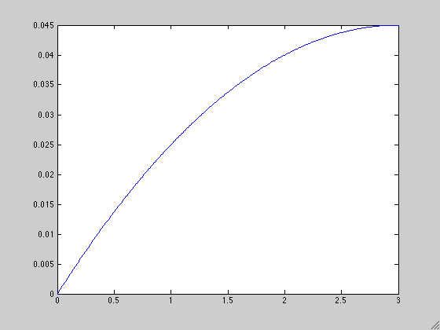

3)

clear

clc

clf

l=3; EA=100; f=1; K=zeros(2,2); F=zeros(2,1);n=2;u=0;

J=l/2;

ksi=[-1/sqrt(3),1/sqrt(3)];

x =l/2+l/2*ksi;

w =[1,1];

for k=1:n %goes through gauss points

for i=1:n

for j=1:n

K(i,j)=K(i,j)+dL(i,x(k))*dL(j,x(k))*w(k)*J*EA;

end

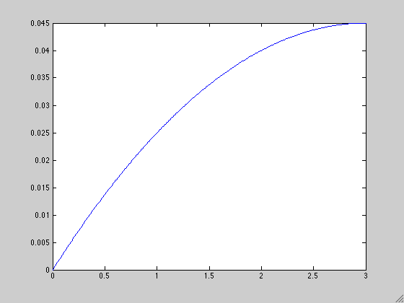 F(i)=F(i)+f*L(i,x(k))*J*w(k);

end

end

K

F

beta=K\F

for e=1:2

syms X

u=u+beta(e)*L(e,X);

end

u

s=(0:.01:3);

u=@(s) (s.*(2.*s-3))/200-(3*s.*(s-3))/200; %sum i=1 to 2 L_i(x)*beta_i

plot(s,u(s))

K =

177.7778 -88.8889

-88.8889 77.7778

F =

2.0000

0.5000

beta =

0.0337

0.0450

u =

(X*(2*X - 3))/200 - (3*X*(X - 3))/200

>>

……………

function val=L (index,x)

if index==1

val=-4/9*x*(x-3);

elseif index ==2

val=(1/9)*x*(2*x-3);

end

end

……………

function val=dL (index,x)

if index==1

val=4/3-(8/9)*x;

elseif index==2

val=(1/9)*(4*x-3);

end

end