* Task: “Find a topic that interests you and read about it”
* Fine to present what others have done and put it in your own words

**Proposal**

* 2-4 pages
* Includes lit review

**Prompt**

* The story of Poincare and how he gave a solution to the Restricted Three Body Problem is the story of a contest that was fixed, so that he could win it, see p. 167 of (Diacu and Holmes 1996). This project involves some historical research, but fortunately, two recent papers (in the Archive for History of Exact Sciences (Barrow-Green, 1994; Andersson, 1994) have everything that you want to know about this interesting story.

**Lutzen Note**

* “Barrow-Green discusses all the problems of the competition in more detail than Andersson and explains the mistake in a less technical way”
* “Andersson gives a mathematically more precise summary of the content of the prize paper and discusses Phragmen’s intervention in more detail”

**Barrow-Green: Oscar II’s Prize Competition and the Error in Poincare’s Memoir on the Three Body Problem**

* **Intro**
* Poincare’s 3BP memoir published autumn 1890 [1] in Acta Mathematica
* Poincare’s correction of paper led to his discovery of homoclinic points
* **The Competition**
* King Oscar II sponsored it – he studied math at university and helped found Acta [1]
* Competition announced in 1885 in the German and French Actas [7a]. Offered gold medal and 2500 Crowns [8]
* Entries to be sent to the chief editor of Acta before 06/01/1888. Submissions sent anonymously with a motto, and a separate letter with that motto, name, and address
* There was MAD drama among prominent international mathematicians
* Made up of four questions. At least two were made with the goal of appealing to Poincare. Possibly all four. (although he only attempted Question 1 .. the most difficult)
* 12 entries. Five attempts at #1, 1 at #3, and 6 choosing their own topics
* Poincare sent his submission with a signed cover letter and personal note to one of the judges … not much for anonymity (baller move?) … apparently he knew they’d recognize his entry by the content and handwriting anyway
* Question #1 was about the n-body problem, but Poincare went for the restricted three body problem
* The commission had decided that Poincare was their choice, but they had a lot of hard work left. Understanding Poincare’s work was a total bitch. It was 158 pages long (when printed for Acta), “contained many new ideas and results,” and was fairly lacking in detail
  + “… *But it must be acknowledged that in this work as in almost all his researches, Poincare shows the way and gives the signs, but leaves much to be done to fill the gaps and complete his work.* *PICARD has often asked him for enlightenment and explanations on very important points in his articles in the Comptes Rendus, without being able to obtain anything except the response: "it is so, it is like that", so that he seems like a seer to whom truths appear in a bright light, but mostly to him alone.”*
* One of the judges (Mittag-Leffler) wanted the version submitted to the king to be complete, so he pressed Poincare hard for more detail. Poincare eventually responded with an extra 93 pages of notes
* Another judge (Weierstrass) wasn’t pumped that Mittag-Leffler was communicating with Poincare since it was supposed to be anonymous … asked that they keep it secret.
* Gylden had done similar math to Poincare before the publishing, and upon the publishing, disagreed with Poincare on a power series. Gylden said it converged, Poincare said it was inconclusive. Gylden brought this whole drama up with Mittag-Leffler, who the king demanded give a response, so Mittag-Leffler went to Poincare. Poincare reasoned that “convergence” and “divergence” mean different things to mathematicians and astronomers
* Mittag-Leffler tried to convince the Academy that Poincare’s work was superior and he deserved the prize, but the Academy ruled that Gylden had already published the work that Poincare had done.
* Hermite still decided to side with Mittag-Leffler, Weierstrass, and ultimately Poincare
* Discovery of the error – “first glimmer that anything was awry occurred in July 1889.” Editor (Phragmen) was confused about something, had Mittag-Leffler write to Poincare, Poincare realized he had a big mistake with lots of consequences
* By this point, Mittag-Leffler hadn’t mass-printed the memoir, but he had sent some copies out – a few even going international.
* Mittag-Leffler was worried about his reputation. Asked Poincare to pay for the printing of the original verision which had already happened. Poincare agreed. It was 3,500 crowns … 1000 more than his prize money
* By early Jan, 1890, Poincare had completed his reworking and sent a copy to Phragmen for editing. Had significant fundamental changes, and also included some of the notes he’d originally sent Mittag-Leffler … so all-in-all it was a fairly different paper. Printing was completed in November of 1890
* The error was more or less covered up from the general public, and poincare’s final paper was dope.

**The Error**

* The problem statement was to solve the n-body problem … most attempts actually tried to solve the 3BP since it’s the first that we couldn’t solve
* The inherent difficulties of the 3BP (coming from it being nonlinear) led him to work on the CR3BP. In this case two of the bodies (the primaries) revolve around their centre of mass in circular orbits under the influence of their mutual gravitational attraction, while the third body (the planetoid), assumed massless with respect to the other two bodies, moves in the plane defined by the two primaries and, while being gravitationally influenced by them, exerts no influence of its own.
* He created a theory of periodic solutions which included a discovery of asymptotic solutions. Showed that these asymptotic solutions create families in 3D space.
* [referring to invariant integrals] “In the memoir he considered the whole concept in a broader sense, developing a general theory which revealed that the existence of an invariant integral is a fundamental property of Hamiltonian systems of differential equations. In particular, he showed that it is a property of the system of differential equations which describes the restricted three body problem.”
* Poincare used the example of incompressible fluids
* In a series of theorems, Poincare formulated the recurrence theorem
* Another one of these theorem’s contained Poincare’s big stupid error
  + Had something to do with the geometric nature of curves
* …”Thus, in [P1] Poincare believed he had proved that for sufficiently small values of the parameter \mu there was, relative to a given unstable periodic solution, a set of asymptotic solutions which could be considered stable, that these solutions were well behaved, and that they could be completely under- stood. His analysis in [P2] led to a very different conclusion. “
* “Nevertheless, as he had learnt from his work on invariant integrals, lack of closure did not rule out the possibility of intersection. Thus the question he now asked was whether it was possible for the curves O'B and O'B' to intersect. For if this should occur, any trajectory which passed through the point of intersection would simultaneously belong to both sides of the asymptotic surface. In other words if C is the closed trajectory which passes through the point O' and represents the periodic solution, then a trajectory passing through the point of intersection would begin, when t is very large and negative, by being very close to the closed trajectory C, and it would then asymptotically move away, deviating greatly from C, before asymptotically reapproaching C as t becomes very large and positive. By showing that the system satisfied the conditions of Theorem III [P2], Poincare was able to show that such trajectories, which he called doubly asymptotic trajectories, did indeed exist, and moreover that there were in fact an infinite number of them. Poincare later called these trajectories homoclinic trajectories and the points of intersection are now known as homoclinic points [30]”
  + “arguably the first mathematical description of chaotic motion within a dynamical system”

**Andersson: Poincare’s Discovery of Homoclinic Points**

* **Abstract**
* Poincare started the modern theory of dynamical systems. “He introduced global, topological methods into the study of non-linear differential equations and invented general procedures for finding periodic solutions.”
  + Also some other stuff
* Found homoclinic points
* **Paper**
* Weierstrass was Mittag-Leffler’s old teacher
* Invariant integrals are “differential forms whose integrals over suitable manifolds preserve their value when the manifolds are transported by the flow”
  + “the volume is an integral invariant for Hamiltonian systems”
* Description of recurrence theorem (highlighted, pg 4)
* Final form of paper – 12/1890 Acta Mathematica
* “By appeal to the recurrence theorem he proves that if there is one doubly asymptotic solution there must be infinitely many.”
* “a non-periodic solution which tends towards the same periodic solution both when t tends to -inf and to +inf is called a homoclinic solution. For a periodic solution of hyperbolic type of a Hamiltonian system with two degrees of freedom, such a solution corresponds to a point of intersection (a homoclinic point) of the stable and unstable curves associated with the corresponding return map. ”

**Poincare and the Three Body Problem (1997)**

* **5.5 Theory of Invariant Integrals (p 83)**
* Mistake came from failing “to take proper account of the exact geometric nature of a particular curve”
* Poisson stability: the motion of a point P is said to be stable if it returns infinitely often to positions arbitrarily close to its initial position
* [p 89 …. paragraph 3 … on a change]
* Mistake was in the Corollary to Theorem III [P1] … changed the theorem and removed the corollary altogether
* In [P1] used the term quasi-closed, but did not use it in [P2]…. A curve C which is coincident with its nth iterate, “which in general is dependent on \mu and is contained on part of a transverse section S, was quasi-closed if there were two points A and B on it which were separated by a finite arc but whose distance apart was very small of pth order.”
* **Theorem III [P1]:** If an invariant curve C is quasi-closed such that the distance between the points of closure A and B is very small of nth order, and there exists a positive invariant integral, the distance from the point A to its iterate A1 and that of B to its iterate B1 are very small of nth order.
* **Corollary [P1]:** If it has been proved that an invariant curve C is quasi-closed so that the distance between the points of closure A and B is very small of nth order at least, if moreover it is known that the distance of the point A to its iterate is a finite quantity or a small quantity of n-1th order at most, and finally if there exists a positive invariant integral, then the curve C is closed. (so 5.5.ii is right (for [P1]), not 5.5.i) 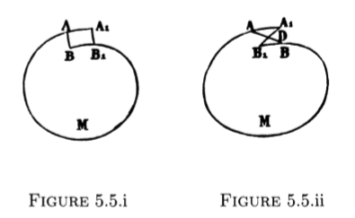
* Poincare gave no proof of the corollary!!
* “What he did not explore was the possibility that the curve, rather than bing closed, might be self-intersecting. In essence he failed to take into account the full range of possibilities consistent with the constraint of area-preservation imposed by the existence of the invariant integral. … As he later realized and showed in Theorem III [P2], the concept consistent with area preservation was not closure but self-intersection.”
* **Theorem III [P2]:** Let A1-A-M-B1-B be an invariant curve, such that A1 and B1 are the iterates of A and B. Suppose that the arcs A-A1 and B-B1 are very small (ie, they tend to zero with \mu) but that their curvature is finite. Suppose that the invariant curve and the position of the points A and B depend upon \mu according to some rule, and that there exists a positive invariant integral. If the distance A-B is very small of the nth order and the distance A-A1 is not very small of the nth order, then the arc A-A1 intersects the arc B-B1
  + This forced him to realize that the curve was self-intersecting. So the true correct diagram is:  
     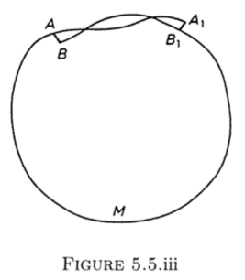
* The mistake was a complete shock to Poincare
* **5.6 Theory of Periodic Solutions (p 92)**
* (skipping a bunch of stuff on characteristic exponents)
* (page 101) In [P1], Poincare didn’t consider the difference between the characteristic exponents asymptotic solutions for autonomous and nonautonomous Hamiltonian systems
  + Found that the series expansion of η is not convergent for autonomous Hamiltonian systems (as in the case of the CR3BP)
  + (origins of η on page 98) … 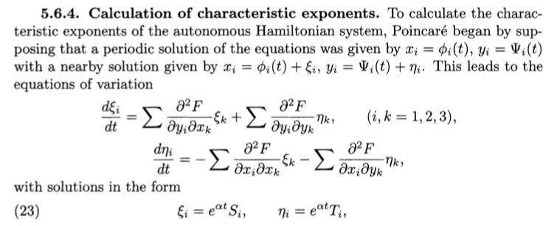  
    …  
    …  
    …  
    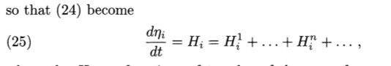
* **5.8 Study of Asymptotic Surfaces**
* (page 117) … Curves A-O’-B’ and A’-O’-B can’t be closed … even though they don’t close, O’-B’ and O’-B an intersect. “When this happens, any trajectory passing through the intersection simultaneously belongs to both sides of the asymptotic surface. To distinguish this type of trajectory, Poincare called them *doubly asymptotic*.” Later he started calling them *homoclinic*..
  + 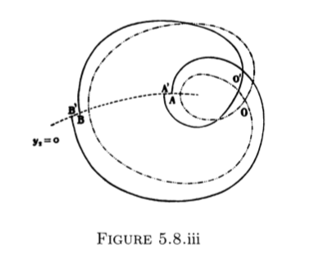
  + Trajectory begins very close to intersection C at t = Large/Negative, and asymptotically moves away then reproaches C as t = Large/Positive
  + There are an infinite number of doubly asymptotic trajectories
  + “This is arguably the first mathematical description of chaotic motion within a dynamical system”

Looking good! Sorry for the silence – it’s been a very busy time for both of us. Didn’t know we had any other relatives out here! Hopefully we eventually get a chance to meet