There are majorly two things about the algorithm inside the network that we would like to ask you for details, namely the algorithms of “signaling cascades” and “decaying mechanisms”.

First, we would like to define the so-called “signaling cascades” as “the series of signal transductions”, which occur between each pair of the layers. As above, there are 17 kinds of connections among the layers of our current network. For each kind of connection, we should need to define the corresponding signaling cascade, involving the particular process of the signal transductions within it. During our implementation of defining the signaling cascade with respect to each connection, we found that we are fairly not clear about the corresponding process of the signal transductions. Let’s take the cascade of the connection from Obj2 to Output for example, we can only guess the process of its signal transductions and define it with many times of trial and error. For this example, what we have currently defined for the cascade is something like this:

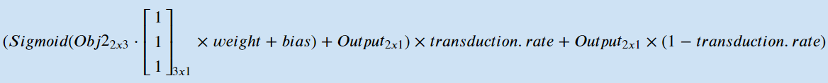. Within this formula, Obj2 and Output are matrices refer to the two layers respectively, and the “transduction.rate” refers to the rate at which the new signal is transduced to Output. As for the 3x1 matrix with all elements equal to 1, is the matrix that we used to define the connections from Obj2 to Output on the “node” level, which in this case, means the three nodes in the first row of Obj2 coactivate the node in the first row of Output. The other processes of signal transductions in the rest are basically all of this kind (or similar to), with simply the different combination of parameters.

Second, after many times of trial and error, we found that there might be something like a decaying mechanism within each layer. We would like to define the so-called “decaying mechanism” as a mechanism by which the activation value inside each node “decays” as the cycle of activation proceeds. Let’s take an invalid trial for example to demonstrate the reason why we think there should be such a need to have decaying mechanism. Suppose during the “cue phase” in which the cue appears on the “left” side, the left sides of Spat1 and Obj1 are somehow coactivated through the pathways between Spat1 and Obj1. Then, after entering the “target phase” in which the target appears on the “right” side, not surprisingly, the right sides of Spat1 and Obj1 are also coactivated. At this moment, what we paid attention to is that if there is not any so-called “decaying mechanism”, the left sides of Obj1 and Spat1 should be continued to coactivate even though the cue on the left side is no longer exist in the target phase. The consequence of this kind of situation is that the activation level of the right sides of Obj1 and Spat1 in the target phase, might not successfully overcome the left sides as the cycle proceeds unless there would be a decaying mechanism within each of them. Furthermore, from the view of neurophysiology, we also think that it should be reasonable that once the stimuli on one side of the field disappears, the activation level on the corresponding sides of each layer in our brain should then decay gradually as time goes by.