# SkinningTools UI

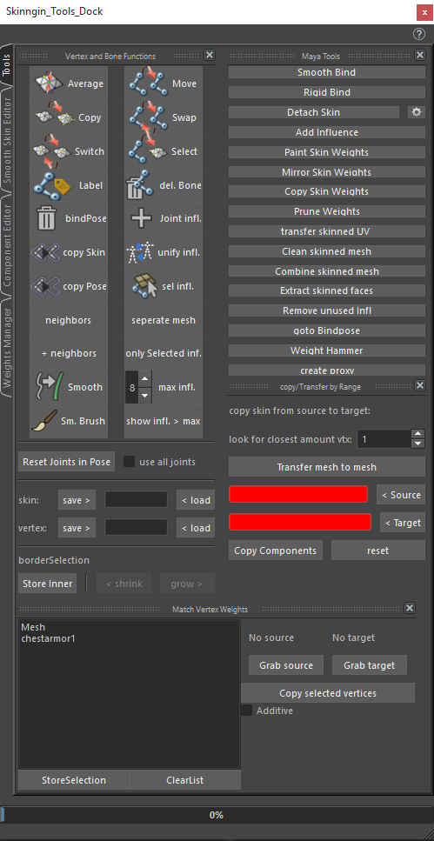Maya Tools

First part of the tool is; all useful Maya tools combined in one window for ease of access. All buttons open the toolbox options to make sure that all settings are correct and for easy adjustment, except for detach skin which has the option to show the toolbox “[]” and the weight hammer which has no options to change. Combine skinned mesh is added with support for Maya versions before 2015.The only tools that are different are:

**Transfer uv**, transfers the uv’s from a non-skinned object to the skinned object.

**Clean skinned mesh**, freezes the transform and deletest history on selected skinned meshes.

**goto Bindpose**, this uses the prebindmatrix value of the skincluster instead of the bindpose node. So bindposes are not necessary anymore.

**Extract faces,** extracts the selected components as a duplicate mesh with the skinning information intact, allows the user to add alpha decals to the mesh without much problems of recreating the mesh and making sure the skinning is the same.

Vertex and bone functions

**Average vertices (repeat last)**

The average button needs at least 2 “vertices” as an input,

If 2 vertices are selected it will generate a path of edges between the 2 vertices and average the weights over the distance

If 3 vertices or more are selected, it will add all the weighting information from every joint on those vertices and combines them. Then it will divide the values by the amount of vertices and apply them on the last selected vertex.

Right click the button to change average function to percentage or distance

**Copy vertices (repeat last)**

The copy button is to make sure that multiple vertices have the same value (really useful for solid objects in between stretching skin)

Select all the vertices you want to have the same value, as last select the vertex that has the value you want to apply to all the vertices selected and the use the copy tool.

**Switch vertices (repeat last)**

This tool only works on 2 vertices not more; it switches the values for both vertices

**Label (no repeat last)**

The label will automatically figure out what type a joint is based on naming: it tries to label the joint either “Left”, “right” or “center”, it will open up a dialogue which presents options as to which naming convention to follow! This will make sure that copying skin, and mirroring skin will have fewer problems with joints that are on top of each other (like roll bones)

**Del. bindPoses (no repeat last)**

This will identify all the bindPose nodes in the scene attached to any skincluster and remove them, if the object needs to be set to bindpose, use the “goto bindPose” button in the upper region of the tool.

**Copy skin (repeat last)**

This will transfer skin from first selected object to other objects using Maya’s default copy skin method; this will make sure that the meshes that will receive the skinvalue are detached from their skincluster before creating a new one

**Copy Pose (repeat last)**

this will do the same as the Transfer skin button except it deletes the history of the skincluster before copying the skin keeping the pose the mesh is in.

**Neighbors/neighbors + (repeat last)**

these options can smooth out the weights, they use a less invasive way of smoothing then the weights hammer, “neighbors” only smooth’s the first detectable components outside of the selection, while “neighbors +” smooth’s the selection first and then smooth’s the first detectable components outside of the selection, this will give a better falloff.

**Smooth (repeat last)**

The smooth button works similar to the average button, but it will find all the neighboring vertices for you. Select all vertices that need a smoothed influence on the skin and hit this button to smooth these out (weight hammer works similar but is a bit more harsh)

**Smooth Brush (repeat last)**

The smooth brush is an adaptation of the smooth button to a brush, it will allow to smooth over all bones at once (standard smooth brush of Maya allow smoothing only over 1 bone at a time)

**Move bones (repeat last)**

When you want to have all the influence that are on one joint removed and applied to another joint the move tool will do this. Really handy if you want to remove a joint and also be sure where all the weighting values are distributed. Select the bone which has the values, then the bone you want to apply the values to and lastly the mesh which is attached to the bones.

**Swap bones (repeat last)**

This tool switches the values from one bone to another bone and vice versa. This is especially handy if you have extra joints in for example the shoulder (rolls bone and shoulder bone) if you apply the weights in the wrong order, this tool will switch the weighting values for you while keeping the other values intact. So first select the joints you want the influences switched, then select the mesh to which they are bound and run the tool.

**Select influences (repeat last)**

This is a visualization tool which allows you to select all the vertices that are influenced by a bone or a multiple selection of bones( no matter how small) this makes it easy to see if vertices are influenced that should not be.

**Delete Bone (no repeat last)**

The delete bone button will remove a bone and try to fix the skinning (note: the bone should not have any children and should be parented to the bone that will take on its influences) this makes sure that the skin will not be broken

**Add joint infl. (repeat last)**

Adds a joint to the selected mesh as an influence, it will be added with 0.0 weight value for the joint so it does not break the skin.

**Unify Joint infl. (repeat last)**

Select 2 meshes with a skincluster, this option will make sure that the same bones are influencing both objects; all objects that are added to make sure the influences are unified will be added with 0.0 weight values.

**Select joint infl. (repeat last)**

This option will select all the joints that are influencing the current selected mesh.

**Separate Mesh: ( no repeat last)**

separates the skinned meshes by their mesh shells but keeps the skinning information in tact, allows the used to focus on the skinned mesh piece by piece, the mesh can later be combined back into one piece if desired.

**Only selected Inf.: ( repeat last)**

Select components you want to isolate joint influences for, and select the joints. When used this function will remove all the influences of all the joints that are not selected from your selected components.

**Max infl. (no repeat last)**

The field that comes with this button allows for input how many joints you want to have as an influence per vertex as a maximum, for example; 8 will allow only 8 bones to influence a certain vertex for every vertex in that selected mesh.

**Show infl. > max (no repeat last)**

This will help visualize and select which vertices have more bone influences then specified in the input above

**Skin: save > < load (no repeat last)**save stores the entire skincluster, now the mesh can be adjusted even history deleted, load will re-apply the entire skincluster ( only works if vertex ids are still the same)

**Vertex: save > < load (no repeat last)**save stores weight information from one vertex, load will set the weight of that stored vertex onto other selected vertices ( could be from another mesh object, as long as the influences are the same!)

Copy/Transfer by range

**Copy skin from source to target**

**Copy**

This will allow you to copy the skin influences from a selection of vertices, to another selection of vertices on the same mesh, it does not give perfect results but helps a lot with double sided meshes like cloth.

First select faces/edges/vertices which cover the influences you want to copy and when all the source objects are selected hit the “< source” button, Then select the faces/edges/vertices that need the influences and hit “< target” button. If you want to prune weights before the copy this option is available as well. The boxes that are now shown in red should turn green when the source and target button are pressed and they should contain the name of the mesh that is used in the selection. Use the spin box to give in the amount of closest points used for transferring the weights.

In the end just press reset to redo your selection or press copy to run the tool. This might take a while depending on how much is selected and stored in either source or target and will most likely not be the final result but close enough to start tweaking (the tool searches for each target vertex the closest source vertex from your selection and copy’s its weight information.

**Transfer**

This does the same as copy only it is not necessary to make selections and store these, the transfer option works from mesh to mesh, making a point cloud from the first selected mesh and stores the weights onto the second selected mesh using the closest distance as put in the spin box.

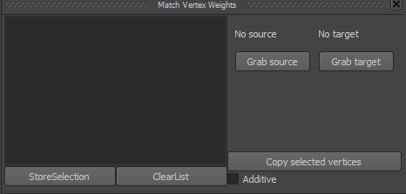

Match vertex weights

This works fast if you want to copy weights between duplicate objects, select the vertices that have the correct weight information and store them on the second object.

**Store selection**

Store the selected vertices so they can be selected easily again, think of this as being a selection set in the skinning tool window

**Clear list**

This will remove all the stored selection sets

**Grab source**

Grab the skincluster from the selected source object

**Grab target**

Grabs the skincluster from the selected target object

**Copy selected vertices**

This will copy over the weights from the source to the target overwriting the vertex weights of the target object

**Additive check**

This will add the source weights to the target weights and will normalize after applying

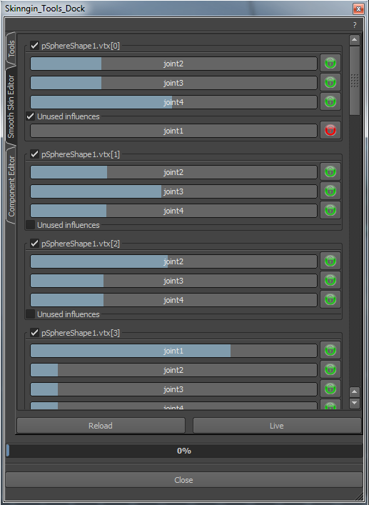

**Smooth-skin editor Tab**

This window shows the selected vertices and the weight information attached.

As you can see “pSphereShape1” is selected and from that a couple of vertices are selected 0,1,2,3, etc. It shows all the joints that influence these vertices. Checking the box “unused influences” allows you to see all the joints that are not influencing the vertex and also allows you to add them as can be seen in the group for vertex 0.

The float fields are linked with the sliders and allow for direct input and visualization of the weight value. So if the slider is dragged, the vertex in the Maya viewport will move as well.

If you are happy with a certain value but still want to tweak the other values, you can lock the value of a joint with the green button which then will turn red. The other sliders will be able to move but always take into account the value that is locked.

These sliders will always maintain the maximum amount of influences and it is not possible to add more than that.

The live button down below will turn green when pressed, this will update the UI every time a new vertex is selected in the viewport, otherwise reload can be used to update the UI

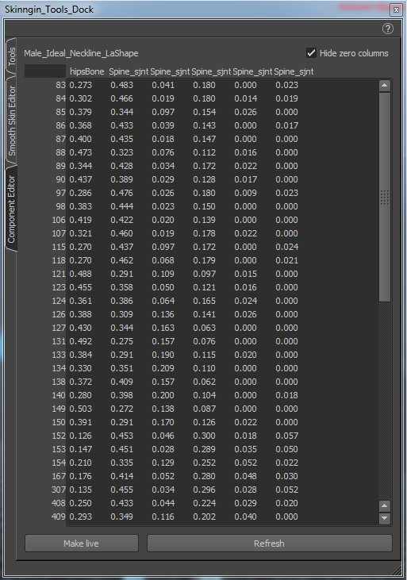**Component editor Tab**

The component editor tab in the skinning tools is a more user friendly version of the component editor as seen in Maya. It takes a mesh or any components as input. (it will only take the components of the first mesh selected)

Hide Zero columns dynamically hides all columns that do not have any weights assigned. Right clicking the header of a column (with the joint name) gives an option box that allows you to lock the entire column, right-clicking a locked column allows you to unlock it or unlock all the columns

This function also has a refresh button which refreshes the Maya selection on user command, or when the make live button is pressed it will update when the selection is updated in the Maya viewport.

**weights manager**

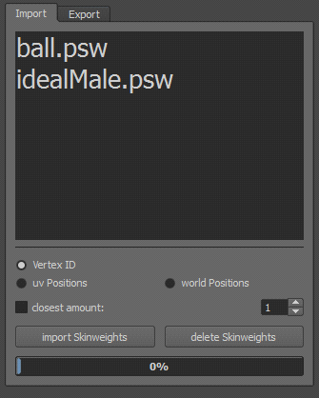

The weights manager can store psw files (pickled skin weight data files) it will list all stored data files in the UI.

it allows the user to load skin weights files with a couple of options  
  
* vertex id: this is the fastest and most suitable option when the mesh has not changed  
* uv positions: best option when vertex id and positions are slightly changed but uv’s are still the same  
* world positions: to use when the model has not changed except for the vertex id’s  
  
closest amount can be used with uv and world positions, it generates a point cloud from the data and tries to find the closest amount of vertices to gather information from given in the spin box.

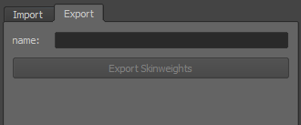

Marking menu

There is also a marking menu added to this tool, the window needs to be open in Maya for it to work

1. Select components of the mesh
2. Middle-click and hold on top of a bone
3. This enters the marking menu of what you can do for the selected component weights and the bone that is under the mouse
4. It also works with smooth selection (will apply the smooth values accordingly).
5. When in smooth selection it will add the menu item for surface aware so it can switch between volume and surface selection.

