**Académie Belge de Luth - Yearbook 2013, pp. 54-60:**

**Lute Music of Servatius Saremont**

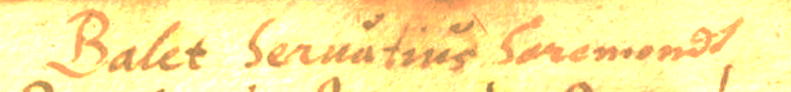

*Title of no. 3.*

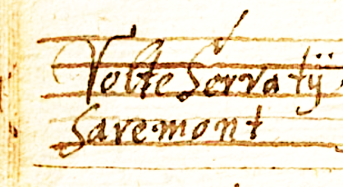

*Title of no. 2.*

Four lute solos in a lute manuscript of Bavarian provenance from around 1615-1620 (D-Ngm 33748/I) are ascribed to Servatius Saremont/Saremondt.[1] A tantz in another German tablature manuscript (D-DEl BB 12150), copied in Tübingen several decades earlier in the 1580s is ascribed Servarij but might be by the same composer. Servatius is the patron saint of the city of Maastricht, as well as the towns of Schijndel near Eindhoven and Grimbergen near Brussels. The [Roman Catholic](http://en.wikipedia.org/wiki/Roman_catholic) Basilica in Maestricht is also dedicated to [Saint Servatius](http://en.wikipedia.org/wiki/Saint_Servatius). And Sarémont is the name of a locality near Liège, about 30 km from Maestricht, presently no more than a few buildings near the Chapel of Noblehay. The family name Saremont, as well as the similar Suremont, is probably Flemish. The names are known in the region of Liège, but not in Antwerp and there are no records of a lutenist of that name.[2] So it seems likely that Servais Saremont was a lutenist from the South Netherlands, and the sources of his music suggest he was known outside the Netherlands.

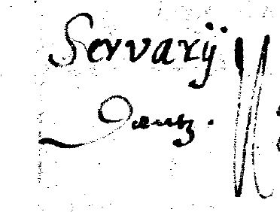

*Title of no. 5.*

Four of the items are French dance forms - two ballet, a volte and a courante - and the fifth a German tantz. The courante is titled volte in the manuscript, but courante in four cognate versions in two different keys, all in continental manuscripts. Three of the titles also include the word d'Angleterre or Anglum suggesting an English origin, so that Saremond may have made an arrangement of an existing English composition. All versions of all five are transcribed here. The tablature was copied carelessly into the principal source with displaced rhythm signs and barlines as well as the length of sections are sometimes irregular, and so these versions have been edited in places, and the changes are listed in the critical commentary.**[3]**

**Worklist**

**1. Ballet**

D-Ngm 33748-I, ff. 61v-62r *Ballet eiusdem* [Seruatius

Saremondt] 2

**2. Volte**

D-Ngm 33748-I, f. 49v *Volte Servatij Saremont* 3

**3. Ballet**

D-Ngm 33748-I, f. 61v *Balet Seruatius Saremondt* 4

**4. Courante**

**a.** D-Ngm 33748-I, f. 50r *Volte Eiusdem* [Seruatius Saremondt] 4

**bi.** B-Br 26369, ff. 17v-18r *Courrante D'angleter* 5

**bii.** Besard 1603, f. 169v *Courante dangleterre* 6

**ci.** GB-HAdolmetsch II.B.1, f. 30v *Courant Anglum* 5

**cii.** D-Ngm 33748-I, f. 71r *Corant Talekij* 6

**5. Tantz**

D-DEl BB 12150, f. 64r *Servarij Tantz* 7

*John H Robinson, September 2013*

1. The titles of no 1 & 4 read *eiusdem*, which refers to the ascription of the previous item in the manuscript, no 3 & 2, respectively.
2. For example a Servais Saremont *c.*1510-1586 and another of the same same name dying before 1613 are recorded in the Geneanet genealogical website - thank you to Godelieve Spiessens and François-Pierre Goy for this information:

   <http://gw.geneanet.org/gedeon?lang=fr;pz=fictif;nz=fictif;ocz=0;p=servais;n=de+saremont;oc=3>
3. All the sources are in French tablature for renaissance lute. Editorial changes are shown in grey, and the changes are abbreviated below to indicate the letter and number of course so that a1-b1 means a on 1st course followed by b on the 1st, and a1c2 means chord of a on 1st course and c on 2nd course. The rhythm signs in the principal source [D-Ngm 33748/I] are frequently poorly aligned with the tablature letters and have been tacitly repositioned editorially. **1.** 7th course in F; A8B16C8; bar 13 - 2 bars of crotchets instead of one bar of quavers; 16/3 - minim a1c2d3 absent; 17/8 - b1 instead of a1; 18/3 - d4 added; 20/2 - a2 instead of b2; 20/3 - d5 added; 25/3-4 double bar line absent; 25/4-5 - a1-c1 instead of a6-c6; 29/3-4 - minim-quaver instead of 2 quavers; 29-30 to 31-32 barlines displaced 3 quavers left; 32/5-6 - crotchets instead of quavers; 32/between 5-6 - c2 added. **2.** 7th course in F; A7B11C8; 6/2-3 - quavers instead of crotchets; 7/1 - minim instead of dotted minim; 16/6 - d2 instead of c2; 18/1 a5 absent; 18/3 a3 added; 20/1 - a5 instead of e5; 26-28 - these 3 bars of the 3rd strain are additional to the 8 bars of the division; 28-29 - single instead of double bar line. **3.** 7th course in F; A4B6; no changes. **4a.** 6-c lute; A9A8B9C8; in G; 17/1 - dotted minim absent; 20/2 - b2 instead of b1; 33/1-4 - four notes a line lower; 33/5 - a3 absent. **4bi.** 6-c lute; A8B8C88; in G; 3/4 - a3 instead of e3 [e3 in Besard]; single bar lines absent except at 3-4, 5-6, 9-10, 11-12, 13-14, 15-16, 17-18, 19-20, 21-22, 23-24, 27-28 & 30-31; 10/1 - c5 instead of e5 [e5 in Besard]; 12-13 & 24-25 - single instead of double bar lines; double bar lines absent at 16-17 & 24-25; 21/1 - a5 instead of a6 [a5 also in Besard]; 24/1 - minim absent [present in Besard]; Besard's version is identical to 4a, except for the differences notes fr 4b; bar lines are present at 7-8 & 25-26; and 25/1 - a2 added 6. **4bii.** barred in 6 instead of 3 crotchets; 16-17, 24-25 - double bar lines absent; 21/1 - a5 instead of a6. **4ci.** 7th course in F; A8B4C8; in F; no changes; the version in D-Ngm 33748-I is identical to 4c. **4cii.** no change. **5.** no changes.

   Sources: **B-Br S 26.369** - Bruxelles, Bibliothèque du Conservatoire Royale de Musique de Bruxelles, MS Littera S 26.369, *c.*1620; **D-DEl BB 12150** - Dessau, Stadtbibliothek, MS BB 12150, inscribed '1580 Inchoatus Tubingae suevorum 2 Januarij Anno sup[ra] 80' 'Christianus fürst zu Anhalt'; **D-Ngm 33748/I** - Nürnberg, Germanisches National-museum, MS 33748/I, *c.*1615-1620, modern edition and facsimile: *Nürnberg Lautenbuch* Die Tabulatur Heft 23-27 (Hofheim am Taunus: Hofmeister, 1979); **GB-HAdolmetsch II.B.1** - Haslemere, Dolmetsch Library, MS II.B.1, Bavarian provenance, *c.*1620; Besard 1603 - Jean-Baptiste Besard *Thesaurus Harmonicus* (Koln: Grevenbruch 1603), facsimile edition: (Genève: Minkoff Editions, 1975); **Besard 1603** - Jean-Baptiste Besard *Thesaurus Harmonicus* (Köln, Grevenbruch 1603).