**Music supplement to Lute News 115 (October 2015): the galliards of Lorenzino Tracetti and Vincenzo Pinti, Daniel Bacheler's Round & John Dowland part 16: Captain Candische his Galliard (21)**

Here are the twenty of gagliarde by Lorenzino and/or Equitis Romani/Cavaglier del Liuto/Knight of the Lute, as an appendix to the catalogue of their music published by Mariagrazia Carlone,[1] and all alternative versions are in the *Lutezine* accompanying this *Lute News*. Lorenzino is best known to us for his preludes, toccatas and fantasias, but his gagliarde are equally interesting for their rhythmic variety, melodic development and flowing divisions.**[2]**

**L1.** PL-Kj 40032, p. 304 *Gagliarda di Lorenzino* C[3]17

I-PESo P XVII. (Albani) 125 [2.22], ff. [20v-21r] untitled

**L2a.** F-Pn Rés.Vnd.29, ff. 5v-6r *Gagliarda del Cavaliere* C33

B-Br Lit. S. 16.663, ff. 3v-5r untitled

D-W Guelf.18.8 VI, ff 170r-171v *Gagliarda*

I-PESc b.10, ff. 11v-12r *Gagliarda dell'Cavaliereo del leuto*

I-PESo P XVII. 125 [2.22], ff. [16v-17r] untitled

**L3.** PL-Kj 40032, p. 361 *Gagliarda di ~~Lorenzino~~ Santino* [4] C18

**L4.** Besard 1603, ff. 127v-128r *Galliarda eiusdem* [Laurencini] C26

I-PESo P XVII. 125 [2.22], ff. [8v-9r] untitled

**L5a.** Besard 1603, f. 121r *Galliarda Laurencini* Crawford[5] 15; C20

**L5b.** Hove *Florida* 1601, f. 98r *Gailliarda* HoveB[6] 369

**L6.** Besard 1603, f. 126v *Galliarda Laurencini* Crawford 10; C24

**L7.** Besard 1603, f. 124v ii *Galliarda Laurencini* Crawford 30; C22

**L8.** Besard 1603, f. 124v i *Galliarda Laurencini* Crawford 29; C21

**L9.** Besard 1603, f. 117r *Galliarda Laurencini* Crawford 28; C19

**L10.** D-W Guelf.18.8 VI, ff. 177v-178r *Gagliarda bella Laurencinus* C27

**L11.** D-W Guelf.18.8 VI, ff. 183v-184r *Gagliarda bella Laurencinj*[7] C30

**L12.** D-W Guelf.18.8 VI, ff. 184r-184v *La medisima* [Laurencinj] *in un'altro tono*[8] C31

**L13.** D-W Guelf.18.8 (Hainhofer) VI, ff. 183r-183v *La medesima* [Laurencinij] *in un'altro tono* C29

**L14.** I-COc 1.1.20, ff. 63v-65r *Gagliarda del Cavagliere* C34

**L15a.** Besard 1603, f. 107v *Galliarda equitis Romani* C36

D-Hbusch w.s. (Herold), ff. 22r-23r *Galliarda* C32[9]

cf. Piccinini *Libro Primo* 1623, pp. 60-61 *Gagliarda VI*

CDN-Mc w.s. (Montreal), ff. 61v-63r *Gagliarda*

D-Dl 1.V.8 (Loss), f. 78v untitled

**L16.** Besard 1603, f. 125v *Galliarda Laurencini* Crawford 16; C23

**L17.** Besard 1603, f. 127r *Galliarda euisdem* [Laurencini] C25

**L18.** I-COc 1.1.20, ff. 85v-87r *Gagliarda del Cavagliere* C35

**L19.** D-W Guelf.18.8 VI, f. 183r *Gagliarda bella Laurencinj* C28

**L20.** D-W Guelf.18.8 VI, ff. 168v-169r *Gagliarda Equitis Romanj* C37

Jean Baptiste Besard's *Thesaurus Harmonicus* of 1603 is dedicated to Laurencini with whom he claims to have studied. Besard's *Thesaurus* is the major source of Lorenzino's music and also includes music ascribed to Equitis Romani which since the 19th century was considered to be an alternative name for Laurencini. However, in the 1980s two separate Roman lute composers were identified from literary sources, one Lorenzino Tracetti, Golden Knight of the Lute, who died in Rome in 1590, and the other Vincenzo Pinti, Cavalier del Liuto (Knight of the Lute) who died in 1608.[10] Both were members of different orders of knights in Rome, and none of the titles to the music includes their family names, probably because their papal associations required a degree of anonymity. Excepting the possibility of the original scribes confusing the two, all the lute solos ascribed Laurencini or Lorenzino can be fairly safely attributed to Tracetti. But, it is not possible to distinguish them on the basis of the music, consequently some confusion remains over which of them composed the music ascribed to Equitis Romani/ Cavagliere del Liuto/Knight of the Lute. No L15 and L20 which are ascribed to Equitis Romani in Besard or Hainhofer (D-W Guelf.18.8) are likely to be by Vincenzo Pinti, as both sources have separate entries for the two in their lists of composers. However, no L2, L14 & L18 are ascribed to Cava(g)liere in sources that lack any pieces ascribed to Lorenzino, so these could be by either composer.[11] What follows is a very brief summary of the lives of the two composers, and the reader is referred to Mariagrazia Carlone's articles for the details.[12]

**Lorenzino Tracetti** (*c.*1550-1590) may be the child 'Lorenzino soprano' recorded between 1559 and 1564 at the Basilica of San Lorenzo in Damaso in Rome (so he was probably born *c.*1550), which is probably the lutenist Lorenzino as a boy chorister. In the period 1570-1572, 'Lorenzino Traetti dal Liuto' was a musician in the chapel of Cardinal Ippolito II d'Este (1509-1572) at his villa in Tivoli near Rome, but the lutenist got into trouble for frequently travelling to Rome to perform at 'the houses of cardinals and lords'. In 1590 'Lorenzino Tracetti/Traiecti del Liuto' is recorded as the son of Francesco 'gallus belgicus', a singer at San Lorenzo. So it seems Lorenzino was Flemish, and it is possible that the family was from Maastricht, the Latin form of which is Trajectum ad Mosam.[13] Following the death of Ippolito, Lorenzino was in negotiations for a post with Charles IX, King of France, although the offer was probably withdrawn when Charles died in 1574. Around this time Lorenzino was actively sought for a post at the Bavarian court of Prince Wilhelm of Wittelsbach, following a protracted attempt at hiring him first by Orlando di Lasso, maestro di cappella of the Bavarian court, and then by Wilhelm's brother Ernst who was in Rome in 1574. There is no record that he went to Bavaria as he is not mentioned in court salary accounts. However, there are letters in the Bavarian court records that refer to the wife of one 'Lorentzin' and it is known that he married Lucrezia Paolina, probably between 1572 and 1574, and it would provide a conduit for the transmission of his music (although none of the gagliarde) into a number of German lute sources, albeit posthumously. But he probably remained in Rome for the rest of his life. There is no record yet found of his employment or his patrons, but in 1580 a Roman document refers to 'Dominus Laurentius Traciettus Romanus regionis Trevij' substantially supplementing his wife's dowry with gold and jewellery. It is known that he lived in the prestigious neighbourhood of Ponte in Rome and owned a vineyard and a grove near San Lorenzo, and the contents of his house upon his death in 1590, aged about 40, included his professional tools: three lutes, a chitarrone, eleven tablature books (lets hope they turn up!), a set of books to sing in five parts, and ruled paper (needed by a composer or teacher to write down music).

**Vincenzo Pinti** (1542-1608), a.k.a. Cavalier del Liuto was 66 when he died in 1608, and so was born in 1542. He was a groom of the chamber of Pope Julius III (1487-1555) and in the service of Cardinal Alessandro Farnese in 1581, remaining until the Cardinal died in 1589. The late Cardinal's office of vice-chancellor passed to Allesandro Peretti, Cardinal Montalto, and the Cavalier is then recorded in Montalto's service in 1589, 1593 and 1602. The residency of the vice-chancellor included the church of San Lorenzo in Damaso, and a tomb inscription there reading *Vincentio Pinto civi Romano Lusitaniae* (i.e. Portugal) *Christi Militiae Equiti* is recorded although the tomb has gone.

The major sources are Besard's *Thesaurus* published in Köln in 1603 [9] and Philip Hainhofer's lute books [6], and then one or two are found in each of another nine mainly Italian manuscripts, as well two published lute anthologies, Hove's *Florida* of 1601 and Piccinini's *Libro Primo* of 1623. Only one version of each gagliarda is known, except for two of no L5 (the other unascribed and embellished in Hove's *Florida* published in Utrecht in 1601), three of no L2 (all in Italian manuscripts and corrupt, needing reconstruction) and four of no L15 (three anonymous, one ascribed), the alternative versions of each consigned to the *Lutezine*. No L11 & L12 are gagliarde in different keys on the tune of a popular Italian gagliarda, reminiscent of the Walsingham tune used in English variation sets and the famous galliard by Gregory Huwet,[14] and no L3 is a doubtful ascription as the scribe changed Lorenzino to Santino in the title, highlighting the similarities in the style of the two composers as seen in several of the gagliarde here.[15] On p. 8 of the preface to his *Libro Primo*, Alessandro Piccinini relates that the Cavalier del Liuto relished playing the newly developed archlute, and the print includes a gagliarda for 13-c archlute without attribution (no L15b, edited in the Lutezine), concordant with an 8-course lute version in *Thesaurus* ascribed to Equitis Romani (no L15a), so Piccinini was presumably honouring the memory of Vincenzo Pinti, and one wonders whether Piccinini or Pinti made the archlute arrangement of the earlier lute gagliarda.

**Daniel Bacheler**

**DB43a.** GB-Lbl Eg. 2046, f. 28v *A Carranta* [16] BachelerL[17] no 43

GB-Ctc O.16.2, pp. 139-138 *mr Daniell Bachelers Round*; GB-Cu Add.3056, ff. 43v-44r untitled

GB-Lbl Add.38539, ff. 8v-9r *Almayne*

Here is a version of Daniel Bacheler's Round, which is a set of variations on the French air *En m'en revenant de sainct Nicolas* first published as a setting for four voices in Le Roy & Ballard *Airs de court* (Paris 1596), and borrowed for the German student drinking song *More Palatino*. In the Bacheler modern edition, Martin Long did not recognise the tune and only listed the second and third sources above, missing two closely concordant versions in English sources. One is edited here and the other three, as well as all the other settings of the tune for plucked instruments known to me, are edited in the *Lutezine* accompanying this *Lute News*.

**John Dowland**

**JD21a.** GB-Cu Add.2764(2), f. 6v *Capit*(ain) *Candische his Galy*(ard)

**JD21b.** GB-Cu Dd.2.11, f. 56r J *Dowl*(and) DowlandCLM 21

**JD21c.** GB-Lam 601 (Mynshall), f. 1r *John Dowlands Galliard*

**JD21d.** GB-Lbl M.1353 (Hirsch), f. 11v untitled

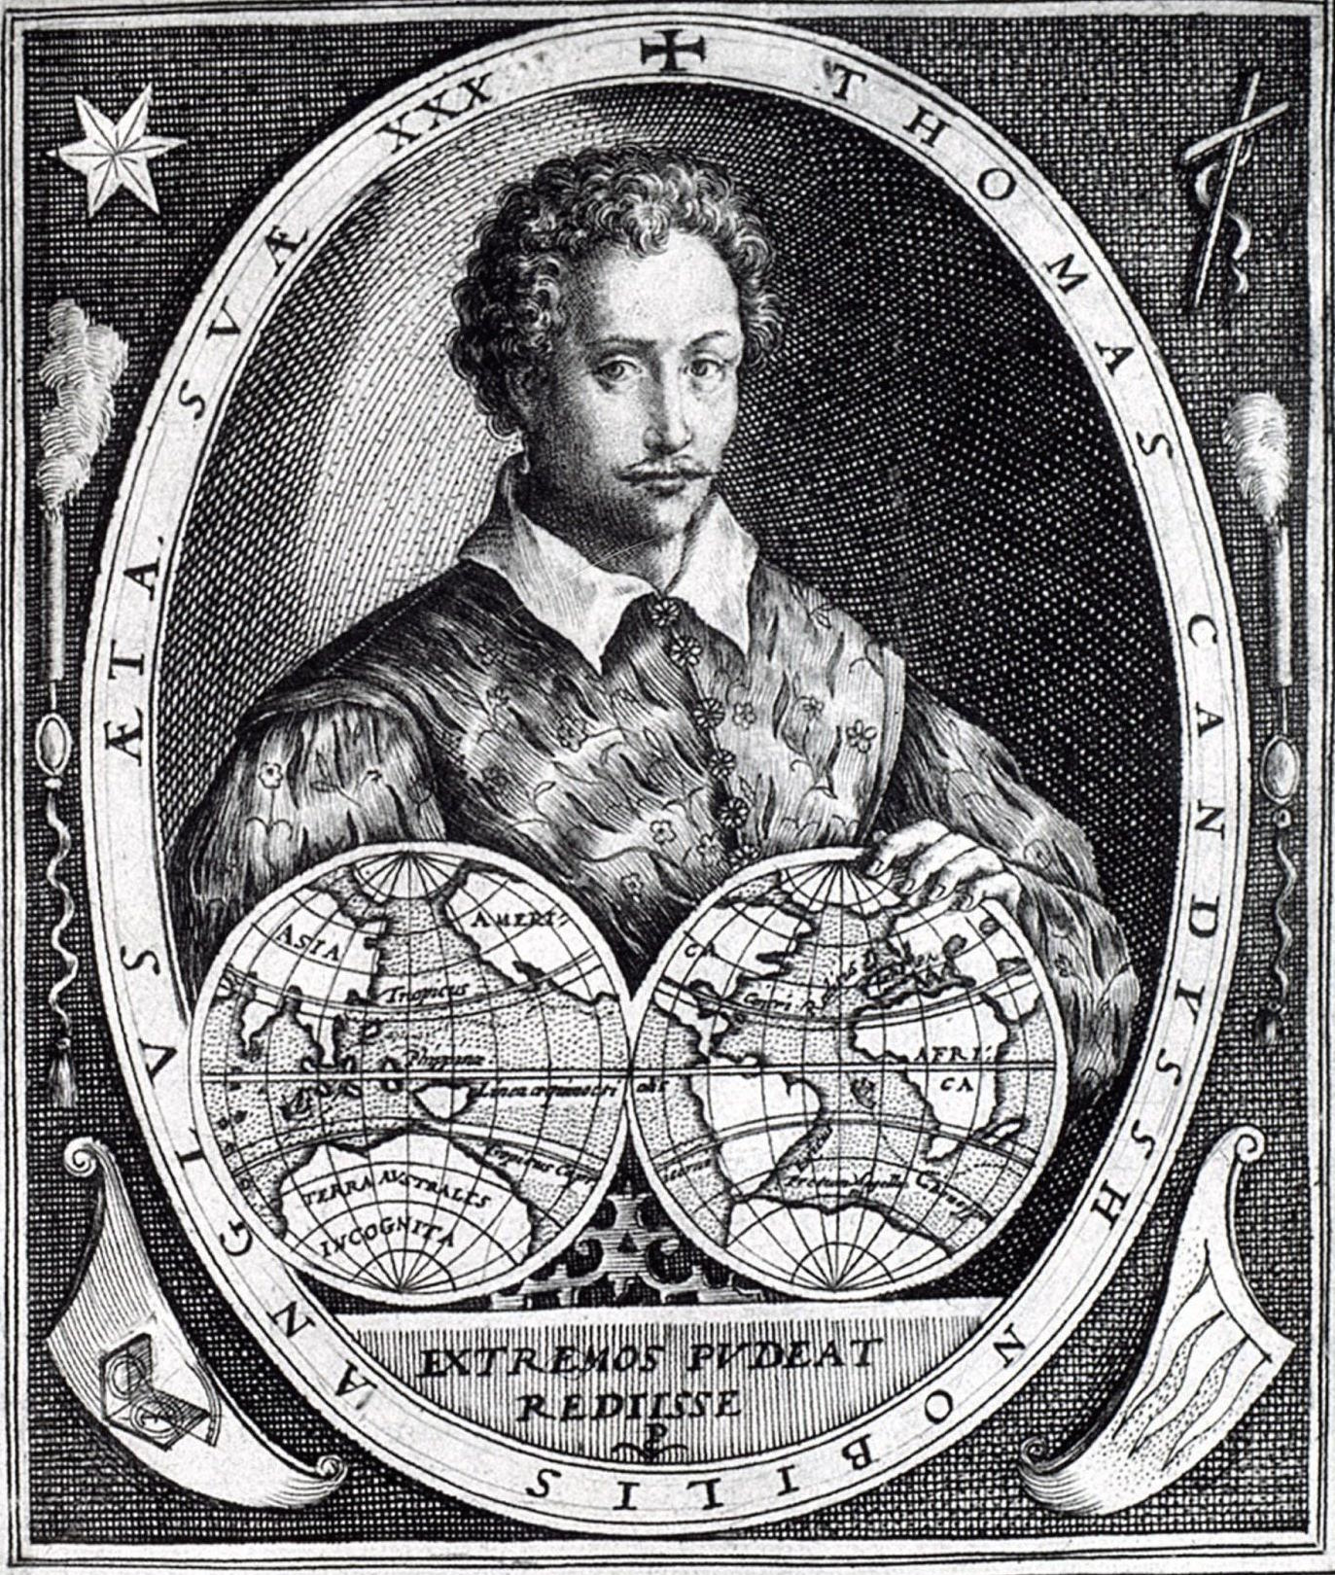The Dowland series continues with four versions of just one lute solo, *Captain Ca*(ve)*ndishes Galliard* all found in English sources, all probably copied in the 1590s. Two are ascribed and two are not, one of the latter bearing the dedication. Neither Poulton nor Ward[18] identified the dedicatee, but Rainer aus dem Spring has suggested it could be the English explorer Sir Thomas Cavendish (1560-1592), called 'the navigator' after he circumnavigated the globe between July 1586 and September 1588 (pictured here aged thirty in an anonymous copy of an engraving from two years earlier by Jodocus Hondius).[19] He was knighted by Elizabeth I on his return and set out on a second expedition in 1591, but died on board the next year aged only 32. So the galliard was probably written and/or dedicated to mark his departure in 1586 when he was just Captain and not yet Sir, otherwise for his departure in 1591, his return in 1588, or his death in 1592, and so is probably an early work of Dowland who was 23 in 1586. The four versions are closely concordant, the first opening with a simplified first bar, and some with a few ornaments, fingering indications and a few variants and errors.[20] Dinko Fabris has argued that Dowland's music was influenced by Lorenzino,[21] and the rhythmic structure of this galliard is similar to some of Lorenzino's gagliarde.

*John H Robinson - September 2015*

**Commentary to *Lute News* 115 and some items in the Lutezine: L1.** barring irregular and double bar lines absent; 3/3 - d2 instead of e2; 7/1 - f2 instead of a2; 8/1-4 - quaver a2a3b4a7 4 semiquavers d3-b3-a3-b3 quaver c4 instead of 4 quavers a2a3b4a7-b3-a3-c4; 16/1-2 - minim and semibreve absent; 16/2 - c4 instead of a7; 23/1 - a5 instead of c5; 29/7 to 32/2 - absent due to page missing, freely reconstructed from bars elsewhere in the piece. **L2a.** all rhythm signs absent; double bar lines absent; 2/1 - chord absent; 9/1 - b4 added; 14/1, 28/2 & 53/2 - a7 instead of a8; 41 - bar absent; 43/1 - a4 instead of a3; 46/6 - e6 instead of d6. **L2b - in the Lutezine**: bar lines absent; 3/1 - minim 3 notes to the right; 4/2 to 5/6, 11/2 to 14/2 - crotchets absent; 15/1 & 17/1 - crotchet 2 notes to the right; 16/1, 18/1, 20/1 & 22/1 - minim instead of dotted minim; 18/6-7 - c4-a3 absent; 19/3 & 6 - c3 instead of c4; 20/1 - dotted minim absent; 25 & 26 - rhythm signs absent; 28/2-3, 29/2-3, 30/2-3, 31/2-3, 32/3 & 50/3 to 51/2 - minims absent; 35/2 - a7 absent; 35/4-6 - rhythm signs absent. **L2c - in the Lutezine**: bar lines absent (except 14/2-3, 36/2-3 & 49/2-3 single instead of double bar lines); anacrusis/1-3, 2/2-5 & 24/2-5 - quavers instead of crotchets; 10/6 - c4 absent; 14/1 - dotted minim absent; 15/1 - minim instead of dotted minim; 26/5 - minim absent; 34/4 to 35/12 - quavers absent; 36/1 - dotted semibreve absent; 37/1, 45/1, 50/1 & 58/1 - d7 instead of a7; 39/1 - a4 instead of a3; 41/2 - d1 instead of a1; 46/6 - c4 absent; 55/2-3 - quavers absent; 62/1 - fermata absent. **L3.** rhythm signs half value thoughout; 21/3 - dotted quaver instead of quaver. **L4.** barred in 6 instead of 3 minims; double bar lines absent; 13/10-11 - e5-c5 instead of c5-e5; 14/1 - minim d2a3a4c5 absent; 19/3 to 20/6 - crotchets absent; 25/4 - crotchet a note to the left; 28/1 - d2 instead of d3; 65/1-2 - 2 crotchets e2f3e4c5-f3 instead of crotchet e2f3e4c5 quavers f1-e1-c1-f2-e2-c2 minim f3; 66/5-8 - quavers instead of crotchets; 75/8 - crotchet 4 notes to the right. **L5a.** barred in 6 instead of 3 minims; 11/1 - a2 absent; 18-19 - single instead of double barline; 23/3 - a5 instead of a6; 24/2 - a5 added; 25/3 - a3 added. **L5b.** barred in 6 instead of 3 minims; double bar lines absent; 7th and 8th course notated a a7, 6/2 - crotchet a note to the right; 10/2-4 - c3-e3-a2 instead of a3-c3-e3; 18/6-8 - dot under 7 instead of 6 & 8; 19/3 - a1 instead of a2; 23/5 & 24/4 - crotchets instead of minims; 24/1 - e5 instead of e4; 38/2 & 50/4 - c7 insted of c8; 39/1 - c5 instead of c6; 40/5 - d6 aligned under previous d3; 42/2 & 44/2 - a7 insted of a8; 45/5 - c1 instead of e1; 46/7-9 - dot under 8 instead of 7 & 9; 48/6 - d5 instead of e5;51/4-7 - crotchets absent. **L6.** barred in 6 instead of 3 minims; bar lines? and double bar lines absent; 19/1 - dotted minim instead of minim; 32/7 - d3 instead of b3; 37/5 - minim instead of crotchet. **L7.** barred in 6 instead of 3 minims; bar lines? and double bar lines absent; 9/3-4 & 19/1 - crotchets absent. **L8.** repeat of A strain of only 7 bars and seems corrupt, and final bar of B strain of 5 beats, retained as in original; barred in 6 instead of 3 minims; double bar lines absent; 2/5 - a3 instead of b3; 12/1 - c5 instead of b5; 28/1 - d2 instead of b2; 28/3 - d2 absent. **L9.** barred in 6 instead of 3 minims; double bar lines absent; anacrusis preceded by a semibreve; 11/4-5 - d1-f1 instead of f1-d1. **L10.** barring irregular and double bar lines absent; x as tenuto (hold) signs; 1/1 & 19/3 - minims absent; 3/1 & 5/4 - d4 instead of d3; 30/2 - h1 instead of i1. **L11.** barring irregular; double bar lines absent; 8/2-5 - crotchets instead of quavers; 16/5 - g3 instead of e3; 33/2 - a4 absent; 33/10 - a2 instead of d2. **L12.** double bar lines absent except at bar 8-9 13-14 - bar line absent; 24/8 - c3 instead c4. **L13.** barring irregular and double bar lines absent; 8/2 - l4 instead of k4; 25-26 & 39-40 - bar lines absent. **L14.** barring irregular and double bar lines absent; 1/1 - minim and chord absent; 2/1 - crotchet instead of minim; 3/2-3 - c3-c5 absent and crotchet above following d3; 5/1, 7/1, 23/1 & 49/1- minims instead of dotted minims; 5/3 to 6/3 & 34/7 to 35/1 - crotchets instead of minims; 11/1-2 - dotted crotchet quaver instead of 2 quavers; 12/2-3 - e1 h4 vertically aligned; 15/2-5 - crotchets absent; 16/1 - crotchet a1c2d3 instead of dotted crotchet g1h2h3; 20/3 - e6 instead of e7; 21/3 & 45/4 to 46/2 - minims absent; 22/1-12 - quavers absent; 25/1-6 - crotchets absent; 28/1 - minim instead of dotted minim; 32/1 - dotted crotchet absent; 32/7 - e2 instead of e1; 33/2 - b5 instead of b4; 38/1 - c2 absent; 38/2 to 39/4 - crotchets absent; 48/1-12 - crotchets instead of quavers; 48/8 - f1 absent; 52/1-2 - minim crotchet absent; 53/2 - c3 added; 58/2 - a1-a5 vertically aligned; 58/3 - c1e2 added. **L15a.** barring irregular and barred in 6 instead of 3 minims; double bar lines absent; 1/5 - minim absent; 2/3 - crotchet instead of minim; 9/3 - crotchet a note to the left; 12/2 - c7 instead of a6; 35/1 - c4 absent. **15b - in the Lutezine**: B strain absent; x as tenuto (hold) signs and single dots under notes to indicate fingering off beats with left hand index finger; 3/1 - x to left of c2 added but impossible to hold; 20/6 - crotchet instead of dotted crotchet. **15c - in the Lutezine**: double bar lines absent; single dots under notes to indicate fingering off beats with left hand index finger; 24/1 & 54/1 - minims instead of dotted minims; 25/1 - crotchet instead of dotted crotchet. **15d.** incipit only from Coelho, unable to get a copy but the Conservatory has plans to digitise it. **L16.** barred in 6 instead of 3 minims; double bar lines absent. **L17.** barred in 6 instead of 3 minims; double bar lines absent; anacrusis preceded by semibreve; 11/8 to 12/1 - crotchets instead of minims; 28/1 - a3 instead of c3. **L18.** barred in 6 instead of 3 minims; double bar lines absent; 1/1-2 - minim crotchet instead of dotted crotchet quaver; 3/3-6 & 34/1 - crotchets absent; 4/7 - crotchet a note to the left; 6/3 - crotchet a note to the right; 6/5, 28/5 & 42/9 - d7 instead of a7; 29/3 to 31/12, 36/2-7 & 42/1 to 43/12 - crotchets instead of quavers; 44/7-8 - crotchet fermata absent. **L19.** double bar lines absent; 6/1 - a2 instead of b2; 14/6 - crotchet instead of quaver; 14/7-10, 22/8-11 & 23/8-11 - quavers instead of semiquavers; 14/9 - c2 instead of b2; 21/6 - c4 added. **L20.** double bar lines absent; 10/2-8 - rhythm signs absent; 13/4 - d6 instead of c6; 15/2 to 16/3 - crotchets absent; 17/6-7 & 27/3-4 - quavers absent; 18 - bar absent; 27/1 - d1 instead of c1; 31/2 - e2 instead of c2; 44/1 - c6 instead of c5; 57/5-9 - a3-b3-d3-b3-d3 instead of a1-b1-d1-b1-d1; 70/2 to 71/4 - crotchetsa3-b3-d3-b3-d3 quavers. **DB43a.** double bar lines absent; 3/3 - d1 absent; 27-28, 35-36, 62-63 & 71-72 - bar lines absent; 40/1 - a6 instead of a7; 67/6 - a4 instead of c4; 69 - bar absent. **DB43b - in the Lutezine:** regularised to 2 minim per bar instead of barring irregularly in 2, 3 or 4 minims per bar; double bar lines absent; 7F notated as a/// except as a/ at 24/3 and a(7) at 56/1, 64/2 & 72/2; 47/1-4 - crotchets instead of quavers; 52/2 - f4 instead of a7; 53/2 - c6 instead of d6; 69 - bar absent; 72/3 - minim and fermata over final bar line. **DB43c - in the Lutezine:** sloping horizontal lines for held notes; a few ornaments '+' probably for an appoggiatura from below and ':' for upper mordant; 1-33/5 - absent and substituted from DB43c; 36/4 - a2 instead of a4; 48/3-4 - double bar line one note to the right; 56/1 - crotchet instead of dotted crotchet; 57/4 - d1 instead of a1; 64/2-3 - double bar line absent; 70/6-8 - c4-e4-f1 instead of c5-e5-d1. **DB43d - in the Lutezine:** double bar lines absent; sloping horizontal lines for held notes; one and two dots under letters for plucking with index and middle fingers of right hand; a ridiculous number of ornaments '#' and 'x' probably for upper and lower mordants; 14/2 - a9 instead of a10; 37/3 - c8 instead of a8; 12-13, 15-16, 34-35, 39-40, 44-45, 55-56, 66-67 & 71-72 - bar lines absent. **JD21a.** right hand fingering dots and # ornament; 4/2-3 - quavers instead of crotchets; 7/3 - minim instead of crotchet; 7-8 - bar line absent; 10/1-4, 12/1, 13/4 & 15/5 tablature missing due to damage to paper; 16/2 - crotchet instead of fermata. **JD21b.** between 8-9 - bar 9 repeated and crossed out. **JD21c.** right hand fingering dots, vertical ties and # ornament; 1/1, 2/1, 6/1, 9/1, 10/1, 11/1, 13/1 & 14/1 - crotchets instead of dotted crotchets; 7/4-5 - crotchets instead of quavers; 16 - rhythm signs absent. **JD21d.** 2/1 - crotchet instead of dotted crotchet; 7-8 - bar line absent; 16/1 - c4 absent. **Rippe13.** dots to indicate left hand fingering of off beats and sloping horizontal lines for tenuto (hold) signs; 13/1 - d3 instead of d2 (not changed in CNRS

edition); 16/1 - e3 instead of e4; 27/1 a3 instaed of a5 (not changed in CNRS edition); 32/4 - a1 instead of c1; 33/1 - c1 instead of a1; 44/1 - h3 instead of h4; 103/4 - e2 instead of e1; 164/2 - g4 instead of h4; 260/1 - c3 instead of a3. **Rippe14.** dots to indicate left hand fingering of off beats and sloping horizontal lines for tenuto (hold) signs; 41/1 - d6 instead of f6; 63/2 - d2 instead of d3; 122/1 - c2 instead of d2; 145/1 - c5 instead of c4; 194/2 - d4 instead of c4. **Rippe15a.** dots to indicate left hand fingering of off beats and sloping horizontal lines for tenuto (hold) signs; 15/2 - a1 instead of e1; 72/2-4 - a5-c5-e5 instead of a6-c6-e6; 94/1 - d3 instead of b3; 108/2-4 - c5-e5-a4 instead of c6-e6-a5. **Rippe15b.** single dots to indicate fingering with left hand index or middle finger and sloping horizontal lines for tenuto (hold) signs; 85/1 - c2 instead of d2. **Rippe 15c.** 21/3 - a3 crossed out; 22/1 - c5 crossed out; 23/1 - c6 crossed out; 25/1 - b3 crossed out; 43/1-2 - minims absent; 47/between 2-3 - c1 inserted; 95/2-4 - d2-c2-a2 crossed out.

**Addendum** to *Lute News* 113 (April 2015), no JD58a/b - thank you to Chris Goodwin (and see letter on the back page of *Lute News* 65, April 2003, p. 28) for the additional information that a proverb that Dowland could have been acknowledging in the title to his *Shoemakers Wife A Toy* (DowlandCLM 58) was published by John Heywood in *A dialogue conteinyng the nomber in effect of all the prouerbes in the englishe tongue* in the first edition of 1546 part 1 chapter XI, sig. E1v and in a different form in the 1562 edition no 277, sig. y1r - see below for extracts from the online facsimile of the 1546 and 1562 editions, as well as another eight editions, available from Early English Books Online at <http://eebo.chadwyck.com/home> access to which requires a subscription.

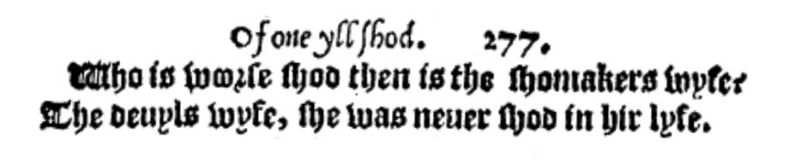

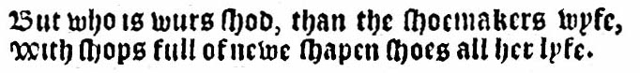

1546 1562

But who is worse shod, than the shoemakers wife, Who is worse shod then is the shoemakers wife:

With shops full of new shapen shoes all her life. The devils wife, she was never shod in her life.

1. Mariagrazia Carlone ‘The Knights of the Lute: Musical Sources’ *Journal of the Lute Society of America* xxxviii (2005), pp. 1-45. A gagliarda (Carlone no 16) paired with a passomezo, and a gagliarda Romanescha (Carlone no 38) are not included here and will be included with the passomezi and miscellaneaous items later in the series. Lorenzino's only known courante was edited in *Lute News* 114 (April 2015). Thank you to Mariagrazia Carlone for comments and corrections to the text here.
2. Recordings of Lorenzino's gagliarde: Paul Beier *Il Cavaliere del Liuto: Music by Laurencinus Romanus* (Stradivarius STR 33447, 1996), my no 4, 6, 8, 11, 15, 17 & 18; Marco Pesci *Lorenzino del Liuto: Preludes Fantasia Dances* (NAXOS 8.570165, 2006), my no 4, 6 & 16.
3. Numbering from inventory in Mariagrazia Carlone article in footnote 1.
4. Also edited in *Lute News* 111 (October 2014), no 34.
5. Numbering from Tim Crawford (ed.) *Thirty Pieces for Lute by Laurencini* (The Lute Society Music Editions, 1979).
6. Jan W.J. Burgers *Joachim van den Hove: Life and Works* (Utrecht, KVNM 2013).
7. Also edited in the *Lutezine* to *Lute News* 102 (July 2012), no 4j.
8. Also edited in the *Lutezine* to *Lute News* 102 (July 2012), no 4n.
9. Although given a separate number, C32 (Herold, ff. 22r-23r *Galliarda*) is a concordance for C36. The four sources of C36 listed by Carlone includes D-Hbusch w.s. (Herold), ff. 32v-33v *Galliarda* which is a version of *Fin de Gaillarde* (Vallet Secretum Musarum I 1615, pp. 39-40) unrelated to any Lorenzino gagliarde, so is probably an error for ff. 22r-23r, that is no C32.
10. Different to Lorenzino Bolognese, Lorenzo del Leuto detto Perla from Padua and Lorenzo Allegri (1567-1648) also called Lorenzo del liuto, or another lutenist named Lorenzo recorded in Rome in the 1620s.
11. However, no L14 & L18 are unique to the Raimondo lute book that also includes a vocal intabulation by Cavagliere that is ascribed to Laurencini in Besard, as well as a prelude and a fantasia that are anonymous but ascribed to Lorenzino in other sources. See also Paul Beier 'Some observations on the music of Lorenzino and the Knight of the Lute’ *Journal of the Lute Society of America* xxxviii (2005), pp. 46-69
12. Mariagrazia Carlone 'The Knights of the Lute' *Journal of the Lute Society of America* 37 (2004), pp. 1-125, which includes transcripts of all the relevant documents. See also Marco Pesci 'Lorenzo Tracetti, alias Lorenzino, suonatore di liuto' *Recercare* IX (1997) 233-242.
13. Another Fleming in Rome at the same time was Giovanni/Jean Matelart (<1538-1607), who published a lute book in 1559 and in 1565 was appointed was maestro di cappella at the Roman church of San Lorenzo.
14. See *Lute News* 104 and associated *Lutezine* (December 2012) for all settings of the tune known to me.
15. All the lute music of Santino Garsi da Parma was edited for *Lute News* 111 and the accompanying *Lutezine* in October 2014.
16. See commentary on page 30.
17. Martin Long (ed.) *Daniel Bacheler Selected Works for Lute* (London, Oxford University Press, 1970), listed as no 43 but music not included. Wonderfully played by Paul O'Dette on CD *Daniel Bacheler: The Bacheler's Delight* (Harmonia Mundi 907389, 2006), track 8.
18. Numbering from Diana Poulton & Basil Lam (eds.) *The Collected Lute Music of John Dowland* (London, Faber, 1974/R1978 & 1981), pp. 89 & 323; and see Diana Poulton *John Dowland* (London, Faber 1972/1982), p. 142; Dowland no 21 is not described in John M. Ward 'A Dowland Miscellany' *Journal of the Lute Society of America* x (1977). p. 142. Recordings of this galliard are included in the Complete Dowland CD sets: Jakob Lindberg *Dowland: Complete Lute Music* (L'Oiseau-Lyre [vinyl LPs] D187D5, 1980); Paul O’Dette *John Dowland: Complete Lute Works* vol. 2 (Harmonia Mundi HMX 2907160.64, 1996/7); Nigel North *John Dowland: Complete Lute Music* (NAXOS 8.557586 8.557862 8.570449 8.570284, 2006-2009); and Jakob Lindberg *John Dowland: The Complete Solo Lute Music* (BIS SACD 1724, 1994/2008).
19. Thomas Cavendish is the central figure in the historical novel *Captain for Elizabeth*, written by Jan Westcott and published in 1948 and based on the events of his first circumnavigation.
20. See commentary on page 30.
21. Dinko Fabris *Andreas Falconieri Napolitani* ((Rome, Torre d'Orpheo 1987), p. 24: 'the great English lutenist [Dowland] shows in his music a formal structure in common with that of Lorenzino' [translated from Italian by Paul Beier].