**Music supplement to Lute News 127 (October 2018): Lute arrangements of music by William Byrd - John Dowland part 28: Earl of Darby's Galliard (JD44) & music for Richard Tarleton (JD59 JD81 plus JD78) - The nightingale & Richard Martin's Change thy mind**

**William Byrd**

There is no evidence that William Byrd played or composed music for the lute, but lute arrangements by others of a dozen or so of his works are known. All are edited here to update Nigel North's edition of 1976, adding a complete lute setting in the Hirsch lute book of a four-voice fantasia from Byrd's *Psalmes Songs and Sonnets* of 1611.[1] Byrd's music set by others is also the subject of a more recent article by Richard Turbet.[2]

William Byrd[3] was born in 1539 or 1540 and married Julian Birley in 1568. They had several children including a son Thomas who was also a musician. Byrd's wife died between 1606 and 1609 and he died in his eighties in July 1623. The catholic Paget family were his patrons from 1576 and another catholic family, the Petres of Ingateson Hall, were his patrons in the 1580s. An early record of him as a composer is the motet *In exitu Israel* which he co-wrote with John Shepherd (d.1558) and William Mundy (d.1591). He was appointed organist and master of the choristers at Lincoln Cathedral in 1563 and then as Gentleman (and composer) of the Chapel Royal in place of Robert Parsons in 1571/2 holding the post for fifty years until his death. In January 1574/5 Elizabeth I granted him and his teacher Thomas Tallis a patent for the rights to print music for twenty-one years. Francis Meres *Palladis Tamia Wits Treasury* of 1598 lists him as one of England's excellent musicians.[4]

The lute arrangements for three of Byrd's works here are attributed to Francis Cutting (nos. 3, 5 & 10), and another one (no. 13) to Collard. The latter is presumably Edward Collard recorded as one of the three lutes in Elizabeth I's court for the brief period of 1598-1599[5] and to whom nine lute solos are ascribed, edited in *Lute News* 105 (April 2005). The lute arrangements are all transcriptions from keyboard originals except nos. 1 & 10 are from consort pieces. The divisions of the pavans and galliards are idiomatic for the lute rather than following the keyboard sources. An incomplete lute setting, lacking the treble, of the fantasia for instrumental ensemble à4 is in the Paston manuscript Add.29246,[6] but a complete lute solo (**no. 1**) was only identified by Peter Trent in the late 1970s, too late for inclusion in the Byrd OUP edition.[7] Pavan **no. 2** lacks divisions but includes a bass line in mensural notation copied (later?) below the tablature in the Weld lute book. It doubles the bass line of the lute rather than being an independent second part, and so is omitted here. Pavan **no. 3** opens with the Lachrimae theme and the three strains all have elaborate divisions. The lute setting is titled *A Pauen Mr Birde set to lute by fr. Cutting* but is ascribed to Thomas Morley in the Fitzwilliam Virginal Book and is considered to be by Morley on stylistic grounds. As well as the lute arrangement with its high fret positions and elaborate divisions, pavan **no. 4** is known from both keyboard and mixed consort settings. Both lute sources of pavan **no. 5**, one with and one without divisions, are attributed to Francis Cutting but only one identifies Byrd as the composer and Cutting as the arranger. The keyboard source ascribes it to Byrd and is titled Pavana Bray, which might refer to Father William Bray from the Jesuit College of St. Omer in Bruges, founded in 1593 as an institution for the catholic education of expatriate English students. The lute setting of pavan **no. 6** is ascribed to Byrd and is not known from non-lute sources. It is uncharacteristic of his music and so the ascription could be an error. It seems unlikely his son Thomas was old enough to have composed it as the source is from the 1580s. Galliard **no. 7** is known from three keyboard sources as well as arrangements for lute and cittern, one of the latter with a second part for bass viol. One lute setting in F is in three sources differing in details, and another setting in G is in a fourth source, which Christopher Morrongiello has suggested could be another arrangement by Collard.[8] It is more awkward on the lute than the setting in F. Galliards **nos. 8 & 9** lack titles but bear the initials WB that could refer to William Byrd but are uncharacteristic of his music, and could instead refer to William Barley although no other lute music is known to have been composed by him. Alternatives are William Blitheman, also one of England's excellent musician's according to Frances Meres,[9] or William Bathe, who published A Briefe Introductione to the True Arte of Musicke in 1584 and *A Briefe Introduction to the Skill of Song c.*1580. As neither are known as lutenists, it could be that these are lute settings of music by one of them for other instruments. A letter from the Earl of Worcester to the Earl of Shrewsbury relates that 'We are frolichere in court; much dancing in the privy chamber of country dances ... Irish tunes are at this time most pleasing but in Winter Lullaby, an old song of Mr Byrd, will be more in request as I think', referring to Byrd's song *Lullaby, my sweet little baby* in his *Psalmes Songs and Sonnets* of 1611.[10] It was arranged for keyboard, lyra viols and lute. The keyboard setting is not thought to be Byrd's own and as one source is dated 1590 it is possible in this case that it is by his son Thomas. The lute setting **no. 10** is by Francis Cutting, and reproduces the vocal setting quite faithfully including the melody somewhat submerged in the alto voice and filling out the chords and so exploiting the resonance of the lute. **No. 11** is one of many lute settings of Lord Willoughby's Welcome Home, and is an anonymous direct transcription of Byrd's keyboard setting. **No. 12** is also a direct transcription of all fourteen variations of Byrd's keyboard setting, and Jan Burgers proposed the lute setting could be by Francis Cutting. **No. 13** is an untitled set of variations on *hughe ashtons grownde* ascribed to *Collard*. Hugh Aston/Assheton/ Ashton/Haston (*c.*1485-1558) graduated Bachelor of Music at Oxford in 1510 and composed church music and music for keyboard including this ground. The lute arrangement is based on Byrd's keyboard variations on Aston's ground rather than a direct transcription.

**1.** GB-Lbl Hirsch 1353, f. 21v untitled pp. 4-5

F-Pn Rés.1122, p. 16 *A Fancy Fantacy William Byrde* - short score

GB-Lbl Add.29246, ff. 41v-42r *Mr. Birde. Fantasia*

- lute intabulation of three lower voices (lacking cantus)

GB-Ob Mus.Sch.D.245, p. 104 (I), D.246, p. 105 (II), D.247, f. 23v (IV)

*10 mr Birde* - viol consort (lacking III)

US-NYp Drexel 4181, ff. 180v-181r (I), 4184, ff. 151v-152r (II), 4182, ff. 184v-185r (III), 4183, ff. 166v-187r (IV) *4 voc. Mr Bird fantasia* - viols

Byrd *Psalmes Songs and Sonnets* 1611, no. 15 *4.Voc. Fantazia* - instr.ens. à4[11]

**2.** GB-WPforester welde, f. 7v *Pauane Mr Wm Birde* 6

- followed by the bass in mensural notation - ByrdN 3; Turbet 23

keyboard (MB27[12] 23a): GB-Lbl Add.30485, ff. 107v-109r untitled; US-NYp Drexel 5612, pp. 96-97 *A Pavion Mr Birde*

**3.** GB-Cu Dd.9.33, ff. 11v-12r *A Pauen Mr Birde set to lute by fr. Cutting* [13] - ByrdN 8; CuttingB[14] 16 8-10

keyboard: GB-Cfm 168, pp. 272-273 *Pavana Thomas Morley*

**4.** GB-Cu Dd 9.33, ff. 35v-36r *Mr Birdes* (pavan) 11-13

- ByrdN 4; Turbet 15

Walsingham,[15] no. 34 *A Pavan of Mr Byrd's* - mixed consort Turbet 22

keyboard (MB27 31a): GB-Lbl Add.31392, ff. 3v-5r *A pavin mr Byrd*; GB-Lbl Mus.1591 (Nevell),[16] ff. 75v-78v *The: v: pauian:*; US-NYp Drexel 5612, p. 136 *Mr Bird A Pavion*

**5** GB-Cu Dd 9.33, ff. 12v-13r *Pauan fr Cutting* [17] 16-18

- ByrdN 2a; CuttingB 21b; Turbet 14

Barley 1596 (Orpharion), sigs. D3v-D4v *Master Birds Pauen*

*set by Francis Cutting A pauan by Mr Byrde* - ByrdN 2b; CuttingB 21a; Turbet 13. keyboard (MB28[18] 59a): GB-Cfm 168, pp. 169-170 *Pavana Bray William Byrd:*

**6.** IRL-Dtc 410/I, pp. 90-91 *mer William Birdes pauine* - ByrdN 9 18-19

**7.** GB-WPforester welde, f. 8r *The Galiard Mr Birde* - ByrdN 5a 20-21

GB-Lbl Hirsch M.1353, f. 2r untitled - Turbet 17)

GB-Cu Dd 9.33, ff. 59v-60r untitled - ByrdN 5b; Turbet 18

GB-Cu Dd 2.11, f. 101v *Mr Birdes* - ByrdN 5c; Turbet 19

GB-Cu Dd.4.23, f. 1v *Mr. Birds Galliarde* - cittern

Holborne 1597, sigs. I3v-I4r *Maister Birds Galliard* - bass viol and cittern

keyboard (MB27 29b): GB-Cfm 168, pp. 285-286 *Galiarda William Byrd*; GB-Lbl Mus.1591, ff. 61v-62v *mr: w: birde: the galliarde to the same* (i.e. *the firste pavian*); US-NYp Drexel 5612, p. 134 *The Galliard*

**8.** GB-Cu Dd.5.78.3, f. 53r ii *WB* (galliard) - ByrdN 10 8

**9.** GB-Cu Dd.5.78.3, f. 53r i *WB* (galliard) - ByrdN 11 13

**10.** GB-Cu Dd 9.33, ff. 4v-5r *Mr Birdes Lullaby*

*set by fr. Cutting* - ByrdN 1; CuttingB 49; Turbet 12 22-23

GB-Cu Dd.4.23, f. 8v *lullaby* - cittern solo

GB-Lam 600, ff. 78v-79r *Birds Lullaby* - lyra viol part (ffhfh)[19]

GB-Lbl Add.31992, ff. 21v-22r *fol. 46 Mr Byrde Lullaby La.p.al.3.t.*

- lute intabulation of three lower voices (lacking cantus)

Byrd *Psalmes Songs and Sonnets* 1611, no. 32 *Lullaby, my sweet little baby*

- viol consort à5 (superius part copied into US-U 783.9T136s cop.2 - Taylor's *Sacred Hymns* 1615); keyboard (MB 28 110, MB55[20] 53): GB-Lbl Add.30485, f. 57v *lulaby* - incomplete; GB-Lbl Add.30485, ff. 101v-102v untitled; US-NYp Drexel 5612, p. 194 *lullaby Mr Bird*

[Additional: GB-Cu Dd.2.11, f. 65r *Lullaby*; NL-Lt 1666 f. 400v *Lullabye*]

**11.** GB-Lbl Eg.2046, f. 33v *My lord willoughbies welcom home* [21]

*by Mr byrde* - ByrdN 6; Turbet 20 24-25

Byrd's keyboard setting (MB27 7): GB-Cfm 168, pp. 278-279 *Rowland William Byrd*; F-Pn 1186,[22] ff. 64v-65r *My Lord Willbee's wellcome home*; GB-Lbl Add.30485, f. 115v *the second straine of o neighboure robart;* GB-Lbl Mus.1591, ff. 146v-148v *lord willobies welcome home maister willm birde*; GB-Lbl RM24.d.3, ff. 13v-14v *Lo: willobees wellcome home Mr: Birde*; US-NYp Drexel 5609, pp. 146-147 *My Lord Willbee's welcome home*

**12.** GB-Gu Euing 25 ff. 33r-34vuntitled pp. 26-29

- (The woods so wild) ByrdN 7;[23] CuttingB 55; Turbet 21

Byrd's keyboard setting (MB28 85): F-Pn 1186, f. 117r *Woode so wilde* - 1st var only; GB-Cfm 168, pp. 127-128 *The woods so wild William Byrd 1590* ; GB-Lbl Add.30485, f. 67r *walke the woods so wilde*; GB-Lbl Add.31403, f. 23v *The wood so wylde: Mr William Byrd*; GB-Lbl Mus.1591, ff. 109r-113r *Will yow walke the woodes soe wylde mr: w: birde: anno: dni: 1590:* (earlier version lacking variations 12 & 13); GB-Lbl RM24.d.3, f. 61v p. 118 *The wood soe wilde*; US-NYp Drexel 5609, p. 90 *Woode so wilde*

**13.** GB-Cu Dd.5.78.3, ff. 41v-42v *Collard* [24]- Byrd N 14 30-32

GB-Cu Dd.2.11, ff. 101-101v untitled

Byrd's keyboard setting (MB27 20): GB-Lbl Mus.1591, ff. 153v-161r *hughe ashtons: grownde: mr w: birde:* GB-Cfm 168, pp. 111-114 *Tr. Ground* *William Byrd*; GB-Lbl RM24.d.3 (Forster), ff. 196v-203r *A grounde Mr Byrd*; GB-Lbl Add.30485, f. 61r *Mr Birds Grownd*

**John Dowland**

Nine sources of The Earl of Derby's Galliard JD44 are known, five with ascriptions to Dowland and four anonymous, all with three strains of ten, eight and twelve bars, and all for a lute in G with a diapason tuned to D (a seventh course except an 8th in D for JD44g and a 9th in D for JD44i). Six of the sources include divisions and all settings differ considerably in figuration, especially in the degree of written out embellish-ment and the variety of attempts to correctly notate the complex rhythm of the third strain, all reconstructed here or in the *Lutezine* (and see commentary in the *Lutezine* for details). The sources also differ in notated playing instructions, such as sloping lines for tenuto (JD44c,e,f), dots below tablature letters for right hand fingering (JD44a,c,e,f,i use one dot for index finger and JD44a also uses two dots for middle finger) and ornaments (JD44c,e use #, JD44f uses #, as well as +, and JD44a uses # for a shake? and + for a fall?, as well as • for a relish?). Mathew Holmes copied a version on the first page of his fourth lute book (Nn.6.36) and then copied another version on the second page, both with divisions. Both also include written out ornamental shakes but the second is significantly different from the first, so presumably from a different exemplar. Both also have a lot of mistakes and the second in particular is marred by numerous crossings out, so that Holmes did not make a very good start to a new lute book, and curiously the second version was chosen for inclusion in DowlandCLM.[25] But the best version by far is in the Sampson lute book (GB-Lam 602, *c.*1609), and Robert Spencer commented in the Boethius Press catalogue of 1991 that it was 'a superbly graced version'. This version and one lacking divisions from Mathew Holmes' second lute book (Dd.5.78.3) are included here, and the rest are edited in the *Lutezine*. The version in Robert Dowland's *Varietie* published in 1610 also contains errors such as a missing bar in the division to the third strain and does not seem to have been revised to any advantage (this version also included in DowlandCLM). So it is an example of *Varietie* being far from the ideal showcase of his father's music! Versions are also in the English sources Euing 25 and the Weld lute book, and two more are in continental manuscripts. Three of the sources are dedicated to the Earl of Derby and 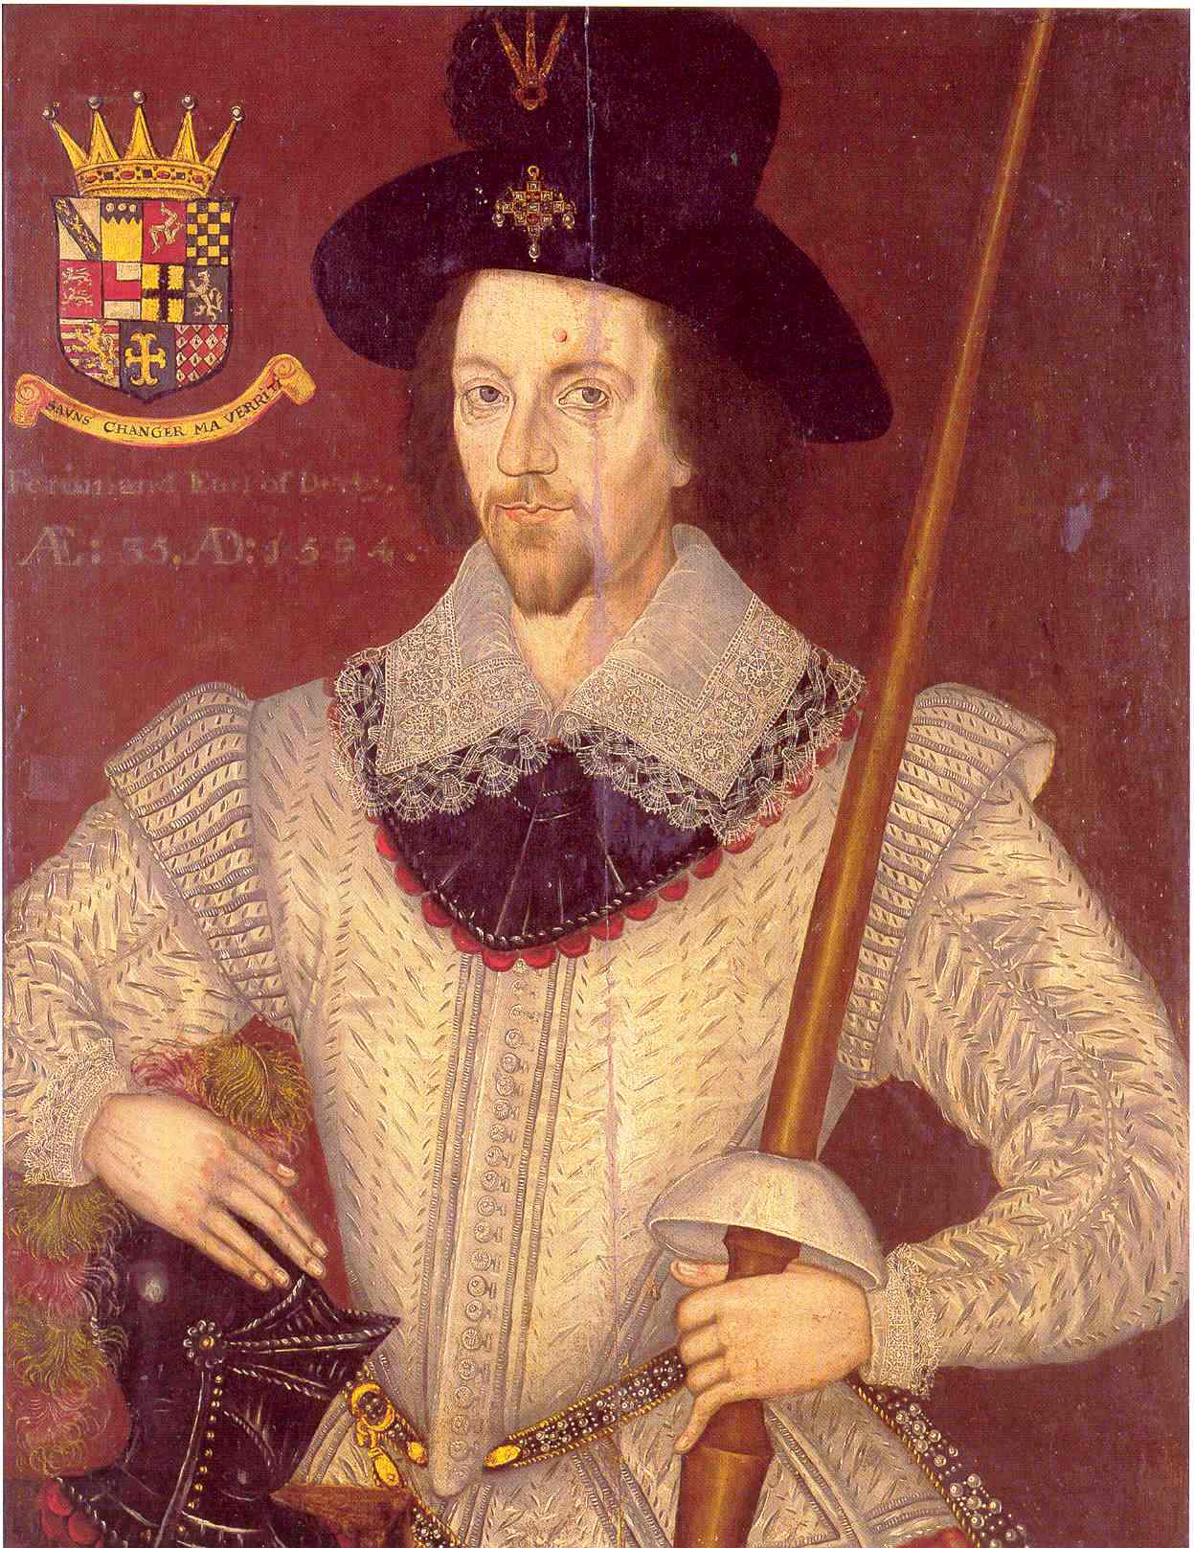*Varietie* specifically names the Earl as Ferdinando, which must be Ferdinando Stanley 5th Earl of Derby (see anonymous painting left) who acceded to the Earldom in 1593 and died a year later, probably from poisoning. The circumstances for the dedications are not known but its grave but bold character would have suited his funeral. However, it is curious that the sources from around the time he died or before (JD44b,d,f), lack the dedication, which is only found in three, later, sources (Nn.6.36 copied by Mathew Holmes *c.*1605-1615, *Varietie* published in 1610 and the Schele lute book dated 1619), when Ferdinando's brother William was the current, 6th Earl of Derby. The Earls of Derby up to Ferdinando were also titled Baron Strange, and a few lute solos are dedicated to the Strangs including one by Dowland,[26] edited in the *Lutezine*.

**JD44a**. GB-Lam 602, f. 13v *a galiarde by mr Dowland* pp. 14-15

**JD44b**. GB-Cu Dd.5.78.3, f. 38r *J D.* 15

JD44c. GB-Cu Nn.6.36, f. 2r *The Erle of Darbies Galiard*

*by Mr Jo. Dowland* - DowlandCLM 44

JD 44d. GB-Gu Euing 25, f. 21r untitled

JD 44e. GB-Cu Nn.6.36, f. 1r untitled

JD 44f. GB-WPforester welde, f. 7r *Galliard Dowlande*

JD 44g. Dowland 1610, sig. M2v *The Right Honourable Ferdinando*

*Earle of Darby, his Galliard* - DowlandCLM 44a

JD 44h. D-Hs ND VI 3238, p. 142 *Mÿ lord of Darbois Galliard. M. Johan Doulandt*

JD 44i. D-Hbusch, ff. 39v-40v *Galliarda*

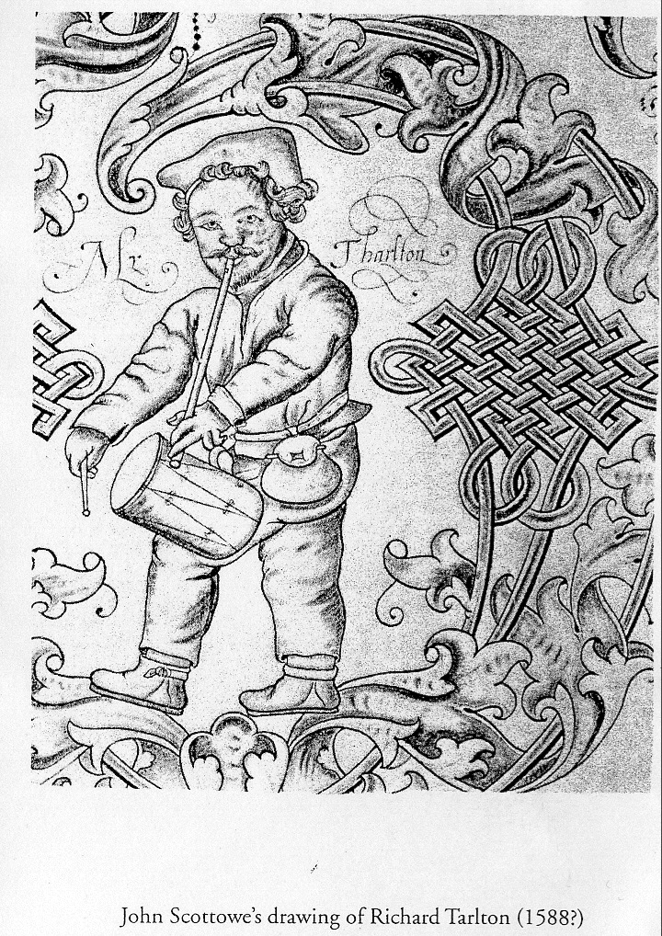Here are three short items, one ascribed to Dowland and two likely to be by him. Two of the three are also associated with the name Tarleton, almost certainly Richard Tarleton who was unique in being both an Elizabethan court fool/jester and a famous comic actor on the public stage (illustration of Tarlton with pipe and tabor right from John Scottowe's drawing *c.*1588 in GB-Lbl Harl. 3885, f. 19r).[27] Other music now lost, seems to have been associated with Tarleton, such as *tarlton trunke hose[28]* and *tarlton is buten cape* in the dance tune list from Lleweni Hall in North Wales written in the 1590s,[29] and *Tarltons Medley* called for in the broadside ballad 'A new Medley, or, A Messe of All-together. To the tune of Tarltons Medley' beginning 'Strange news is come from Hounslo heath' (EBBA[30] 30205 -1601-1640?). According to Diana Poulton JD59 *tarletones riserrectione* is 'one of Dowland's small scale masterpieces, almost certainly an early piece since it would have been written to commemorate the death in 1588 of the famous comic actor Richard Tarleton'. Although not ascribed, JD78 has much in common with JD59 and is amongst a group of ten untitled lute solos the rest known to be by Dowland from other sources suggesting this one is also by him. JD81 is also untitled but a mixed consort setting calls it *Tarletons Jigge*. It is reminiscent of Dowland's other jigs, and so could also be by him. The source of the lute solo is Mathew Holmes first lute book, and after copying it was amended: the original is here and the amended version is in the *Lutezine*.

**JD59.** US-NHub Rare Ma21 W632, f. 11r *tarletones riserrectione / Jo Dowlande* - DowlandCLM 59 p. 19

**JD78.** GB-Gu Euing 25, f. 26r untitled 25

**JD81.** GB-Cu Dd.2.11, f. 56r untitled - DowlandCLM 81 29

GB-Cu Dd.4.23, f. 25r *Tarletons Willy* - cittern *Lutezine*

Mixed consort: GB-Cu Dd.3.18, f. 53r *Tarleton Jigg* - lute; GB-Cu Dd.14.24, f. 17r *Tarletons Jigge* - cittern; GB-Cu Dd.5.21, f. 5r *Tarletons Jigge* - recorder; GB-Cu Dd.5.20, f. 5r *Tarletons Jigge* - bass viol - MB40[31] 23

**The Nightingale**

From the large number of sources, it seems that *The Nightingale* was an unusually popular tune in the seventeenth century, probably because of the imitation of the bird's song in the second strain. Settings are known in English and continental sources for lute (2), cittern (4), lyra viol (10) and keyboard (18), as well as one each for recorder, cithrinchen, mandore, violin and flageolet. One version for lute is edited here, and another ten settings (and other nightingale tunes) are in the *Lutezine*. The original ballad the tune was probably written for is 'The Nightingale: Whose curious Notes are here explain'd, In a dainty Ditty sweetly fain'd. To a new and much affected Court Tune' beginning: 'You Gallants that resort To Hide Parke or Totnam Court' with the refrain 'Sweet, sweet, sweet, sweet, Jug, jug, jug, jug, sweet, jug, jug, jug, jug, the Nightingale doth sing' (EBBA 30207 - 1624-1680?). Other ballads that call for the tune include Martin Parker's 'The Wooing Lasse, and the Way-ward Lad, Who long had made his Sweet-heart sad, Because to her hee would not yeeld, Till Cupid him to Love compeld. To the tune of The Nightingale' beginning 'Vpon a Holyday, When the Nymphs had leave to play' (EBBA 30354 - 1634-1658?), and paraphrases of the first stanza of the first part and the fifth stanza of the second part were reprinted with the music in Thomas D'Urfey's *Wit and Mirth, or Pills to Purge Melancholy* of1719 V pp. 86-87; and as late as the nineteenth century in 'Lamentation & Confession of Palmer: Air - The Nightingale' beginning 'In Rugeley town I was born and reared, All in the county of Staffordshire' (Bod[32]14540 Roud V16160 - 1856). Ottorino Respighi (1879-1936) used the same tune in his orchestral suite *Gli Uccelli,* 1927, as incidental music for Aristophanes' *The Birds* of 1928*.* And *Air 18 The Nightengale* lacking music is in Gabriel Odingsells' *Bays 0pera* of1730 but the text does fit the tune here.

**N1.** GB-Ctc O.16.2, p. 130 untitled 21

Mace *Musick's Monument* 1676, p. 201 *Nightingal* - lute (dedff)

cognates for other instruments are in the *Lutezine*

**Change thy mind by Richard Martin**

Here is an anonymous lute setting, with a change of key, of the tune from a lute song by Richard Martin (1570-1618) to the poem 'Change thy minde' by Robert Devereux, Earl of Essex, found in Robert Dowland's *A Musical Banquet* of 1610.

**C1.** Robert Dowland *Musical Banquet* 1610, sigs. B2v-C1r *II.Change*

*thy minde since she doth change - Richard Martin. The Right Honourable Robert Earle of Essex: Earle Marshall of England* - lute song[33] 7

**C2.** IRL-Dm Z.3.2.13 (Marsh), p. 380 *chayng thy minde* - lute 7

*John H Robinson - October 2018*

1. Nigel North *Music for the Lute 6: William Byrd* (OUP 1976), see ByrdN numbering in the worklist. North included lute versions of three corantos (ByrdN 12), edited for the *Lutezine* to *Lute News* 117 (April 2016), and la Volta (ByrdN 13), a few versions edited for *Lute News* 78 (June 2006). But Byrd did not compose them and the lute settings are unrelated to Byrd'sversions so they are not included here. I also made my own lute arrangements of Byrd's settings from the Fitzwilliam Virginal Book of *Callino Casturame* and *The Daunce* (Dulcina) for the *Lutezine* to *Lute News* 125 (April 2018) and *The Bells* for the *Lutezine* to *Lute News* 126 (July 2018).
2. Richard Turbet ‘Byrd’s music arranged for instruments by his contemporaries’ *The Viola da Gamba Society Journal* III/2 (2009), pp. 113-116 (see Turbet numbering in the worklist).
3. Biographical details from Andrew Ashbee and David Lasocki *Biographical Dictionary of English Court Musicians* (Ashgate 1998) I pp. 222-226 (in the Byrd entry of *Grove Music Online* his birthdate is given as 1543.
4. 'Englande hath these [excellent Musitians]; Maister Cooper, Maister Fairfax, Maister Tallis, Master Tauerner, Maister Blithman, Maister Bird, Doctor Tie, Doctor Dallis, Doctor Bull, M. Thomas Mud, sometimes fellow of Pembrook hal in Cambridge, M. Edward Iohnson, Maister Blankes, Maister Randall, Maister Philips, Maister Dowland, and M. Morley.'
5. Ashbee & Lasocki 1998, *op. cit..* I p. 276.
6. British Library online facsimile: <http://www.bl.uk/manuscripts/FullDisplay.aspx?ref=Add_MS_29246>
7. For more on the lute intabulations of Byrd’s vocal music in the Paston manuscripts see Philip Brett ‘Pitch and transformation in the Paston manuscripts’ in: C. Banks, A. Searle and M. Turner (eds) *Sundry sorts of music books: essays on the British Library collections, presented to O.W. Neighbour on his 70th birthday*, (London: British Library, 1993), 89-118.
8. Thank you to Chris Morrongiello for this information and other comments.
9. See quote in footnote 4.
10. 'Be still, my blessed Babe, though cause Thou hast to mourn,  
    Whose blood most innocent to shed the cruel king has sworn' etc. refrain: 'O woe and woeful heavy day when wretches have their will!  
    Lulla, la-lulla, lulla, lullaby'. Full text at:

    <http://www3.cpdl.org/wiki/index.php/Lulla,_lullaby,_my_sweet_little_baby_(William_Byrd)>
11. Kenneth Elliott *The Byrd Edition* 17: *Consort Music* (Stainer & Bell 1971) 4.
12. Alan Brown *William Byrd Keyboard Music* I Musica Britannica 27 (1976).
13. Also edited for *Lute News* 61 (April 2002) with music of Thomas Morley.
14. Jan Burgers *Francis Cutting: Collected Lute Music* (Lübeck, Tree Edition 2002) - most of the editorial corrections incorporated here.
15. Hull, University Library (GB-Hu) DD HO 20/1 - treble viol; HO 20/2 - flute; and Oakland, Mills College Library (US-OAm) Parton MS - cittern.
16. British Library online facsimile:

    <http://www.bl.uk/manuscripts/FullDisplay.aspx?ref=MS_Mus._1591>
17. Played by Alex MacCartney *Elizabeth's Lutes* (Veterum Musica 2015) tr 10.
18. Alan Brown *William Byrd Keyboard Music* II Musica Britannica 28 (1976).
19. Richard Carter published a hypothetical completion of *Lulla, lullaby* for three lyra viols in *Birds Lullaby Set for Three Bass Viols Alfonso Way* Oriana Music OM119 (Kritzendorf 2008).
20. Alan Brown *Elizabethan Keyboard Music* Musica Britannica 55 (1989).
21. All edited for *Lute News* 113 & *Lutezine* (April 2015).
22. BNF online facsimile:

    <https://gallica.bnf.fr/ark:/12148/btv1b531553751>
23. All settings edited for *Lute News/Lutezine* 107 (October 2013).
24. Also edited for *Lute News* 105 (April 2013) with music of Edward Collard.
25. Diana Poulton and Basil Lam *The Collected Lute Music of John Dowland* (London, Faber, 1974/R1978/R1981), pp.149-154 & 329-330; Diana Poulton *John Dowland* (Faber 1972/R1982), pp. 157-158.
26. JD65, GB-Cu Dd.2.11, f. 58r *Lord Strangs March J D*, edited for *Lute News* 100 (December 2011).
27. See John Southworth *Fools and Jesters at the English Court* (Sutton Publishing 1998), pp. 107-117 & 124-129.
28. The tune is also quoted in the anonymous play *The Partiall Law* of 1625 (act II scene iv): Woman 2. 'Nay that's as old as the beginning of the world, or Tarleton's Trunk-hose'.
29. See Sally Harper ‘An Elizabethan Tune List from Lleweni Hall, North Wales’ RMA Research Chronicle no 38 (2005), pp. 45-98.
30. University of California Santa Barbara: English Broadside Ballad Archive: <http://ebba.english.ucsb.edu>
31. Warwick Edwards *Music for Mixed Consort* Musica Britannica 40 (1977).
32. Broadside Ballads Online at the Bodleian Libraries:

    <http://ballads.bodleian.ox.ac.uk>
33. Text for all five verses can be found at:

    <http://www.lieder.net/lieder/get_text.html?TextId=4662>