**Music supplement to Lute News 69 (April 2004) Collected Lute Music of Francis Pilkington**

This supplement includes all the lute solos associated with the Cheshire lutenist and composer Francis Pilkington (c1570-1638).[1] He held posts at Chester Cathedral from 1602, taking holy orders and being ordained priest in 1614, maintaining his position in the cathedral choir for more than a quarter of a century, up to his death in 1638. His lute music amounts to fifteen solos ascribed by name or initials for six- or seven- course lute in renaissance tuning in a variety of forms: five pavans, six galliards, a curranta, two sets of variations and an almaine.[2] Also included are three doubtful items, an almaine probably composed by Robert Johnson that Pilkington may have arranged for the lute-like instrument, the stump, a lute duet for which only one part is ascribed to Pilkington, and a pavan for Orpharion included in one of Pilkington’s prints but ascribed to the Earl of Derby.[3] All Pilkington’s lute music is found in four sources comprising eight items ascribed simply to ‘Francis Pilkington’ or contractions thereof in Dd.2.11 (*c.*1590-5), which suggest they were composed before he was awarded Bacheler of Music from Lincoln College Oxford in 1595, when he was probably in his mid twenties; five more are found in 31392 (*c.*1600-1605), all referring to his B. Mus.; and one further item without reference to his B. Mus. in Dd.9.33 copied by Mathew Holmes probably *c.*1600-5, which is curious as it might be expected that Holmes would have known of Pilkington’s Oxford B. Mus. in 1595. There seems no reason to doubt these ascriptions despite the fact that none appear in more than one source. Pilkington presumably composed the pavan printed in his *First Booke of Songs* published in 1605,[4] for lute accompanied by a part for bass viol in mensural notation that largely doubles the bass, although it stands alone as a lute solo (reproduced here with and without the bass viol part). The lute sources all considerably predate his two books of madrigals[5],[6] suggesting the lute music that survives comes from earlier in his life, although he refers to himself as ‘Lutenist’ on the title page of all three of his prints, published 1605, 1613 and 1624.3-5 Pilkington’s lute music is quite distinctive compared to his contemporaries and represents an important contribution to the English renaissance lute repertoire, although influences are apparent as in the cadences of each strain of pavan 3 which are similar to those in Dowland’s Lachrimae pavan, and no. 9 is reminiscent of Dowland’s Lady Rich galliard throughout. All the lute solos were reproduced in facsimile and piano transcription in an edition by Brian Jeffery in 1970,[7] and this supplement is a companion to provide the edited tablature. Eight of the fifteen lute solos are dedicated to one of six people, five referred to in Dd.2.11 and one in 31392. I have establish little more about the dedicatees than was known to Richard Newton in 1959 and to Brian Jeffery in 1970.[8]

Four doubtful items are included here and numbered 16-19 following the numbering for the fifteen lute solos in Jeffery’s edition. No. 16 is *Alman R Johnson to the stumpe by F P...* (what follows the ‘P’ is not clear) and is from Oxford, Library of Christ Church, Ms. Mus. 532, the title suggesting it is a setting for the stump[9] by ‘F P’ of an almaine by Robert Johnson. The initials ‘FP’ in the original title may be a reference to Francis Pilkington.[10] The tablature is reproduced here as in the original for the 15-course stump, as well as in my transcription for 7-course lute transposing the bass passages up an octave. Also included as no. 17 is a duet for equal lutes because one part is ascribed to Francis Pilkington, acknowledging his B. Mus., although the other part, in an unrelated manuscript, is ascribed to Mr. (John?) Marchant.[11] It seems unlikely that the composers wrote one part each and so one or both of the ascriptions are probably wrong, although on stylistic grounds Pilkington seems more likely to be the composer. No. 18 is a pavan for orpharion ‘made by’ the Earl of Derby that Pilkington printed in his *Second Set of Madrigals*,5 included here because it is possible that Pilkington influenced or even assisted in its composition which is suggested by a degree of similarity with the lute solos ascribed to him.[12] Pilkington may have been familiar with the orpharion as he gave it as an alternative to the lute for accompanying the songs in his *First Booke of Songs* in 1605.[13] Finally, no. 19 is anonymous but has the character of Pilkington's music, especially no. 12 here and so may be by him. Mrs. Jane Leighton may have been a member of the family of Sir William Leighton (1565-1622) whose *Teares or Lamentacions* of 1614 included two consort alnthems by Pilkington.

**Worklist:[14]**

Minor editorial changes made without comment. Numbering from Jeffery.

**1. Pavan:** GB-Cu Dd.2.11, f. 6r *Georg*[e] *Pilkingtons funerall / made by Fr. pilkington.*

**2. Pavan:** GB-Lbl 31392, f. 23v *A pauen by ffra / Pilk:: Ba:: of musick* [7th course tuned to D]

**3a. Pavan**: Pilkington *First Booke of Songs* 1605, sig. Miiv *A Pauin for the Lute and Base Violl. XXII./XXII. BASSO.* [7 to D]

**3b. Pavan:** Lute solo without bass viol part.

**4. Pavan:** GB-Cu Dd.2.11, ff. 14r-13v *A Paven / Fr. Pilkingto*[n] 4-6

**5. Pavan:** GB-Lbl 31392, f. 24v *A pauen by ffra: Pilk / Bachiller of musick* [7 to D]

**6. Galliard:** GB-Cu Dd.9.33, f. 8r *A Galliarde / Fr: Pilkington* [7 to D, used only once]**[15]**

**7. Galliard:** GB-Cu Dd.2.11, f. 4r *Mrs E. Murcots / Delight. / Fr Pilkington*

**8. Galliard:** GB-Cu Dd.2.11, f. 85r *Mris Anne / Harecourts / Galliarde. / Fr. Pilk*[ington]*:*

**9. Galliard:** GB-Lbl 31392, ff. 22v-23r *mrs marie / Oldfeilds galliard / by ffra: pilkington / Bachi: of musick.* [7 to D]

**10. Galliard:** GB-Cu Dd.2.11, f. 5r *Mrs Elizabeth Murcots Fr Pilkington*

**11. Galliard:** GB-Cu Dd.2.11, f. 5v *Mer Ti*[mothy?]*: Wagstaffs Content of Desier. F. Pilk*

**12. Curranta:** GB-Cu Dd.2.11, f. 3v *Curranta for Mrs E. murcott. / F Pilkington*

**13. The Spanish Pavan:** GB-Lbl 31392, f. 25v *the Spanish Pauen set out by ffra: Pilkington / Ba: of Musick*

**14. Almaine:** GB-Cu Dd.2.11, f. 5v *The L. Hastings / God morow / Fr Pilkingto*[n]

**15. Go from my Window:** GB-Lbl 31392, ff. 26v-27r *goe from my / wyndowe by / maister Frauncis / Pilkington Bacheler of Mu:*

**16. Almaine for stump** [doubtful]

a. Och 532, last piece *Alman R Johnson to the stump by F P*... [15-course stump]

b. Transcribed for renaissance lute [7 to F]

**17. Eccho or Almaine for two lutes** [doubtful]

a. Brogyntyn (*c*1595-1600), p. 31 *Eccho for 2 luts by Mr ffra Pilk Bach: of Musicke* [lute I]

b. Sampson (*c*1609), f. 11v *an allman for ii lute by mr Marchant* [lute II]

**18. Pavan for orpharion** [by the Earl of Derby - using fret ‘n’ in 12th bar. Pilkington 1624, no. 27 (Altus part-book, sigs. E1r-E1v), *A Pauin made for the Orpharion, by the Right Honorable, William Earle of Darbie, and by him consented to be in my Bookes placed* [index: *A Pauin by the Earle of Darbie for the Orpherion XXVII*] [courses 7-10 tuned to F, E, D and C]

**19. Mrs Jane Leighton’s choyce**: GB-Lam 601 (Mynshall), f. 6v *Mrs Jane Leightons choyce*

*John H. Robinson, Newcastle University, February 2004*

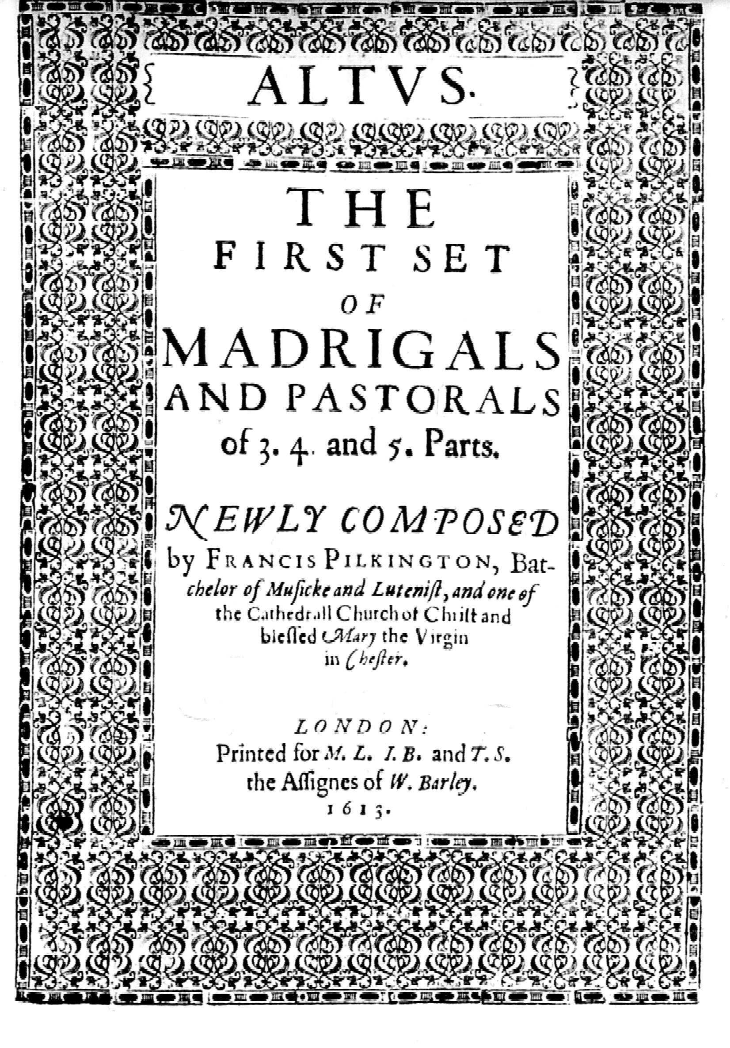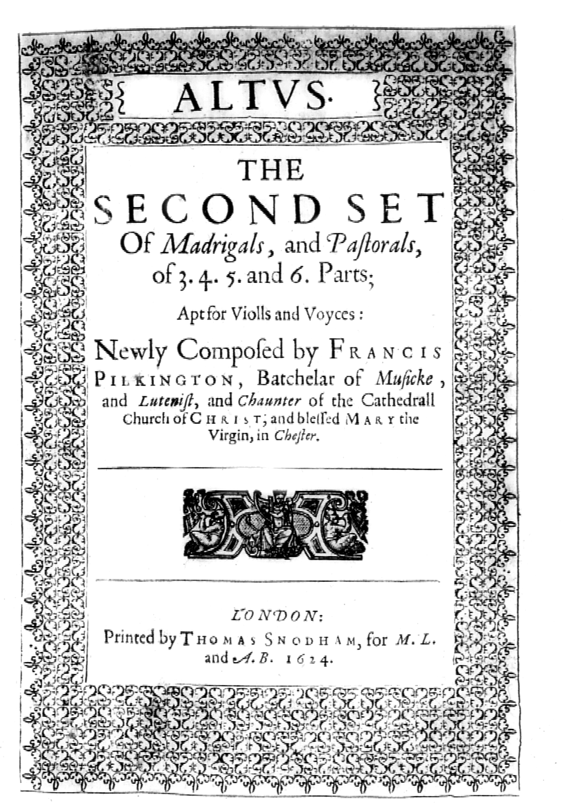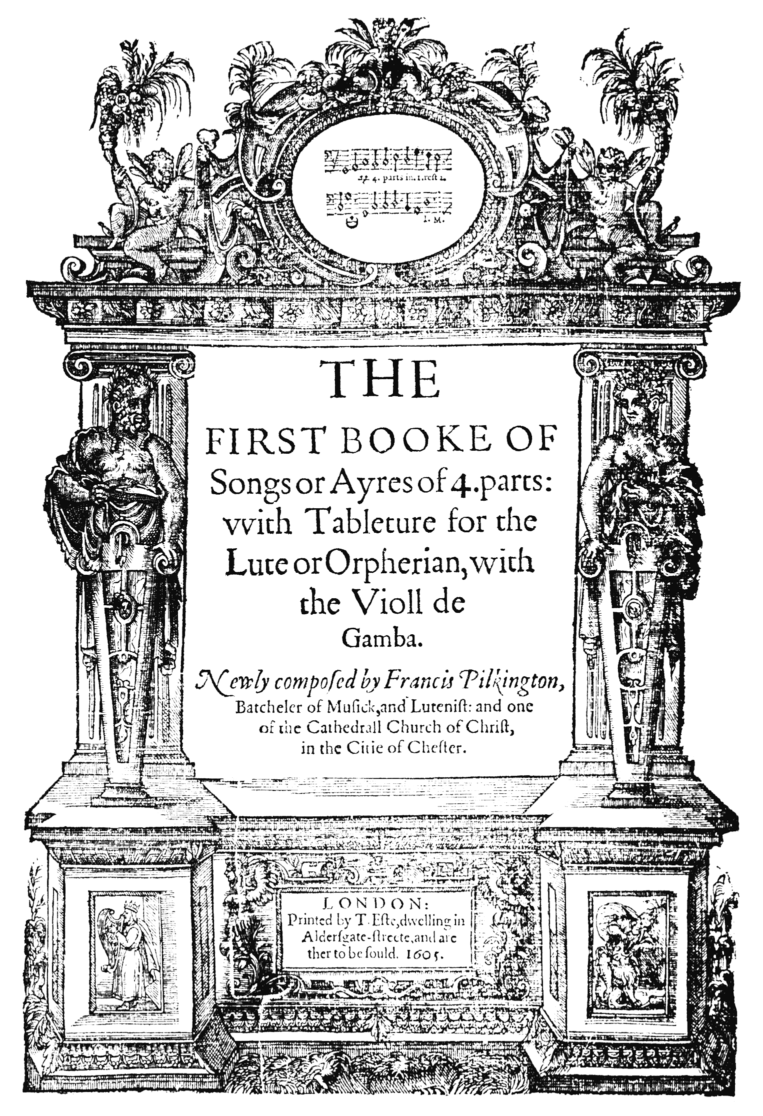

1. Thanks to Ian Harwood for proof-reading this text. Cf. David Brown, ‘Pilkington, Francis’, *New Grove II* on-line. Richard Newton, ‘The Lute Music of Francis Pilkington’, *Lute Society Journal*, i (1959), pp. 31–7. To hear a selection of Pilkington’s music see the CD ‘Music Dear Solace to my Thoughts: Francis Pilkington: Songs from the First Booke of Ayres and Lute Solos’ by Bruce Scott Fithian (tenor) and Olav Chris Henricksen (lute), Centaur Records CRC 2614 (2002). Vere Pilkington, a descendant of Francis Pilkington, owned the Boynton keyboard and lyra viol manuscript until it was purchased in 1996 by the British Library since when it has been known as Add. MS 63852 (contents listed in Virginia Brooks, *British Keyboard Music to c.1660: Sources and Thematic Index*, Oxford: Clarendon Press, 1996, p. 45). It has the initials E. B. on the cover (and the last Cambridge lute manuscript copied by Mathew Holmes, Nn.6.36, f. 17r has the title 'Mrs E B teares') but the identity of EB is not known.
2. The CD by Bruce Scott (tenor) and Olav Chris Henriksen (lute) *Music Dear Solace to my Thoughts: Francis Pilkington - Songs from The First Booke of Ayres and Lute Solos* (Centaur CRC 2614, 2002), included lute solos 3, 6, 7, 12, 13, 14, 15.
3. William Stanley (d.1642), 6th Earl of Derby, who in 1594 succeeded his brother Ferdinando Stanley, the 5th Earl of Derby and dedicatee of Pilkington’s *First Booke of Songs*. Edmund Spenser celebrated Ferdinando in his *Colin Clovts Come Hom*e *Againe*, lines 434-442, beginning ‘Amyntas quite is gone and lies full low,’ and hence Pilkington is probably acknowledging him in the title of his song ‘Amyntas with his Phyllis fair’, no. 7 in the *First Set of Madrigals*. See also the lute solo probably titled *Amyntas* in Yale University, Beinecke Library, James Marshall and Marie-Louise Osborn Collection, Osborn shelves f.7 [formerly fb 7], f. 82r.
4. *THE FIRST BOOKE OF/ Songs or Ayres of 4. parts:/ with Tableture for the Lute or Orpherion, with/ the Violl de/ Gamba. Newly composed by Francis Pilkington,/ Batcheler of Musick, and Lutenist: and one/ of the Cathedrall Church of Christ,/ in the Citie of Chester./ LONDON:/ Printed by T. Este, dwelling in/ Aldergate-streete, and are/ ther to be sould. 1605* (copy in British Library, shelf mark K.2.i.11), which includes 21 songs for voice with accompaniment in tablature for lute with a 7th course tuned to D or for 4 voices, followed by one lute and bass duet - my no. 3 and see p. 3 for title page. Facsimile: David Greer, ed. (London, Scolar Press, 1978). The first book of songs was dedicated to ‘the Right honourable William [6th] Earle of Derby, Lord Stanl[e]y, Lord Strange, of Knocking and of the Isle of Man, and Knight of the most noble Order of the Garter’. The first twenty songs were also copied by Thomas Hamond (*d*1662) into the four part-books GB-Ob f.7-10, cf. David Greer, ‘Collected English Partsongs’ I, *Musica Britannica* LIII (London: Stainer and Bell, 1987) and thank you to Peter Ward Jones, Music Librarian, Music Section of the Department of Special Collections and Western Manuscripts at the Bodleian Library for additional information. There is also a keyboard arrangement of the second song ‘My choice is made, and I desire no change’ by Robert Hall in the Bunbury virginal manuscript [GB-PLlancelyn bunbury] which originated in Cheshire, f. 32v, *My Choice is made and I desire no change / My choice / finis F. P. B. M. R. H.* expanded to read ‘Francis Pilkington Bacheler of Musick [set by] Robert Hall’, the latter the composer of other items in the manuscript. The virginal manuscript (*c*1635-40) of Pricilla Bunbury (1615-1681, daughter of Sir Henry Bunbury of Stanney, High Sheriff of Cheshire) is in the private library of Roger Lancelyn Green, Poulton Hall, Poulton-Lancelyn, Bebington, Wirral (modern edition: Virginia Brookes, Albany, 1993); cf. John L. Boston, ‘Priscilla Bunbury’s Virginal Book’, Music and Letters 36 (1955), pp. 365-373. Curiously, David C. Price (*Patrons and Musicians of the English Renaissance*, Cambridge, 1981, p. 202) argues that 'In other words its [i.e. Bunbury’s] provincialism and retrospective quality (the inclusion of so many early Pilkington pieces for example) represent affection for a tradition of exchange between court and country house music, ... '. However, the published inventory (Virginia Brooks, *British Keyboard Music to c.1660. Sources and Thematic Index*, London: Oxford University Press, 1996, pp. 6-7) does not refer to any other music by Pilkington in the Bunbury manuscript and so it is not clear what Price meant by ‘so many early Pilkington pieces’.
5. *THE/ FIRST SET/ OF/ MADRIGALS/ AND PASTORALS/ of 3. 4. and 5. Parts. NEWLY COMPOSED/ by FRANCIS PILKINGTON, Bat-/cheler of Musicke and Lutenist, and one of/ the Cathedrall Church of Christ and/ blessed Mary the Virgin/ in Chester./ LONDON:/ Printed for M.L., I.B. and T.S./ the Assignees of W. Barley./ 1613* (copy in British Library, shelf mark K.2.d.10), which comprises 22 consort songs (no. xvi, *Weepe sad Vrania* headed *An Elegie on the death of his Worhipfull friend, Master Thomas Purcell of Dinthill, Esquire, in Salop.*’) and was dedicated to ‘the Right Worshipfull, Sir Thomas Smith of Hough, in the Countie of Chester, Knight’. Modern edition: *The English Madrigalists*, 25, edited by Edmund H. Fellowes, revised Thurston Dart, (London: Stainer and Bell, 1923/R1959), and see my p. 3 for title page.
6. *THE/ SECOND SET/ Of Madrigals, and Pastorals,/ of 3. 4. 5. and 6. Parts;/ Apt for Violls and Voyces:/ Newly Composed by FRANCIS/ PILKINGTON, Batchelar of Musicke,/ and Lutenist, and Chaunter of the Cathedrall/ Church of CHRIST, and/ blessed MARY the/ Virgin, in Chester./ LONDON:/ Printed by Thomas Snodham, for M.L. and A.B. 1624* (copy in British Library, shelf mark K.2.d.11), was dedicated to ‘the Right Worshipfull, And worthy of much Honor, Sir Peter Leighe of Lyme, Knight.’, and included 25 consort songs, plus *A Fancie for the Violls* (no. xxxiii) for a consort of six viols, as well as *A Dialogue for the Violls and Voyces, and the lute* à 6 (no. xxvi, beginning *Svrcease you youthfull shepheardesses all*) in the Cantus part book with the lute part in tablature for 10-course renaissance lute in the Sextus part book; and the pavan for 10-course orpharion (no. xxvii) **–** my no. 18. See p. 3 for title page. Modern edition: *The English Madrigalists*, 26, edited by Edmund H. Fellowes, revised Thurston Dart (London: Stainer and Bell, 1923/R1958), which mentions but does not include the pavan for orpharion. Sir William Leighton’s *Teares or Lamentacions* of 1614 (modern edition: *Early English Church Music* 11, edited by Cecil Hill, London: Stainer and Bell, 1970), also included two consort anthems ascribed *Francis Pilkington B.M.*, no. 20, *Hidden, O Lord, are my most horrid sins* for four unaccompanied voices and no. 35, *High mighty God of righteousness* for five unaccompanied voices. The cantus parts from Leighton (including the two above, headed *Fra Pilkington* on p. 16 & pp. 21-2, respectively) were copied into the manuscript GB-Lbl Roy. App. 63, although not mentioned in Hill’s modern edition of Leighton.
7. Brian Jeffery (ed.), *Francis Pilkington: Complete Works for Solo Lute* (London: Oxford University Press, 1970).
8. Mrs. Elizabeth Murcott, probably a Cheshire name, was the dedicatee of three of Pilkington’s lute solos in Dd.2.11, but remains unidentified. A Mr. Timothy Wagstaff of Harbury, Warwickshire was at Oxford at the same time as Pilkington, taking his BA from Oriel on 13 February 1595/6 a few months after Pilkington. The Lord Hastings is the courtesy title of the eldest son of the Earl of Huntingdon and Newton suggested Francis Hastings (1560-95) son of George Hastings fourth Earl of Huntingdon as Pilkington’s dedicatee, which I have been unable to confirm from the Dictionary of National Biography. A lute solo in in Yale University, Beinecke Library, James Marshall and Marie-Louise Osborn Collection, Osborn Shelves f.7 (*c*1625), f. 81r, *My Lady Hastings Allmane* is presumably dedicated to the wife of a later Lord Hastings, whom I have been unable to identify. George Pilkington has not been identified but is perhaps a brother of Francis referred to in the dedication to the *First Booke of Songs* in 1605 acknowledging that ‘I must confess my selfe many waies obliged to your Lordships familie, not onely, for that my Father and Brother receiued many graces of your Honours noble Father [Henry Stanley, 4th Earl of Derby, 1531-1593], whom they followed, but that my self had the like of your most honorable Brother [Ferdinando Stanley, 5th Earl of Derby, 1559-1594], euen from the first notice he chanced to take of mee.’ Anne Harecourt is probably connected with the Harcourt family of Stanton Manor, Oxfordshire and may be the same as the dedicatee of Dd.3.18, f. 52v, *My La. Harecourts Galliarde* [consort lute part]. Oldfield is a Cheshire name, and Marie may be Mary, daughter of John Somerford of Somerford, who married Philip Oldfield, second son of Philip Oldfeild of Bradwall in 1600.
9. Ian Harwood, ‘Stump’ *New Grove* xviii, p. 307, describes the stump as 'An English instrument of the early 17th-c' and says its written in six-line french tablature with seven fingered course tuned like a renaissance lute plus eight diapasons. There are nine diapasons in the present item indicated ‘a’ and ‘1-8’, tuned F, Eflat, D, C, Bflat, Aflat, G, F and Eflat in descending order. William Lawes recorded wrote a catch beginning ‘Stand still and listen if you hear with me Anthony Markes on his stump, probably referring to Andrew Markes, a lutenist to the Earl of Rutland at Belvoir Castle, see Matthew Spring, *History of the Lute in Britain* (London: Oxford University Press, 2001), pp. 216-7.
10. Facsimile and transcription published in Albert Sundermann (ed.), *Robert Johnson: Complete Works for Solo Lute* (London: Oxford University Press, 1970), no. XIII, although the full title is not given and the possible ascription to FP is not discussed; but see Peter Holman, ‘New sources of music by Robert Johnson’ *The Lute Society Journal* xx (1978), p. 51.
11. The duet was reproduced in the tablature supplement ‘The Complete Lute Music of Mathias Mason and John Marchant’ in *Lute News* 47 (September 1998, with addendum in Lute News 53, April 2000).
12. Thanks to David Greer for the loan of a microfilm from which I made the transcription. This pavan is a rare example of music specifically calling for the orpharion (cf. Donald Gill, ‘The Orpharion and Bandora’, *Galpin Society Journal* xiii, 1960, pp. 14-25; Ian Harwood, ‘Orpharion’ *New Grove* xiii, 869-70). In the preface ‘To the Reader’ of *A new Booke of Tabliture* *for the Orpharion Contayning sundrie sorts of lessons, collected together out of diuers good Authors, for the furtherance and delight of such as are desirous to practice on this Instrument Neuer before Published* (London, 1596; facsimile: Stuttgart, Cornetto 2000), William Barley states that ‘to acquaint thee likewise with the stately Orpharion, although indeede that the lessons which are played vpon the Lute may as well be plaied vpon the Orpharion,’ and that ‘the Orpharion is strong [strung!] with more stringes than the Lute, and also hath more frets or stops, and whereas the Lute is strong with gut strings, the Orpherion is strong with wire stringes, by reason of which stringing, the Orpharion doth necessarilie require a more gentle & drawing stroke than the Lute, I mean the fingers of the right hand must be easile drawen ouer the stringes, and not suddenly griped, or sharpely stroken as the Lute is: for if yee should doo so, then the wire stringes would clash or iarre together the one against the other; which would be a cause that the sound would bee harsh and vnpleasant...’ continuing ‘And concerning the frets or stoppes, the difference doth consist in the different number that is betweene them, for the lute hath no farther than i. and the Orpharion hath to q. but it is seldome that any lesson for the Orpharion doth passe the stops of L. or M. yet those that are cunning, can at their pleasure make vse for all the stops.’ Thus the Orpharion is tuned the same as a renaissance lute and what is assumed to be ‘lute’ tablature can be played on either instrument. In fact, the fourteen solos for Orpharion in Barley’s print are indistinguishable from the lute repertoire comprising music by John Dowland (4) and Francis Cutting (6) as well as three galliards for the Countess of Sussex (Lady Bridgett, to whom Barley dedicated the book) by Philip Rosseter and a galliard by E[dward?] I[ohnson?], none of which employ unusually high fret positions. The only other orpharion music known to me is in GB-Cu Dd.3.18, Mathew Holmes’ manuscript of lute duet and consort parts, which includes one item with surviving parts for three orpharions (f. 54r i, *Pauan orpharion R. Reade*; f. 54r ii, *The same*; and ff. 54v-55r, untitled); another item has two orpharion parts (Dd.3.18, f. 54v, untitled, f. 55r, untitled) and a part in the recorder part-book Dd.5.21, f. 12r, *T. orphario*[n]*/ Ri Reade*; a third item has two orpharion parts (Dd.3.18, f. 54v, untitled, f. 55r, *W*[iers?] *& V*[iols?]*/ R Reade*) and a part in Dd.5.21, f. 11r anotated *for iii wiers*; and a fourth item has an orpharion part (Dd.3.18, f. 56r, untitled), and a bass viol part (Dd.5.20, f. 10v, *for iii v*[iols?] *& 3 orph. / Mr Reade*), and it is presumed that additional parts are missing (cf. Lyle Nordstrom, The Cambridge Consort Books *JLSA v*, 1972, pp. 70-103; Matthew Spring suggested to me that ‘iii wiers’ could refer to some combination of orpharions with bandora and/or cittern). These are identified as orpharion pieces based either on the titles, or the occasional use of fret ‘n’ in the tablature. Thomas Robinson’s *The Schoole of Musicke* (London 1603) includes instructions ‘perfectly teaching the true fingering of the Lute, Pandora, Orpharion, and Violl de Gamba’, but Robinson then refers to all the tablature that follows as ‘Lute lessons’ towards the end of the instructions. Thomas Mace refers to ‘Auferions’ in the context of ‘Bandores, Citterns and instruments Strung with Wyar Strings’ on p. 70 of *Musick’s Monument* (1676). According to John M. Ward (‘Sprightly & Cheerful Musick’, *Lute Society Journal* xxi (1979-81), pp. 28 & 233), as well as Francis’ presumed association with the stump and orpharion, his grandson Thomas, who was a musician to Queen Henrietta Maria, wife of Charles I, probably invented an instrument called the Orphion. Also Sir Peter Leycester named Thomas Pilkington as ‘the most excellent Artist on this Instrument either in England or ffrance’ on the gittern, and wrote a poem for him entitled ‘On Pilkington the musician fallinge into a Ditch,’ which begins ‘Pilkington with his Kitte hath many a merry fit. Thereon he doth excel.’ - and a poem of Sir Aston Cokayne ‘A Funeral Elegy upon the Death of Mr. Thomas Pilkington, one of the Queen’s Musicians, who deceased at Wolverhampton about the 35. Year of his Age, and lies there buried’, informs us that ‘The grieved Nation will be out of tune;/ For *Pilkington* is dead, who did command/ All Instruments with his unequal’d hand;/ Mastring all Musick that was known before;/ He did invent the *Orphion*, and gave more.’ However, the Pilkington family may not have been unusual in their association with such a diversity of plucked instruments in the early 17th century.
13. The orpharion is an alternative to the lute on the title pages of many other prints; namely, John Dowland’s *First/ Second/ Third Booke of Songs* (1597, 1600 and 1603), Allison’s *Psalms of Dauid* (1599), Jones’ *First Booke of Songes* (1600), Rosseter’s *A Booke of Ayres* (1601); Bartlet’s *A Booke of Ayres* (1606); Ford’s *Musicke of Sundrie Kindes* (1607); Hume’s *Captaine Humes Poeticall Musicke* (1607) [alternatively for ‘two orpherions, and a Basse-Viole’ or ‘ the voyce to some of these musicks, but especially to the three Basse-Viols, or to the two Orpherions with one Basse-Viole to play the ground’]; Tailour’s *Sacred Hymns* (1615); and Campion’s *The Third and Fourth Booke of Ayres* (*c*1618). Thanks to Stewart McCoy for this information.
14. Thank you to Martin Shepherd for his interpretation of all the ornament signs in the original sources.
15. Two extra bars at the end appear to be an alternative opening for the division to the third strain, so I have reproduced them at the end of the piece with my reconstruction of the remaining six bars to complete the strain.