**Music supplement to Lute News 70 (June 2004): Renaissance Dances, Part I.**

As a companion to the tablature supplement to *Lute News* 68 (December 2003) of ‘Twenty Four Preludes and Recercars from the Early Renaissance’, here is the first part of my own selection of favourite renaissance dances, mainly if not all Italian, found in a variety of manuscripts[1] and prints[2] - more will follow in a later supplement. The forms include bass dances (nos. 9, 10), pavana (no. 18), paduanas (4, 28), galliards (nos. 8, 11, 16, 17, 19, 20), saltarellos (nos. 7, 24), calatas (nos. 26, 27), balletto (no. 25), or are simply called danza or tanz (nos. 1, 6, 12), and some have titles which I cannot explain (nos. 2, 3, 5, 8, 21, 22, 23). The originals are notated in Italian tablature, except nos. 12-13 which are in German tablature and no. 17 plus the items from Attaingnant, nos. 10-11 and 18-20, which are in French tablature. The rhythm signs and bar lines are lacking or incomplete in the original sources of nos. 1, 3, 9 and 26, and so have been reconstructed editorially.[3]

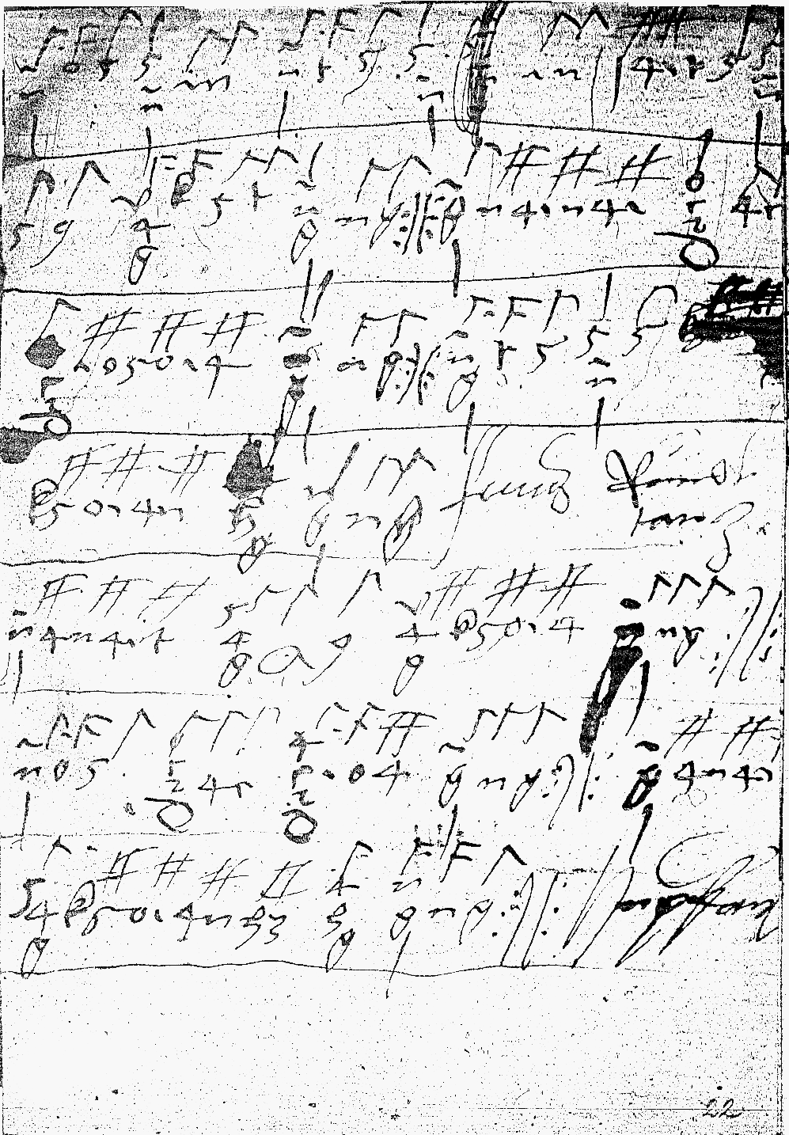

Craus f. 22 r: *Rundt tanz* / *Hupfauff*

The paper of Add. 31389 has an Italian watermark but its provenance before acquisition in the 19th-c by the English collector James Marshall is not known. However, it is possible that it was brought from Italy to the court of Henry VIII given that no. 1 is ascribed to Zuan Piero[4] who can be identified as John Peter de Brescia, Henry VIII’s favourite lutenist in 1512 when he was given an annuity of £40 a year for life. He remained in court service until 1536, although occasionally returning to Italy. He may be the same ‘zuan piero’ mentioned in Eitner’s *Quellen-Lexicon* as a lutenist at St Mark’s in Venice in 1517. He is also referred to as Peter the luter, Petrus or Peter de Brisia, Peter de Bruxia, Peter de Brecia luter, John Piero of Brescia, John Petrus of Bressa, and Zuan Piero, in court records between 1512 and 1533 and on one occasion signed himself Giovanni Pietro de Bustis. He was a member of Princess Mary’s household probably after being eclipsed as the King’s favourite lute player in 1517 by ‘a lad [probably the young Philip van Wilder according to Peter Holman] so excellent a performer on the lute, that his Majesty never tired of listening to him, to the despair of Zuan Piero’. A cognate version is found in the Marciana keyboard manuscript as ‘Fa la danza zuan piero’. No. 6 from a print published by Casteliono in Milan in 1536 ascribed to Jo Petro (= Zuan Piero) although included as part of a dance suite by Pietro Paulo Borrono and is based on the same tune. No. 3 is another dance from Add. 31389, probably using a song title that reads ‘Tu dia che son fantira [or fantina]’.

The few other ascribed items here are the calata[5] de Strambotti (no. 27) from the 1508 print of Joan Ambrosio Dalza, presumably composed or arranged by him. Pierre Blondeau[6] is thought to have edited all the lute music for publication in Attaingnant’s two prints. One pavane in the *Dixhuit basses dances* of 1530 is ascribed ‘Blondeau’ and another fifteen items, including my no. 18, are ascribed ‘P.B.’ However, he may have arranged rather than composed them, as all the dances in Attaingnant’s 1530 lute book are likely of be of Italian origin. Blondeau was *clerc* [and singer] in the Sainte-Chapelle in Paris in 1506 and *noteur* [music copyist] at the Chapel Royal in 1532. No. 25 is a baletto by Vicenzo Capirola (1474->1548), one of the few dances in this superb early 16th-c manuscript.[7] The galliard no. 17, published in Paris in 1558, is one of the few surviving dances by the Mantuan Albert De Rippe (c.1500-1551) who visited England in 1529 during the time he was lutenist to the French king François I. An item by Melchiore de Barberiis of Padua (no. 24b) is included because it is related to the *Saltarello alla Visentina* (no. 24a) from a manuscript in Munich (see below).

An anonymous bass dance ‘Sansserre” (no. 10) and three galliards (nos. 11, 19, 20) from Attaingnant’s 1530 print are also included here. Another bass dance (no. 9) is from a manuscript begun in the late fifteenth century. No. 26 is a calata from the Thibault manuscript (*c*.1505). The remainder of the selection are anonymous Italian dances found in manuscripts from North of the Alps. Nos. 4, 13 (a setting of the well known cara cossa[8]), 2 and 28 are from a Vienese manuscript now in Wroclaw, and no. 12 is from the lute book of the Vienese nobleman Stefan Craus. The facsimile in fig. 1 shows the original irregular rhythms which I have not attempted to reconstruct apart from adding barlines. No. 5 is from a manuscript probably of Bavarian origin and now in Paris.

Much Italian music is preserved in lute manuscripts in the Bayerische Staatsbibliothek in Munich. The six items (nos. 2, 7, 21-24a) from Mus. ms. 1511b are particularly attractive; the first two of these (as well as no. 28) may be familiar as related to the suite Pavana/Saltarello/Piva alla Venetiana in Dalza’s print. I have chosen a version of the popular Rocha al Fuso (no. 14) from Mus. ms. 1511d and of La Traditora (no. 15), on the passamezo antico ground, from Mus. ms. 266. No 16 follows no. 8 without a break in Mus. ms. 1627, although I think the change of key indicates that they are separate galliards.

**Worklist**

1. Add. 31389, ff. 9r-9v *cha la danza Zua[n] piero*

2. Munich 1511b, f. 13r *Cura/za*

3. Add. 31389, ff. 11r-11v *Tu dia ch*[e] *so*[n] *fa*[n]*tira*

4. Wroclaw 352, f. 35r */* *Paduana*

5. Paris 429, ff. 124v-125v *La grimoda*

cf. Phalèse 1546, sig. ff3r *Passa mezo*

Phalèse 1563, f. 66r *Passomezo*

6. Casteliono *Intabolatura de Leuto* 1536, f. 23r *Fala danza* [index: *Fa la danza. Jo. Petro che la balla ben*]

7. Munich 1511b, f. 13r *Sal/ta/rello /alla ve/nitiana*

8. Munich 1627, f. 24r *Gaillardo di forauia alla dalliana*

9. Pesaro 1144, pp. 35-43 *bassada*[n]*za*

Thibault, ff. 15r-16v: *Basadanza*

10. Attaingnant 1530,[9] f. 8r *Sansserre Basse dance*

11. Attaingnant 1530, f. 31r *Gaillarde*

12a-b. Craus, f. 22r [78r] *Rundt tanz* - *Hupfauff*

13. Wroclaw 352, f. 63r / *La Cara Cossa*

14. Munich 1511d, ff. 16v-17r *Dagi la rocha al fuso*

15. Munich 266, f. 33r *De La traditora No. 2.*[10]

16. Munich 1627, f. 24r  *Gailla/rdo*

17. De Rippe VI 1558, f. 21r *GAillarde*

[header: *Gaillarde D’Albert*]

18-20. Attaingnant 1530, ff. 35r, 30v-31r *Pauane*

*P*[ierre]*. B*[londeau]*.* - *Gaillarde* - *Gaillarde*

21. Munich 1511b, f. 7v *El Sten/dardo*

22. Munich 1511b, f. 8v *La quen/tana*

23a. Munich 1511b, f. 9r *Lode/sana*

Munich 1511b, ff. 21v-22r *Lode/sana*

23b. Wroclaw 352, ff. 67v-68r *Lodosana [11]*

24a. Munich 1511b, f. 12v *Saltarello alla Visentina*

24b. Barberiis 1549, sig. c3r *Vesentino*

25. Capirola, ff. 19v-20r *Ti*[entalore?] *baleto*

*da balar bello*

26. Thibault, ff. 53r-53v *Calata*

27. Dalza 1508, f. 44v *Calata de Strambotti*

28. Wroclaw 352, ff. 60v-61r *Im abzug/ Paduaner*

cf. Wroclaw 352, f. 48r */Fulsa peiß mich nith*

*John H Robinson, May 2004*

1. Manuscript sources: **a.** Pesaro, Biblioteca Oliveriana, MS No. 1144, *c*.1480-1540. **b.** Paris, Bibliothèque Nationale, Rés. Vmd. ms. 27, Thibault manuscript, *c*.1505 (Venetian), cf. facsimile (Genève: Éditions Minkoff, 1981). **c.** Chicago, Newberry Library, Special Collections, Ms. Lute Codex Vincenzo Capirola, *Compositione di meser Vicenzo Capirola gentil homo bresano*, *c.*1517, cf. facsimile edition with introduction by Orlando Christoforetti (Florence: SPES, 1981), cf. Federico Marincola, ‘The instructions from Vincenzo Capirola’s Lute Book - A new translation’ *The Lute* 23 (1983), pp. 23-7. **d.** London, British Library, Add. Ms. 31389, *c*.1520-30, cf. report of a talk on this manuscript by Tim Crawford in *Lute News* 10 (October 1988), p. 4, and inventory by Denys Stephens in *Lute News* 59 (September 2001), p. 5. **e.** Wien, Österreichische Nationalbibliothek, Musikabteilung, Ms. Mus. 18688, Stefan Craus lute book, *c*.1523-40. **f.** Munich, Bayerische Staatsbibliothek, Mus. Ms. 266, Marco dall Aquila section (ff. 20r-63v), *c*.1535-45. **g.** Wroclaw, Biblioteka Kapitulna, Ms. 352, *c*.1538-44. **h.** Munich, Bayerische Staatsbibliothek, Mus. Ms. 267 (Herwart library), *c.*1550. **i.** Munich, Bayerische Staatsbibliothek, Mus. Ms. 1511b (from Herwart library, Italian origin), *c.*1550. **j.** Munich, Bayerische Staatsbibliothek, Mus. Ms. 1511d (from the Herwart library, Italian origin), *c.*1550. **k.** Munich, Bayerische Staatsbibliothek, Mus. Ms. 1627 (German origin), *c.*1550-80. **l.** Paris, Bibliothèque Nationale, Rès. 429 (Bavarian origin?), c.1560-5. I would like to thank Arthur Ness and Tim Crawford for access to copies of the Munich manuscripts.
2. Prints: **a.** Joan Ambrosio Dalza, *Intabulatura de lauto, Libro Quarto* (Venetia: Petrucci, 1508), facsimile edition of copy in B-Br: (Genève: Minkoff Reprint, 1980). **b.** Pierre Attaingnant, *Dixhuit basses dances ... en tablature du Lutz* (Paris 1530), edited in tablature and staff notation by D. Heartz, *Attaingnant, Pierre, Preludes, Chansons and Dances for Lute, Paris 1529-30* (Neuilly-sur-Seine, 1964), and H. Mönkemeyer, *Attaingnant, Pierre, Dixhuit basses dances*, 2 vols (Hofheim-Taunus: Hofmeister, 1966). Thanks to Rainer aus dem Spring for the loan of a microfilm of the unique copy in the Preussischer Kulturbesitz in Berlin (D-Bds, not D-Mbs as listed in H. M. Brown, *Instrumental Music Printed Before 1600: A Bibliography* (Cambridge MA: Harvard University Press, 1965)). **c.** *Intabolatura de Leuto de Diversi Autori* (Milano: Io Antonio Casteliono, 1536), facsimile edition of copy in I-Fc: (Firenze: SPES, 1979). **d.** Melchiore de Barberiis, *Opera Intitolata Contina, Intabolatura di Lauto, Libro Decimo* (Venetia: Scotto, 1549). **e.** Albert De Rippe, *Sixiesme Livre de Tabulatura de Leut* (Paris: Fezandat, 1558), modern edition, M. Vaccaro, Oeuvres d’Albert de Rippe, vol. III (Paris: CNRS, 1975), p. 191. According to Brown, similar to Mainero 1578, p. 11, *La Lavandara Gagliarda* [à 4], and Phalèse and Bellère, *Chorearum Molliorum Collectinea*, 1583, f. 16r, *Galliarde la Lavandara* [à 4].
3. I have used Tim Crawford’s reconstruction of no. 1 and reconstructed no. 3 myself. Thank you to Denys Stephen’s for sending a copy of his transcription of no. 3 for comparison.
4. M. Spring, *The Lute in Britain: A History of the Instrument and Its Music* (Oxford: Oxford University Press, 2001), pp. 59-60; A. Ashbee, D. Lasocki assisted by P. Holman and F. Kisby, *A Biographical Dictionary of English Court Musicians 1485-1714* (Aldershot: Ashgate, 1998), vol. I, pp. 186-7; A. Ashbee, *Records of English Court Music*, vol. vii. 1485-1558 (Aldershot: Scolar Press, 1993), pp. 39,41,43,46-7,49(2),50(2),52,56,61-2,70; vol. viii: 1485-1714 (Aldershot: Scolar Press, 1995), pp. 4-5; P. Holman, *Four and Twenty Fiddlers: The Violin at the English Court 1540-1690* (Oxford: Clarendon Press, 1993), p. 72.
5. The calata dance form is related to the passacalle and gassenhauer, cf. Daniel Heartz, ‘calata’, *New Grove* iii, p. 612.
6. Douglas Alton Smith, *A History of the Lute from Antiquity to the Renaissance* (Lute Society of America, 2002), p. 196.
7. For example, no. 10 in Dick Hoban (ed.), *The Art of the Lute in Renassiance Italy* - Volume II (Fort Worth TX: Lyre Music, 1999), which is an anthology of 125 Italian renaissance dances from prints, although not including any other items found here.
8. For many cognate versions of nos. 13 (Cara cossa), 14 (Rocha al fuso) and 15 (La traditora), see L. H. Moe, ‘Dance music in printed Italian lute tablatures from 1507-1611’, 2 vols. (Dissertation, Harvard University, 1956).
9. Two CDs feature music from Attaingnant’s *Tres breve et familiere introduction* of 1529 and *Dixhuit basses dances* of 1530: Chris Wilson’s CD *La Magdelena: Lute Music in Renaissance France* (Virgin Veritas 7243 5 45140 2 9, 1995) and Hopkinson Smith’s CD *Pierre Attaingnant - preludes, chansons, dances for the lute* (Astrée naïve E8854, 2001), but none of the items I’ve used.

   My nos. 10, 18 & 19, but not 11 & 20, were edited in a two-volume anthology of 359 lute solos from French renaissance prints, including most items from Attaingnant 1529 and 1530, by Dick Hoban (ed.), *The Art of the Lute in Renassiance France* - 2 vols (Fort Worth TX: Lyre Music, 2002-3), cf. [www.lyremusic.com](http://www.lyremusic.com).
10. Christopher Wilson plays this version, ascribing it to Marco dall Aquila, on his 1996 CD *Lute Music of Dall’Aquila and Da Crema: Ricercars, Intabulations and Dances* (NAXOS 8.550778). Munich 266 ff. 33r-34r includes five versions of La Traditora in a variety of keys, and Paul O’Dette recorded the third (*No 3./ de la traditora. MD.LA.* from f. 33v) on his 1994 CD *Dolcissima et Amorosa: Early Itlaian RenaissanceLute Music* (Harmonia Mundi HMU 907043).
11. Cf. H Newsidler, *Ein newes Lautenbüchlein* 1540/R1544, sig. f. 4v, *Lodesana, Ein Welscher tantz*; Bianchini [‘Rosetto’], *Intabolatura De Lauto* 15465, sig. B4v, *Lodesana* [= Gerle, *Eyn Newes sehr Künstlichs Lautenbuch* 1552, sig. M4r, *Der 5. Lodesano*]; Phalèse, *Hortus Musarum* 1552, p. 94, *La lodisana* [lute duet].