**Music supplement to Lute News 76 (December 2005):**

**A Selection of Morris tunes and English Ballads**

This tablature supplement brings together arrange-ments for 6-course lute of ballad settings and morris tunes, including several versions of the Staines Morris. These are followed by variations for lute probably all based on popular ballads, some better known than others. Some are authentic lute settings and others transcriptions from music for other instruments.

The morris tune settings (no 1a-h) begin with two for lute based on the same tune followed by **a morris** by Charles Colman that Playford printed in 1652 for a lyra viol tuned edfhf (intervals between courses starting at the top). The remainder are all versions of the **Staines Morris**, the first in triple time. The others are in duple time, beginning with three that are quite similar, the first in Playford's *Dancing Master* as a melody for violin transcribed for lute with harmonies based on the lute version, the second an original lute setting and the last a transcription of a solo cittern version by T[homas] R[obinson] with bass notes added and rhythm flags halved. The group ends with an almaine for Sir Henry Guildford the opening of which quotes the tune of the Staines Morris. Robert Dowland included it in his *Varietie of Lute Lessons* printed in 1610 but without ascription.[1] The cadence at the end of the divisions on the first strain is very similar to one in Robert Dowland's pavan for Sir Thomas Monson in *Varietie*, and so one wonders whether Robert composed or arranged this almaine. Otherwise it has traits and the quality you would expect from masters like Philip Rosseter.

**Trenchmore** (no 2) was apparently a lively Irish dance.[2] In addition to John Johnson's treble and ground arrangement, a few settings for lute solo as well as cittern, keyboard and violin survive.[3] The set of eleven variations for 7-course lute included here is the most elaborate and attractive and is probably familiar from Paul O'Dette's *Robin Hood* CD.[4] The original is incomplete and the final four bars were reconstructed editorially. Although untitled, the elaborate set of variations in no 4 is based on the tune known as **Up Tails All**[5] and is also on Paul O'Dette's *Robin Hood* CD. However, the version he used is sandwiched here between two shorter versions.[6]

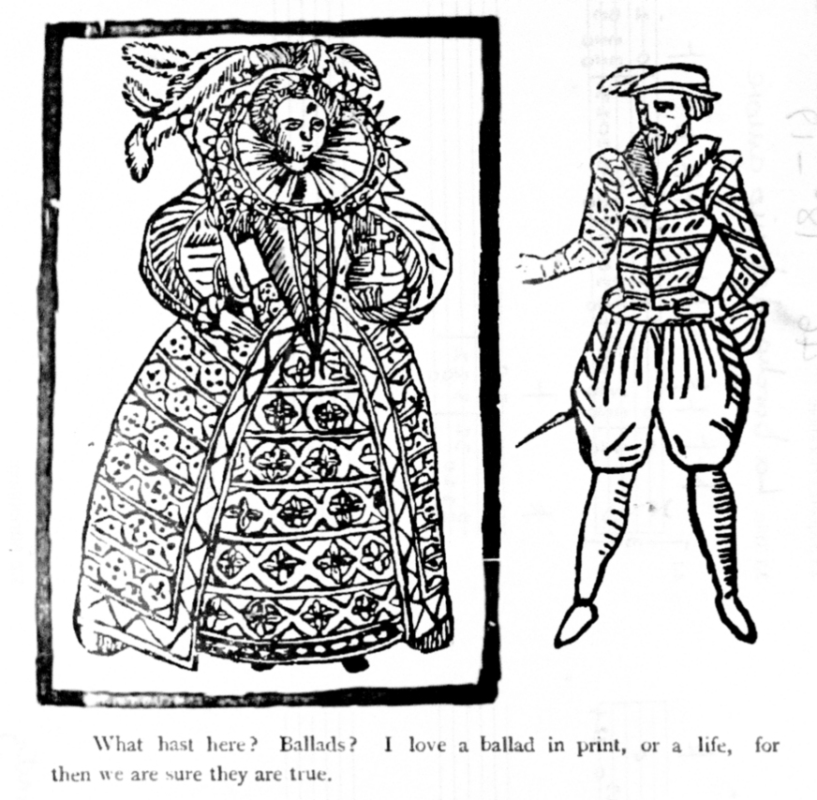

The title of lute solos **The Wood Bynde** (no 3), **Over the Broome Bessy** (no 6, six variations)[7] and **Only Joy** (no 10, four variations) are not known in any other context but may refer to lost ballads.[8] The origin of the title **Lost is my Liberty** (no 11) and the dedicatee of the alternative title L. of Dehim's Lamentation are also obscure. Three versions are here run together as a continuous set of five variations. The first two only have fifteen bars and the remaining three 16 bars, which has been left as in the originals. **Woodycock** may have a similar meaning to Cuckcold, and the tune of this name may be related to an early 17th-century broadside 'A proper new Ballad, shewing a merrie jest of one Jeamie of Woodicock Hill, and his wife,' to 'a new tune, called Woodicocks Hill,' [9] although the versions from the 1580s may not have been the same tune. Here an original lute setting (no 5) is followed by a transcription from Playford's violin melody, the two versions illustrating variants of the tune.

The name Peggy features in the tunes for a number of ballads.[10] These survive with different tunes to the set of variations called **Peggie** for lyra viol tuned ffhfh and transcribed for 7-course renaissance lute here (no 7). The many ornaments and phrasing indications in the original have been omitted. The set of variations on **The Hornpipe** (no 8) is not at all like a hornpipe and is not concordant with similarly titled music for keyboard, etc. The twenty-seven variations vary the simple 4-bar harmony with exemplary diversity, and some of the variations are different to the version in the alternative source.[11]

There are many settings of **Monsieur's Almaine**,[12] probably named after the Duke D’Alençon, who is called Monsieur in the New Year’s Gifts of 1582. However, ‘Monsieur’ was also affected by the actor Will Kemp.[13] Two versions are included here (no 9), a particularly attractive set of six variations untitled in the Euing lute book, preceded by a simpler version in which the duration of rhythm flags has been doubled here to match the rest.

The next group includes three sets of variations of **Loth to Depart** (no 12), the sentiments of which are expressed in the words to a round or canon in Ravenscroft's *Deuteromelia* of 1609 (although not to the tune here) 'Sing with thy mouth, sing with thy heart, like faithful friends, sing loath to depart.' [14] The two original lute settings of Loth to Depart are followed by the related Tell me John, transcribed here from the original bandora tablature. The latter is ascribed to W.S. who could be the London Wait William Sanders, or the composer [William] Sim[me]s to whom lute solos are ascribed in Cambridge Ms. Add. 3056.[15]

The anonymous and untitled set of three variations (no 13) is another setting of Anthony Holborne's Il nodo di Gordio or **The Gordian Knot,** a metaphor for an intractable problem solved by cutting the 'Gordian knot' from the myth associated in legend with Alexander the Great. Gordius, a ruler of the capital of ancient Phrygia fulfilled an oracle of Zeus by securing his wagon near the temple by tying an intricate knot. Alexander cut the knot with his sword fulfilling another oracle to be conqueror of all Asia. One wonders who composed this setting, the last variation might even suggest John Dowland.

**Buggle Bowe** is a tune named for singing one of the sections of the Elizabethan broadside 'Frauncis new Jigge' by George Attwell, licensed for publication in 1595.[16] The version here (no 14) is a set of eighteen variations again illustrating a variety of ways to write divisions on a simple ground. In the chapter 'On the Trout' in *The Compleat Angler*, first published in 1653, Izaak Walton gave the line to the character Piscator 'I'll promise you I'll sing a song that was lately made, at my request, by Mr. William Basse; one that hath made the choice songs of the "Hunter in his Career" and of "Tom of Bedlam" and many others of note; and this, that I will sing, is in praise of Angling.' The lute solo **Hunter's Career** could be the tune Basse wrote, included here in two versions (no 15), one for 7-course and the other 10-course lute. The earliest broadside probably sung to the tune was 'Mount Taragh's Triumph, 5 Iuly 1626, to the tune of "the Careere."'[17]

**Worklist**

Minor editorial changes have been made without comment

1. **Morris Tunes**

a. Mynshall, f. 8r *The Moris*

cf. Keyboard: Drexel 5609, p. 156 *The Morris* & p. 66 [*The Battel*] *The Morris*; Paris 1186, f. 92v *The Morris* & f. 99, [*The Battel*] *The morris*

b. Thysius, f. 455r *Moriskas Brande*

cf. Thysius, f. 455r untitled

c. Playford *Musicks Recreation on the Lyra Viol* 1652, p. 76 *Morris Dr.* *Colman* [transcribed from lyra viol]

d. Dtc 408/II, p. 91 *Staynes Moris*

e. Playford, *Dancing Master* 1651, p. 87 *Stanes Morris*

[transcribed from violin]

f. Trumbull, f. 9v *Staines Morris*

g. Dd.4.23, f. 19r *Staines Morris* [transcribed from cittern]

h. *Varietie* 1610, sig. P1r *Sir Henry Guilforde his Almaine*

2. **Trenchmore**

Nn.6.36, ff. 33v-34r untitled

3. **The Wood Bynde**

Board, f. 25v *The wood Bynde* [7th course in F, 8th in D]

4. **Up Tails All**

a. Pickeringe, f. 34r *A Toye*

b. Nn.6.36, f. 10v untitled [7th in D]

c. Dd.9.33, f. 95v untitled

cf. FVB, pp. 352-355 *Up T. all 32 Giles Farnaby* [keyboard]; Playford, *Dancing Master* 1651, p. 97, *Up Tailes all* [violin]

5. **Woodycock**

a. Nn.6.36, f. 3r *Wooddicock*

b. Playford, *Dancing Master* 1651, p. 15 *Wooddicock/ Woodycock* or *The green man* [transcribed from violin]; cf. Valerius 1626, p. 198 *Engels Woddecot* [voice, lute, cittern]; Manchester Gamba Book, pp. 4-5 *Woodicocke* [lyra viol]; Dd.5.20, f. 33v *Wooddicocke* [bass viol]; FVB, pp. 259-262 *Wooddycock 11 Giles Farnaby* [keyboard]; Starter 1621, p. 99 *Drinck-Liedeken* [song]

6. **Over the Broome Bessy**

Dd.2.11, f. 80v *ouer the Broome Bessy*

7. **Peggie**

Browne/Braye, ff. 77r-77v *Peggie* [transcribed from lyra viol]

8. **The Hornpipe**

Dd.2.11, f. 81v untitled; cf. Ballet, pp. 12-13 *The Horne Pipe*

9. **Monsieur's Almaine**

a. Thysius, f. 485r untitled

b. Euing, f. 19v untitled = Mynshall, f. 10r *Mounsiers Allma*

10. **Only Joy**

Dd.9.33, f. 5r *Only ioye*

11. **Lost is my Liberty**

a. Ballet, p. 11, *Lost is my lyberty*

b. Dd.2.11, f. 40v untitled

c. Dd.2.11, f. 41r *My L*[ord?]*. of Dehims Lamentacion*

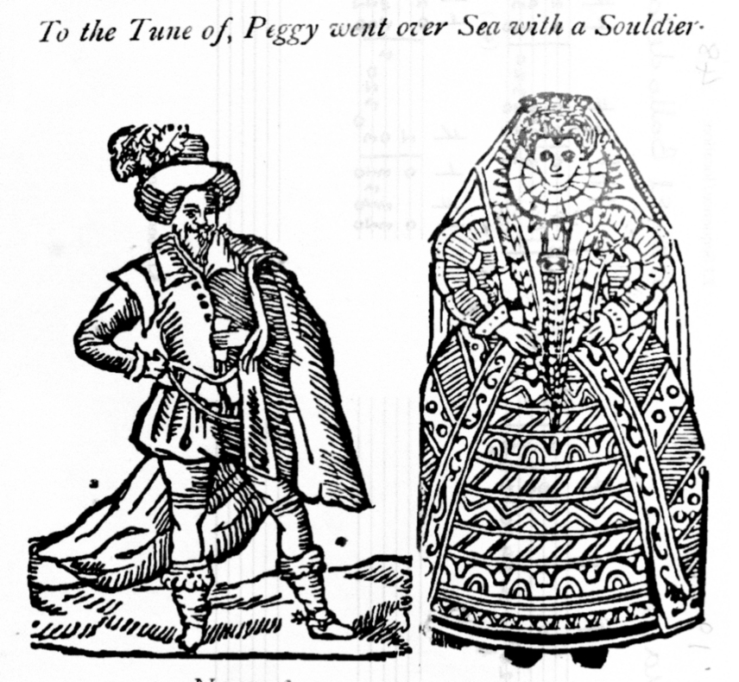

12. **Loth to Depart**

a. Pickeringe, f. 33r untitled

b. Euing, f. 28r untitled = Dd.2.11, f. 9r *Lothe to Departe*

cf. Board, f. 7v *Lothe to Depart/ Lothe to Departe*; Dd.9.33, ff. 68v-69v *Loth to departe Jo: Dowland* [DowlandCLM no 69]; Euing, f. 31r [untitled]; Thysius, f. 394v *Alter part*. Keyboard: FVB, pp. 333-334 *Loth to depart 21 Giles Farnaby*; Drexel 5609, p. 141 untitled; Paris 1186, f. 57v untitled

c. Browne-Braye, f. 92v *Tell me John W.S.* [transcribed from bandora]; cf. Thysius, f. 20r *Gailliarde Tell messon*

13. **The Gordian Knot**

Dd.9.33, f. 52v, untitled [3 variations, 7th in D]

cf. Board, ff. 21v-22r *Il nodo di gordio By Mr Holborne*; Dd.2.11, f. 59r *A: Holb* (HolborneS, no 57)

14. **Buggle Bowe**

Dd.2.11, f. 82r *Buggle Bowe*

15. **Hunter's Career**

a. Board, f. 27v *The Hunters Careere* [7th in F]

b. Straloch, pp. 16-17 *Hunters Careire* [7th in D, 10th in C]

Skene, p. 235 *Hunters Carrier* [mandora]; Boteler, f. 18r *The hunters Careare* [cittern]; Panmure 11, f. 42r The carrier [cittern]; Och 437, f. 8v *humbers carrere* [keyboard]

*John H Robinson, Newcastle University, November 2005*

1. Nigel North (Linn CKD097) and Lutz Kirchoff (Sony SBK 60098) both recorded it on their CDs of music from *Varietie*.
2. Simpson, *The British Broadside Ballad and its Music* (New Brunswick: Rutgers University Press, 1966), pp. 716-718; Seán Donnelly, ‘Trenchmore: An Irish Dance in Tudor and Stuart England’ at http://www.setdance.com/journal/trenchmore.html
3. Jan Burgers, *John Johnson: Collected Lute Music* (Lübeck: Tree Edition, 2001), no 66. Concordances in the Lute Society facsimile edition of *The Folger-Dowland Manuscript* (Guildford, 2003).
4. *Robin Hood: Elizabethan Ballad Settings* by Paul O'Dette, lute, orpharion and cittern (Harmonia Mundi, HMU 907265, 2001).
5. Simpson, *op. cit.*, pp. 727-8.
6. Diana Poulton (ed.), *English Ballad Tunes for the Lute*, Cambridge Lute Series II (Gamut, 1975), no. 6.
7. Included in Anthony Rooley, *The Compleat Beginner* (London: Early Music Centre Publications/Brian Jordan, 1976), no. 30.
8. See Hyder E. Rollins 'An Analytical Index to the Ballad-Entries in the Registers of the Company of Stationers of London' *Studies in Philology* 21/1 (1924), pp. 1-324, no. 2377 'A saynge betwene the quene and Englonde Called comme over the browne Bessye to me' 1564; = no. 587 'a Dyologe sett furthe by twene the quenes maiestie and Englonde' (1558-9) beginning 'Come over the born Bessy', Harl. Misc. X, 260.
9. Simpson, *op. cit.*, pp. 796-7.
10. See illustrations from *The Roxburghe Ballads*, Charles Hindley (ed.) (1873), on pp. 1 & 11; and Simpson, *op. cit.*, pp. 177, 498, 570–5, 581, sources include Ballet, p. 26, *peg a ramsey*.
11. Which was included in *Musicke with Her Silver Sound ... being the finest of musicke for solo lute from Renaissance England*, Richard Darsie and John Robinson (ed.) (Silver Sound, 1999).
12. Concordances in the Lute Society facsimile edition of *The Welde Lute Book* (Guildford, 2004).
13. Simpson, *op. cit.,* pp. 495-496.
14. Simpson, *op. cit.,* pp. 456-457.
15. See tablature supplement to *Lute News* 45 (March 1998).
16. Simpson, *op. cit.*, pp. 74.
17. Simpson, *op. cit.*, pp. 37-39 266.