**Music supplement to Lute News 81 (April 2007)**

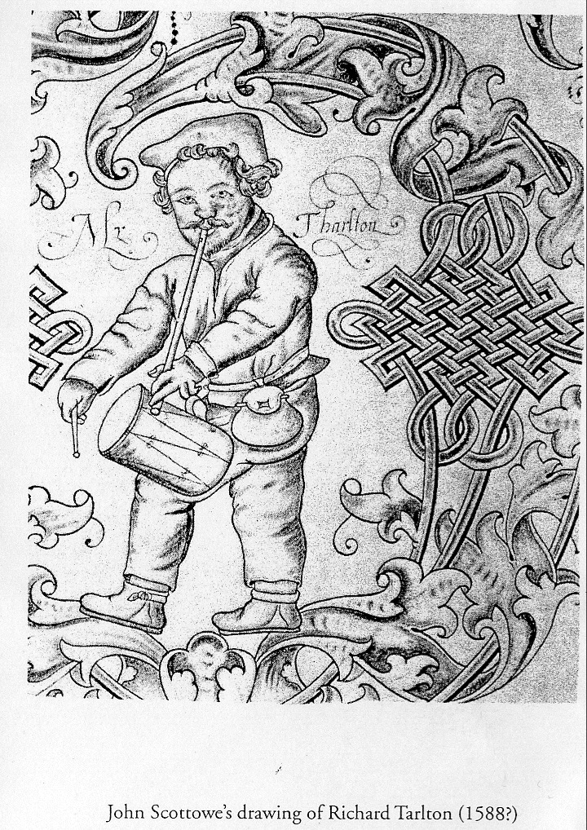

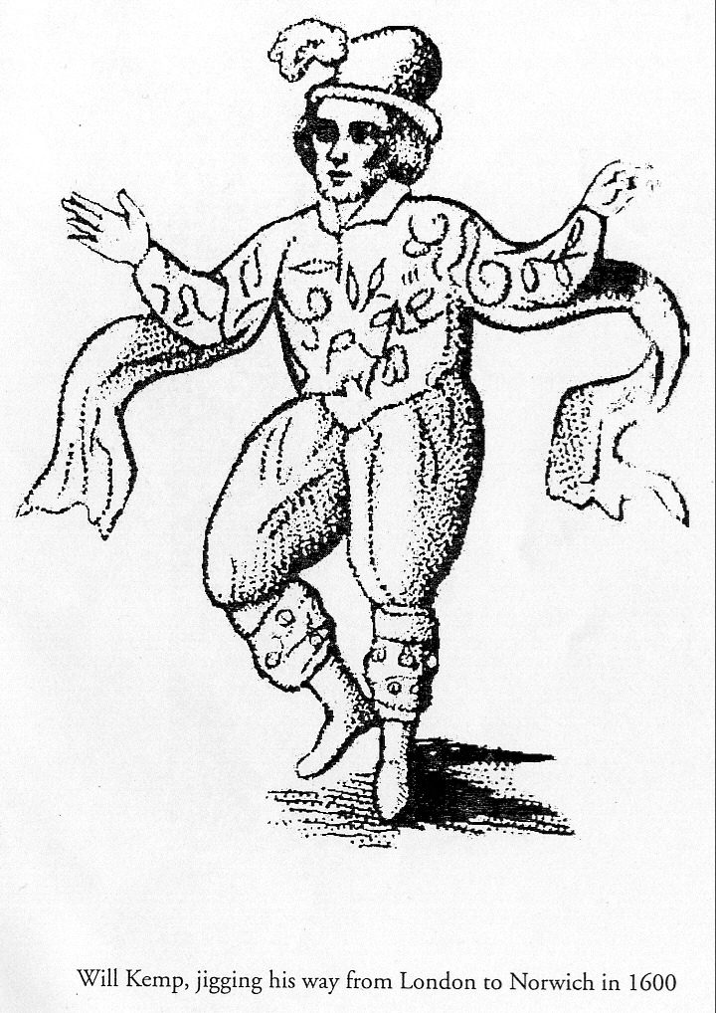

**Lute Music for Comic Actors Fools Buffoons and Matachins**

This tablature supplement explores lute settings of music for comedy characters from masques and the stage. The selection includes lute solos associated with five famous comedy actors as well as those titled to suggest reference to stage fools and many settings of Les Bouffons and Matachins. No. 1a-e are assumed to be lute arrangements of music for the comic actors Robert Reynolds (*fl*1616-1642) a.k.a Pickleherring, Edward Alleyn (1566-1626) or John or Richard Alleyn, Will Kemp (*fl* 1585-1600) (above left), Richard Tarleton (*d*1588) (above right, both pictures from Chris Goodwin) and John Singer (*fl*1583-1603).[1] Fools featured in Jacobean masques such as ‘the Follies...which were twelve she-fooles’ in Jonson’s *Love Freed from Ignorance and Folly* (1611) so that *Foule d'Engleterre, Engelsche Foulle* and *Ballat de Folles* may celebrate these fools on stage (no. 2a-c), although the precise translation of ‘foule’ and ‘foulle’ is problematic.[2] The many versions of Les Bouffons are based on the passamezo moderno, or sometimes other grounds. Randle Cotgrave, *A Dictionerie of the French and English Tongues* (London, 1611), defines ‘Buffon’ as a ‘buffoon, ieaster [jester], synco-phant, merrie foole, sportfull companion; one that liues by making others merrie,’ and since called French comedians or costumed dancers who performed the Moresca, or Matachin.[3] Barbetta acknowledges an English origin with the title *Balletto d’Inghilterra deta il Bufon* (no. 3c). A duet version for lutes a 4th apart by Wolfgang Heckel survives (see cognate list) but is not included here, although some of the versions based on the passomezo moderno in C and F fit together quite well. A selection of sixteen versions is included to illustrate the diversity of arrangements. The matachins is defined as a figured battle dance for a team of men, and is a term derived from the Spanish ‘matar’ (kill), or the Italian ‘matta’ (buffoon or fool),[4] either performed as a grotesque dance of fools or as a skilled sword dance or even as a ritual dance of death, reflecting the Dutch titles of nos. 3a.vii and 4e, and the title *Matassin oder Toden Tantz* appears in Normiger’s tablature [in New Grove 2 but not known to me]. A selection of eight of the best versions are included, the earliest titled *Factie* in Phalèse’s print of 1549 and the best by Lorenzino (no. 4h), despite the slightly irregular structure of 13 phrases of 4 bars each except the 3rd and 10th of 5 bars.

**Worklist**[5]

**1a. Jigs? for Robert Reynolds a.k.a. Pickleherring**

1a.i. B-Br 26.369, f. 22r *Pickell Hehringk*

1a.ii-iii. D-B N 479, f. 5r & 69v untitled - *ein Soldaten ist vorhand*[en] [A soldier is here?] [Eyck *Euterpe* 1644, f. 57v *Janneman en Alemoer* - flute]

**1b. Jig for Edward Alleyn?**

GB-Cu Dd.9.33, f. 28r *Allins Jigg[6]*

**1c. Jig for Will Kemp**[7]

GB-Cu Dd.2.11, f. 99v *Kemps Jigge*

**1d. Jig for Richard Tarleton**

1d.i. GB-Cu Dd.2.11, f. 56r *Tarletons Jigge* [CLMJD no. 81

1d.ii. US-NH Ma21 W632 (Wickhambrook), f. 11r *tarletones riserrectione Jo Dowlande* [CLMJD no. 59]

**1e. Jig for John Singer**

1e.i. GB-Cu Nn.6.36, f. 3r *Singers Jigge*

1e.ii. GB-Lam 603 (Board), f. 9r untitled

1e.iii. GB-Cu Dd.9.33, f. 81v *Jo Singer* [transcribed from bandora]

**2. The Fool**[8]

2a. Valerius, *Neder-Landtsche Gedenck-Clanck* 1626, p. 33 *Op de Engelsche Foulle. Of: Walsch Waelinneken* [~the lady of Wallonië]

2b.i-ii. NL-Lu 1666 (Thysius), f. 396r *La Foule d'Engleterre*

2c. GB-Cu Dd.9.33, ff. 57v-58r *Ballat des folles[9]*

**3. Les Bouffons**[10] **all in duple time**

**a. based on 8-bar passamezo moderno ground with chord sequence I IV I V I IV I/V I**

3a.i. US-Ws V.a.159 (Giles Lodge), f. 7r *The Anticke* [the antic]

3a.ii. S-B PB fil.172 (Per Brahes), f. 10r *Les Boffons*

3a.iii. CH-Bu F.IX.70, p. 286 *Bouffons*

3a.iv. CH-Bu F.X.11, ff. 19v-20r *Les buffons/Proportio* [11]

3a.v. CH-Bu F.IX.70, p. 240 *XII Alio modo/ Les bouffons/*

*Proportio*

3a.vi. NL-Lu 1666, f. 1r *La Chasse* [The hunt]

3a.vii. NL-Lu 1666, f. 337r *De Doot* [Death]

second half uses a different ground

3a.viii. IRL-Dtc 408/II, p. 104 *Buffons*

3a.ix. NL-Lu 1666, f. 351v *Boter op de pensen* [Butter on the belly]

3a.x. CH-Bu F.IX.70, p. 240 *XIII Aio modo les bouffons/ Proportio*

3a.xi. D-B Hove 1, f. 160v *Bouffons*[12]

3a.xii. D-B Hove 1, f. 160v *Bouffons*

**b. based on variants of 8-bar passamezo antico ground with chord sequence i VII i V/i VII V-i V**

3b.i. IRL-Dtc 410/I (Dallis), p. 3 *boufons*

3b.ii. D-B Hove 1, f. 161r *Bouffons*

**c. based on a ground similar to the Bergamasca with the chord sequence I I V I**

3c. Barbetta, *Intavolatura di Liuto* 1585, p. 18 *Balletto d’Inghilterra deta il Bufon*

**d. based on 4-bar Bergamasca[13] ground with chord sequence I IV V I**

3d. GB-En Adv. MS. 5.2.18 (Straloch),[14] p. 1 *The buffins*

**4. Matachins**[15] **in triple time with some form of alternating tonic-subdominant I-IV, IV-I or IV-IV-I** **ground in 2- or 3-bar phrases**

4a. Phalèse, *Carminum Quae Chely* 1549, sig. I4r *Factie*

4b. I-Lg 774 (Lucca), f. 12v *Mattuccino*

4c. B-Br II.275 (Cavalcanti), f. 11r *Mataccinni*

4d. Barbetta 1585, p. 13 *Moresca Terza, Deta Il Mattacino*

also reproduced in Lute Society tablature sheet C13

4e. NL-Lu 1666, f. 416r *Den dooden dans* [Death’s Dance]*. Matachine*

4f. US-SFsc M2.1 M3 (De Bellis), pp. 32-33 *matacino in tenore*

left hand fingering above tablature letters omitted

4g. Waissel, *Tabulatura Continens* 1573, sig. Mivr *Tantz Matazina*

4h. PL-Kj 40032, pp. 352-3 *Matachin con sus differencias di Lorenzino*

[Additional: extended Matachins edited in LZtoLN131]

*John H Robinson, Newcastle University, March 2007*

1. See *An index to The Elizabethan Stage and William Shakespeare by Sir Edmund Chambers* compiled by Beatrice White (Oxford University Press for the Shakespeare Association, 1934), for many references to these comic actors. No music survives for the comic actor John Spencer a.k.a Hans Stockfish.
2. Thank you to Jan Burgers for translation of the Dutch titles.
3. John M. Ward, ‘Apropos *The British Broadside Ballad and Its Music*’, *JAMS* 20 (1967) pp. 50-56; John M. Ward, *Music for Elizabethan Lutes* (Oxford: Clarendon, 1992) vol. 1, pp. 123-128; John M. Ward, ‘The Buffons family of tune families*’*, in *Themes and Variations: Writings on music in honour of Rulan Chao Pian*, B. Yung and J. Lam (eds.) (Cambridge MA, 1994), pp. 290-351. Ruth van Baak Griffioen, *Jacob van Eyck's Der Fluyten Lust-hof*, Muziekhistorische monografieën 13, (Utrecht: Koninklijke Vereniging voor Nederlandse Musiek-geschiedenis, 2005), pp. 125-126.
4. Julia Sutton, ‘matachin’ *New Grove* 2 (2001), 16: 114-6.
5. See tablature supplement to *Lute News* 51 (September 1999), no. 8.
6. Same as *Almaine Jo Johnson*, Jan Burgers, *John Johnson: Collected Lute Music* (Lübeck: Tree Edition, 2001), no. 31.

   [All sources edited for LZ&LN137]
7. See Lute Society tablature sheets C25 and C86 and the tablature supplement to *Lute News* 64 (December 2002), no. 3.
8. A cognate for CH-Bu F.IX.70, p. 291 *Chorea Anglicana*; D-B 4022, f. 26v *Englische Toy;* D-B 40141, f. 46v *Tantz / Proportio*; D-Kl 4o108 I, f. 2v [untitled]; D-LEm II.6.15, p. 369 *Klapper Tantz;* GB-Cu Dd.9.33, f. 83v [untitled]; GB Lwa 105, f. 1r [untitled]; IRL-Dtc 410/I, p. 71 *passomeze d’angleterre*; LT-Va 285-MF-LXXIX, f. 57v [untitled]; US-Hub Osborn fb7, f. 89v *The Queenes Pantophle*; Phalèse *Theatrum Musicum* 1563, f. 64r Passomezo. Opening the same as Robinson 1603, sig. Iiv, *Toy*; GB-Gu Euing 25, f. 29v, [untitled]. Cittern: GB-Cu Dd.4.23, f. 6v *Phs Toy*. Keyboard: Eysbock, f. 31r, *En*[g]*lender dans*; GB-Cfm Mus.168, p. 37, *Muscadin*; GB-Cfm Mus.168, p. 410, *Muscadin Giles Farnaby*; D-B Lynar A1, pp. 268-270, *Kempes moris mr Geilles Farnabi Backeler in de Musick*. Violin: John Playford*, Dancing Master* 1651, p. 26, *The Cherping of the Larke*. Instrumental ensemble: Playford, *Courtly Masking Ayres* 1662, p. 206, title?; Playford 1700, p. ?, *The Lark*; Roger 1700, p. 24 *Engelsche foly*. Vocal: Pretere, *Gheestelijck Paradijsken der Wel-lusticheden. 4* 1619, p. 8 *De Enghelsche Foille*. See tablature supplement to *Lute News* 64 (December 2002), no. 4.
9. See tablature supplement to *Lute News* 65 (April 2003), no. 4.
10. Other solo lute versions of **Les Bouffons**: CH-Bu F.IX.70, p. 239 *XI Les bouffons/ Proportio* [on passammezo moderno in C]; CH-Bu F.IX.70, p. 241 *XIIII Alio modo/ Les bouffons/ Proportio* [on passammezo antico in C]; F-Pn Rés 941, f. 2r [Bou]*ffons* [G]; F-Pn Rés 941, f. 2r *autre/ bouffons* [F]; F-Pn Rés 941, f. 2v [Bou]*ffons* [C]; F-Pn Rés 941, f. 2v [Bou]*ffons* [C]; F-Pn Rés 941, ff. 42v-43r [Bou]*ffons* [C]; F-Pn Rés 941, f. 43v [Autr]*e* [bouffons] [G]. GB-En Acc. 9769 84/1.6 (Balcarres), p. 54 *John come kisse me now, or the buffines, John Morisons way by mr Beck* (D minor tuning). Lute duet for lutes a 4th apart, lute 1: Heckel 15565/15623, p. 107 *Les Bouffon* = NL-At Ms. 208.A.27, f. 45r *Les Buffons Wolffgang Heckels XXII* = PL-Kj W510, f. 49r *Les Bouffons/ Disc*[ant]. Lute 2: Heckel 1556/1564, p. 83 *Les Bouffon* = NL-At Ms. 208.A.27, f. 45v *Les buffons Wolffgang Heck. XXIII* = Wecker 1552, p. 34 *Les Buffons*. For gitterne: US-N Hub Mus. 13, f. 44r *Thantik*. Related to Phalese 1549, sig. I4r *Si uous estes belle*. For mandora: GB-En Adv.5.2.15, p. 191 [untitled]; GB-En Adv.5.2.15, p. 192 [untitled]; GB-En Adv.5.2.15, p. 194 *The fowrth measue of the Buffins*. For guitar: Morlaye 1552, f. 23v *Buffons*; Phalèse & Bellère 1570, f. 59v *Almande. Les Bouffons/ Plus diminuée*; Phalèse & Bellère 1570, f. 57v *Pavane des Bouffons*; Phalèse & Bellère 1570, f. 58r *Gaillarde des Bouffons*. For cittern: GB-En 9450, f. 41r *The buffins*; US-CA Mus. 181, f. 39v *bufons*; Morlaye 1552, f. 28v *Boufons*; Le Roy & Ballard 15645, f. 14v *Les Bouffons/ Plus diminuée* = Kargel 1578, sig. I1r *Les Bouffons superius*; Le Roy & Ballard 1565, ff. 8v-9r *Les Bouffons/ Bouffons plus diminuée* [included in Lute Society tablature sheet C31] = Phalèse & Bellère 1570, f. 24v *Les Bouffons. Bassus/ Plus diminuee* = Kargel 1578, sig. I1r *Les Bouffons Bassus* = Phalèse & Bellère 1582, f. 69r *Bouffons Bassus*; Vreedman 1568, f. 2r *Les Bouffons*; Phalèse & Bellère 1570, ff. 23v-24r *Les Bouffons. Superius/ Plus diminuee*; cf. Le Roy & Ballard 1565, ff. 9v-10r *Pavane des Bouffons* = Phalèse & Bellère 1570, f. 25r-25v *Pavane des Bouffons/ Autrement* = Kargel 1578, sig. I4v *Pavane des Bouffons*; Le Roy & Ballard 1565, ff. 10v-11r *Gaillarde des Bouffons* = Phalèse & Bellère 1570, ff. 25v-26r *Gaillarde des Bouffons/ Autrement* = Kargel 1578, sig. I4v *Gaillarde des Bouffons*. For keyboard: GB-Lbl Add.23623, ff. 22v-27v *Les Bouffons van Jan Bull: Doctr:*. For instrumental ensemble à 4: Estrés 1559, f. 4v *Les Bouffons* = Phalèse & Bellère 1571, f. 2v *Les Bouffons*. Melody in mensural notation: Arbeau 1589, f. 99r *Air des Bouffons*.
11. A Latin phrase on folio 19v reads ‘Bacchus et argenta mutant mores sapientum’ translated by Mathias Rösel as ‘Alcohol and silver [= money] change the habits of wise men’
12. The tune of **John come kiss me now**. See Peter Holman, *Chelys*, 13 (1984), 10-15. Variations for lute: GB-Cu 3056, ff. 69v–70v [untitled]; GB-En 9769 84/1.6 (Balcarres), p. 54 *John come kisse me now, or the buffines, John Morisons way. by mr Beck*; GB-Lbl 38539 (ML), ff. 11v-12v *John com kisse me new*; GB-WPforester, ff. 10v-11r *A Treble*. For cittern: GB-En 9450 (Edwards), ff. 41r-41v *Jhon cum kisse mee now*; J-Tn 4540-ne, sig. B4r *John kiss me*; US-CAh 179 (Boteler), f. 10r *John cum kis mee now* and f. 44v *John cum kis mee now*; US-CAh 181 (Otley), f. 14v *John come kisse me now* / *John come kiss me &c. the second way*; US-CAh 182 (Ridout), f. 66r *John come kisse me now* and f. 78v *John cum kisse me nou*; Robinson, *New Citharen Lessons* (1609), sig. G2v *Ioan come kisse me now*; Playford, *A Book of New Lessons for the Cither & Gitternn* 1650/1652, p. 1 *John come kisse me now First way*/ *John come kiss me now/ Second way* *John come kisse me now/ The third way*; Playford, *Musicks Delight on the Cithren*, sig. B2v–B3r *IOhn come kiss me now*. For keyboard: F-Pn Rés. 1186, f. 58r *John come kisse me now*; GB-Cfm 168, pp. 23-26 *Jhon come kiss me now/William Byrd*; GB-Lbl 29996, ff. 206v-209v *John Tomkins / jone come kiss me nowe / Mr John Tomkins*; US-NYp 5609, p. 142 *John come kiss me now*; GB-En 3296 (Sinkler), ff. 49-52r *John come kiss me now*.
13. Cognates for **Bergamasca**, in C: A-KR L 64, f. 28v [untitled] & 152v *Bergamasco*; CH-Bu F.IX.70 p. 288 *Bergamasca* & 291 *Bergamasca*; CZ-Pu XXIII.F.174, f. 13r *Bergamasca*; D-B 4022 f. 14r *Bargamas*; D-B Hove 1, f. 166r *Bargamasca* & 166r-165v *Bargama*; D-B N 479, f. 1r [untitled] & 70v-71r *Bargamasco*; D-KNh R 242, ff. 203v-204r *Burgemasco*; D-LEm II.6.15, p. 367 *Pamarasken /Tantz 6*; D-LEm II.6.23, f. 59v [untitled]; D-Lr 2000, p. 17 *Bargemasco* & 64-6 [untitled]; D-Mbs Mus. pr. 93, f. 4v *Bergamasco*; D-Mbs 21646, ff. 91r-90v *Bargamasco*; D-Ngm 33748 I, ff. 1v-2r *Bergamo*; D-Sl G.I.4 I, ff. 27v-28r *Passamezo GA Terzi Bergamasco*; GB-Lbl Sloane 1021, f. 69r *Bergamasco* & 69r *Aliter Bergam* & 69r-69v *Aliter*; IRL-Dm Z.3.2.13, pp. 423-424 [untitled]; LT-Va 285-MF-LXXIX, f. 64v [untitled] & 68v *Bargemasco*; NL-Lu 1666, f. 397r *Bargamasco* & f. 397v [untitled] & f. 398r [untitled]; PL-Kj 40143, f. 99v *Bergomas Ao 1602 20. Octobr.*; RF-SPan O N° 124, f. 38v *Bargamasco*; S-B 172, f. 10r *Bergamasca* & 18r *Bergamasco*. Cognates in F: A-KR L 81, f. 163r *Bergamasco*; D-B Hove 1, ff. 167r-166v *Bargamasca*; D-B 4022 ff. 45v-46r *Bergamasca*; D-BAU 13.4°.85, p. 47 *Bergamasco* & 52-53 *Bargemasco Bocqueti;* D-Dl M 297, pp. 174-179 *Pergamasco*; D-Hbusch, ff. 28r-31v *Bergamasca*; D-Hs M B/2768, pp. 10-16 *Bargamasco di Gioan. Battista Domenicho/ Contrapunto sopr'alla bergamasco del Me*; D-KNh R 242, ff. 204v-205r *Bergamasco*; D-LEm II.6.15, pp. 172-173 *Pargamasco*; D-Sl G.I.4 I, ff. 40v-41r *Ballo Allemano I*[ohn] *A*[ntonio] *T*[erzi] *B*[ergamo]*/La proportion del pto ballo*; D-W Guelf. 18.8, ff. 248v-249r *Bergamasca/Alio modo. Hortentij Perlae*; F-Pn Rés. 941, f. 32r *Bergamasca*; GB-HAdolmetsch II.B.1, ff. 228r-231r *Bergamasco*; GB-Lbl Sloane 1021, ff. 68r-69r *Bergamasco* & 69v [untitled]; LT-Va 285-MF-LXXIX, f. 4r [untitled]; NL-Lu 1666, f. 397v [untitled]; PL-Kj 40032, p. 351 *Bergamasca*; Barbetta 1585, p. 14 *Moresca Quarta, Deta la Bergamasca*; Gorzanis 1564, sigs. E1r-E2v *Saltarello dito Il Bergamasco*; Besard 1603, f. 106v *Bergamasco I.B.Besardi*; Hove 1612, ff. 54v-55r *Bargamasca /Giovan Battista Domenicho*; Fuhrmann 1615, pp. 182-184 *Pergamasco*; Vallet 1615, pp. 41-42 *Les pantalons A.9.*; Kapsberger 1640, pp. 31-32 *Bergamasca*; Gianoncelli 1650, pp. 8-9 *Bergamasca*. Cognates in G: D-LEm II.6.15, p. 389 *Pergamasc 43*; NL-Lu 1666, f. 397r [untitled]; Abondante 1587, pp. 58-59 *Bergamasca*. Cognate in C: Piccinini 1639, pp. 16-20 *Bergamasco*. Baroque tuning: A-KR L 81, f. 51r [untitled]; A-Wn S.M.1586, f. 26v *Pantalon*; D-B 40264, p. 90 *Bergamossco*; D-Mbs 21646, f. 6r *Duble* & 6v *Bergmaso/ Doubla* & 87v *Pargemasca*; D-Sl 1214, p. 27 *Bargamasco*; F-Pn Rés. F 993, f. 2r [untitled]; F-Pn Rés 31, ff. 45v-46r [untitled]; F-Pn Rés 50, ff. 2r-2v [untitled]/ *Romanesca*; F-VE 711, f. 1r *bergamasque*. Keyboard: Gresse, f. 1v *Bargamasko*. Instrumental: Roger 1700, p. 17 *Schermuts ky*. Vocal: Pers 1648, p. 33 *Bergamasco, een,twee,drie,&c*.
14. Modern edition: Wayne Cripps (ed.), *The Straloch Manuscript* (Fort Worth: Lyre Music, 1995).
15. Cognates for **Matachins**: CH-Bu F.IX.70, p. 101 *XLII Mattacino*; F-Pn Rés.941, f. 24v [Mat]*acini*; F-Pn Rés.1109, f. 57v *Matachins* - cittern; F-Pn Rés. Vmd ms. 28, f. 11r *Mattachino* I-Fn Magl.XIX 105, f. 16v *Mattacina*; I-Nc 7664, f. 84v *Mattacina*; I-PESc b.14, f. 20v *Il Mattutino*; I-SGc 31, f. 10r *Mattacini*; DK-Kk Thott 841,4o, f. 81v *Matazina Tantz*; PL-Kj J 150, f. 2r *Matazina*. For guitar: US-NHub osborn 13, f. 40r *Matazine* - gittern; Phalèse & Bellère, *Selectissima Elegantissimaque*, 1570, f. 79v *Matachins*. For cittern: Morlaye, *Quatriesme Livre*, 1552, f. 28r *Matasins*; Le Roy, *Second Livre*, 1564, f. 15v *Les Matachins*; Phalèse & Bellere, *Hortulus Citharae*, 1570, f. 75r *Les Matachins*; Phalèse & Bellère, *Hortulus Citharae*, 1582, f. 90v *Les Matachins*.