**Music supplement to Lute News 83 (October 2007): Complete lute music ascribed to Thomas Dallis, Edward Herbert and John Lawrence plus a selection from the lute books of John Wilson, Christopher Lowther, and Trinity College MS O.16.2.**

This tablature supplement includes the complete lute music ascribed to three English composers, Thomas Dallis from the ‘Golden Age’ of English lute music in the last two decades of the sixteenth century, as well as Edward Herbert, a nobleman and amateur lutenist, and John Lawrence, a Caroline court lutenist, the last two from the period of decline of English lute music during the first half of the seventeenth century. Dallis wrote for a 6-course lute and Herbert persisted with a lute in renaissance or *viel ton* tuning, whereas Lawrence embraced the new tunings and the influence of the French school of lutenist composers in England. Also included is a selection of music in *viel ton* tuning (one transcribed) contemporary with Herbert and Lawrence, some composed or collected by John Wilson and Christopher Lowther and the rest anonymous lute settings of ballads presumably popularised in the theatres and playhouses.

**Thomas Dallis** (*fl.* 1583-1598) is associated with a lute book in Trinity College Library, Dublin [EIRE Dtc], MS 410/I (formerly Ms. D.3.30/I), *c*1583 bound with the unrelated Dublin virginal manuscript MS 410/2. The manuscript has been called the ‘Dallis’ lute book because of a Latin inscription in red ink on p. 12 which reads ‘Incepi Nonis Augusti praeceptore M[agist]ro Thoma[s] Dallis. Cantabrigiae Anno 1583’ translating as ‘I began on August 9 with Mr Thomas Dallis as my teacher. Cambridge 1583’ suggesting the lute book belonged to a pupil of Thomas Dallis.[1] It has been suggested that this pupil is the H. R. referred to in the title *parsons in nomine set forth by H. R.* to the music on pages 130-131.[2] Thomas Dallis is also known from contemporary references linking him with Cambridge in the 1590s. The Autobiography of Thomas Whythorne (1528-1595) includes a scrap of paper probably written in or soon after July 1592 which lists ‘Doktor Bull & dokter Dally. Doktor Bullm iz of *y*e Queens ma*z*estiesz chappell. and Doker Dally, waz of Trinite Colle*z* in Cambri*z*’[3] as well as Master Morley and Master Dowland among prominent musicians of the time. In 1594 Edward Johnson supplicated Cambridge University to be examined for his bachelor of music degree from Gonville and Caius College by Dr. Bull and Dr. Dallis.[4] Incidentally, Johnson had been head of household music at Hengrave Hall, the Suffolk home of the Kytsons, where he had succeeded a William Lawrence in about 1572. This may have been the same as or related to the William Lawrence who sang at Westminster Abbey 1583-1585 and then St Paul’s before being sworn in as Gentleman of the Chapel Royal in 1593,[5] a possible ancestor of the Caroline court lutenist John Lawrence (see below). Returning to Thomas Dallis, Francis Meres, *Palladis Tamia* 1598, f. 288v includes the passage ‘As Greece had these excellent musicians ... so England hath Master Cooper, Master Fairfax, Master Tallis, Master Taverner, Master Blitheman, Master Bird, Doctor Tie, Doctor Dallis, Doctor Bull ... Master Philips, Master Dowland, and Master Morley.’[6] Finally, the records of Norwich cathedral include a reversion of the post of Master of the Choristers, dated 1565, to one Thomas Dalyce, which, according to Ian Harwood, could possibly be a reference to the father of Dr. Thomas Dallis.[7]

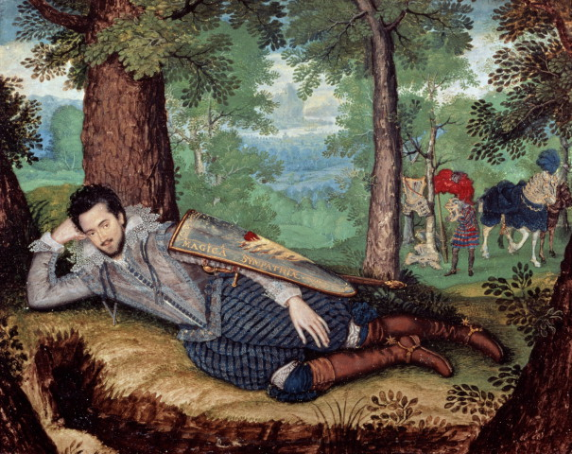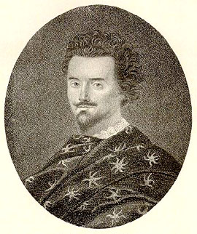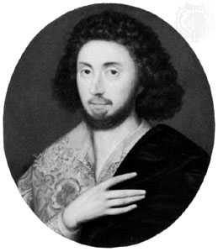

The Dallis lute book includes four items, a fansye (no 1), galliard arrangement (no 2a) and two psalm settings (no 5 & 6) ascribed to Dallis by name, and another three items appear to be signed with the initials TD (two settings of Rogier Pathie’s Si pur ti guardo (no 3a & 3b), and a duet with an untexted melody with lute accompaniment, not included here,[8] all for 6-course lute. As the Dallis lute book includes much Italian music it is not surprising that the fansye is also Italianate. Of the two settings of Si pur ti guardo, the second (no 3b) is almost identical to the arrangement on f. 27r of Pierre Phalèse’ *Theatrum Musicus* published in 1568, and reprinted in the enlarged edition of 1571, so it seems unlikely that Dallis made the arrangement himself. Interestingly, Phalèse included a different setting in the earlier 1563 edition of *Theatrum Musicus*, suggesting the 1568 and 1571 version that is concordant with the Dallis lute book was intabulated in the mid-1560s. Thus, the Phalèse concordance may cast doubt on the ascription to Thomas Dallis of one if not both versions of Si pur ti guardo, based only on the initials ‘TD’ which are in any case quite difficult to read. The simple settings of psalms 5 and 6 might have been used to accompany singing of these Genevan psalms. More elaborate lute settings can be found in Matthaeus Reymann’s *Cythara Sacra* of 1613 and Daniel Laelius’s *Testudo Spiritualis* of 1617 which are both devoted to solo lute settings and variations on all 150 psalms. The cognate version of the galliard (no 2b) in an earlier manuscript [US Ws V.a.159, *c*1559-1571], suggests that Dallis arranged an already popular galliard based on the ‘willow song’[9] that Shakespeare referred to in Othello act 4, scene III, line 39, and sung by Desdemona, beginning ‘The poor soul sat sighing by a sycamore tree, Sing all a green willow’.[10] Tablature for no 2a and 2b already appeared in Chris Goodwin’s article ‘Will you go walk the woods so wild? and the question of popular music’ *Lute News* 64 (December 2002), pp. 15-17, and a facsimile and a hypothetical four-part arrangement of the Dallis version as well as an arrangement for voices and viols or lute of the US Ws V.a.159 version appear in Ian Payne’s article ‘Recent discoveries in lute song 2: An Elizabethan ‘willow’ song revisited’ *Lute News* 73 (April 2005), pp. 27-33.

**Edward Herbert** (3 March 1583-1648) was a courtier, author and historian.[11] The three known pictures of him are reproduced right.[12] He became a gentleman commoner of University College, Oxford in 1596, in the last years that Thomas Dallis was teaching in Cambridge. Soon afterwards he married Mary, daughter of Sir William Herbert and made his first appearance at court in 1600. He was made a knight of the bath on James I’s accession in 1603 living in Montgomery castle in Wales where he ‘attained also to sing my part at first sight in Musick, and to play on the Lute with very little or almost no teaching’. In the period 1608-1619 he left England to travel widely on the continent. In his autobiography, published in 1764 by Horace Walpole, he refers to ‘playing on the lute, and singing according to the rules of the French masters’ during his visit to Paris in 1608-1609. In 1619 he was sent to the court of Louis XIII as James I’s ambassador but was dismissed in 1624 over his outspoken criticism of the marriage of Prince Charles to Anne of Denmark and received the marginal Irish peerage of Castle Island. After the death of James I in 1625, he petitioned Charles I for an English peerage and was finally created Lord Herbert of Cherbury in 1629. Although still resident at Montgomery castle he spent most of his time in London, being granted apartments at Richmond in 1632 where he began work on *The Life and Raigne of King Henry the Eighth*, published in 1643. He was brother to the poet George Herbert (1593-1633), see:

<http://www.luminarium.org/sevenlit/herbert/herbbib.htm>

His personal lute book [GB-Cfm Mus.689] is inscribed ‘The Lutebook of Edward Lord Herbert, of Cherbury and Castle Island, containing diverse selected Lessons of excellent Authors in severall Cuntreys. Wherein are also some few of my owne Composition. E. Herbert’.[13] The ‘some few’ (in fact 8) he composed are two preludes, four pavans and two courantes for 10-course lute in a number of unusual keys and more than one tuning for the diapasons (assuming a lute at G pitch): 7F 8E/Eb, 9D and 10C (no 9, 10, 12, 13, 16, 18) and 7F 8Eb 9Db and 10 Bb (no 11, 17). One prelude and one pavan were copied twice with slight variants (see worklist). His music adheres to the contrapuntal manner of the previous generation and shows no influence of the new French style. According to Matthew Spring, Herbert’s lute solos ‘are of little musical interest apart from the choice of keys and very low tessitura’.[14] No 13, and 16a/b were copied on 3 March in 1626 and 1627, which, from the inscription *die scilicet natalitio* in the titleto the latter, was his birthday.[15] 1626-1627 were the years immediately after his falling from favour at court and these pavans in minor keys seem to capture the mood of his injured pride at falling from favour at court, particularly felt on birthdays in his mid-forties!

**John Lawrence** (?-1635) was appointed as one of the musicians of the ‘Lutes and Voices’ on or before July 1626 at the court of Charles I.[16] He was probably appointed when Charles became king as there is no record that he served him as Prince of Wales. In January 1633/4 he was paid £8 for a treble lute and he is recorded as playing treble lute in James Shirley's masque *The Triumph of Peace* for the Inns of Court with music set by William Lawes and Simon Ives and performed on the 3 February 1633/4 at Whitehall and again on the 13th at the Merchant Taylor’s Hall. He died shortly before 30 April 1635 and was replaced by William Lawes. He may have been related to the William Lawrence of the previous generation and referred to above. His autograph signatures can be found in Longleat House, Whitelocke Papers Parcel II, no 6, relating to the accounts for *The Triumph of Peace* (top, above) and in an acquittance book for 1628 (PRO E405/543, bottom, above). From the three known lute solos ascribed to him (no 23-25 here) it seems that he could ably compose in the new French style in one of the new tunings, all three requiring a 10-course lute tuned ‘flat way, or Lawrence’ as indicated below the music in GB-Lbl Eg.2406 which suggests this tuning was particularly associated with him. A pavan for lyra viol tuned in intervals of alternating 5ths and 6ths is ascribed to him in the Manchester Gamba book [GB-Mp BRm 832 Vu 51].[17] It is here transcribed into the ‘flat way’ lute tuning (no 22), which is so successful that one wonders if it was originally composed for the lute and transcribed for lyra viol by someone else.

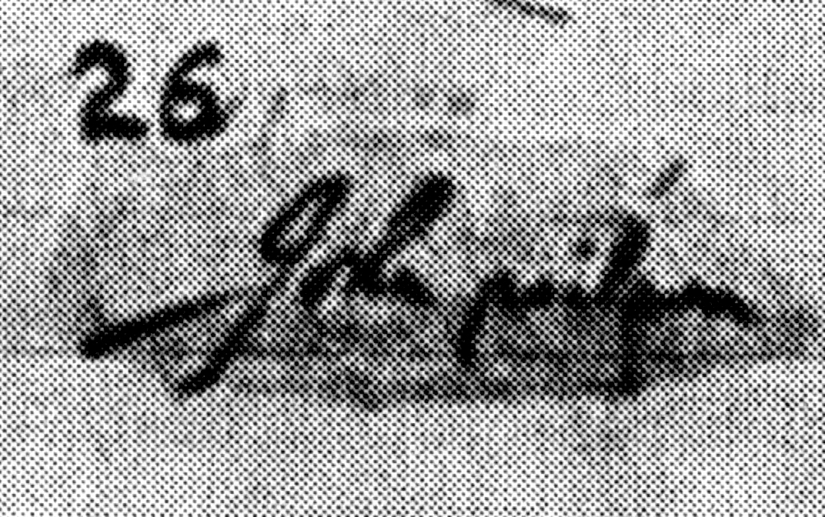

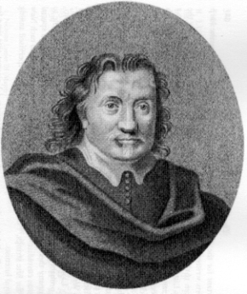

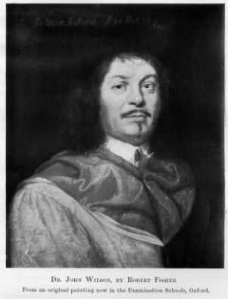

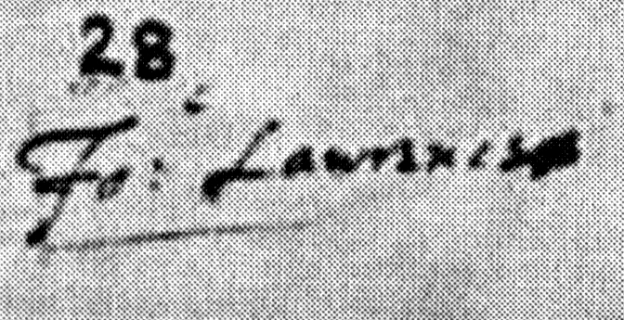

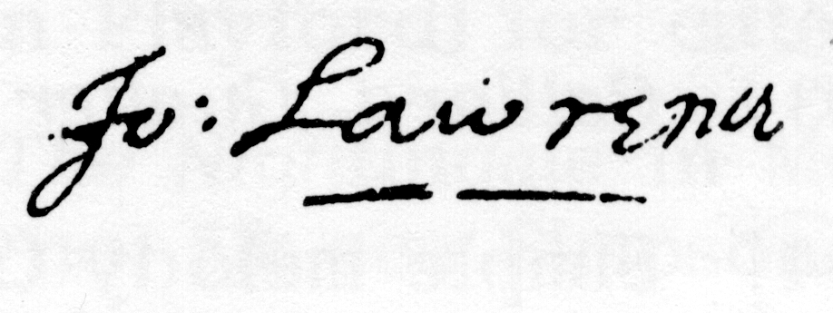

**John Wilson** (1595-1674),[18] was a multi-talented composer and musician. He was associated with the players called *The King’s Men* in 1617 and so he may also be the Iacke Wilson referred to on p. 107 of the 1623 first folio edition of Shakespeare’s *Much Ado about Nothing*. He became the company’s main songwriter until about 1634, sharing the role with Robert Johnson who died in 1633, and was succeeded by William Lawes (that is, before Lawes replaced John Lawrence in the ‘Lutes and Voices’ in 1635, see above). Wilson was also admitted as one of the London City waits in 1622 remaining a member until after April 1641. In February 1633/4 he sang at both performances of Shirley’s masque *The Triumph of Peace* (at which John Lawrence played treble lute). After much petitioning, he was appointed as member of the ‘Lutes and Voices’ at the court of Charles I from 1635 and was to be one of the Lutes in 1643, replacing John Friend, but the civil war intervened. However he attended Charles I at Oxford during the Civil War. Meanwhile he graduated D. Mus. at Oxford in 1643/4 and became Heather professor of music in 1656. He was reappointed at court at the restoration in 1660 and was elevated to Gentleman of the Chapel Royal in 1662 in the place of Henry Lawes. Anthony Wood recorded that John Wilson was ‘the best at the lute in all England. He sometimes play’d the lute, but mostly presided the consort’. He published his *Psalterium Carolinum* in 1657 and *Cheerful Ayres or Ballads* in 1660. He died aged 78 in February 1673/4 and was buried in Westminster Abbey. Two pictures are known, one inscribed 1655 (top, left)[19] and the other later known from an engraving of 1692 of an undated painting (middle, left). His autograph signature is found on the same page of the Whitelocke Papers as that of John Lawrence (bottom, left).

He was one of the most prolific English seventeenth-century composers of vocal music, his output including 256 solo songs and more than 72 part songs, as well as 31 sacred works. Most of his songs are found in a manuscript in Oxford [GB-Ob MS Mus. b. 1, *c*1650-1655], compiled under Wilson’s direction and to which he added annotations and corrections As well as the 226 songs, the manuscript includes thirty untitled preludes in every major and minor chromatic key thought to be for 12-course lute or theorbo, two included here (no 20 & 21).[20] The first prelude here does not use the first course - possibly so that it could be played on either a lute or a theorbo (both in *vieil ton* tuning, but the theorbo with top and/or second string tuned down an octave). However, the second prelude uses the top course tuned as for a lute, not a theorbo. Viol music ascribed to ‘Wilson’ and ‘Mr Willson’ also survives.[21]

Six anonymous items from lute manuscripts roughly contemporary with Herbert, Lawrence and Wilson are also included here. The first is titled *Half hannikin* (no 4) in English sources and is from the later section of the Margaret Board lute book copied around 1630. The original is for 10-course lute in English Gautier tuning (intervals of edeff), but transcribed here for a 10-course lute in *viel ton* tuning (7F, 8E and 10C, assuming a lute in G). Some Dutch cognates include the name **Hansken** (little Hans) in the titles, but Adriansen’s print of 1592 and Hove’s from 1601 are too early to refer to Hansken, a famous performing elephant from Sri Lanka that toured many countries in Europe 1630-1655, sketched by Rembrandt (see right). The title of one cognate, *Hansken is so fraeyen gesel* was kindly translated by Jan Burgers as ‘little Hans is such a good companion.’ Despite a similarity in the name, an association with the English lutenist Raphael Haesken (Hoskins in English), who was active in Antwerp from before 1562 until he died in 1616, seems unlikely.[22]



Two more anonymous items are from a manuscript in the Fitzwilliam Museum Library, Cambridge (GB-Cfm, Mus.688) inscribed 'Aetatis me[ae?]/ 26 1/2 ann: 1637: Friday 15 September I begune to learne/ on the Lute at Hamburgh the money is to owe/ the : 15 : October and soe on In order I pay my Lute/ Mr: [blank space] dutchman a doller an a halfe/ each moneth before hande, he is to come to me dayly/ from 7 : of ye clocke till nighte (or from : 3 : till 4 : in the/ after noone if not on showe dayes)/: 1637 : Christopher Lowther'. This is the personal lute book of Sir **Christopher Lowther** (1611-1644) for an eleven-course lute in *viel ton* tuning, copied in Hamburgh mostly in his own hand. The manuscript remained in the Lowther family until presented to the Fitzwilliam Museum in 1949 by the Sixth Earl of Lonsdale, Viscount and Baron Lowther, Captain Lancelot Edward Lowther (1867-1953).**[23]** Most of the manuscript was left blank, probably because Christopher’s father died as he began his lute book and so he presumably had to return to England to manage family affairs. His own untimely death seven years later presumably prevented him completing it. None of the music is ascribed to Lowther himself so that two anonymous items, both on folio 172v not in his own hand, are included here. The simplicity of the music as well as the heavy annotation with ornaments and fingering indications for left hand and right hand, are consistent with the didactic purpose of the manuscript, and it seems likely that these pieces were copied by his teacher. The first (no 8) is an untitled courante and the second (no 7) is titled *The Schäfferin* [shepherdess], the subject of an ode by the contemporary German poet Martin Opitz (1597-1639) - the first line of which is included in the title.[24]

The remaining anonymous items are lute settings of ballad tunes found in a manuscript for 10-course lute [7F, 8Eb, 9D and 10C] at Trinity College, Cambridge (GB-Ctc Ms O.16.2), the music in *viel ton* tuning copied in the 1620s: *Over the mountains* (no 17), see Simpson, pp. 472-474 and Apropos, pp. 57-58; *See the buildings* (no 14), see Simpson,9 pp. 640-641; and *A Health to Betty* (no 15), see Simpson, pp. 298-299, 446 & 655 and Apropos, 9 p. 46. All three were evidently very popular, judging from the many cognate versions of each that survive for lute, viol[s], keyboard, cittern and violin.

**Worklist** - minor editorial changes made without comment.

**Thomas Dallis**

**1.** IRL-Dtc 410 I, p. 27 *M. T. Dallis fansye* [G]

**2a.** IRL-Dtc 410 I, p. 26 *gailiard all a greane willowe Mr T. Dallis* [D]

**2b.** US-Ws V.a.159, f. 19r *All of green willow* [C minor]

**3a**. IRL-Dtc 410 I, pp. 76-77 *Si porti guardo TD* [F]

IRL-Dtc 410/I, p. 30 untitled fragment [F]

**3b.** IRL-Dtc 410 I, p. 105 *Sipurti guardo mr TD?* [F] = Phalèse *Luculentum Theatrum Musicum* 1568, f. 26r *Si purti guardo* = Phalèse & Bellère *Theatrum Musicum Longe* 1571, f. 58r *Si purti guardo*.[25]

**Anon from Margaret Board’s lute book**

**4.** GB-Lam 603, f. 38r *half hanniken* [C, transcribed from English Gautier ‘edeff’ tuning]. Cognates: NL-Lu 1666 (Thysius), f. 435r *Courante van Hansken* & f. 431r *Courante* & f. 435r untitled; Adriaenssen *Novum Pratum Musicum* 1592, f. 82r *Courante*; Hove *Florida* 1601, f. 110r *Hansken is so fraeyen gesel*. Cittern: US-CA Mus.179, f. 24r *half hannikin*; US-CA Mus.182, f. 66v *Halfe Hannikinge.* Violin: Playford *The Dancing Master* 1651, p. 43 *Halfe Hannikin* & p. 45, *Jog on* [see Simpson, pp. 392-394; Apropos, p. 49]. Keyboard: GB-Cfm Mus.168, pp. 416-418 *Hanskin Richard Farnaby*.

**Thomas Dallis**

**5.** IRL-Dtc 410 I, p. 215 i [psalm 5] *Mr Dallis* [C minor]

Lute cognates: IRL-Dtc 410 I, p. 160 *Psal.5. Aux p*[ar]*oles que ie veux dire*; LT-Va 285-MF-LXXIX, f. 43r *Psalm: 5. O Herr dein Ohren zu. Psalm: 64*; NL-Lu 1666, f. 233v *Psal*[m]*. 5. Mr Jan Pietersz Sweling* [Sweelinck] & f. 238r *Psalm 5* & f. 300v [psalm 5, Le Jeune]; Le Roy, *Tiers Livre de Tabulature de Luth* 1552, ff. 9v-10r *Verba mea auribus per pseul. V. Aux parolles que ie veulx dire*; Reymann, *Cythara Sacra* 1613, sig. B2v-B3r *Psalmus 5./Variatio*; Laelius, *Testudo Spiritualis*, 1617, p. 14 *Psalm 5. Aures Deus verb/ Aux paroles que/ O Herr dein ohren/ Der Hoort God myn*; Zahn no 1796.

**6.** IRL-Dtc 410 I, p. 215 ii [psalm 6] *Mr Dallis* [E minor]

Lute cognates: D-B 40264, p. 166 *ex D/ 6 Psalm/ A*; LT-Va 285-MF-LXXIX, f. 43v *Psalm: 6. In deinem grossen Zoren*; NL-Lu 1666, f. 238v *Zweling met 4/ psal*[m]*. 6: 1* [Sweelinck] & ff. 238v-239r *Psalm 6* [3 settings]; Reymann, *Cythara Sacra* 1613, sig. B3r-B3v *Psalmus 6./Variatio*; Laelius, *Testudo Spiritualis*, 1617, p. 15 *Psalm 6. O Rex supreme/ Ne uneille pas/ In deinem grossen/ Wilt mp niet strassen Heer*; Zahn no 2266.

**Anon from Christopher Lowther’s lute book**

**7.** GB-Cfm 688, f. 172v ii *The Shefferin* [C minor]

**8.** GB-Cfm 688, f. 172v i Untitled courante [C]

Fingering indications for left hand (one, two, three or four dots in the original indicated here with numbers 1, 2, 3 or 4 for index, middle, ring and little fingers) and right hand (one two or three vertical dashes in the original indicated here as one, two or three dots for right first, middle and ring fingers) as in original.

**Edward Herbert**

**9.** GB-Cfm 689, f. 51r *Prelude of my owne making. H* [Bb minor]

= GB-Cfm 689, f. 50v *Prelude Herbert*

**10.** GB-Cfm 689, f. 68r *Prelude. H:* [C minor]

**11.** GB-Cfm 689, f. 90r *Pavan of the Composition of mee Herbert of Cherbury and Castle Island. 1640* [Eb minor]

**12.** GB-Cfm 689, f. 78r *Courante of my owne composition at Montgomery Castle Aug. 10. 1628 Herbert* [A minor]

**13.** GB-Cfm 689, f. 13v *Pavan of my owne Composition 3 martij 1626 Herbert* [D minor]

**Anon from Trinity O.16.2**

**14.** GB-Ctc O.16.2, p. 136 *The Bu*[ildings]*:* [G minor]

Lyra viol: GB-Lbl 63852, f. 100v *The Buildings*; GB-Lam 600, f. 39r *See the Buildings*; GB-Mp BRm 832 Vu 51, p. 19 *The Buildings R*[icharde]. *S*[umarte]. Bass viol[s]: IRL-Dm Z3.4.13, no 11 The Buildings?; GB-Ob D.245/246, p. 154/178 *See the building* [duet]. Keyboard: GB-PLlancelyn Bunbury, f. 12v *The Buildings* & ff. 27v-28r *The buildings*; GB-Och 431, f. 4v *The Buildings*; GB-Och 437, f. 4r untitled; US-NYp Drexel 5612, p. 80 untitled.

**15.** GB-Ctc O.16.2, p. 136 *A Health to Bettey* [G minor]

GB-Ctc O.16.2, p. 118 *A toy*; cf. Mathew *The Lutes Apology* 1652, p. 14 *11. what you will*. Lyra viol: GB-DU Mus.10455 (Blaikie), p. 4 *A Health to Bettie*; GB-Lbl Add.59869 (Cartwright), f. 24r *A Health to Bety*. Cittern: Playford *Musick’s Delight on the Cithren* 1666, sig. D2v *HEalth to Betty*. Violin: Playford *The Dancing Master* 1651, p. 21 *A Health to Betty*.

**Edward Herbert**

**16a.** GB-Cfm 689, f. 82r *Pavan of the Composition of mee Edward Lord Herbert 1627 3.to Martij die scilicet natalitio*

**16b.** GB-Cfm 689, f. 79r *Pavan of my owne composition 3 Martij 16*[27] [A minor]

**17.** GB-Cfm 689, f. 90v *A Pauan composed by mee Herbert of Cherbury and Castle Island: 1639* [Bb minor]

**18.** GB-Cfm 689, f. 15v *Courante EH:* [D minor]

**Anon from Trinity O.16.2**

**19.** GB-Ctc O.16.2, p. 135 *Over the mountaines* [C]

GB-Lam 603, f. 38v *loue will find out the way*. Lyra viol: GB-En Dep. 214, no 24 (Sutherland), p. 6 *ouer the mountains*; GB-Lbl 63852 (Boynton), f. 117r *Over the mountains*. Cittern: GB-En 4950 (Edwards), f. 41v *Ouer the mountaines*; US-CAh Mus 179 (Boteler), f. 4r *Ouer the Mountaine:*; US-CAh Mus 181 (Otley), f. 16v *Over the mountaines*; Playford *A Booke of New Lessons for the Cithern & Gittern* 1652, p. 4 *9. Over the mountaines*; Playford *Musick’s Delight on the Cithren* 1666, sig. B3v *Over the Mountains*. Song: GB-En 9477 (Millar), f. 72r *Over the mountains*. [More in *Lute News* 120]

**John Wilson**

**20.** GB-Ob Mus. b.1, f. 3v ii Untitled prelude [Bb]

**21.** GB-Ob Mus. b.1, f. 7v i Untitled prelude [F minor]

**John Lawrence - in flat way or Lawrence tuning[26]**

**22.** GB-Mp BRm 832 Vu 51, p. 89 *Pavine John Lawrence* - transcribed from lyra viol

**23.** GB-Lbl Eg.2046, f. 43r ii *Ballat John Lawrence*

GB-CHEr DLT B31(Leycester), f. 82r iiiuntitled - lyra viol

**24.** GB-Lam 603, ff. 35r-35v *Almand*

GB-Lbl Eg.2046, f. 43r i *Coranto John Lawrence*

**25.** GB-Lbl Eg.2046, f. 44r ii *Serabrande John Lawrence*

Right and left hand fingering indications as the original but notated here as for no 7 & 8.

John H Robinson, Newcastle University, October 2007

1. H. Macaulay FitzGibbon, ‘The Lute Books of Ballet and Dallis’ *Music & Letters*, (1930) 11/1 71-77; John M Ward and ‘Music 200’, ‘The Lute Books of Trinity College, Dublin - I: MS D. 3.30/I: The so-called Dallis Lute Book,’ *The Lute Society Journal* (1967) ix 17-40; Diana Poulton ‘Dallis, Thomas’ *New Grove 2* vi 864.
2. Julia Craig-McFeely, ‘English Lute Manuscripts and Scribes 1530-1630’, 3 vols (D Phil thesis, University of Oxford, 1994), appendix 1, p. 349; and see http://www.ramesescats.co.uk/thesis/ to download pdf for appendix 1a, p. 50.
3. The ‘y’ of ‘ye’ is the Anglo Saxon letter *thorn* for the sound *th*. as in ym for *th*em and yt for *th*at, and ‘z’ is the Anglo Saxon letter *yogh* for the sound *dzh* as in Tou*jou*rs, see Lionel Munby, Steve Hobbs and Alan Crosby *Reading Tudor and Stuart Handwriting* (Salisbury: British Association for Local History, 2002), pp. 15-16.
4. D Brown/Ian Harwood ‘Johnson, Edward’ *New Grove 2* 13: 157.
5. Ian Harwood personal communication; Andrew Ashbee, David Lasocki, Peter Holman and Fiona Kisby (eds.) *A Biographical Dictionary of English Court Musicians* [BDECM] (Aldershot: Ashgate, 1998), II, pp. 713.
6. John M Ward (1967), *op. cit*.; J. Sternfeld, ‘The Use of Song in Shakespeare's Tragedies’ *Proc* *Royal Music Assn* (1959) 86: 45-59.
7. Ian Harwood, ‘A possible Dallis reference’ *The Lute Society Journal* (1976) xviii 46.
8. IRL-Dtc 410 I, pp. 178-179, *per TD* [melody in mensural notation and lute accompaniment], modern edition: Chris Goodwin (ed.) *The English Lute Song before Dowland: 1. Songs from the Dallis MS c.1583* (Oldham: The Lute Society, 1996), no. 9, pp. 24-25.
9. Claude M. Simpson, *The British Broadside Ballad and Its Music* (New Brunswick: Rutgers University Press, 1966), pp. 788-791 and John M. Ward, ‘Apropos *The British broadside ballad and its music*’, *Journal of the American Musicological Society* (1967) xx 85.
10. Ernest Brennecke ‘Nay, That's Not Next!: The Significance of Desdemona's Willow Song’ *Shakespeare Quarterly* (1953) iv 35-38; John P. Cutts ‘A Reconsideration of the Willow Song’ *Journal of the American Musicological Society*, (1957) 10/1: 14-24; F. P. Sternfeld, ‘The Use of Song in Shakespeare's Tragedies’ *Proc* *Royal Music Assn.* (1959) 86: 45-59 F. W. Sternfeld *Music in Shakespearean Tragedy* (London, 1963), chapter II: The Willow Song, pp. 23-52.
11. Thurston Dart ‘Lord Herbert of Cherbury’s Lute-Book’ *Music & Letters* (1957) 38: 1-16: Diana Poulton/Robert Spencer ‘Herbert, Edward’ *New Grove 2* xi 401.
12. The middle picture is reproduced complete on the cover of Paul O’Dette’s CD ‘Lord Herbert of Cherbury’s Lute Book’ (Harmonia Mundi 907068, 1992 – on which track 28 is a Herbert pavan, my no. 11). Pictures located using Google images search of his name.
13. C. Price ‘An organisational peculiarity of Herbert of Cherbury’s lute-book’ *The Lute* (1969) xi 5-27; J. Craig-McFeely ‘A can of worms: Lord Herbert’s Lute Book’ *The Lute* (1991) xxxi 20-48.
14. Matthew Spring *The Lute in Britain: A History of the instrument and its music* (Oxford: University Press, 2001), p. 338.
15. Thank you to Mathias Rösel for translating the Latin phrase *die scilicet natalitio* (that is [my] birthday).
16. Richard Newton ‘English lute music of the golden age’ *J Royal Music Assn* 65 (1938) 63-90; Murray Lefkowitz, ‘The Longleat Papers of Bulstrode Whitelocke; New Light on Shirley's "Triumph of Peace"’ *Journal of the American Musicological Society* (1965) 18: 42-60; R. Spencer ‘Three English lute manuscripts’ *Early Music* (1975)3: 119-124; BDECM, II, pp. 712-713; M. Spring *op. cit.*, chap 10.
17. Lyra viol tuning fhfhf (intervals between strings beginning at the top). Facsimile edition: Paul Furness (ed.) *The Manchester Gamba Book* (Mytholmroyd, 2003).
18. BDECM II, pp. 1157-1159; Ian Spink ‘Wilson, John’ *New Grove 2* xxvii 423-424; Matthew Spring, *op. cit.*, chap 10.
19. See Rachael Poole ‘The Oxford Music School and the collection of portraits formerly preserved there’ *The Musical Antiquary* (1913) iv 143-159.
20. Matthew Spring (ed.) *John Wilson: Thirty Preludes in all (24) keys for lute,* facsimile and transcription (Utrecht: Diapason Press, 1992), no 2 and 17.
21. Viol music by or for ‘Wilson’: GB-Cu Dd.6.48, f. 9r *Coranto* = GB-Gum LM 1083/91/35, p. 3 *A short sarraband*; GB-Lbl Add.36484, no. 97 *Wilson’s fantasy* [IV], GB-Eu La 488, f. 43r [I] = GB-En 9450, f. 4r [I] & 20r [II], IRL-Dtc Press B.1.32 [I], cf. Musica Britannica 15, no. 85. In addition four suites each of an almain, air, coranto and saraband for treble viol[in?] are ascribed ‘Mr Willson’ in GB-W Vicars choral MS 94, pp. 145-160.
22. See the newsletter of the Belgian Lute Academy, *Geluit-Luthinerie*, no 31, ‘Luthistes anversois (6): Raphael Hoigskins alias Haesken (Angleterre, avant 1537 - Anvers, c. 1616)’ by G. Spiessens.
23. A. G. Mathew, ‘An old lute book’, *The Musical Times* (1949) 90: 189-190. G. Beechey, ‘Christopher Lowther’s Lute Book’, *Galpin Society Journal* (1971) 24: 51-59.
24. Identified by Rainer aus dem Spring as Ode III, *Martin Opitz, Gedichte*, ed. Jan-Dirk Müller (published by Phillip Reclam Junior, Stuttgart, 1970), p. 159, which begins ‘Wol dem der weit von hohen dingen/ Den Fuß stellt auff der Einfalt Bahn/ Wer seinen Muth zu hoch wil schwingen/ Der stöst gar leichtlich oben an/ Ein jeder lobe seinen Sinn/ Ich liebe meine Schäfferinn’.
25. Si pur ti guardo is a 4-part madrigal attributed to Rogier Pathie [and Baldasarre Donato]. Vocal model: RISM 15708, p. 46. Cognates in F: CH-Bu F.IX.70, pp. 66-67 *III Si purdi guardo. 4. vocum*; NL Lu 1666, ff. 167r-167v *Si pur ti guardo / Mr David* [edited in *Lute News* 77 (March 2006)] & 168r-168v [untitled]; Rotta *Intabolatura di Lauto* 1546, ff. 44v-45v *Se pur ti guardo* = Phalèse 1552, p. 34 *Si pur ti guardo*; Gorzanis *Il Secondo Libro de Intabulatura di Liuto* 1563, pp. 60-61 *Se pur ti guardo*; Phalèse *Theatrum Musicum* 1563, f. 37r; *Si por ti guardo*Jobin *Das Erste Buch* 1572, sig. B1v *I. Si purti guardo*; Waissel *Tabulatura Continens* 1573, sig. C4r *15 Si pourti guardo*. In G: Ochsenkun *Tabulaturbuch auff die Lauten* 1558, f. 85v *Se purti guardo Incerti Autor*; Phalèse & Bellère *Thesaurus Musicus* 1574, ff. 46v-47r *Si purti guardo*. In A flat: Valderrábano *Libro Musica de Vihuela* 1547, f. 33r *Sepurte guardo*. Cittern: Vreedman *Nova Longeque Elegantissima Cithara Ludenda Carmina* 1568, f. 24v *Si parti guardo*; Phalèse & Bellere *Hortulus Cytharae* 1570, f. 22v *Si purti guardo* = Kargel *Renovata Cythara* 1578, f. E2v *Se purti guardo* = Phalèse & Bellère *Hortulus Cytharae* 1582, f. 11v *Si pur ti guardo*. Vocal: Phalèse *Horti Musarum* 1553, sig. B4r *Si purte guardo* [lute song]; Phalèse *Septiesme livre* 1567, p. 46 *Si pur ti guardo*; Stalpart *Gulde-Jaer Ons Heeren Jesu Christi Op alle de zonnendagen des Jaers* 1628, p. 48 *Se pur ti guardo* & p. 72 *Se pur ti guardo*. Same music as Allein nach dir Herr, Zahn no 8541: CH-Bu F.IX.70, p. 96 *XXXIIII Allein nach dir Herr*; CH-Bu F.IX.70, p. 320 *I Allein nach dir Herr*; CZ-Pu 59r.469, ff. 123v-124r *Allein nach dir Herr Jesu Christe Sipliciter absq coleratim*; D-W Guelf. 18.7, ff. 28v-29r *Allain nach dir Herr. Jacobus Reijs* & 29v-30 *Alio modo*; S-Skma Sackska samlingen, ff. 13v-14v *Allein nach dir Herr*. Keyboard: S-Skma 1, ff. 49v-52v *Allein nach dir herr*; Schmid *Zwey Bücher* 1577, f. V2v *Allein nach dir Herr, oder Si purti Quarto a4*; Ammerbach *Orgel oder Instrument Tabulatur* 1571, f. 19v *Allein nach dir Herr Jhesu Christ verlanget* = Ammerbach *Orgel oder Instrument Tabulaturbuch* 1583, p. 73 *Allein nach dir Herr*.
26. A further three almands and two corants all anonymous and in ‘harp flat or Lawrence tuning’ on ff. 35r-36r of GB-Lam 603 could also be by John Lawrence..