**Music supplement to Lute News 84 (December 2007)**

**A selection of lute solos from the lute book of Wolfgang Hoffmann von Grünbühel**

This tablature supplement includes a selection of lute solos and a duet from the early seventeenth-century lute-book of Wolfgang Hoffmann von Grünbühel, Staats-bibliothek zu Berlin Preussischer Kulturbesitz, N. Mus. ms. 479, which was largely unknown until the recent appearance of Richard Charteris’ article in *The Lute*.[1]

The original owner was Baron Wolfgang Hoffmann von Grünbühel und Stechau (1607–1641), who belonged to a wealthy family with estates in Styria (Austria), Bohemia and Moravia. Baron Wolfgang Hoffmann von Grünbühel was a descendant of Hans Hoffmann von Grünbühel (d. 1564), a private advisor to the Holy Roman Emperor, Ferdinand I (1503–1564). Wolfgang Hoffmann’s grandfather, Ferdinand Hoffmann (1540–1607), whose godfather was in fact Emperor Ferdinand I, received the title of Count Janowitz. Ferdinand Hoffmann purchased major estates in Bohemia and Moravia, and served at the Prague court of Emperor Rudolf II (1552–1612). The grandfather Ferdinand Hoffmann, who studied in Padua in 1553 and held prominent positions throughout his career, was a major book collector. When he died in 1607, his library at Schloss Janowitz (located 65 kilometres from Prague) was ‘probably the finest private collection in central Europe’. The most valuable component of his library comprised the book collection of the Nuremberg physician Hieronymus Münzer (1437–1508). The Hoffmann library was inherited by Ferdinand’s son, Andreas, and then his grandson Wolfgang Hoffmann, the original owner of the lute-book at Staatsbibliothek zu Berlin, N. Mus. ms. 479. When Wolfgang Hoffmann von Grünbühel died in 1641, the family library was inherited by his son Wolfgang Friedrich. Eventually it passed to Wolfgang Friedrich’s daughters, Johanna Maria and Maria Elisabeth, who in turn donated the collection in 1669 to their guardian, Prince Ferdinand Josef von Dietrichstein (1636–1690). In 1988, the Staatsbibliothek zu Berlin purchased the lute-book from the antiquarian bookseller Christian M. Nebehay in Vienna.

On the front pastedown (see facsimile below), the original owner wrote ‘Wolf[g]ang Hoffman L B de Grunpihel et Strechau Dominus in Rabenstein scripsit Argentina 1619 ...’. Rabenstein and Strechau are places in Styria in Austria. Wolfgang Hoffmann von Grünbühel wrote this inscription in Strasburg in 1619, probably while he was studying there. The lute-book was almost certainly compiled for his instruction on the instrument, and indeed his interest in lute music is confirmed by other lute sources that were formerly in the Hoffmann collection (see the article). It is quite likely that he met, and possibly received lessons from, the Strasburg lutenist Elias Mertel (*c*.1561–1626), who was then one of the instrument’s best known practitioners in central Europe as well as being intabulator and composer.[2]

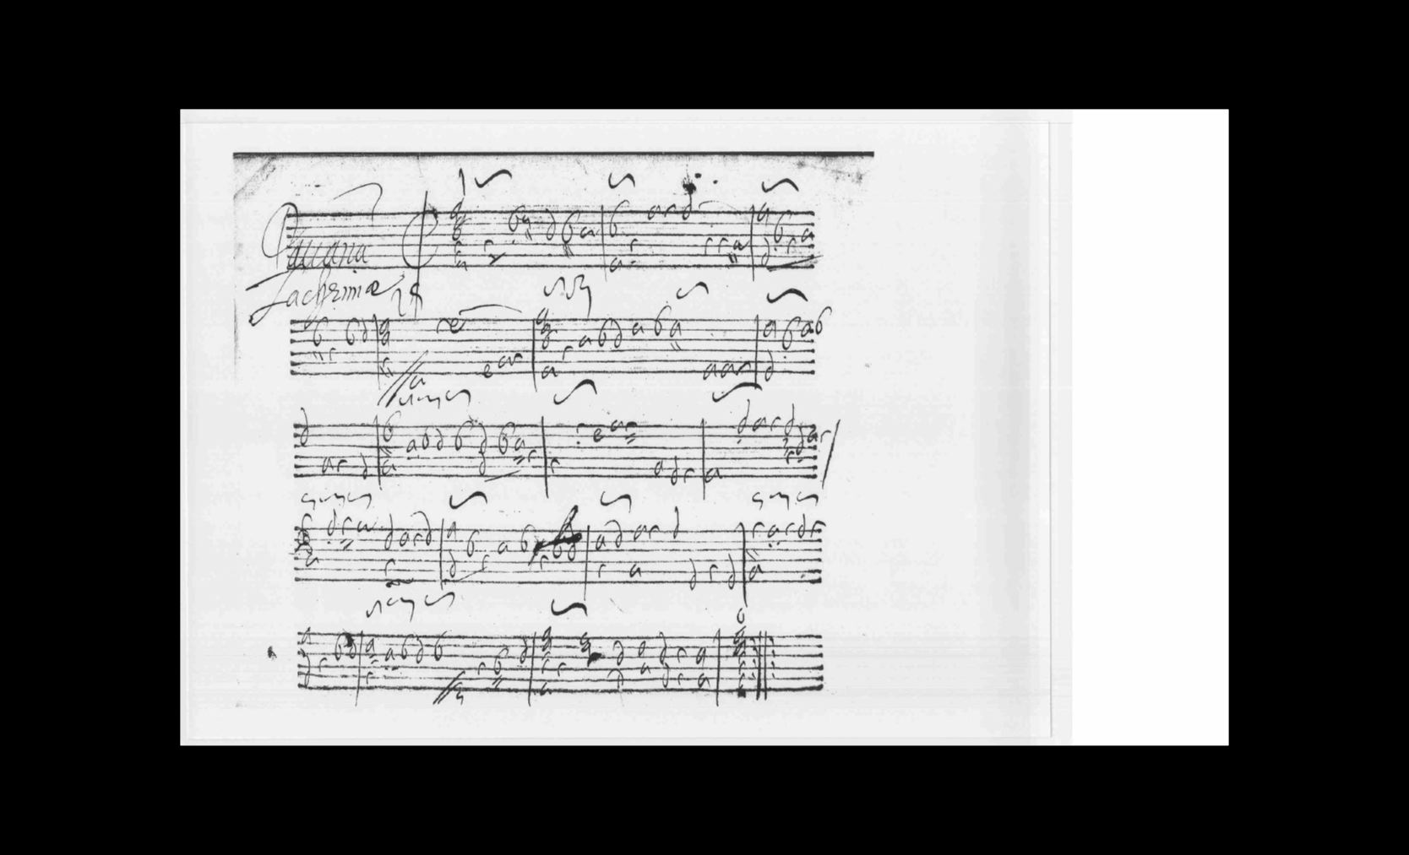

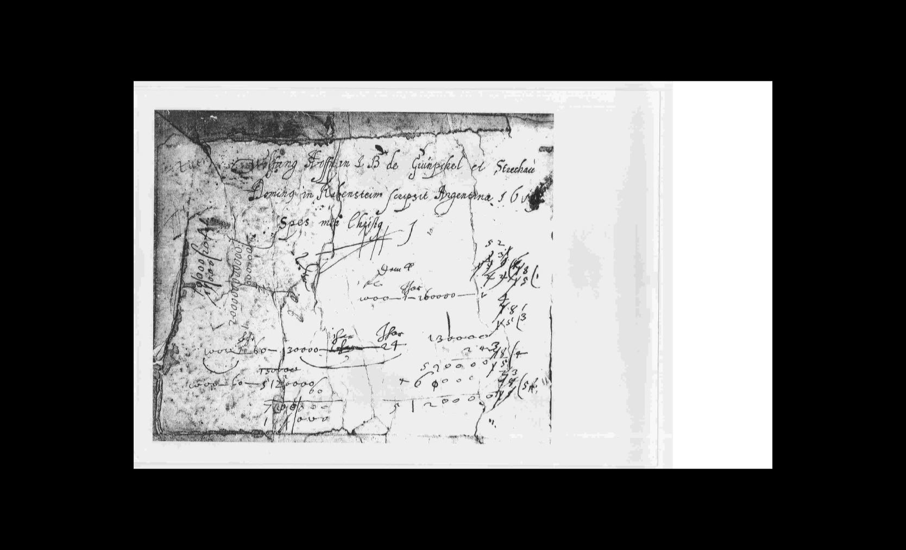

The lute-book contains 86 works in French lute tablature by French, English, Italian, and German composers, though most of them are arrangements made by others. Most of the works comprise dances, preludes, untitled pieces and lute versions of *airs de cour*. In addition to two preludes (see no 1 edited here), the instrumental genres comprise an almande gratiae (no 8), ballett (17, see no 9, 14 & 15), bergamasco (2, see no 10), branle (1), chorea (1), courante (24, see no 12 & 16), galliard (5, see no 5), mascarate (4, see no 2), passamezzo (2), pavan (2, see no 6), prelude (7), saltarello (1), sarabande (2, see no 13 which uses the ground I-IV-I-V of the Spanish zarabanda), volte (3, see no 16) and a setting of the continental ballad ‘Francescina’ (no 4). Three pieces in the manuscript were composed for two lutes in unison, a chorea and two courantes. One of the courantes is in fact an arrangement of the English tune known as Packington’s Pound (no 7, reproduced as in the original despite the few dissonances). Another work consists of a three-movement suite for a masque. Only six compositions are accompanied by manuscript attributions: a ‘Favorite’ and a courante by ‘Gauttier’ (or Gothier) - not to be confused with the French lutenists and composers Ennemond Gaultier (1575–1651) or his cousin Denis Gaultier (1597/1603–1672); a galliard by Elias Mertel; a courante by the French composer and singer Jacques Salmon (b. *c.*1545; *fl*. 1571–1586; no 17) which is anonymous in another source so that the composer is only identified in the present manuscript; a courante possibly by the Italian lutenist and composer Laurencinus Romanus or Lorenzino (d. 1608); and a prelude by the otherwise unknown composer ‘H Pÿso’.

Among other continental composers whose music is represented are the French lutenists and composers Mercure d’Orléans (*fl*. *c*.1590–*c*.1619), Robert Ballard (*c.*1575–1649), and Charles de Lespine (b. ?1580, d. after 1627), and the French-based, Polish lutenist and composer Jakub Reys (*c.*1550–*c*.1605). The manuscript also contains lute arrangements of *airs de cour* without text underlay, though some have titles. They comprise three pieces inspired by Pierre Guédron’s ‘Est ce Mars ce grand dieu des alarmes’ published in 1613 - one was composed by Robert Ballard; two works inspired by the unattributed ‘En me revenant de Saint Nicolas’ published in 1597; one piece inspired by Pierre Guédron’s ‘Je rencontrai l’autre jour’, published in 1613; a work inspired by Pierre Guédron’s ‘C’est trop courir les eaux’, published in 1617; and one composition inspired by Jean Boyer’s ‘Sa beauté extrême’, published in 1619. Four courantes in the lute-book are based on the popular dance tune ‘La Vignonne’, which was probably written by the French lutenist Jérôme Vignon (b. ?1590s; d. after 1653).

The lute-book also includes two unattributed compositions by the famous English lutenist and composer John Dowland (1563–1626), both of which are edited here. The first, his ‘Frog Galliard’ (no 5), appeared in many other lute versions, though most of them, like this one, were arranged by others. In addition to lute, the piece was circulated in versions by others for keyboard, cittern, mandora, mixed consort, viols as well as a ballad (see worklist). Rather than G major, as the version Dowland autographed in US Ws V.b.280, f. 12v, the present piece is in F major, assuming a lute tuned in G. At times the arrangement in the Grünbühel lute-book is quite different from the Dowland version. For instance, instead of repeating each strain after its first statement, as in Dowland’s version, this source gives the two strains one after the other and then follows them with a lively second section (‘2 deel’) containing the repeats. The second work by Dowland represents a new cognate version of his most famous composition, the ‘Lachrimae Pavan’, which appeared in approximately 100 early manuscripts and printed editions (see worklist). A few of the versions belonged to Dowland, though the majority were arrangements made by others. This version (no 6 - the words ‘animi gratia’ are written under bar 30) is in the form of divisions but largely adhering to the harmony of the original (see facsimile on the previous page).

Unattributed lute arrangements of popular English ballad tunes, though mostly unnamed in the source, comprise two settings of ‘Pickelhering/ Walking in a Country Town’, and single settings of ‘Bonny Sweet Robin’ (or ‘Robin Is to the Greenwood Gone’), ‘Packington’s Pound’ (no 7) and ‘Walsingham’. Other English works include a galliard by Robert Johnson known as ‘My Lady Mildemay’s Delight’, ‘Ballet Anglois’ (no 3), ‘Mascarada The Nobleman’, and ‘Ingleza’ (no 11).

The music is written for a ten-course lute in *viel ton* tuning. Assuming that the uppermost string was g´, then two tuning guides near the beginning of the manuscript indicate that the instrument was tuned C D E flat F G c f a d´ g´. However, some of the music uses an 8th course tuned to E natural (such as no 1, 10, 12 here) or a 10th course tuned to B flat (such as no 14 here). Playing indications abound in the lute-book, but vertical ties in chords, horizontal ties and *tenuto* signs (‘x’) to indicate holding of bass notes and right hand fingering (one dot under a tablature letter for index finger and two dots or two short vertical lines sloping to the right or to the left have all been interpreted as indicating the middle finger) have been reproduced as in the original. However, the two short vertical lines also often appear within a chord or below the bass note of a chord, the significance of which is not clear. These and other signs (shown in facsimile on the previous page) as well as ‘/’ within chords to indicate spreading, have been omitted. Minor editorial corrections have been made without comment.

**Worklist**

1. *Praeludium* ff. 68v-69r

2. *Mascar*[a]*te* f. 8v

3. *Ballet Anglois* ff. 36v-37v

4. *Franciscano* [3] ff. 64v-65r

5. *Frog galliard/2 deel* [4] [bars 39 & 63 added] ff. 60v-62r

6. *Pauana Lachrimae* [5] ff. 72v-74r

7a. *Courante Discantus Primus* [lute I] ff. 25v-26r

7b. *Eiusdem Discantus Secundus* [lute II][6] ff. 26v-27r

8. *Almande gratiae* [7] ff. 46v-47r

Hove 1601, f. 109r *Almande Gratie*

B-Bc Lit. S1 26.369, f. 35r *Almande grassie*

9. *Ballet* ff. 66v-67r

10. *Bargamasco* [8] [barring adjusted editorially] ff. 70v-71r

11. *Ingleza* ff. 65v-66r

12. *Courante* ff. 49v-50r

13. *Sarabande* [bar 23 added editorially] ff. 53v-54r

D-Kl 4o Mus. 108.I, ff. 98v-99r *Sarabande*

14. *Ballet* f. 67v

15. *Ballet madame* f. 43r

16. *Volte* f. 10r

17. *Courante de Mr Salomon* [Jacques Salmon] f. 20v

US-R Vault M140 V186S, p. 34 [untitled]

Richard Charteris, University of Sydney

and John H. Robinson, Newcastle University

1. Richard Charteris, ‘Wolfgang Hoffmann von Grünbühel’s Lute-Book: A New Source of European Music’ *The Lute* 46, pp. 1-46 (2006), publication coinciding with this issue of *Lute News*
2. For the 26 lute solos by Elias Mertel see John H. Robinson *Lute Solos ascribed to Elias Mertel* (Lübeck: Tree Edition, 2007).
3. A section called ‘La bella Francescina’ appears in many battle settings throughout the 16th-century using several tunes, including the tune of the English ballad ‘Mal Sims’ in some versions. Cognates in G minor: GB Lbl Sloane 1021, ff. 76v-77r *Labellana Fran*; LT-Va 285-MF-LXXIX, f. 6r [untitled] = LT-Va 285-MF-LXXIX, f. 54v *Paduana Franciscina* *Bass*; LT-Va 285-MF-LXXIX, f. 35r *Intrada Hass*[ler?]*: NB*; LT-Va 285-MF-LXXIX, f. 41v [untitled]; LT-Va 285-MF-LXXIX, f. 54v *Alia ejusdem Basis*; LT-Va 285-MF-LXXIX, f. 58r *Pavan Fran:*. In D minor: LT Va 285-MF-LXXIX, f. 54v *Paduana Francis*:; LT-Va 285-MF-LXXIX, f. 58r *Pavan Fran*:. In C minor: D-Ngm 33748/I, f. 76r *franzisgina*; GB-Lbl Sloane 1021, f. 77v i, *Labella Franciscana* *alias Dannenbaum*. Cognate versions of ‘Mal Sims’ in G minor: D-B 4022, f. 43v *Mal sims*; D-Kl 4o Mus.108, f. 4r *Paduana*; D-LEm II.6.15, p. 168 *Intrada Angellica*; D-LEm II.6.15, p. 483 *Matrigalia 17*; GB-Cu Dd.9.33, ff. 62v-63r *Mall Sims*; GB-Cu Add.3056, f. 43r *Mall Symms*; GB-Lam 601, f. 11v: [untitled, index: *Mall Symes*] = US-Ws V.b.280, f. 15v *Mall: Symes*; GB-Lbl Add.6402, f. 2r *Dumesai*; GB-Lbl Add.38539, ff. 9v-10r *Mall Simmes*; GB-Lbl Eg.2046, ff. 26v-27r *Mall Symes*; Hove 1612, f. 59r *Ballet Englese/ Incerte*; Vallet 1615, p. 92 *Bal Anglois/ Mal Simmes*. In D minor: D-B 40141, f. 187r [untitled]; D-Dl M 297, pp. 136-8 *Englischer Leufherger*; D-Kl 4o Mus.108, ff. 59v-60r *Ballett ángloys*; D-LEm II.6.15, p. 97 *Paduana*; D-LEm III.11.26, p. 2 *Chorea Anglica*. In C minor: GB-Lbl Sloane 1021, f. 77v iv *Littawe Engelsche Leuffauch*; Vallet 1616, pp. 8-9 *Malsimmes*. Lute duet: US-NHub fb7, f. 81v *Mall Sims* [lute I only]. Lute, cittern and 2 voices: Valerius 1626, pp. 206-8 *‘t Engels Malsims, metten Bas: zynde op een twee-spraeck gestelt, tusschen A ende B*. Cittern: US-CA Mus.182, ff. 75v-76r *Malsymes 28*. Mandora: GB-En Adv.5.2.15, pp. 3-5 *Male Simme*. Keyboard: D-B Ly A1, pp. 290-1 *Malle Siemon/ Lenhardus Wooddeson*; F-Pn 1186, f. 118v *Mal Sims*:; GB-Cfm Mus.168, pp. 33-4 *M. S*.; GB-Cfm Mus.168, pp. 394-5 *Mal Sims/ Giles Farnaby*; GB-Lbl Add.30486, f. 21r *Mall Simms*; GB-Lbl Add.30486, f. 22r *Wanton Season*; GB-Lbl Add.36661, ff. 62v-63r *Mall Simmes/ Mall Sims Tho: Tunstall Ayprill the 23r 1630*; GB-Och 437, f. 2r *Mall Syms*; PL-Kj 40316, ff. 14v-15r *Canzon di do*; RF-SPan 204, f. 29r *Molle Sijmen Mr JP* [Sweelinck]; S Sk 1, f. 38v *Allamande Doulandt*; S-Sk 1, ff. 59v-60r *Pauan*; US-NYp Drexel 5609, p. 92 *Mal Sims*; US-NYp Drexel 5609, p. 227 *Mal Sims by Giles Farnaby/ This is in Queen Elizabeth’s Virginal Book*; US-NYp Drexel 5612, pp. 156-7 *Lessons in D soll re:/ Mall Simes*. Violin and bass: Vallet 1642 section III, no. 18 *Malsimmes*. Instrumental ensemble: GB-Lbl Add.17795, f. 41r *Mall Simmes*; GB-Ob 245-6, p. 3, *Mall Simes*. Mixed consort: Rosseter 1609, no. 25 *Mall Simms. Incertus Edmond Kete*.
4. Lute cognates in F: D Dl M 297, p. 134 *Galliardt Gantz berü*[m]*bt*; D LEm II.6.15, p. 198 *Rechenbergers Galliardt 15*; D LEm II.6.15, p. 230 *Galliarda I.A.F*.; D Lr 2000, pp. 4-5 *Galliard*; D Ngm 33748/I, f. 13v *Galliarda*; S B 2245, ff. 15v-16r *Galiarda the frog*. In G: GB Cu Add.3056, ff. 42v-43r *Frogg galliard* [CLMJD 90]; GB Cu Dd.2.11, f. 40v [untitled]; GB Cu Dd.2.11, f. 93r *The Frogg Galliard* [CLMJD 23]; GB Gu Euing 25, ff. 26v-27r [untitled]; D Hs M B/2768, pp. 144-5 *Frogge Galliard*; NL Lu 1666, f. 28v *Frayge Gaillarde*; US Ws V.b.280, f. 12v *frog Galliard / Jo dowlande* [CLMJD 23a]. Lute duet: D Ngm 33748/I, f. 9v *galliarda Frog Cantus* [lute I]; D Ngm 33748/I, f. 10r *galliarda Frog Pasus* [lute II]; LT Va 285-MF-LXXIX, f. 21r *Galliarda Frosce* [lute I]; LT Va 285-MF-LXXIX, f. 22v *Galliarda Frisco. Bass* [lute II]. Lute cittern and voice: Valerius, 1626, pp. 54-5 *Engels Nou, Nou* [index *Nou, nou*]. Cittern: Robinson 1609, sig. G1 *24 The Frogge*. Mandora: GB En Adv.5.2.15, pp. 35-40 *Froggis Galziard*. Keyboard: A LIa hs.475, f. 102v *The frog Galliard*; GB En 9448, ff. 29v-32v The Frogge/August 25 1612 *The Frogge Mr Willoughbye*; GB Lm 46.78/748, ff. 8r-9r *Frogges Galliard*; GB PLlancelyn Bunbury, ff. 28v-30r *Frogg gall/ Robt Hall*. Mixed consort: LT Va 285-MF-LXXIX, f. 5v untitled; LT Va 285-MF-LXXIX, f. 40v *The Frogg Galliard* [du]*plici modo* [bandora]; LT Va 285-MF-LXXIX, f. 40v *2. Variatio* [bandora]; Morley 1599/1611, no. 10 *The frogge galliard*. Lute song: Dowland 1597, sigs. C2v-D1r *VI. Now, O now, I needs must part*. Vocal settings à 3: Camphuysson 1647, p. 24 *Forgs Gaillarde*; Camphuysson 1655, p. 24 *Forgs Gaillarde*; Camphuysson 1675, p. 23 [untitled].
5. Lute cognates in G minor: D B 40141, ff. 36v-38r *Fantasia Joannis Dulandi*; D Hbusch, ff. 24r-27r *Pauana Lachrime*; D Hs M B/2768, pp. 17-9 *Pauana Lachrimi van den Houen der iz Febr Ao 1614*; D Kl 4o Mus.108 I, ff. 5r-5v *pauana lachrima*; D Kl 4o Mus.108 I, ff. 55v-56r *pauana lachrima*; D KNh R.242, ff. 103v-104r *Pavana Lachrimae*; D LEm II.6.15, pp. 78-9 *Pavana Lachrymae 2*; DK Kk Thott 841,4o, ff. 109v-110r *Lachrim Angelica*; GB Cfm Mus.689, ff. 8v-9r P*auana by J. Dowlande Lachrimae*; GB Cu Add.3056, ff. 4v-5r *Lacrimae by MR Dowlande. B.M.*; GB Cu Add.3056, ff. 14v-15r [untitled]; GB Cu Add.3056, ff. 36v-37r *Lacrimae C.K*. = GB HAdolmetsch II.B.1, ff. 225v-227v *Lachrymae* = Fuhrmann 1615, p. 60 *Pavana sexta.* [header *Pavana Lachrimae. .V*[alentin] *S*[trobel]*.*; GB Cu Dd.2.11, f. 81v [untitled]; GB Cu Dd.5.78.3, ff. 9v & 21r *J D* [CLMJD 15]; GB Gu Euing 25, ff. 25v-26r [untitled]; GB Lam 601, f. 11r [untitled, first 2 bars]; GB Lam 603, ff. 11v-12r *Lachremae J D / Lachrymae Made By Mr Jo Dowland Bacheler of Musique*; GB Lbl Add.6402, f. 1r *Lacrame*; GB Lbl Add.31392, ff. 35v-36r *Dowlands Lachrima / Lachrima of maister Dowland*; GB Lbl Add.38539, ff. 22v-23r *Lachrime Pauin by mr John Dowland*; GB Lbl Eg.2046, ff. 16v-17r *Lacrime by dowlande*; GB Lbl Sloane 1021, ff. 21v-22v *Pavan Lachrymae*; GB WPforester welde, f. 4v *Pauane Lachrimæ Mr Dowland*; LT Va 285-MF-LXXIX, f. 24v *Lachrimae*; NL Lu 1666, f. 388v *Lacryime*; US Ws V.b.280, ff. 18v-19r *Lachrame mr Dowland*; Barley 1596, sigs. E1r-E2v *Lacrime by I. D.*; Rude 1600 II, sigs. GG5v-GG6r *91* [index: *Pavana a 5. voc. Dulandi Angli*]; Hove 1601, ff. 94r-95r *Pavana Lachrime/ Reprinse*; Besard 1603, ff. 16v-17r *Fantasia Ioannis Dooland Angli Lachrimae*; Hove 1612, f. 2v *Preludium Lachrime*. In A minor: GB Cu Add.2764(2), ff. 5v-6r *Dowlandes Lacrimae;* GB Cu Dd.2.11, ff. 75v-77r *Lachrimae Jo Dowl*; GB Lbl M.1353, f. 11v [untitled]. In C minor: D LEm II.6.15, pp. 122-3 *Pauana Lacrumae 2*. In D minor: NL Lu 1666, f. 389v *Lachryme* [lute part]. In F minor: A LIa hs.475, f. 12r *Pauana Lachrimi*. Lute trio: Besard 1617, no. 17 *Lachrimae J. Dooland a I.B.B. in hanc concert. accomadatae*. Bandora: GB Cu Dd.2.11, f. 84v *Lachrimae J. D.* Lute, cittern and two voices: Valerius 1626, pp. 216-9 *Pavane Lachrime met den Bass*. Lyra viol: GB Mp 832 Vu 51, p. 18-9 *Lachryme R*[ichard]*.* *S*[umarte]*.* Keyboard: F Pn Rés.1185, pp. 322-7 *A. re Lachrime Pavin*; F Pn Rés.1186, ff. 115v-116r *Lachrymae*; GB Cfm Mus.168, pp. 222-3 *Pavana Lachrymae/ John Dowland sett foorth by William Byrd*; GB Cfm Mus.168, pp. 406-8 *Lachrimae Pavan/ J. D. sett by Giles Farnaby*; GB Cfm Mus.782, ff. 75v-76r *Dowlands Lachrimae out of my cosine Maryes booke*; GB Cfm Mus.782, ff. 83r-84r *Dowlands Lachrimae sett by Mr Randall*; GB Lbl Add.30485, ff. 71r-72v *Lacrimae*; GB Lbl RM.23.1.4, ff. 5v-7v *Lacrime Pavin/ Beniamin Cosyn*; GB Lbl RM.24.d.3, ff. 167r-171r *Lachramie/ Mr Bird*; GB Och 437, f. 11r *Lachrymae*; I Tn Foà 7, ff. 56v-57v *Pavana Lagrime Englese*; S Sk 1, f. 24v *Pauana Lachrima*; S Uu Instr.mus.hs 408, ff. 34v-35r *Paduana Lachrima intavolata da Melchior Schildt*; US NYp 5609, pp. 88-9 *Lachrymae/ Qry. by Dowland*; US NYp 5612, pp. 186-7 *Lacryma A Pavion Jo Do*. Violin and bass: Vallet 1642, section III, no. 17 *Pavanne Lachrime*. Mixed consort: GB Cu Dd.3.18, ff 16v-17r *Lachrimae* [lute]; GB Lam 600, f. 17v [untitled, crossed out and unfinished, bandora]; GB Lam 600, f. 92r *Lachryma* [bandora]; LT Va 285-MF-LXXIX, ff. 38v-39r *Paduana Lachrijmae P* [bandora]; GB Cu Dd.14.24, f. 25r *Lachrima* [cittern]; GB Cu Dd.5.21, f. 3v *Lachrimae* [recorder]; GB Cu Dd.5.20, f. 6v *Lachrimae* [bass viol]; Morley 1599, no. 7 *Lacrime Pavin*. String consort a5 and lute: Dowland 1600, sigs. B2v-C1r *Lachrime./ II. Flow my teares*. Instrumental ensemble; D Kl 4oMus.125(1-5), no. 42 [untitled]; GB Lbl Add.17786-91, f. 14r *Mr Dowland's Lacrimae*; Dowland 1604, sigs. B1v-B2r *Lachrimae Antiquae./1 / Io. Dowland*.
6. Solo lute cognates in C minor: A KR L 81, f. 155r *Englisch Coure* & 155v *Saltatio Anglica*; CZ Pnm IV.G.18, ff. 82r-82v *Passepied*; D Dl M 297, p.143 *Courant*; D Lr 2000, p. 9 *Bransle*; GB Cu Nn.6.36, f. 21r *Pack Pound*; GB Lam 601, f. 8v *packintons compounds* [index: *Packtkintons componds*]; GB Lbl Sloane 1021, f. 49r *Alia*. In F minor: NL Lu 1666, f. 401v *Paccetonspon Chanson Engloise*; Orpharion: Barley 1596, sig. C4v *Bockingtons Pound by Fr C*[utting] [Jan Burgers *Collected Lute Music of Francis Cutting* (Lübeck: Tree Edition, 2002), no 37]. Keyboard: F Pn 1186, f. 101r *Packingtons pound*; GB Cfm Mus.168, p. 296 *Pakingtons Pownde* & p. 53 *Packingtons Pound*; GB Lbl RM.23.1.4, f. 24v-26r *Pakintons pownde/ Ben: Cosyn*; US NYp Drexel 5609, p. 5 *Packingtons pound*. Instr. ensemble à 4: Praetorius *Terpsichore* 1612, no. 123 *Courante*.
7. Same tune as ‘En me revenant de St. Nicolas’ and ‘More Palatino’. Cognates for En me revenant in F: D B N 479, f. 2v [untitled]; D LEm II.6.15, p. 500 *En me reuenant*; GB Cfm 689, f. 31r *En me revenant*; GB Ctc O.16.2, p. 139 *mr Dan iell Bachelers Round*; GB Cu 3056, ff. 43v-44r [untitled]; GB Lam 603, f. 25v *Almayne*; GB Lbl 38539, ff. 8v-9r *Almayne*; GB Lbl Eg. 2046, f. 28v A *Carranta*; Fuhrmann 1615, pp. 158-9 *Ballet 20. En me revenant*; Besard 1617 no. 9 *en Reuenant de Saint Nicolas*. In B flat: GB Cfm 689, f. 44r *En me revenant Etc.*; Fuhrmann 1615, p. 141 *Bransle d.S.Nicola.p.Sig.Jacobum*. Lute tuned harp way: D Us Smr. Misc.132, p. 70 *ballet de St nicolas*. Mandora: D Us Smr. Misc.132, p. 71 *nicola ... di la mandore*; D Us Smr. Misc. 133a, pp. 2-3 *En reuenant S. Nicolas*; D Us Smr. Misc.133b, ff. [1v-2r] *En revenant de S. Nicolas*. Keyboard: A Wn 17771, f. 160v *Revenant per Johan. Bull*; F Pc Rés 1185. pp. 30-1 *Allmaine: Or: Gibbons:*; GB Lbl 10337, f. 27v *Almaygne: Mr. Johnson*; GB Lbl 36661, f. 40r *The Italian Ground: By Mr. Orlando Gibbons*; GB Och 1113, pp. 219-20 *Allmaine Orlan. Gibbons*; Pepusch MS 18/I (lost?), p. 88 *Dr. Bull voor my gemaekt, En revenant*; US NYp Drexel 5609, pp. 32-3 *Almaygne Mr. Johnson*; US NYp Drexel 5612, p. 120-1 *The Italian Grounde Mr. Orlando Gibbons*. Bass in mensural notation: D Us Smr. Misc.132, p. 6 *En revent*; D Us Smr. Misc.132, p. 7 *En revent*. More Palatino in F: D Dl M 297 pp. 132-3 *More Palatino*; D HRD Fü 9829, ff. 10v-11r *More Palatino/ Variatio*; D LEm II.6.15, p. 460 *Flore paladino*; GB Lbl 1021, ff. 65r-66r *More Palatino* [1 setting in B flat, 5 settings in F]; I Fn Fondo.Magl. XIX 105, f. 13r *More Palatino*; S B PB fil.172, ff. 35v-36r *More Palatino*; S B PB fil.172, f. 37r *More Palatino.*
8. For full concordances see the tablature supplement to *Lute News* 81 (Spring 2007): ‘Lute Music for Comic Actors Fools Buffoons and Matachins’, endnote 12.