**Music supplement to Lute News 94 (July 2010):**

**The Complete Fantasias of Julio Abondante detto dal Pestrino**

The music of the Italian lute composer Julio Abondante is unfamiliar to lutenists today, despite the publication of five or more books of his music in Venice over a period of more than forty years in the second half of the sixteenth century.[1] All we know about him is that he describes himself in one of his prints as ‘dal Pestrino’ probably referring to his residence in Calle del Pestrin in the parish of San Stefano in Venice; that ‘Giulio del Pistrino’ is mentioned in Orazio Toscanella’s dedication to Antonio Zantini in *I nomi antichi e moderni delle provincie* (Venice, 1567) as an incomparable lutenist and one of the musicians employed to perform at Zantini’s house in Venice;[2] and that ‘Giulio Abondante detto il Pestrino’ was present at the baptism of a daughter of the Venetian lute maker Moisé Tieffenbrucker in 1575.[3]

Only an incomplete set of five or more lute books of Julio Abondante survive, three printed by Gardano and one by Scotto.[4] His *Libro Primo* was published by Antonio Gardano in 1546[5] (no fantasias) and again in 1563.[6] A *Libro Secondo* published by Girolamo Scotto in 1548 is also extant (five fantasias),[7] but no second book is known from the Gardano press. The next surviving print is a *Libro Quinto* published by Angelo Gardano in 1587 (thirteen fantasias).[8] A seventh book is listed in a catalogue of prints in 1591,[9] presumably published in the 1580s if it ever existed. From the above, it is assumed that a third and fourth books, and possibly a sixth and seventh, were published but copies of none of these are now known. Therefore the series could have been published and republished in several ways, the most likely as a complete series of five or more books by Antonio Gardano beginning in the mid-1540s, of which only the first survives. He may have reissued some or all of them, but only a copy of a reissue of the first book in 1563 by him is known. After the disruption of publishing in Venice in the 1570s,[10] Angelo Gardano may have then reissued the series, of which only *Libro Quinto* from 1587 is known, possibly a reissue of a now lost fifth volume from Antonio’s presumed earlier series. Alternatively, Antonio may only have published an incomplete series, and further volumes were published years later by Angelo following the disruption in the 1570s, including the *Libro Quinto* of 1587. Another possibility is that publication of the series was shared by the Gardano and Scotto press, so that some volumes (e.g. vols I & V) were published by Gardano, and others (e.g. vol II) by Scotto.[11] However, Scotto may also have published more volumes, or even a complete series, that are all but one now lost.

Because of the different forms of Abondante’s name and the forty or so years that elapsed between the publication of the first and fifth books, Eitner mistakenly thought that the ‘Julio Abondante’ of the first two books, and ‘Giulio Abundante, detto dal Pestrino’ of the fifth book, were different composers. However, the Zantini dedication uses the form of the name ‘Giulio dal Pistrino’ as early as 1567, and similar details of figuration link the fantasias in the 1548 and 1587 prints,[12] leaving little doubt that all the fantasias were composed by the same person.

Abondante’s music has received little attention in lute music literature, with a focus on the dances.[13] However, his fantasias are all transcribed from the original Italian tablature into French tablature here. All eighteen are ascribed to him indicating that he composed them, and together they reveal attractive idiomatic lute music as can be seen by their thematic diversity and rich polyphonic textures.[14]

No concordances for music by Abondante are found in lute manuscript sources or other prints, except for a version of the first fantasia in *Libro Secondo* in Bayerische Staats-bibliothek München [D-Mbs] Mus. Ms. 266, on both sides of folio 77, an isolated sheet not related to the rest of this source which comprises several manuscripts copied *c.*1550-1570 bound together. Interestingly, in many places bars are duplicated adding divisions to the repeated bar as if this folio is a draft by a scribe attempting to rework the original as an embellished parody.[15] Comparing them (no 1a and 1b) it can be seen that they are concordant apart from beginning differently and the extent of the embellishments.

**Worklist**

1a. D-Mbs 266, ff. 77r-77v Untitled

1b. Scotto 1548, sigs. F2v-F3r *Fantasia di Iulio abondante*

2. Scotto 1548, sigs. F3r-F3v *Fantasia di Iulio abondante*

3. Scotto 1548, sigs. F4r-F4v *Fantasia di Iulio abondante*

4. Scotto 1548, sigs. G1r-G1v *Fantasia di Iulio abondante*

5. Scotto 1548, sigs. G1v-G2r *Fantasia di Iulio abondante*

6. Gardane 1587, sig. A2r *Fantasia* *Prima di Giulio dal Pestrino*

7. Gardane 1587, sig. A2v *Fantasia Seconda del ditto*

8. Gardane 1587, sigs. A3r-A3v *Fantasia Terza del ditto*

9. Gardane 1587, sigs. A4r-A4v *Fantasia Quinta del ditto*

10. Gardane 1587, sig. A3v *Fantasia Quarta del ditto*

11. Gardane 1587, sigs. A4v-B1r *Fantasia Sesta del ditto*

12. Gardane 1587, sigs. B1r-B2r *Fantasia Settima del detto*

13. Gardane 1587, sigs. B2r-B2v *Fantasia Ottava del detto* *il basso accordato in ottauo co'l Tenore* - transcribed for lute with 7th-course tuned to F

14. Gardane 1587, sigs. B2v-B3r *Fantasia Nona del detto* *Il basso accordato in ottauo co'l Tenore* - transcribed for lute with 7th-course tuned to F

15. Gardane 1587, sigs. B3v-B4r *Fantasia Decima del detto*

16. Gardane 1587, sig. C1v *Fantasia* *decimaterza del detto*

17. Gardane 1587, sigs. B4r-B4v *Fantasia Vndecima del detto*

18. Gardane 1587, sigs. B4v-C1r *Fantasia* *Duodecima del detto*

John H. Robinson, June 2010, Newcastle University

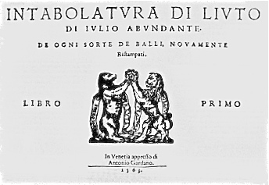

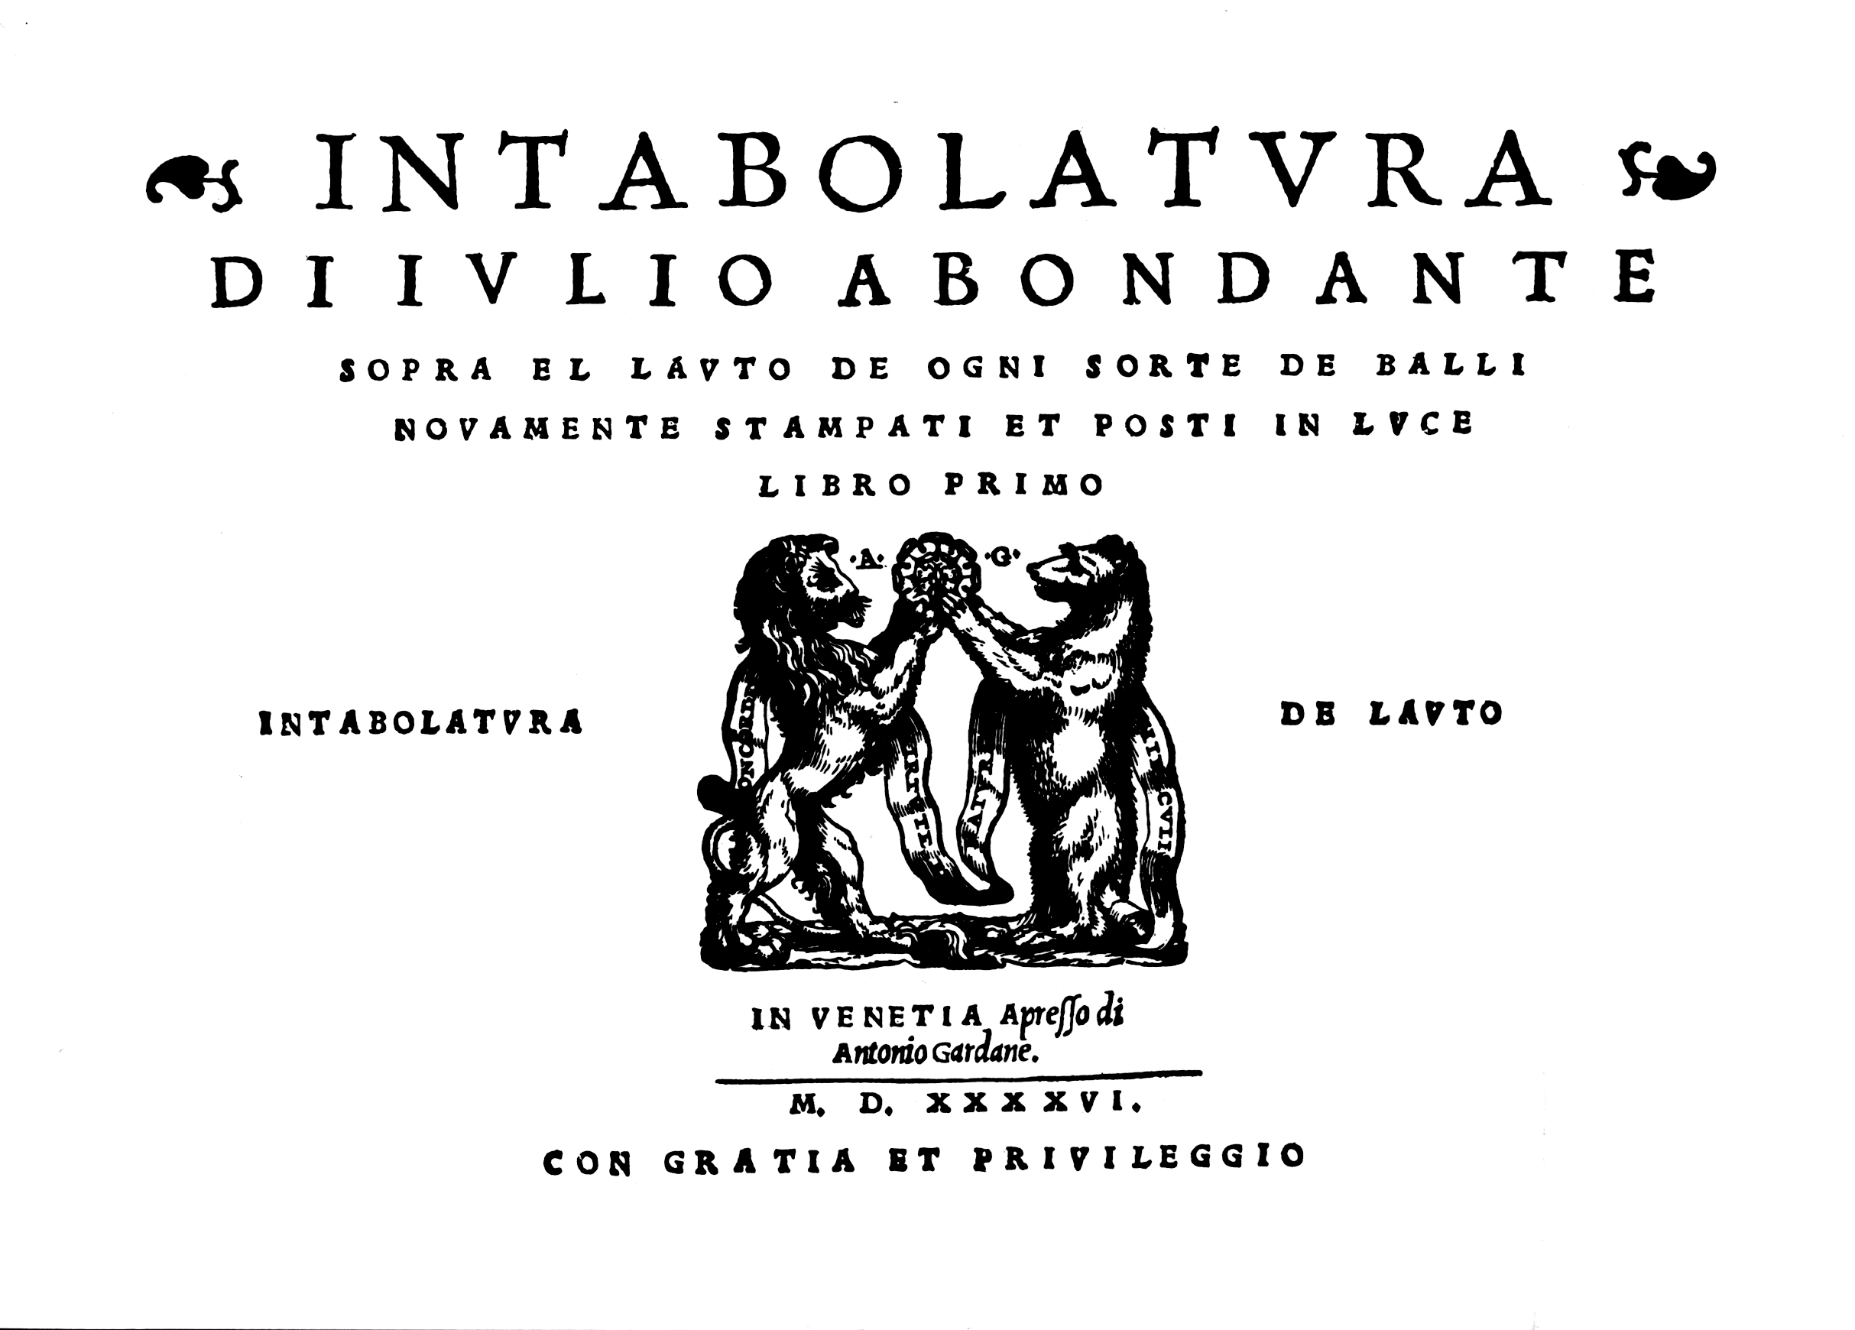

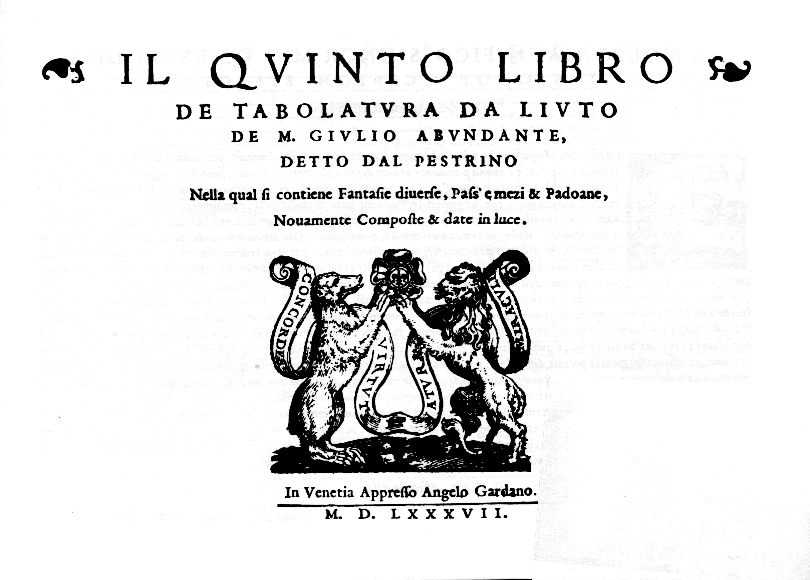

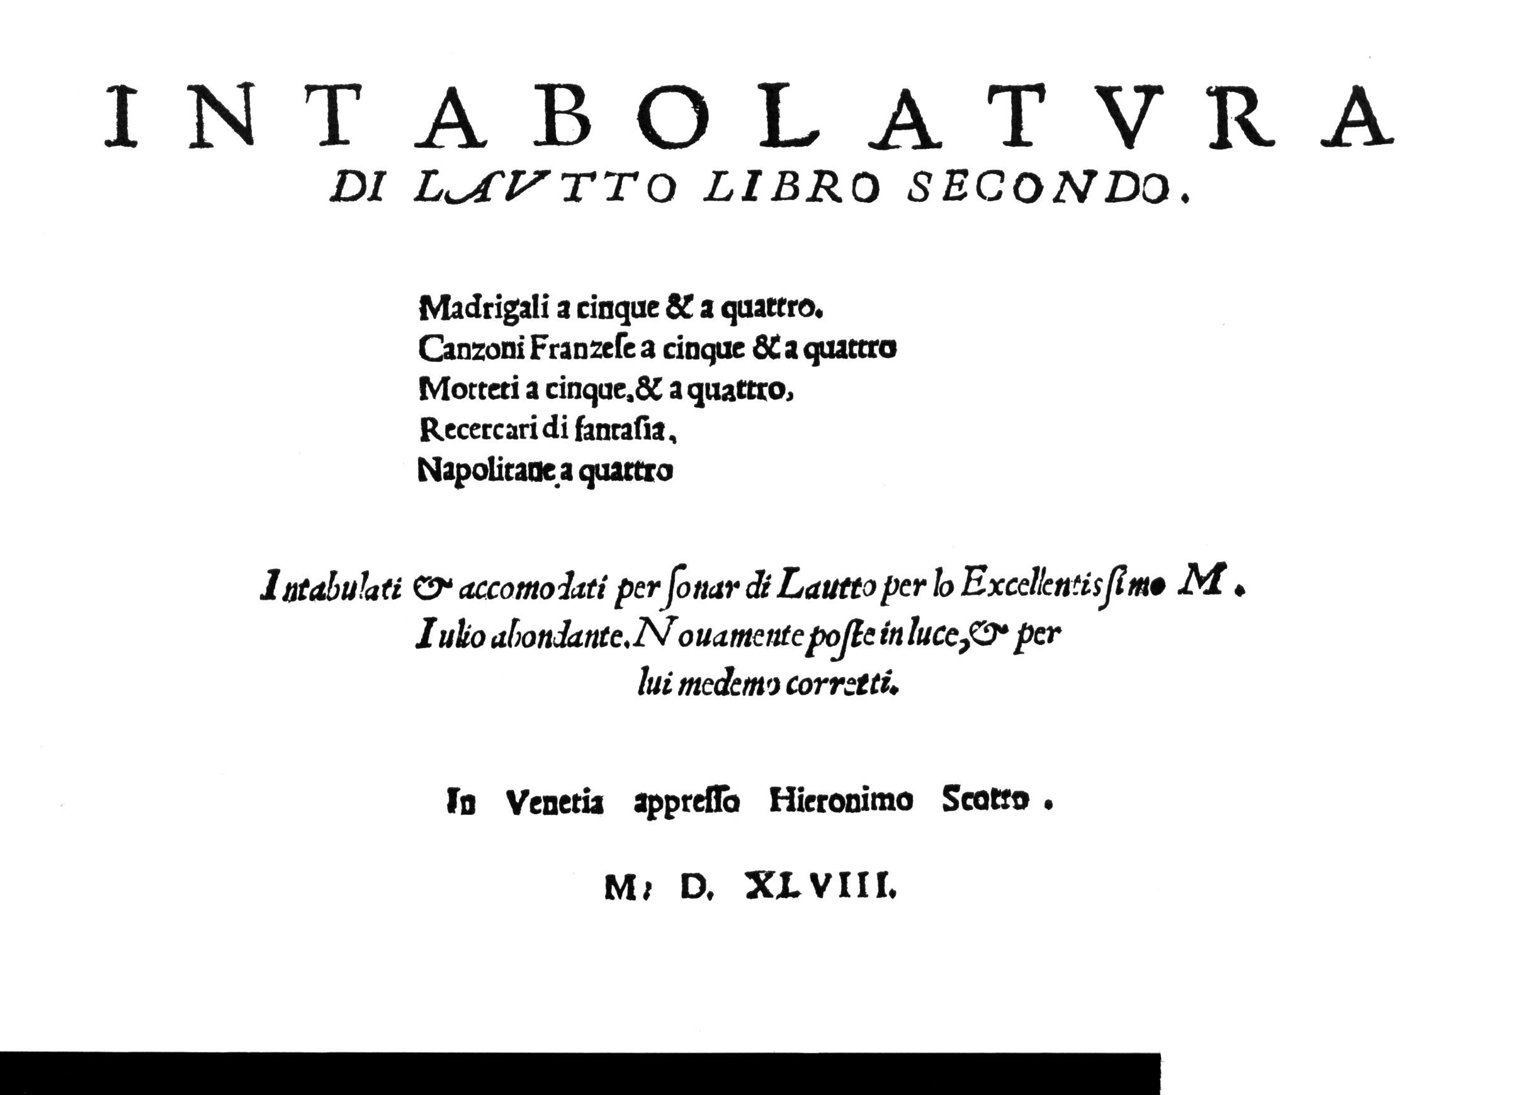

1. Robert Eitner, *Biographisch-Bibliographisches Quellen-Lexicon*, Band I (Leipzig, 1902/R Graz, Akademische Druck, 1959), p. 32; Friedrich Blume/Ludwig Finscher, *Die Musik in Geschichte und Gegenwart*, Personenteil 1 (Kassel, Barenreiter, 1999), p. 54; Henry Sybrandy, *New Grove 2* on-line. Thank you to Arthur Ness for valuable comments on this text.
2. The passage translated as ‘Everybody knows that you [Antonio Zantini] were so fond of music that for a long time you supported the Compagnia dei Fabbretti and the Compagnia dei Fruttaruoli, excellent singers and players of instruments who made the most delightful music at your house, and that for this same purpose you also paid Giulio dal Pestrino, the incomparable lutenist.’ - see Alfred Einstein, *The Italian Madrigal* (New Jersey, Princetown University Press, 1949), pp. 446-7.
3. Douglas Alton Smith, *A History of the Lute from Antiquity to the Renaissance* (The Lute Society of America, 2002), p. 134 (although not citing the source of the information.
4. The Scotto press was established by Otto [I] in 1479, a composer himself, and was taken over by his heirs from 1500 following his death in 1499. From 1533 the business was in the hands of Otto [I]’s nephew Otto [II], until another nephew Girolamo took over in 1539, publishing more than 400 music editions before he died in 1572. The Gardano press was established by the French emigré composer Antonio Gardane (the name changing to Gardano in prints after 1555), passing into the hands of his sons Alessandro and Angelo when he died in 1569, although Alessandro left before 1575 to set up his own press and Angelo continued the family business until he died in 1611; the Gardano press published over 850 music editions, more than all other European publishers put together, see Jane A. Bernstein, *Print Culture and Music in Sixteenth-Century Venice* (Oxford: Oxford University Press, 2001), pp. 135-140.
5. Few lute books were published in Italy before 1546, but fourteen are known to have been printed in that year in Venice alone, including volumes devoted to music of Domenicho Bianchini, Melchiore de Barberis (three volumes), Giovanni Maria da Crema, Marcantonio del Pifaro, Antonio Rotta and Francesco Vindella, as well as three volumes by Francesco da Milano, one shared with Pietro Paulo Borrono. Francesco Marcoloni held a privilege to print tablature using the double impression method that expired in 1546, see Richard J. Agee ‘The Venetian Privilege and Music Printing in the Sixteenth Century’ *Early Music History* 3: 1-42 (1983), but the use of single impression printing of tablature by Girolamo Scotto and Antonio Gardano in Venice from the 1530s would have circumvented the priviledge, so the sudden burst in publications remains unexplained.
6. *Intabolatvra di Ivlio Abodante ... Libro Primo* (Venezia: Antonio Gardane, 1546), facsimile of the unique copy in A-Wn: Genève, Éditions Minkoff, 1982; the tablature was reset correcting errors and published again with the same title by Antonio Gardane in 1563 [unique copy in US-Wc].
7. *Intabolatvra di Lavtto Libro Secondo … M. Iulio abondante* (Venezia: Girolamo Scotto, 1548), dedicated to ‘Al Nobile et Generoso S. Allesandro Ramuino del Nobilissimo S.or Gian Antonio Genouese’, copies in A-Wn and CH-Lcortot (but where is it now?); facsimile: Genève, Éditions Minkoff, 1982.
8. *Il Qvinto Libro de Tabolatvra da Livto de M. Givlio Abvndante, detto dal Pestrino* (Venezia: Angelo Gardane, 1587), dedicated to ‘Al Molto Magnifico Signor Mio Osservandiss Il Signor Scipion Ziliolo, Fú del Signor Allesandro’, copies in A-Wn and I-Bc, facsimiles: Genève, Éditions Minkoff, 1982 and Lübeck, Tree Edition, 2005. The title pages of the three Gardano prints use variants of the Gardane printers mark, Antonio Gardano’s *Libro Primo* of 1546 the so called lion and bear III, and the 1563 reprint lion and bear V, and *Libro Quinto* uses Angelo Gardano’s version of the lion and bear motif with the motto banner ends turned upwards [see images on p. 20 here], see Bernstein, *op. cit.*, pp. 45-46 & 138.
9. Howard Meyer Brown, *Instrumental Music Printed Before 1600: A Bibliography* (Cambridge MA, Harvard University Press, 1965), p. 359 includes [158?]1: *Intavolatura di Liuto del Pestrin lib. 7. Venezia, Giacomo Vincenti* listed in the catalogue *Indice di tutti l’opera di musica che si truova alla stampa della pigna*, Giacomo Vincenti, Venezia 1591, f. 6r, as well as in a catalogue printed in 1604 by the Italian bookseller Giunta.
10. The outbreak of war with the Turks was in 1570, and consequent famine and a typhus epidemic affected Venice, followed by an outbreak of the plague 1575-1577 that killed over a quarter of the population of Venice, see Bernstein, *op. cit.*, p. 136 & 138.
11. Bernstein, *op. cit*, p. 80-81 & 148-151, argues strongly in favour of collaboration between the Scotto and Gardano printing houses, rather than the competition and rivalry favoured by earlier writers.
12. For example, the use of repeated notes as a motif is found in most fantasias from *Libro Quinto*, but especially no 12, and is also found in no 4 from *Libro Secondo*; and the frequent use of rhythms of juxtaposed crotchets quavers and semiquavers in cadential embellishments, although common in lute music of the period, is a unifying feature in most of the fantasias from both books.
13. Smith, *op. cit.*, pp. 100, 132, 134; a complete staff transcription of the surviving books of Abondante, see G. Lefkoff, *Five Sixteenth Century Venetian Lute Books* (Washington DC, 1960). Dick Hoban and Richard Darsie, *The Art of the Lute in Renaissance Italy*, Vol I: *Recercars* (Fort Worth, Lyre Music, 1997), included nos. 1b, 6, 14 & 17 transcribed into French tablature.
14. Although James M. Meadors ‘Italian Lute Fantasias and Recercars Printed in the Second Half of the Sixteenth Century’ (doctoral thesis, Harvard University, 1984), pp. 162-6, concludes that ‘his fantasias are modest in their musical quality’, partly due to ‘the lack of exactness in … imitation’ and because ‘the imitated subject does not persist beyond its first few entries’ and ‘is then dropped in favour of free counterpoint’.
15. Edited here as no 1a to remove duplicated bars, but retaining all the embellished bars plus a few additional editorial amendments.