**Music supplement to Lute News 96 (december 2010): english pavans in mylius 1622**

Johann Daniel Mylius was born in 1585 near Marburg and gained citizenship of Frankfurt am Main (50 km from Marburg) in 1606.[1] He studied chemistry at various German Universities, received a doctorate in medicine at Marburg in 1618, and was employed as physician to Moritz Landgrave of Hesse in Kassel.[2] He published several books on alchemy (see title pages on p. 25 here and the illustration opposite).[3] He played the lute well enough to be paid to perform Sunday lute concerts with organ accompaniment at St Bartholomäus’ church in Frankfurt from 1618, and collected lute music for 6-10 course lute, published in his retrospective anthology *Thesaurus Gratiarum* in Frankfurt in 1622.[4] The thirteen pavans, not in fact mentioned on the title page (see p. 25), are edited here. They are mostly English in origin, eight with ‘Angli’ or ‘Anglica’ in the title, two identified by Mylius as by Dowland but otherwise unknown, and another two to Wilhelmi Angli. Others are anonymous but ascribed to Daniel Bacheler, Philip Rosseter or John Dowland in concordant English sources. All the pavans comprise three strains of irregular numbers of bars (except no 11 are all 8 bars) and all except no 7, 10, 12 & 13 have elaborate divisions characteristic of late renaissance English lute music.[5]



No 1 & 2 are ascribed to Wilhelmi Angli, which could refer to the violinist, composer/arranger and publisher William Brade, an Englishman active in Germany *c.*1590-1630, although no lute music by him is known.[6] However, the similarity of the opening of no 2 to a pavan in GB-Cu Dd.5.78.3,**[7]** ff. 61v-62r *DB*, Herbert of Cherbury lute book, ff. 3v-4r *Pauana del Sr Danielli Inglese* and the Pickeringe lute book, f. 27v *A pauin by Mr Daniell Bachler* [Long no 13], suggests Bacheler is the composer. In fact, Wilhelm may not be the composer of either pavan ascribed to him in Mylius, but rather Mylius acquired some or all of the English lute music from him.[8] No 3 is concordant with an anonymous pavan in GB-Cu Add.3056, into which only the first strain and divisions were copied, and the similarity of the opening to the *Pavan Mr DB* in GB-Cu Nn.6.36, ff. 4v-5r [Long no 3] led Long to consider it a doubtful attribution to Bacheler [Long App. 4]. No 8 is ascribed to Bacheler in versions in both Pickeringe and Herbert, and no 9 to Philip Rosseter in a version in Pickeringe and (see worklist).

The anonymous pavan no 4 is concordant with the version of John Dowland’s pavan for John Langton found in GB-Dd.5.78.3 (and not the later version in Robert Dowland’s *Varietie of Lute Lessons* published in 1610!), and no 5 & 6 are ascribed to Dowland in Mylius although no other versions are known. It has been assumed that they are late works by John Dowland, although it is possible that the highly embellished versions here are Robert Dowland’s reworking of pavans by his father.[9] Finally, a virtually identical version no 13 titled *Pauane en forme de complainte* is found in Nicolas Vallet’s *Secretum Musarum* of 1615, and Vallet may have composed or only collected it.

The tablature in Mylius is quite corrupt with displacement or misreading of rhythm signs and bar lines, tacitly altered here based on concordant versions when available. The two unique Dowland pavans required the most reconstruction and this is only one possible solution.[10]

**Worklist**

1. *Pauana Wilhelmi Angli* [William Brade?] [6-course lute] pp. 44-45

2. *Pauana Anglica Ejusdem* [i.e. Wilhelmi Angli, 7th in D] pp. 46-47

3. *Pauana Anglica* [Daniel Bacheler?, Long app 4, 7D] pp. 50-51

GB-Cu Add.3056, f. 63v [untitled, 1st strain and divisions only]

Fuhrmann 1615, pp. 51-52 *Pavana Englese. Pavana secunda*

4. *Pauana Anglica Excellens* [John Dowland, Poulton no 14, 7D] 48-9

GB-Cu Dd.5.78.3, ff. 2v-3r [untitled]; Dowland 1610, sigs. K1v-K2v *Composed by Iohn Douland Batcheler of Musicke. Pauin. 5 Sir Iohn Langton his Pauin*; Fuhrmann 1615, pp. 53-55 *Pavana Englese tertia. / Pavana tertia*; cf. Dowland 1604, sigs. G1v-G2r *M. John Langtons Pauan / 10 / Io. Dowland* [lute & 5 viols] = Hove 1612, f. 36v *PAvana. / Ioan Dovvlant* [lute part]

5. *Pauana Douulandi Angli* [not in Poulton, 7D] pp. 52-53

6. *Pauana Douulant* [not in Poulton, 7F 8D] pp. 54-56

7. *Pauana* [7D] pp. 65-66

8. *Pauana Anglica* [Daniel Bacheler, Long no 18, 7F] pp. 57-58

GB-Cfm Mus.689, ff. 19v-20r *Pauana mr Daniel Bacheler*

GB-Lbl Eg.2046, ff. 20v-21r *A pauine by daniell Bachler*

Fuhrmann 1615, pp. 56-58 *Pavana quarta*

9. *Pavana Anglica* [Philip Rosseter, Spencer no 3b, 7F 8E 9D] 59-61

GB-Lbl Eg.2046, ff. 25v-26r *A Pavin by Rossetters*

10. *Pauana* [7F] pp. 66-67

11. *Pauana Anglica* [7F 8D] pp. 61-63

12. *Pauana* [7F 8D] pp. 64-65

13. *Pauana* [7F 8E 10C] p. 68

= Vallet 1615, p. 20 *Pauane en forme de complainte A.9.*

John H. Robinson, Newcastle University, November 2010

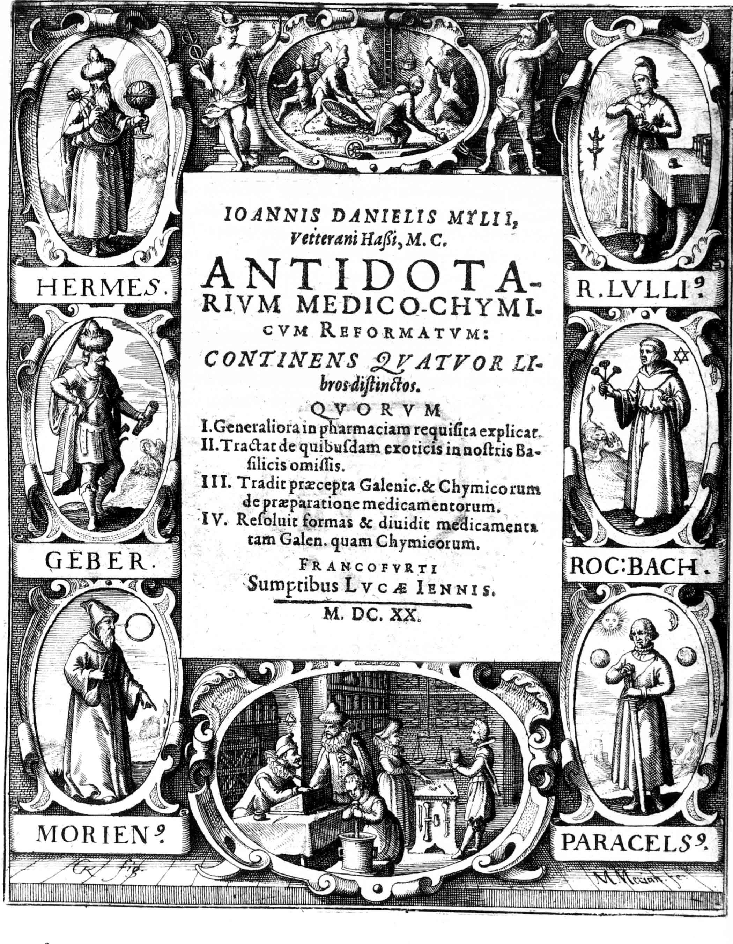

*Antidotarium Medico-Chymicum* 1620

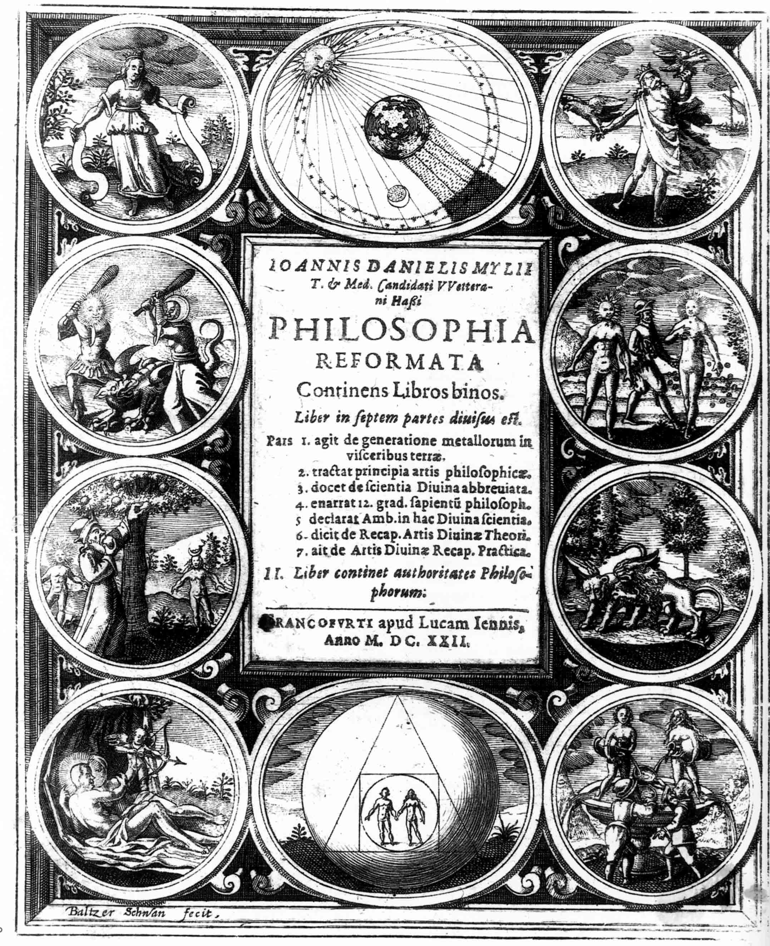

*Philosophia Reformata* 1622

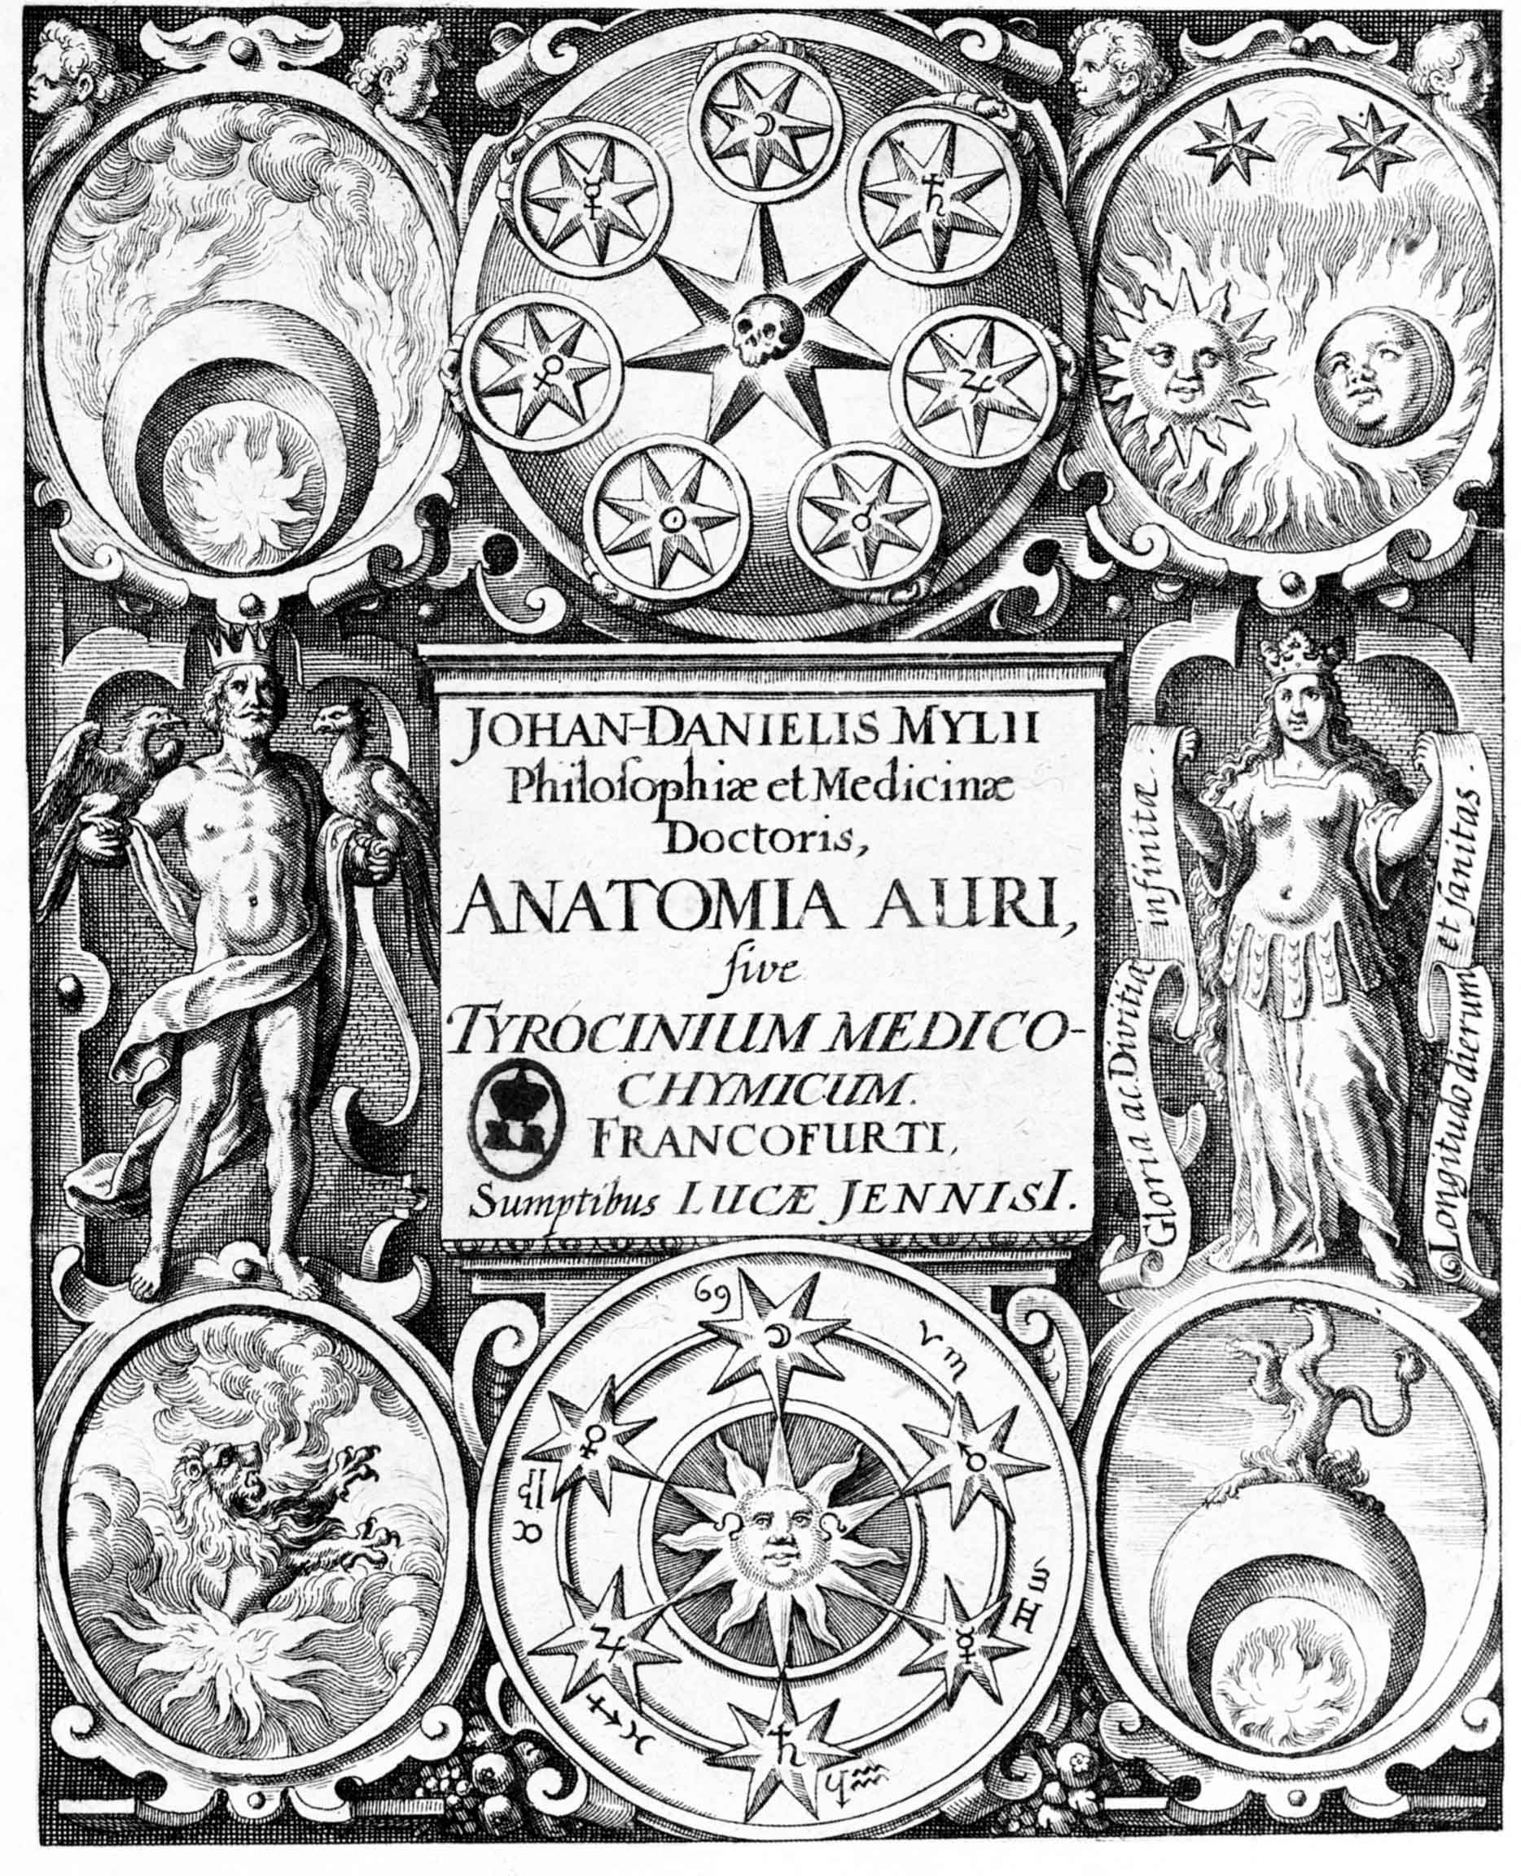

*Anatomia Auri* 1628

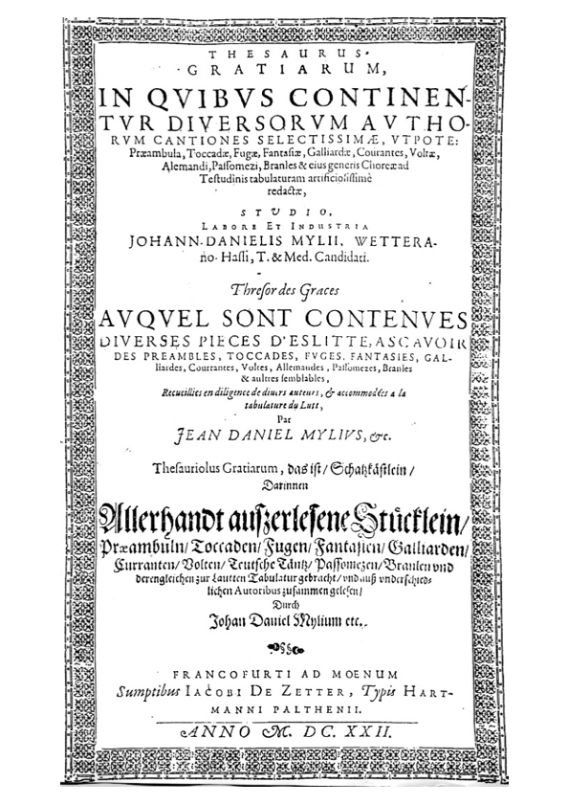

*Thesaurus Gratiarum* 1622

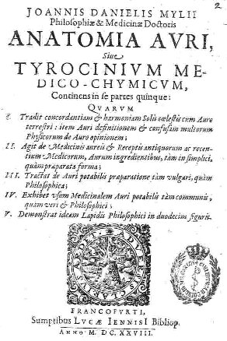

*Anatomia Auri* 1628

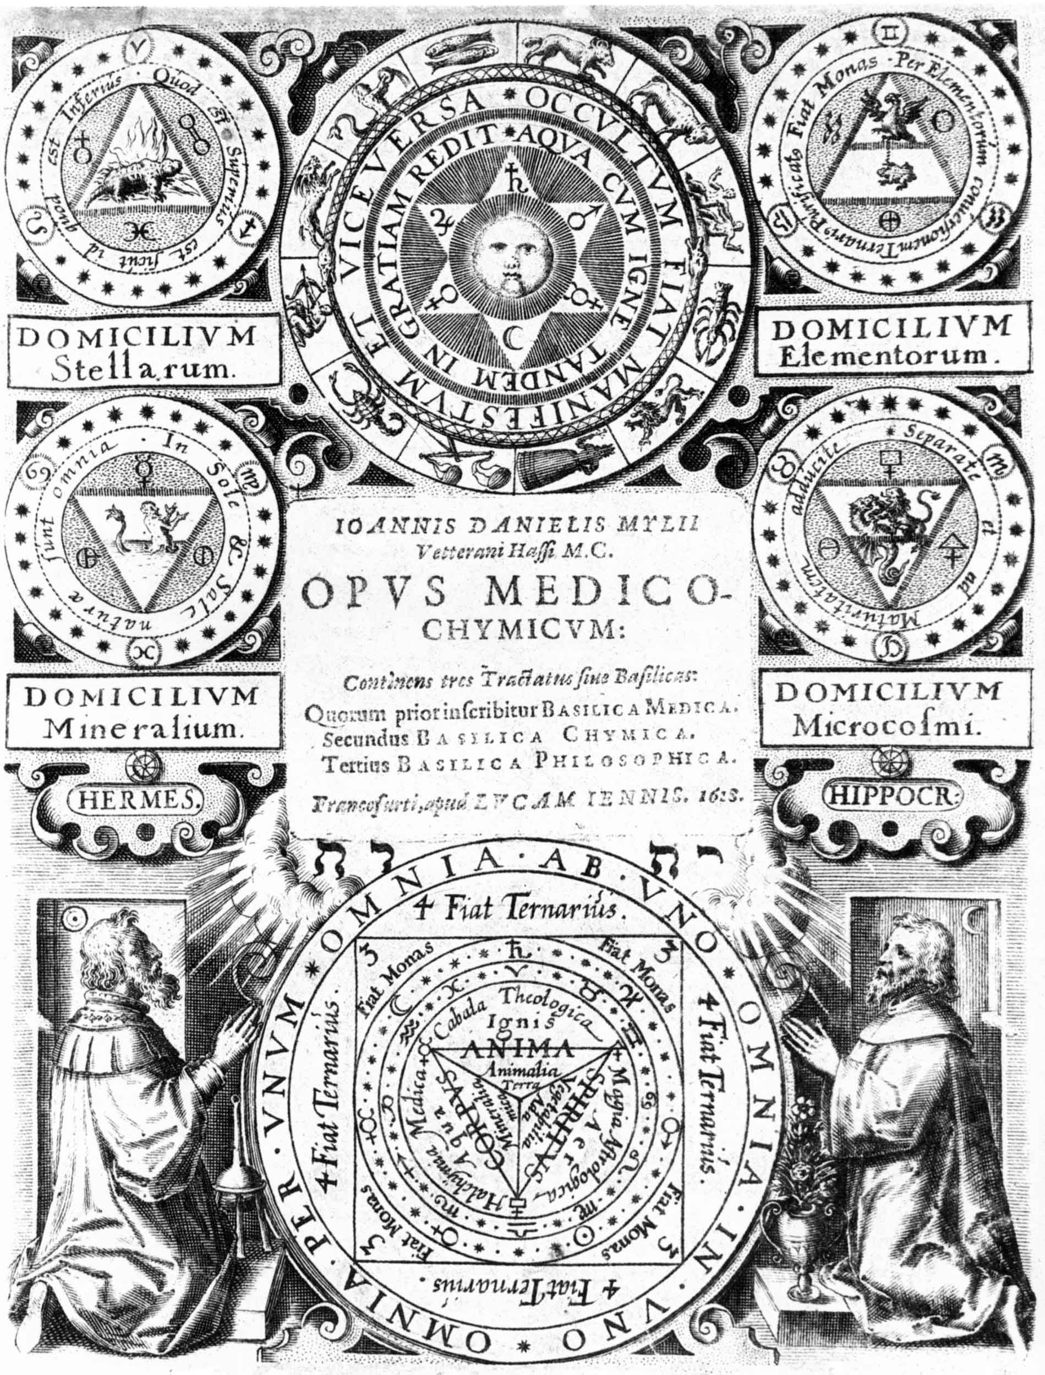

*Opus Medico-Chymicum* 1618

1. *Die Musik in Geschichte und Gegenwart* (ed. Ludwig Finscher, Kassel, Barenreiter 2004): *Personnenteil* 5, cols. 883-884; and *New Grove* on-line.
2. Bruce T. Moran *The Alchemical World of the German Court: Occult Philosophy and Chemical Medicine in the Circle of Moritz of Hessen (1572-1632)* (Stuttgart, Franz Steiner Verlag 1991).
3. From Stanislas Klossowski de Rola *The Golden Game: Alchemical Engravings of the Seventeenth Century* (Thames & Hudson 1988).
4. Containing 21 preludes, 12 toccadas, 11 fantasias 3 called Grammatica, 13 pavans, 23 Courantes most by Michel Angelo Galilei, 8 Ballettos, 14 Voltes. Considered lost but found by Tim Crawford in PL-Kj (thank you to Tim Crawford for access to his microfilm and for the references in fn 2 &3), and a 3rd edition from 1644 is recorded but no copy is known. One of the last known prints of renaissance lute music, post dated by Moy’s *Le Petit Boucquet* of 1631 and Esaias Reusner’s *Musicalischer Lust-Garten* of 1645.
5. See tablature supplement to *Lute News* 80 (December 2006).
6. A lute solo in the Petrus Fabritius lute book ascribed Brade is probably by William’s son Christian Brade - edited in *Lute News* 43 (September 1997).
7. Sources of concordances: Cambridge University Library, Add. 3056, *c.*1610; Georg Leopold Fuhrmann *Testudo Gallo-Germanica* (Nürnberg 1615), facsimile Tree Edition, Lübeck 2003; Diana Poulton *John Dowland* (London, Faber 1972/R1982); London, British Library, Egerton MS 2046: Jane Pickeringe lute book, *c.*1616-50, facsimile Boethius Press 1985; *The Lute Music of Philip Rosseter* (Albury: Lute Society 1998) [Spencer]; Martin Long *Daniel Bacheler: Selected works for lute* (OUP 1972) [Long] and see the inventory of Bacheler’s music on Christian Meyer’s website: http://www-bnus.u-strasbg.fr/Smt/bacheler.htm; Cambridge, Fitzwilliam Museum, Mus. MS. 689: Lord Herbert of Cherbury lute book, *c.*1624-40, facsimile: The Lute Society, forthcoming; Cambridge University Library, Ms. Dd.5.78.3, *c.*1595; Joachim van den Hove *Florida* (Utrecht 1601), facsimile, Utrecht, Koninklijke Vereniging voor Nederlandse Musiekgeschiedenis en Nederlandse Luitvereniging 2004; John Dowland *Lachrimæ* (London 1604), for instrumental ensemble à 5, facsimile: Newbury, Severinus Press 1992; Robert Dowland, *Varietie of Lute-lessons* (London, 1610), facsimile: London, Schott 1958; Nicolas Vallet *Secretum Musarum* (Amsterdam 1615), facsimile: Utrecht, STIMU & Dutch Lute Society 1986.
8. The closeness of the concordances including divisions as well as differences in the required diapasons between pieces suggest direct transmission rather than arrangements by Mylius. Incidentally, no 3, 4, 8 here also have close concordances in Fuhrmann’s print of 1615, and no 7, 10, 11 & 12 are all unique to Mylius.
9. I argued similarly for some of the reworked pavans by John in Robert’s *Varietie* in *Lute News* 74 (June 2005).
10. More literal than the recorded versions on CD in the complete Dowland sets by Jacob Lindberg (BIS 722-24, 1995) and Paul O’Dette (Harmonia Mundi 2907160-4, 1995-7).