**Lutezine to Lute News 106 (July 2013): Music associated with Robin Hood**

**Worklist**[1]

**Tune 1. Robin is to the green wood gone**[2]

**In D minor**

**1a.** LT-Va 285-MF-LXXIX (Königsberg), f. 6v untitled

**1b.** Robinson *The Schoole of Musicke* 1603, sig. I2v *Robin is to the greenwood gone* [Thomas Robinson][3]

**1c.** GB-Gu Euing 25, ff. 46v-47r *Robin hoode p*[er] *mr* *Ascue* [Robert Ascue][4]

**1d**. GB-Gu Euing 25, f. 31r untitled [Robert Ascue]

**1e.** GB-Cu Add.3056, f. 32v *Robin galliard* [Robert Ascue]

**1f.** GB-Cu Nn.6.36, ff. 19v-20r *Robin* [lyra viol - ffeff] VdGS 6505

**1g-i.** GB-Cu Dd.3.18, f. 11r *Robin is to the Greenwood gone* [consort lute part]

**1g-ii** second lute part reconstructed by Stewart McCoy

GB-Cu Dd.5.20, f. 3r *Robin is to the G: gone* [bass viol part]

**1h.** GB-Cu Dd.2.11, f. 53r *Robin***[5]**

**1i.** IRL-Dtc 408/II, p. 113 *Robin hood is to the greenwood gone*

**1j.** GB-Cu Add.2764(2), f. 12r *Hoode*: - Poulton[6] 2

**In C minor**

**1k**. GB-Lam 601 (Mynshall), f. 8r *Bonny sweete Robin*

**1l.** D-Ngm 33748 I, f. 52r untitled

**1m.** GB-Mr 832 Vu 51, p. 14 *Roben is to the greense wood gon R*[ichard]. *S*[umarte]. [lyra viol - ffeff] VdGS Sumarte 14[7]

**1n.** GB-Lbl Add.31392, f. 25r *Jolly Robin* [Robert Ascue]

**1o.** GB-Cu Dd.2.11, f. 66r iii *Robin*

**1p.** D-Kl 4o Mus.108/I, f. 3v *Schön wahr ich gern &C*

**1q.** GB-Lam 603 (Board), f. 12v *Bony Sweete Robin / Bony Sweete Robyn*

**1r.** US-Ws V.b.280 (Folger),[8] f. 16v *Robin is to the Greene wood Gonn*

**1s.** IRL-Dtc 408/I, p. 27 *Bonny Sweet Robin* [lyra viol - ffeff]

**1t.** GB-Ob D.245, p. 133 untitled [lyra viol - ffhfh] VdGS 6505

**1u.** D-B N 479 (Grünbühel), f. 5v untitled

**1v.** J-Tn BM-4540-ne, sig. F3r *good Nyght my Joye* [cittern][9]

**1w.** Holborne 15976, sig. D2r *Bonny sweet Robin*  [cittern]

**Tune 2. Kind Robin** VdGS 7274

GB-DU Mus.10455 (Blaikie), p. 7 *Kind Robin* [lyra viol - defhf]

**Tune 3. Robin Hood**[10]

**3a.** IRL-Dtc 408/II, p. 104 untitled

**3b.** US-Ws V.a.159 (Lodge),[11] f. 5r *Robin Hoode* - Goodwin[12] 12

**3c.** GB-Cu Dd.9.33, f. 81v *Robin Hood* [bandora]

**3d.** GB-Ob D.247, f. 47r *Robin Hood* [lyra viol - ffeff] VdGS 6606

**3e.** Le Roy & Ballard 15523, ff. 21v-22r *Bransle Haulbaroys* [guitar]

**Tune 4. Robin**

NL-Lu 1666 (Thysius), f. 391v *Robyn* - lute II? [F]

**Tune 5. Robin Reddocke or Roddock’s Jig**

**5a.** IRL-Dtc 408/I, p. 26 *Robin Reddocke* - Goodwin 11

**5b.** GB-Lbl Eg.2046, (Pickeringe) f. 33v *A Toye*

**5c.** US-NH Osborn fb7, f. 82r *Roddocks Jigge*

**5d.** US-Ws V.b.280, f. 3r untitled

**5e.** US-Ws V.b.280, f. 6r untitled

**Tune 6. Bonny Sweet Boy**

**6a.** GB-Cu Dd.2.11, f. 66r ii *Bonny sweete. / Boy.*

**6b.** Robinson 1603, sig. M2r *Bony sweet boy*

**6c.** GB-Cu Dd.9.33, f. 82r *Bonny sweet boy Band*ora

Here are all the tablature versions of tunes associated with Robin,[13] except for the variations by John Dowland [DowlandCLM 70], which are in the accompanying *Lute News* 106.[14] The settings of the tune 1 are variously titled Robin, Sweet Robin, Bonny sweet Robin, Jolly Robin, Robin Hood and Robin is to the green wood gone, and tune 3 is also called Robin Hood. These titles may refer to popular tunes or to ballads about Robin Hood that used one or other tune. It is not clear which text was associated with tune 1,[15] and Sternfeld[16] suggested a verse with the words ‘Hey jolly robin, Ho jolly robin / Hey jolly Robin Hood / Love finds out me as well as thee / To follow me, follow me to the greenwood’ from the song ‘In Sherwood lived stout Robin Hood’, no 19 in Robert Jones *Fourth Book of Airs* of 1609, which incorporates titles of several of the known settings and fits tune 1. The earliest known ballad probably calling for tune 1 is ‘A Doleful adewe to the last Earle of Darby to the tune of Bonny sweete Robin’ licensed to John Danter on 26 April 1594, but now lost, and a lost ballad medley registered in 1604 began ‘Tytles of Ballades or A newe medley beginning Robin is to the grene gone as I went to Walsingham’.[17] Later ballads calling for the tune ‘Bonnie sweet Robin’ are found in Richard Johnson’s *The Crown Garland of Golden Roses* (1659) and ‘Bonny Robin’ in Stuart’s *Music for the Tea Table Miscellany* (1725). Also Ophelia quotes ‘For Bonny sweet Robin is all my joy’ in Shakespeare’s *Hamlet*, (Act IV Scene 5 line 182 in the Alexander text), these words fitting bars 1-4 and 13-16 of tune 1, and in 1586, Sir Walter Ralegh wrote to the Earl of Leicester saying ‘The queen is in very good tearms with yow, and thanks be to God, well pacified, and yow are agayne her Sweet Robin’.[18] Anther reference to Robin without any mention of the tune is in the song ‘Now Robin lend me thy bow, Sweet Robin lend to me thy bow’ in Ravenscroft’s *Pammelia* 1609, no 36 [*sic.* =63].

The title *Robing hud* is included in a list, unfortunately lacking the music, compiled at Lleweni Hall in Denbigh, North Wales in the 1590s, which could refer to tune 1 or 3 here. The Lleweni list seems to be a checklist of the popular music performed in this and probably many other households during Elizabeth I’s reign - a transcription is reproduced below.[19] Several texts directly referring to Robin are found in the Roxburghe ballads,[20] two of them ‘to the tune of Robin Hood’: ‘Renowned Robin Hood or Robin Hood and Queen Catherine ... to a new tune’ [p. 419]; ‘Robin Hood reviv’d or Robin Hood and the Stranger ... to a delightful new tune’ [p. 426]; ‘Robin Hood, Will, Scadlock, and Little John ... Tune of Robin Hood or Hey down, a down a down’ [p. 431]; ‘A New Ballad of bold Robin Hood’ [no tune specified] [p. 440]; and ‘Robin and the Bishop ... to the Tune of Robin Hood and the Stranger’ [p. 448] - see page 4 here for sample pages with woodcuts illustrating Robin Hood. Other vocal works that use tune 3 include ‘Robin Hood Robin Hood said little Iohn, Come dance before the Queene a, in a redde Petticote and a greene iacket, a white hose and a greene a, ut supra’ for the tenor of ‘A Round of three Country dances in one’ for 4 voices from Ravenscroft’s *Pammelia* 1609, sigs. F1v-F2r; the treble of ‘We be Soldiers three’ from Ravenscroft’s *Deuteromelia* 1609, sig. B2v; and ‘Robin hood Robin hood, and little John, they leand them to a tree’ from William Cobbold’s *New Fashions* on the cries of London, in GB-Lbl Add.18936, f. 60r.[21] A reference to the tune is also found in *A Discourse of English Poetrie* of 1586, in which William Webbe wrote ‘Nor though many such can frame an Alehouse song of fiue or sixe score verses, hobbling vpon some tune of a Northern Jygge, or Robyn hoode or La lubber etc’.[22]

Twenty-three settings of **tune 1** are included here (plus Dowland’s setting is in the accompanying *Lute News* 106). Nine lute settings are in D minor (including one for lute and bass viol, reproduced as a lute duet here with a reconstructed second lute part by Stewart McCoy based on the bass viol part), eight lute settings are in C minor, four are for lyra viol (3 tuned lute-way so they are in renaissance lute tuning) and two are for cittern. In addition to John Dowland’s variations, settings are ascribed to Robert Ascue (no 1c, 1d, 1e & 1n),[23] Thomas Robinson (no 1b), and Richard Sumarte (no 1m for lyra viol), and presumably Anthony Holborne made his own cittern setting (no 1w). The remaining versions of tune 1 are anonymous. Four versions of a setting by Robert Ascue survive, a longer ascribed version with twelve variations of eight bars (no 1c) in the Euing lute book *c.*1600, and three unascribed shorter versions comprising only half of the variations (4th-9th) with variants. One of these is also in the Euing lute book (no 1b), and another is in GB-Cu Add.3056 *c.*1610 (no 1c) which is concordant with 1b except that two of the variations are quite different (3rd and 6th of the short version). These three are in D minor for a lute with a 7th course tuned to D (assuming a lute in nominal G pitch). The fourth version by Ascue is in C minor for 6-course lute and is found in GB-Lbl Add.31392, *c.*1605.

**Tune 2** is not mentioned in Chappell or Simpson, and is represented by a single anonymous version for lyra viol from a copy of the so-called Blaikie MS. There are five settings of **tune 3**, three are titled Robin Hood,[24] one untitled, and one for guitar titled *Bransle Haulbaroys*.[25] **Tune 4** seems to be a second lute part to a duet or a consort part lacking the melody which could be yet another tune, although the harmony is loosely related to tune 1. Settings of **tune 5** are titled Robin Reddock, Roddock’s Jig, or Toye, and probably refer to a different Robin. Settings of **tune 6** are called Bonny sweet boy which does not include the name Robin, but is included here because of the similarity of the title to some versions of no 1, and the fact that the melody and harmony seem related top tune 1. None of the versions of tunes 2-6 bear any ascriptions, although no 6b was presumably arranged by Thomas Robinson.

*John H. Robinson, May 2013*

**The Lleweni tune list (adapted from Harper 2005)**

1. *fourtune* [Fortune my Foe]

2. *Jonson his meddle* [Johnson’s Medley]

3. *pinsinge the peticote* [Pinching the Petticoat]

4. *hatharne budes* [Hawthorn Buds]

5. *downe right squier* [Downright squire]

6. *grine slifes* [Greensleeves]

7. *gouldilockes* [Goldilocks/Golden Locks]

8. *who can tell* [Who can tell]

9. *floweres of komfort* [Flowers of Comfort]

10. *hartes ease* [Heart’s Ease]

11. *blache smith* [The Blacksmith]

12. *the countese of lester duñp* [The Countess of Leicester’s Dump]

13. *fadinge* [With a Fading]

14. *william stuard* [William Steward]

15. *larouse* [La Rouse]

16. *clif his rounde* [Cliff’s Round]

17. *about the bankes* [About the banks of Helicon]

18. *broune smith* [Brown Smith/Brownswycke?]

19. *Robing hud* **[Robin Hood]**

20. *mi hill wheeler* [My Hill Wheeler (= Whiller?) or Go merrily wheel?]

21. *the sycke manes health* [The Sick Man’s Health]

22. *lunden gage* [London Jig?]

23. *tarlton trunke hose* [Tarlton’s Trunk Hose]

24. *pegi hath lost hur garter* [Peggy has lost her Garter]

25. *light of love* [Light of Love]

26. *hamlinton his health* [Hamilton’s Health]

27. *halfe haniking* [Half Hannikin/Hanskin/Jog on]

28. *shifting the knave of klobes* [Shifting the Knave of Clubs]

29. *gini gether payers* [Jenny gather pears/Jenny pluck pears]

30. *wite a westemaster* [White of Westminster/The Wanton Wife of Westminster?]

31. *loth to depart* [Loth to Depart]

32. *the begininge of the warld* [The begininge of the World/Sellinger’s Round]

33. *the milner* [The Milner]

34. *the Juge his danse* [The Judge’s Dance]

35. *alen his flapes* [Allin’s Flaps]

36. *alen his march* [Allin’s March]

37. *mistres wite his choyse* [Mistress White’s Choice]

38. *sweet barbera* [Sweet Barbara]

39. *Jocand dary* [Jocundary]

40 *hight for my towpens* [Hight for my Tuppence]

41. *makinge was a kuntraye mayd* [Malkin was a country maid]

42. *blacke krooe fether* [Black Crow Feather]

43. *com ~~hither~~ when I cole or labeca* [Come hither when I call or Labeca]

44. *hole in my heele* [Hole in my Heel]

45. *labandilo shot* [Labandala Shot]

46. *pegi ramsdale* [Peg a Ramsay/Peggy Ramsay]

47. *Rooe well yow mariners* [Row well ye Mariners]

48. *woodes so wilde* [The Woods so Wild]

49. *staynes moris* [Staines Morris]

50. *soing of wootes* [Sowing of Oats]

51. *Seedanen* [Sidanen = Sedaney or Dargason?]

52. *sundaye morning* [Saturday night and Sunday morning]

53. *~~peper is blac~~* [Pepper if black]

54. *can yow not hit it* [Can you not hit it]

55. *~~woodes so wilde~~* [The Woods so wild]

56. *cali his onestie* [Callino Casturame?]

57. *over the brode water* [Over the Broad Water]

58. *nwe moten or nova castrona* [New Motion or Nova Castrona]

59. *Sasnet* [Sarcenet/Sarsnet]

60. *nwe antes vp* [New Hunt’s Up]

61. *goe to bed sweet hart & I will com to thee* [Go to Bed Sweetheart and I will come to thee]

62. *floures of the bromne* [Flowers of the Broom]

63. *tom duf* [Tom Dove]

64. *mundese* [Mundesse]

65. *~~Rused~~ motle & toni* [~~Russet~~ The Motley and Toni]

66. *petisivol* [Petit Cheval/Pretty Cheval]

67. *orlando* [Orlando Sleepeth? or Orlando Furioso or Orlando’s Musique]

68. *nwecast* [Newcastle]

69. *~~the milner~~* [The Milner]

70. *tarlton is buten cape* [Tarlton’s Button Cap]

71. *marchent dogter* [The merchant’s daughter]

72. *shaking of sheetes* [The Shaking of the sheets]

73. *lacoranto* [La Coranto]

74. *motlye* [The Motley]

75. *nutmckes and ginger* [Nutmegs and Ginger]

76. *the vicker of fooles* [The Vicar of Fools]

77. *the crampe* [The cramp]

78. *mistres shandoes good night* [Mistress Chandos’s Goodnight]

79. *listi galant* [Lusty Gallant]

80. *blacke almor* [The Black Almaine/Blackamoor]

81. [s?]*even at* [?]*ard* [?]

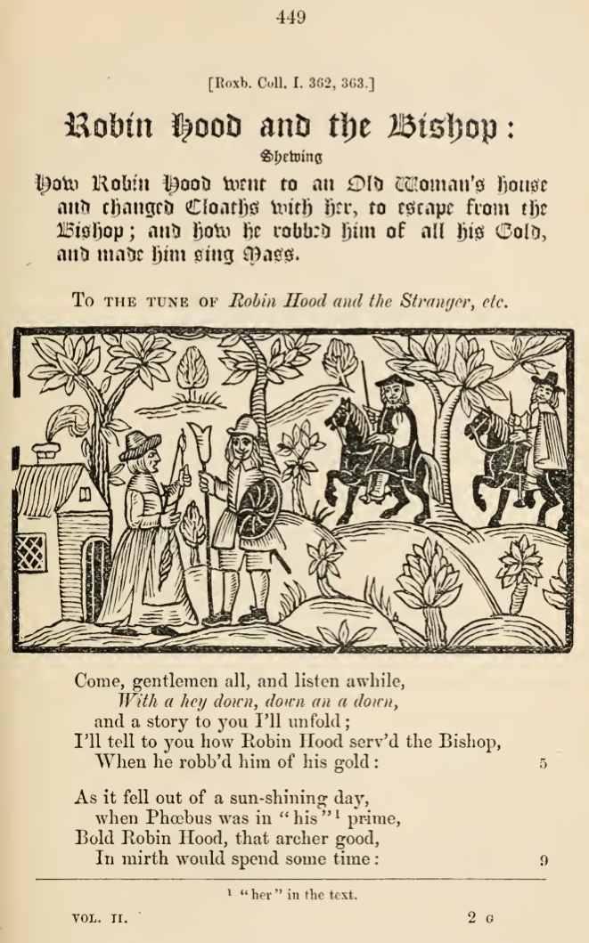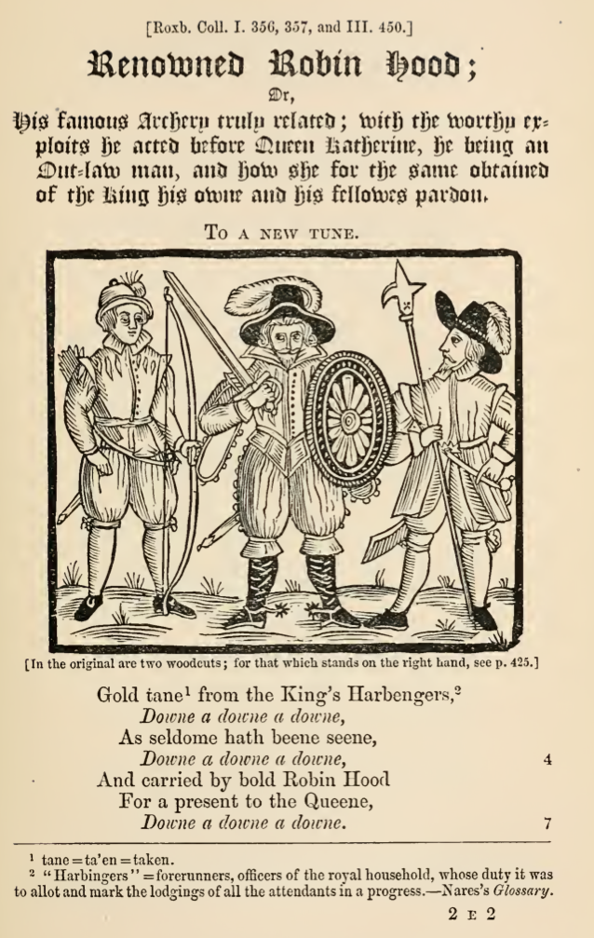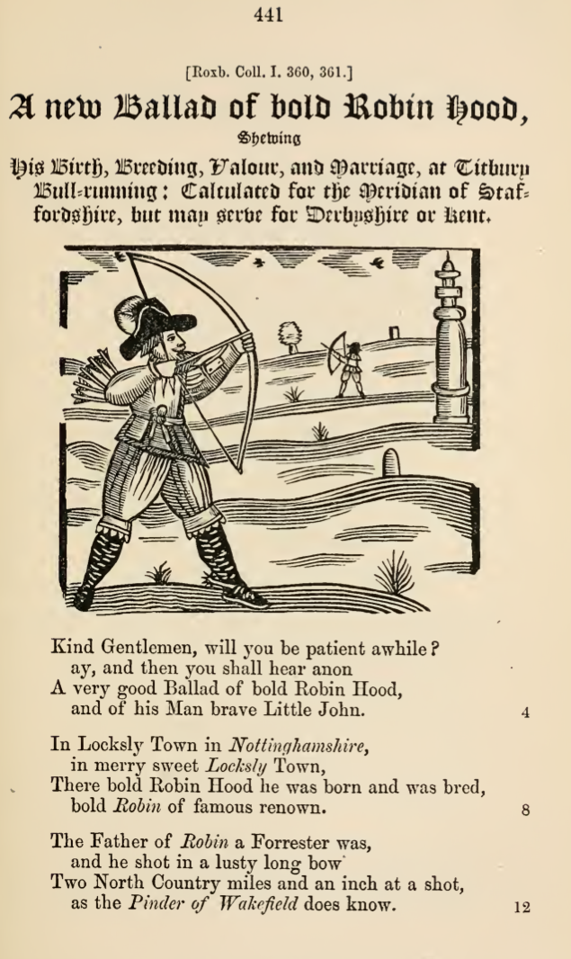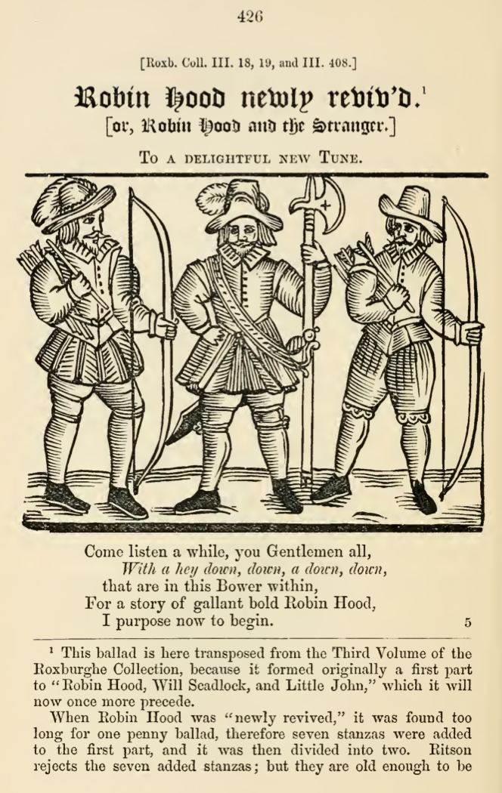

1. Critical commentary - editorial changes [states what is in original and what it is changed to editorially]: **1a.** 7th course in D; double bar lines absent; 7/4, 7/7 and 20/6 - quavers changed to semiquavers. **1b.** 7th course in D. **1c.** 7th course in D; 10/3 - d3 changed to d2; 48-49 - single changed to double bar line; 75/12 - f3 changed to f4; 83/9 - b4 crossed out. **1d.** 7th course in D; 16-17 and 40-41 - single changed to double bar lines; 30/6 - c4 changed to a4; 31/1 - a4 changed to a5; 34/1 - f1 changed to f3; 43 - bar absent. **1e.** 7th course in D; 8-9 and 40-41 - single changed to double bar lines; 18/3-4 - 2 crotchets changed to 2 quavers; 45/6 - c4 changed to f4. **1f.** lyra viol tuned ffefff; 4/1 - c3 changed to e3; 22/6 - e3 changed to e4; 24/1-2 - 2 crotchets altered to 2 minms in original; 33/2 - c2 changed to a2; 34/5 - a6 changed to a5; 37/4, 41/4, 42/4, 50/1, 74/3 & 80/4 - crotchets absent; 49-50 - 1 bars of 12 quavers changed to 2 bars of 8 crotchets each; 50/5-6 dotted crotchet quaver overwritten 2 crotchets; 59/2 - c5 crossed out; 60/3 - k1 changed to l1; 79/1 - a4 changed to e4; 80/9 - a1 crossed out. **1g-i.** lute part; 7th course in D; 1-2, 3-4, 9-10, 11-12, 13-14, 15-16 & 27-28 - bar lines absent; 4/1, 8/1 & 28/1 - c5 crossed out and a7 added later; 24/2 - a2 crossed out; 50/7 - a2 crossed out; 65/2 - h1 crossed out. **1g-ii.** second part for unison 6-course lute reconstructed by Stewart McCoy based on bass viol line. **\*1g-iii.** part for bass viol; **1h.** 6-c lute; 2/1 - h2 crossed out; 2/2 - f1 crossed out.; 4-5 single changed to double bar line. **1i.** 6-c lute; 1st bar line is absent; 6/between 3-4 - a1-c1d2d3a4 crossed out. **1j.** 6-c lute; grey notes and rhythm signs reconstructed as missing due top damage to the fragmentary source; all bar lines editorial and additional bar lines between 1/3-4, 2/3-4, 3/3-4 in original; 3/4 - c1 added. **1k.** 6-c lute; 1-2 and 11-12 - bar lines absent; 2/2 - minim changed to crotchet; 3/3 - minim changed to crotchet; 4/1 - minim changed to dotted minim; 4-5 - ‘bis’ written over double bar line indicating repeat the last section; 5/1, 8/1 - crotchets changed to dotted crotchets; bars 11-12 - 4 crotchets minim changed to 4 quavers crotchet. **1l.** 7th course in F; 7/2 - quaver a note to the right; 11/3 - quaver changed to semiquaver; 13/1 - rhythm sign absent. **1m.** lyra viol tuned ffeff; 13/4 - d2 absent; 21/4 - c1 absent. **1n.** 8-9 - single changed to double bar line; 15/1-2 - dotted minim crotchet changed to dotted crotchet quaver; 39/1 - d7 changed to d6; **1o.** 6-c lute. **1p.** 6-c lute; bar lines absent [except single bar line at 8-9]; 12/5 and 16/4 - crotchets absent; 13/1 - dotted minim changed to dotted crotchet. **1q.** 6-c lute; 4/1 - minim changed to dotted minim.**1r.** 6-c lute; 8/1 - a2 crossed out. **1s.** lyra viol tuned ffeff; 10/6-7 - bar line added; 14-15 - single changed to double bar line; 16/1 - dotted minim changed to minim; 26/3 - crotchet changed to quaver; 26/6 - minim changed to dotted minim; 27/8-9, 28/8-9 & 29/8-9 - bar line added. **1t.** 6-course lyra viol tuned? ffhfh; an ornament of a short vertical line to the left of a note is replced with a colon and an arc of dots above a letter with # here, and vertical curved lines that cannot be reproduce in TAB has been omitted to left of 4/4, 28/4, 33/1, 33/3, 34/3, 35/3, 36/3, 37/3 and 38/3; 24/2 and 28/2 - minims changed to crotchets; 47-48 - bar line absent. **1u.** 7th course in F and 10th course in C; 4/1 - semibreve absent. **1v.** 4-course cittern in Italian tuning; rhythm signs and bar lines absent [except double at 4-5, and single at 7-8 & 9-10]; 1/1, 8/1 & 10/1 - a3a4 changed to c3d4; 3/2 - l2 changed to h2. **1w.** 4-course cittern in Italian tuning; double bar lines absent; **2.** rhythm signs absent; 4-5, 10-11 - bar lines absent; 6-7 - bar line 2 notes to the left. **3a.** 6-c lute; 2-3, 5-6 to 7-8 - bar lines absent; 3-4 - bar line 3 notes to the right; 4-5 single changed to double bar line; 5/1-2 semibreves changed to dotted minims; 8/2 - fermata absent. **3b.** 6-c lute; single changed to double bar lines at 2-3, 4-5 and 8-10, all other bar lines absent; 4/1-4 and 13/4-7 - minim 3 quavers changed to 4 quavers; 4/5 - c2-a5 changed to c2a5; 4/5-6 - minim crotchet changed to crotchet quaver; 6/5 - a5 changed to c5; 12/5 - a4 changed to c5; 14/4 - fermata d3a5 absent. **3c.** 7-course bandora tuned feffdf; 1/4-6 - no rhythm signs in this bar, but the scribe Mathew Holmes placed a dot above the b3 implying the rhythm dotted crotchet - quaver - crotchet; 1/4 - b2 crossed out; 2/1 - d2 crossed out; 7/1 - not clear if # is an ornament on a1 or to show an error with the a3. **3d.** lyra viol tuned ffeff; 19/7 to 22/1 copied as a stave below the end with marks to show where to insert; 21-22, 23-24 and 27-28 - bar lines absent; 22-23 - single changed to double bar line; 27/8 - a5 changed to a6. **3e.** 4-course guitar tuned fef; double bar lines absent. **4.** 7th course in F. **5a.** 6-c lute; double bar lines absent. **5b.** 6-c lute; double bar lines absent. **5c.** 6-c lute; 9/1 - a2 and a6 crossed out; **5d.** 6-c lute; rhythm signs and double bar lines absent. **5e.** 6-c lute; rhythm signs and double bar lines absent [except reythm signs of anacrusis and first bar]; 1/1 - a6 crossed out; 6-7 bar line absent; bars 14 and 16 absent; 15/4 - a2 absent. **6a.** 6-c lute; 1st bar line absent; 2/4 - a3 changed to b3; 8/4 - c2 crossed out; 12/4 - 3rd quaver overwritten with crotchet and 4th quaver and a1 crossed out. **6b.** 7th course in D. **6c.** 6-course bandora tuned feffd; double bar lines absent; # below 1st note and betweem f1 and a5 of 6/4 may be ornaments or corrections; 4/7 - crotchet absent.
2. Mixed consort: US-OAm Parton, p. 5 *The Lady Fra: Sidnes Felicitye* [cittern]; GB-Hu DD HO 20/2 (Walsingham), no. 5 *The Lady Frances Sidneys Felicitye / Daniell Bachiler 1588* [flute]; GB-Hu DD HO 20/1, no. 5 *The Lady Frances Sidneys Felicitie / Da: B:* [treble viol]; GB-Hu DD HO 20/3, no. 5 *The Lady Frances Sidneys Felicitye / Daniell Bachiler* [bass viol]. Instrumental ensemble: GB-Lbl Add.17786-91, f. 15r *My Robin is to the*; Simpson *Taffel-Consort* 1621, no 29 *Ricercar*. Keyboard: D-B Lynar A1, pp. 264-267 *Bonni swet Robin D*[octor?] *B*[ull?]; F-Pn Rés.1185, pp. 268-271 *Bony sweet Robin*:; GB-Cfm Mus.168, pp. 32-33 *Robin / John Munday*; GB-Cfm Mus.168, pp. 234-236 *Bonny sweet Robin 9 / Giles Farnaby*; GB-Lbl Add.23623, ff. 13v-17v *Bonni well Robin van Doct: Jan Bull: / 10 Jan: 1627*; US-NYp Drexel 5612, p. 192-193 *Bonny sweete Robin Mr Bird*. Violin and bass: Vallet *Apolloos soete Lier* 1642, section II, no. 7 *Robin: Coridon ontsteken*.
3. Edited in the tablature supplement to *Lute News* 71 (September 2004) Manuscript sources of music associated with Thomas Robinson, and *Lute Society Tablature Sheet* A20.
4. No 1c-e and n edited in the tablature supplement to *Lute News* 33 (January 1995 and addendum in Lute News 34) ‘The Complete Lute Music of Robert Ascue’, and revised for *Lute Society Tablature Sheet* A2 (January 2006).
5. No 1h, 1o and 6a were edited in Anthony Rooley *The Compleat Beginner* (London, Early Music Centre Publications, 1977) [no 42, 6 & 7]; and no 1o is in Chris Goodwin (ed.) *40 Easy to Early Intermediate Pieces for Renaissance Lute* (Albury, Lute Society Music Editions, 2002) [no 10].
6. Diana Poulton *English Ballad Tunes* (Cambridge, Gamut, 1975).
7. Viola da Gamba Society: http://www.vdgs.org.uk/thematic.html
8. Online colour facsimile from Folger Shakespeare Library, Washington:

   <http://luna.folger.edu/luna/servlet/view/search/?&q=lute%20music>
9. Reproduced as transcribed in John M. Ward ‘Sprightly & Cheerful Musick: Notes on the cittern, gittern and guitar in 16th- and 17th century England’ *Lute Society Journal* xxi (1979-81), p. 168.
10. Keyboard: D-B Lynar A1, pp. 283-286 *Robin*; GB-Lbl RM24.d.3 (Forster), ff. 216v-222r *Robbin Hood*.
11. Online colour facsimile from Folger Shakespeare Library, Washington: luna.folger.edu/luna/servlet/view/search?q==%22V.a.159%22&sort
12. Christopher Goodwin, *et al.* *Fifty-eight Very Easy Pieces for Renaissance Lute* (Lute Society Music Editions 1999).
13. Recordings of tune 1: Paul O’Dette ‘Robin Hoode Mr Ascue’ *Robin Hood: Elizabethan Ballad Settings* (Harmonia Mundi HMU 907265, 2001) [1c]; Nigel North ‘Robyn’ *Go from my Window: English Renaissance Ballad Tunes for the Lute* (LINN CKD176, 2003) [1r]; Lynda Sayce/Matthew Spring ‘Robin’ *A Perfect Harmonie: Elizabethan Lute Duets* (Gift of Music CCL CDG1103, 2004) [1g as a duet with a second lute part]. Recording of tune 5: Christopher Wilson and Shirley Rumsey *Antony Holborne and Thomas Robinson: Pavans and Galliards* (NAXOS 8.553874, 1998) [5b].
14. Four versions of the setting by John Dowland: GB-Cu Dd.9.33, ff. 29v-30r *Robin Jo Dowland* - (DowlandCLM 70); GB-Lbl Eg.2046 (Pickeringe), f. 22v *Sweet Robyne*; GB-Lbl Eg.2046, f. 35r *Sweet Robyhn*; Fuhrmann 1615, pp. 114-115 *Galliarda 6.* [header: *Galliarda J. D*. *6.*]. The anonymous versions no 1i,j,k,l were also included as page fillers. Recordings of Dowland’s setting: Paul O’Dette *John Dowland: Complete Lute Works* vol. 2 (Harmonia Mundi HMX 2907160.64, 1996); Jacob Heringman ‘Sweete Robyne’ *Jane Pickeringe’s Lute Book* (AVIE AV0002, 2002); Jakob Lindberg *John Dowland: The Complete Solo Lute Music* (BIS SACD 1724, 1994/2008); Nigel North *John Dowland Complete Lute Music* vol. 4 (NAXOS 8.570284, 2009); Chris Wilson *Dowland: Complete Lute Music* Anthony Bailes, Jakob Lindberg, Nigel North, Anthony Rooley & Christopher Wilson (L’Oiseau Lyre D187D5, 1980, 5-vinyl LP box set).
15. See Claude M. Simpson *The British Broadside Ballad and Its Music* (New Jersey, Rutgers University Press, 1966), pp. 59-64 ‘Bonny Sweet Robin, or My Robin Is to the Greenwood Gone’; William Chappell (revised H. Ellis Woolridge) *Old English Popular Music* (London, Macmillan, 1893/reprinted New York, Brussels, 1961), part I, p. 153 ‘My Robin is to the Greenwood gone or Bonny Sweet Robin’.
16. Fred. W. Sternfeld *Music in Shakespearean Tragedy* (London 1963), pp. 68-78, which also includes a list of 30 sources of the tunes.
17. John M. Ward, *Music for Elizabethan Lutes* (Oxford, Clarendon Press, 1992), vol. 1, p. 98n.
18. Diana Poulton *John Dowland* (London, Faber, 1972/R1982), pp. 174-175.
19. Based on the comprehensive study by Sally Harper ‘An Elizabethan Tune List from Lleweni Hall, North Wales’ *RMA Research Chronicle* no 38 (2005) pp. 45-98, which includes a facsimile, identifies all the tunes (except the last) and provides an extensive list of possible concordances. Facsimile also at: <http://www.bangor.ac.uk/music/CAWMS/medieval.php.en>
20. William Chappell (ed.) *The Roxburghe Ballads* vol. II (London, Printed by Stephen Austin for the Ballad Society, 1874). For an online facsimile see: [http://archive.org/stream/roxburgheballads02chapuoft#page/n5/mode/2up](http://archive.org/stream/roxburgheballads01chapuoft#page/n5/mode/2up) [for vol. 1, change the ballads02 to ballads01].
21. See Ward 1992, *op cit.*, vol. 1 p. 109, where he also mistakenly includes no 1j as a cognate for tune 3, and lists no 3d as for keyboard; see also Simpson, *op cit*., pp. 608-611 and John M. Ward ‘Apropos *The British Broadside Ballad and Its Music*’ JAMS 20 (1967), pp. 69-70.
22. See <http://www.bartleby.com/209/162.html> - verse 12.
23. Martin Shepherd identified the concordant version in GB-Cu Add.3056 as well as the transposed version in GB-Lbl Add.31392.
24. Ward 1992, *op cit*., vol. 1, pp. 20, 101n, 109, and reconstruction of no 3b here is based on the transcription in vol. 2, no 19.
25. Identified by Mark Wheeler and communicated by email in January 2004.