|  |
| --- |
| **User Manual** |
| **Smart lift** |
| **CSCI321 GA2** |

Table of Contents

Overview 3

Product overview 3

User manual overview 3

System Requirement 3

Type of Computer 3

User interaction and multiple user manual 3

Before Login 3

Simulation 4

Use Default Data 4

Use Specific Data by Searching 5

Change View 6

Show More Floors’ Waiting People Number 6

Show Plan 7

Login as an manager 8

Manage Plan 9

Simulation 16

Log out 16

Login as an administrator 17

Basic Setting 18

Manage Account 19

Create Account 20

Delete Account 21

Manage Plan 23

Simulation 23

About 24

Frequently Asked Question 25

# Overview

## Product overview

The efficiency of lifts within a multi-storey building can be a significant factor in determining the efficiency of a business. Smart lifts will help you determine the appropriate number and type of lifts required in your building based upon speed and carrying capacity.

The lift management system module allows the setting of default floors and setting of rules governing the flow of lifts. The advanced AI module allows for lift management to be automated and adapt to appropriate conditions.

## User manual overview

It is strongly recommended that you read this document before you do any operations. This manual contains detailed information about this software. It will help guide you in how to apply it.

This manual is divided into following main sections: system requirement, user interaction, frequently asked questions, multiple user manual.

# System Requirement

## Type of Computer

Windows 7, XP

# User interaction and multiple user manual

This software can be used by 2 types of users: manager and user.

## Before Login

Smart lift begins with the following appearance.

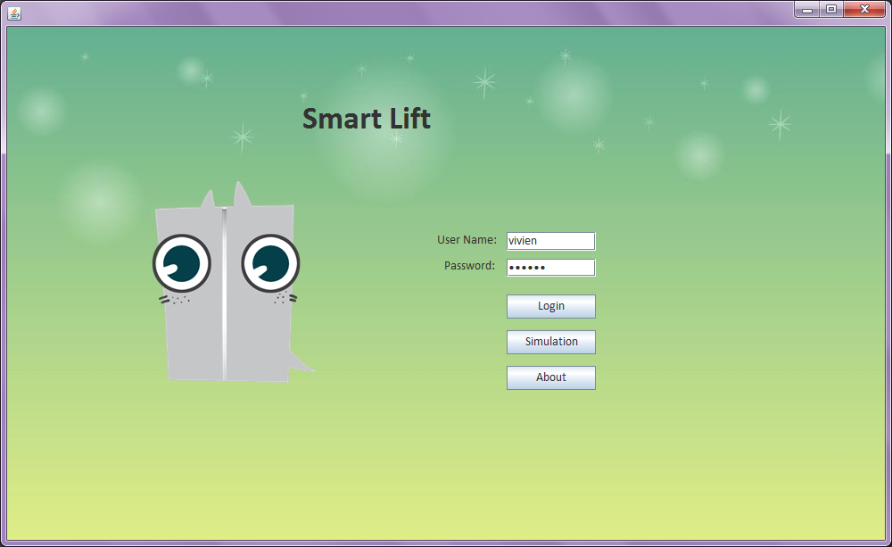

Account Login, will introduce later.

Without account, user can also click the simulation, help and about button.

## Simulation



After click Simulation, it will show the basic setting page.

### Use Default Data

You can choose the default setting of lift to simulation by clicking Simulation button.

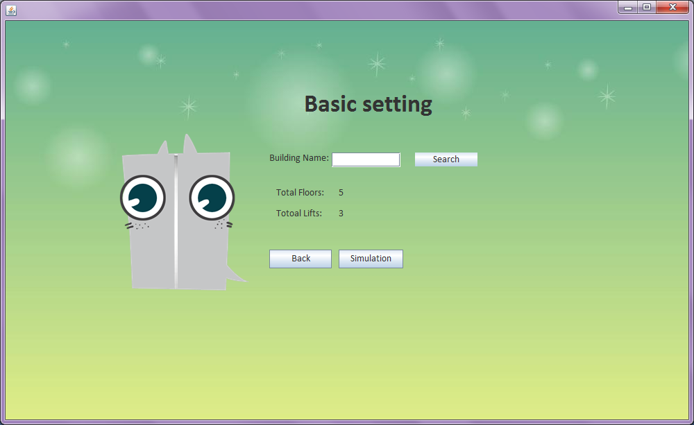

### Use Specific Data by Searching

Or you can search the building data to simulate. The step is following.

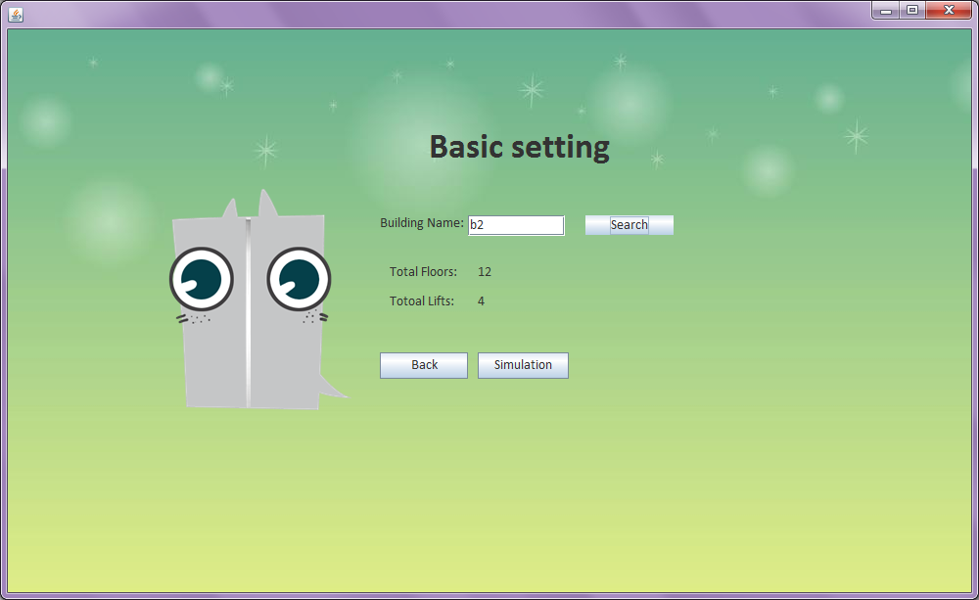

**③**

**①**

**②**

Now the simulation is starting. You can easily see the lift status. Such as the lift ID, the current floor, the current people number in the lift and other lift moving status. On the right side, there is the building floor and the waiting people number.

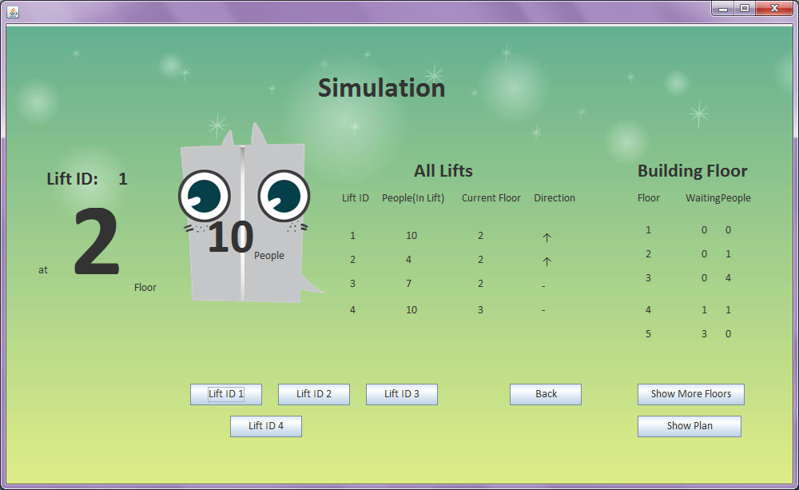

### Change View

Then you can choose the lift ID to change the view.

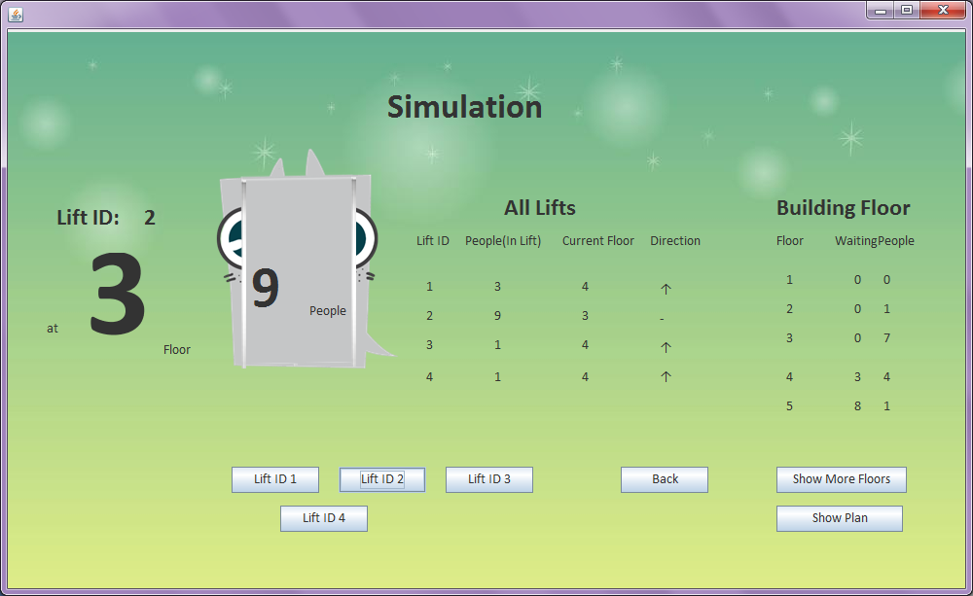

### Show More Floors’ Waiting People Number

You can click show more floors to see waiting people number in more floors.

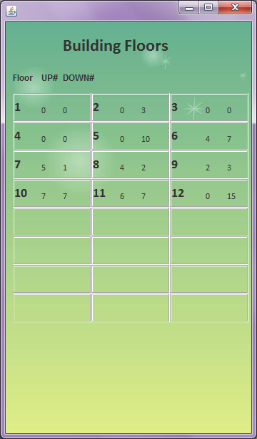

the number of waiting people which want to go down.

the number of waiting people which want to go up.

### Show Plan

You can check the plan by clicking “show plan”, it will show the details of plan.

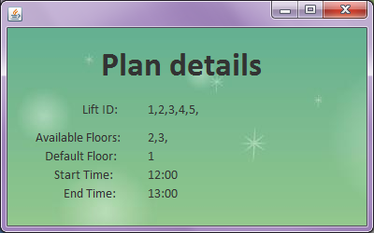

As the picture, the available floors are set to 2 and 3. It means the lifts (1,2,3,4,5) can only go to floor 2 and 3. And the default floor (1) means when the lift is free, it will go the floor 1.

## Login as an manager



If you use wrong account name or password, it doesn’t matter. Try again ^ ^

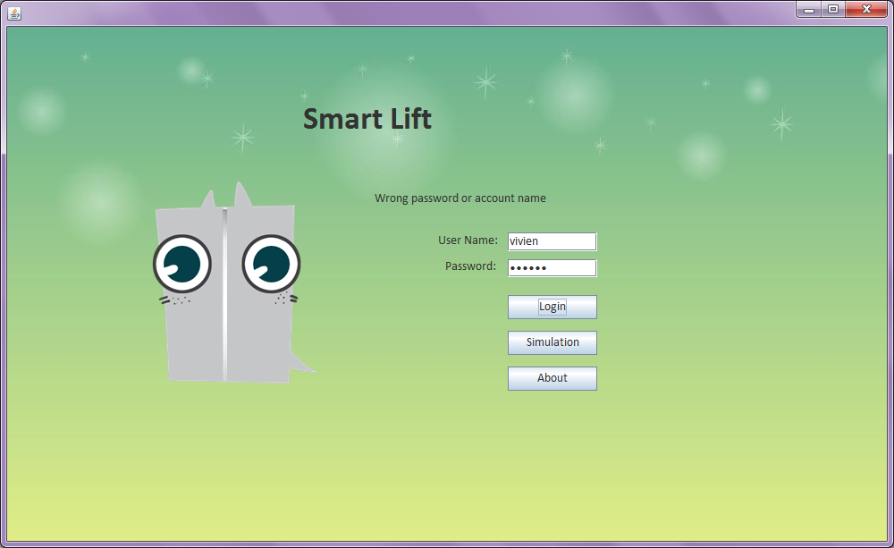

After Login as manager successful, it will show the manage plan page.

### Manage Plan

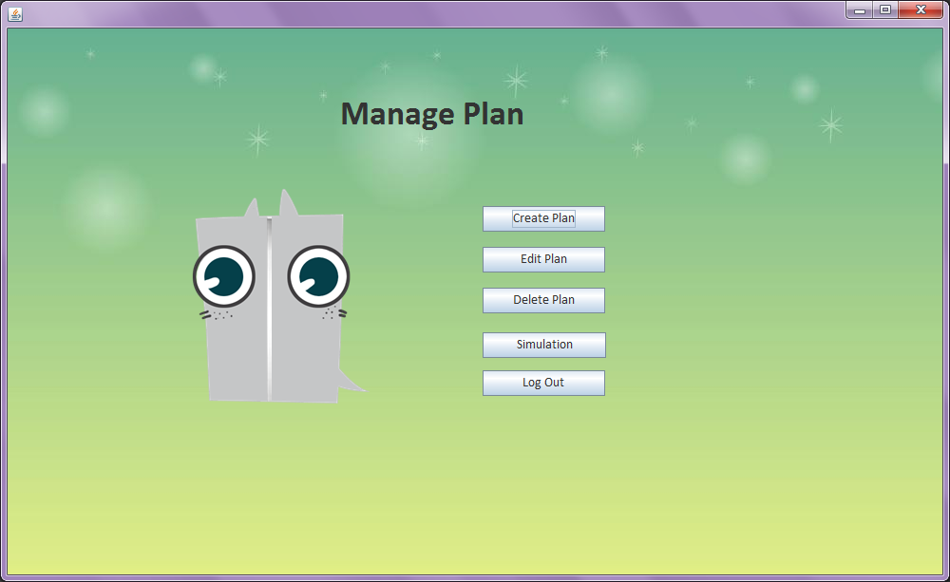

#### Create Plan



After Click Create Plan, it will be a create plan form as following.

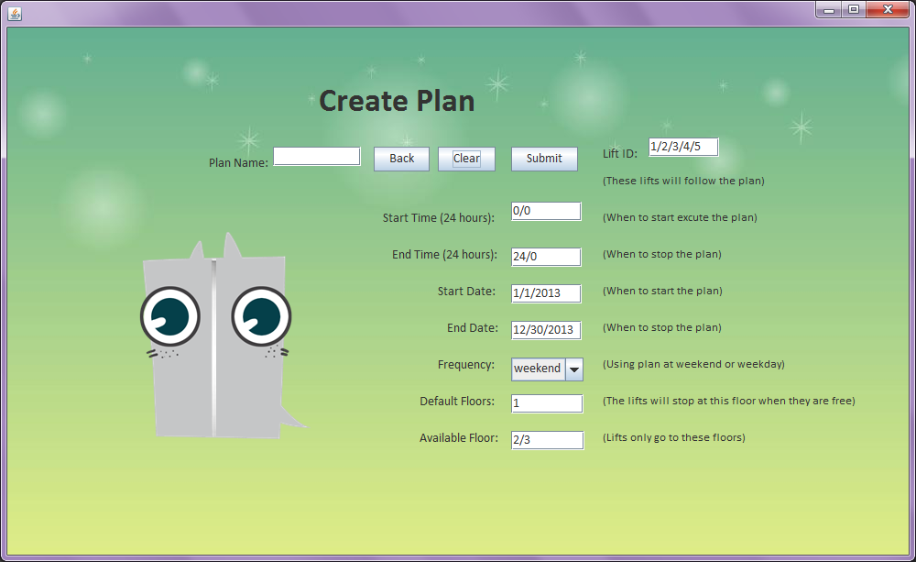

If you just click submit, you will get a tips.

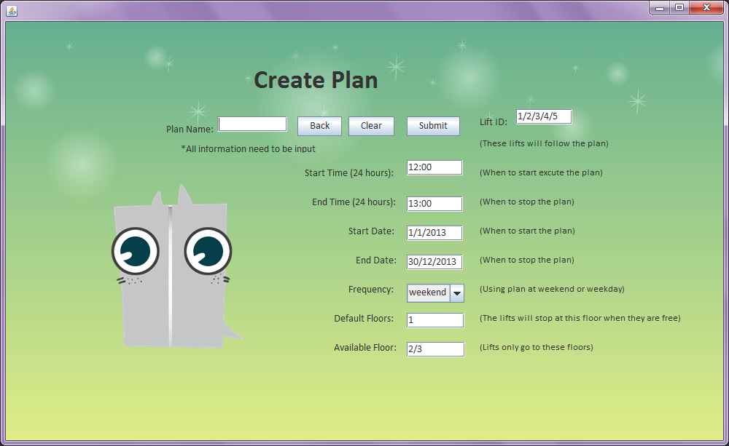

So before submit the create plan, input the relative information.

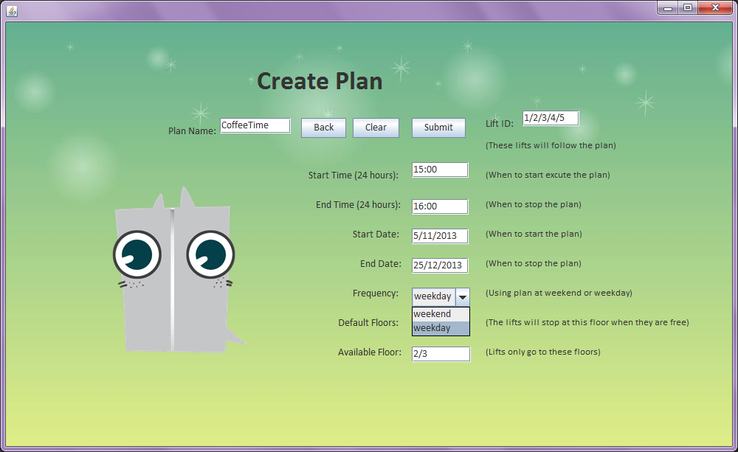

After fulfill the form, you can click clear button before submit. It will give you a clear form.

Then you should create again - -!

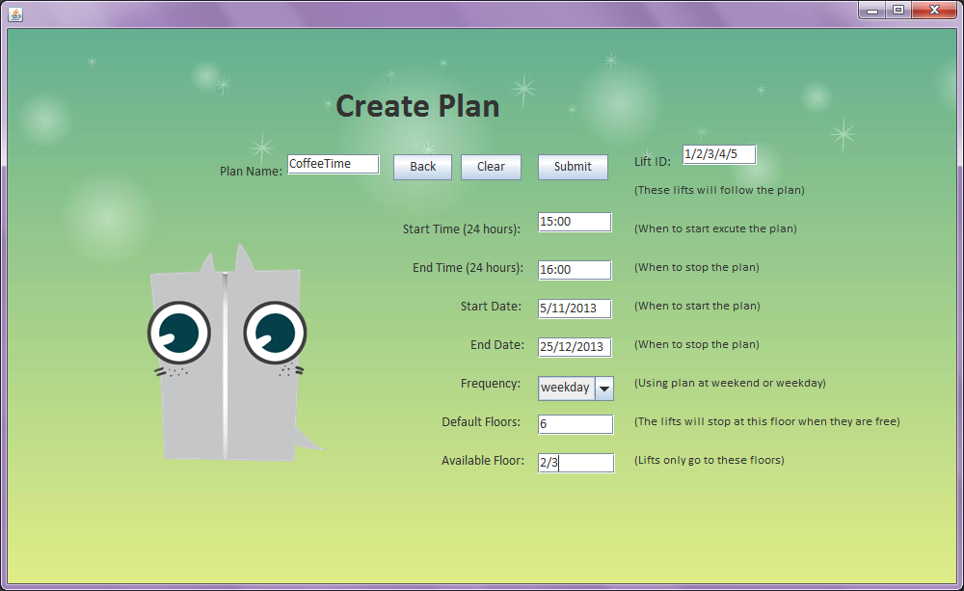

Now create plan is done, click submit button.

After submit, it will turn to the manage plan page.

#### Edit Plan



After click edit plan button…

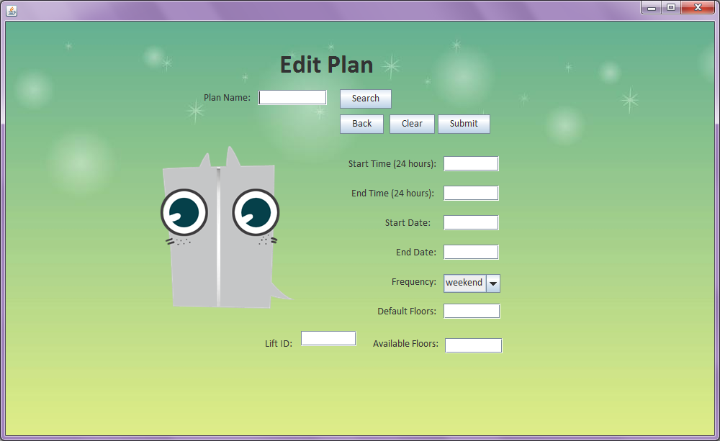

**②**

**①**

You can input the plan name① and click search button to show the details and it is very easy to edit.

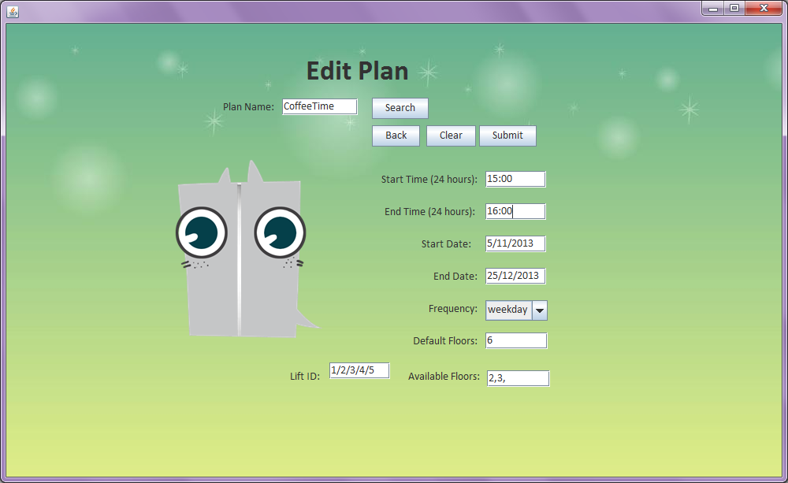

edit plan

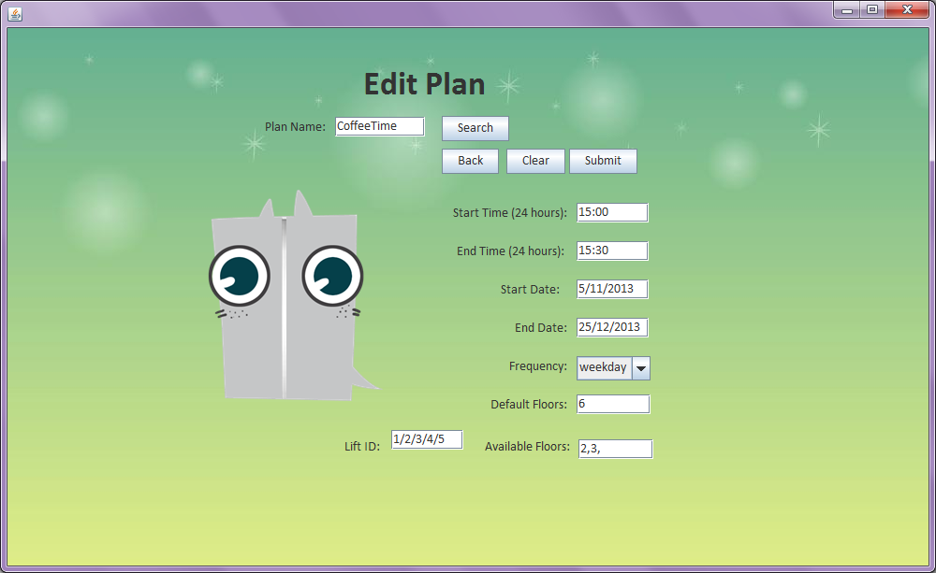

After edit the plan, Submit button.

Then it will turn to manage plan again.

#### Delete Plan



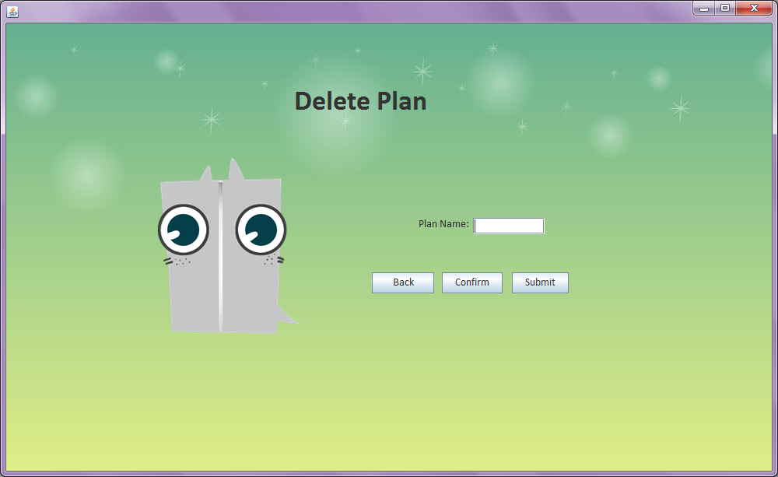

**②**

**①**

Just input the plan name①, and click submit②.

It is not done, just flowing the tips to click confirm button.

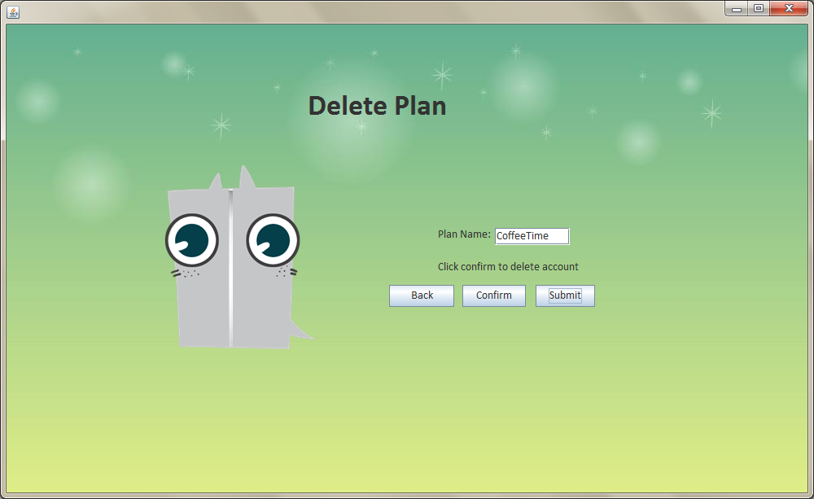

After click confirm button, it will return to the manager’s menu.



You can choose simulation or log out button.

### Simulation

Please see page 4

### Log out

The log out button will bring you to the first page (login page).

## Login as an administrator

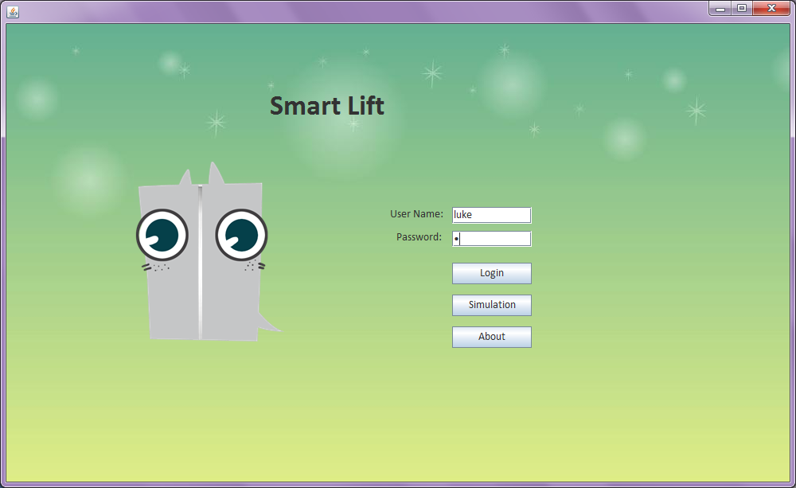

After login as administrator, there are 5 buttons.

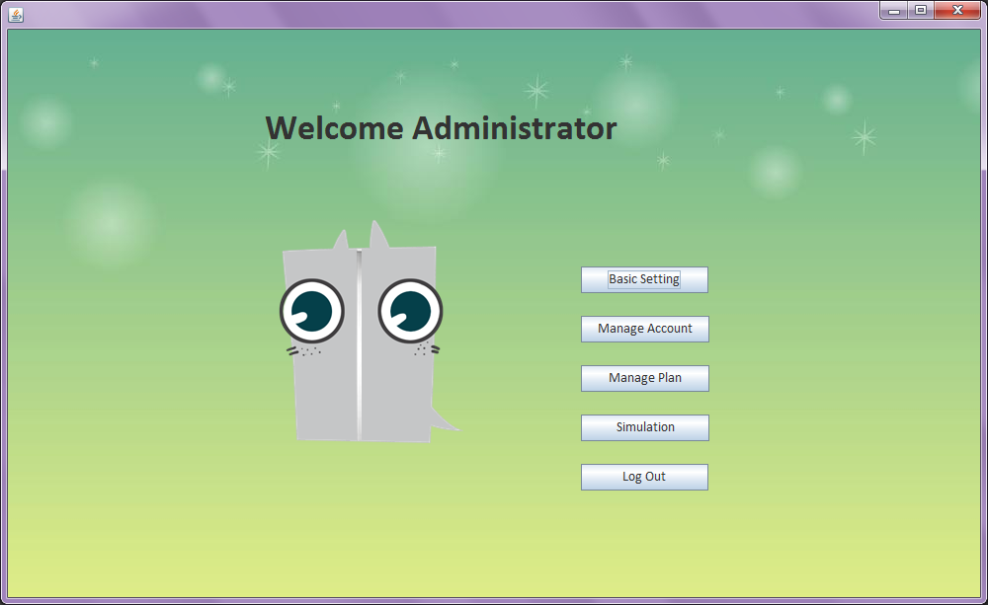

### Basic Setting



There will be a basic setting form.

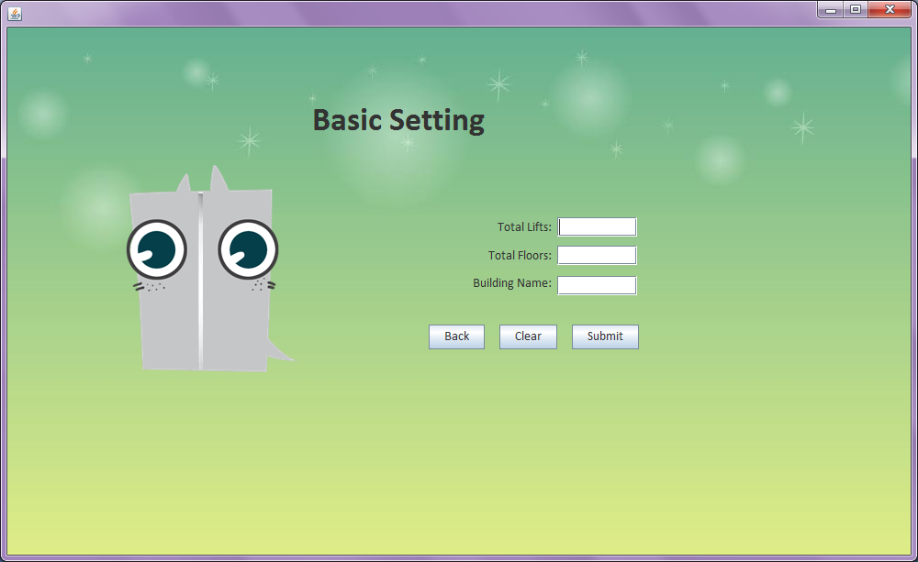

Fill the form, then click submit button.

The clear button will give you a clear form. It is useful when you input 3 wrong data.

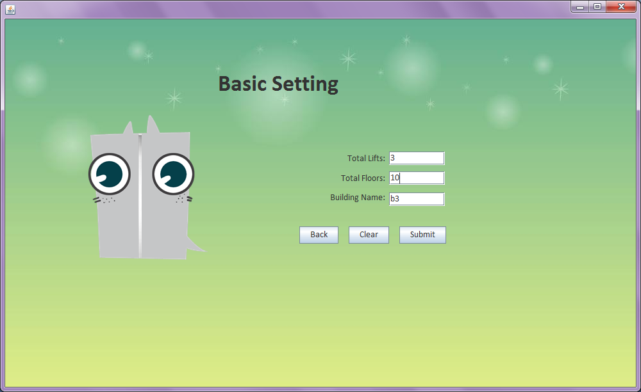

### Manage Account



The manage account includes create account and delete account.

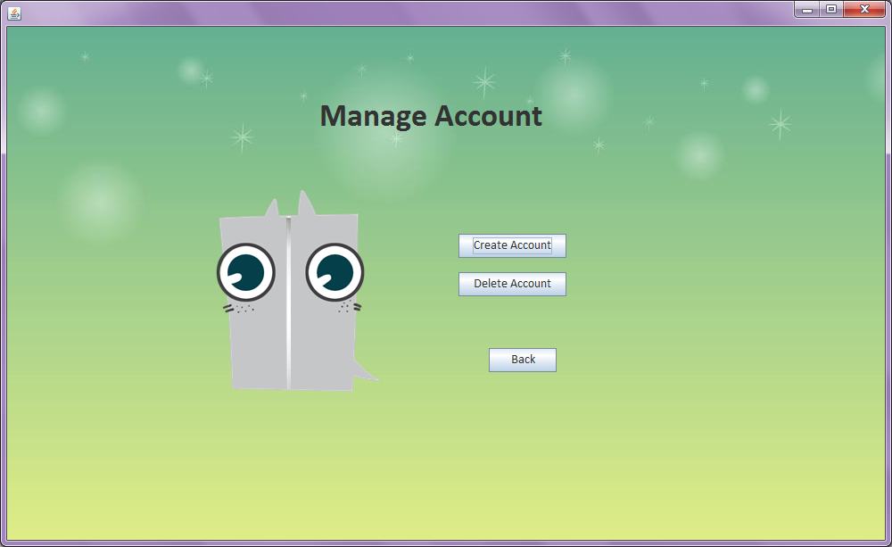

### Create Account



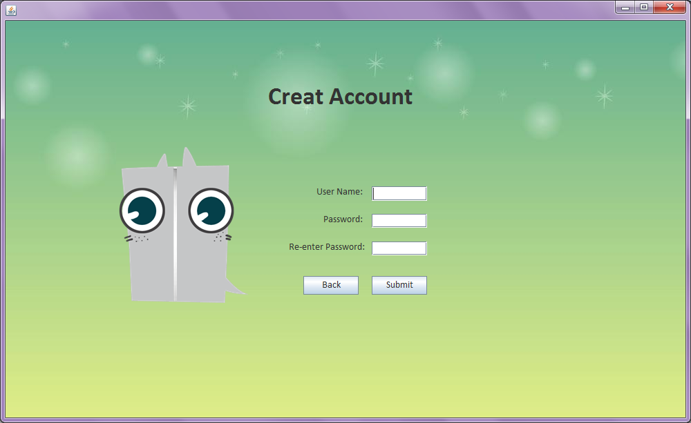

Input username, password, and click submit button.

### Delete Account



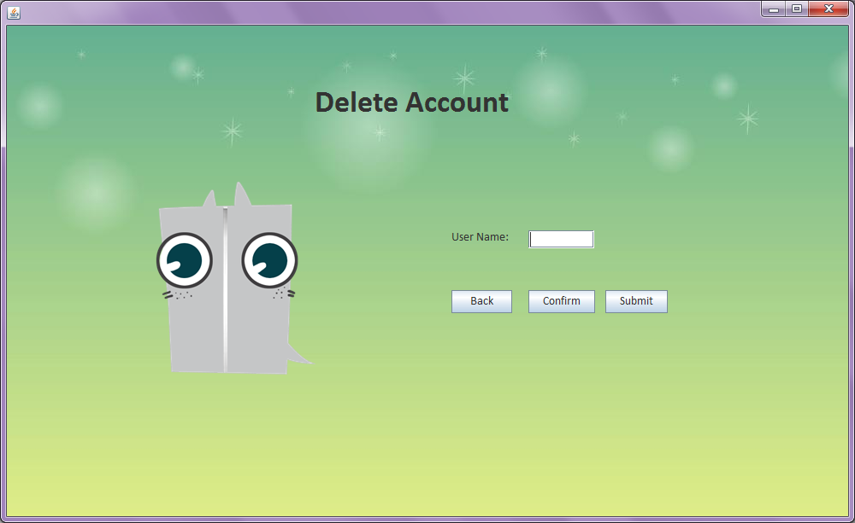

Input user name, and click Submit button.

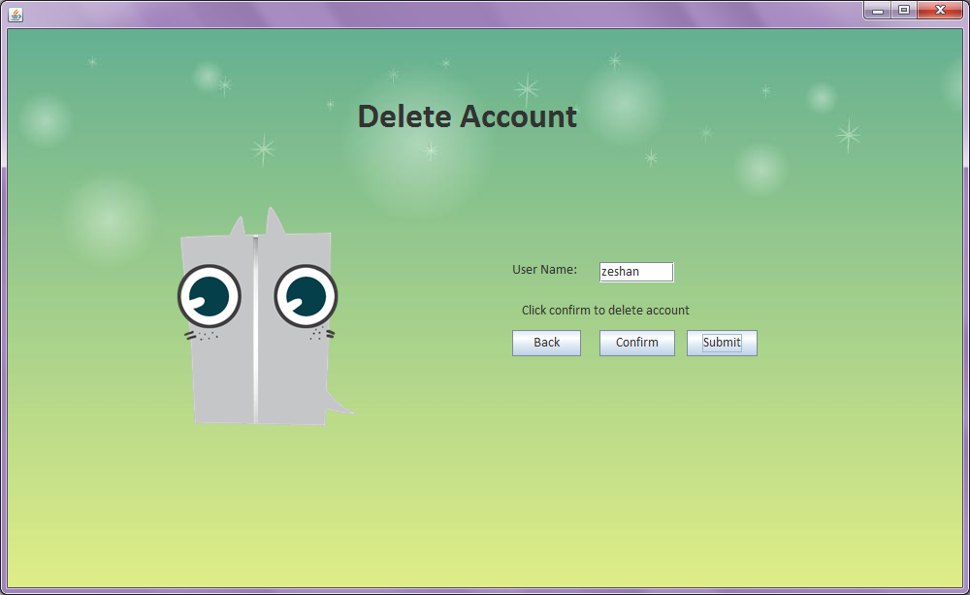

Click confirm button, then delete account is done.

Administrator can also manage plan and simulation.



### Manage Plan

Please see page 9

### Simulation

Please see page 4

## About

You can easily to see information about smart lift and our group by clicking about button in the first page.



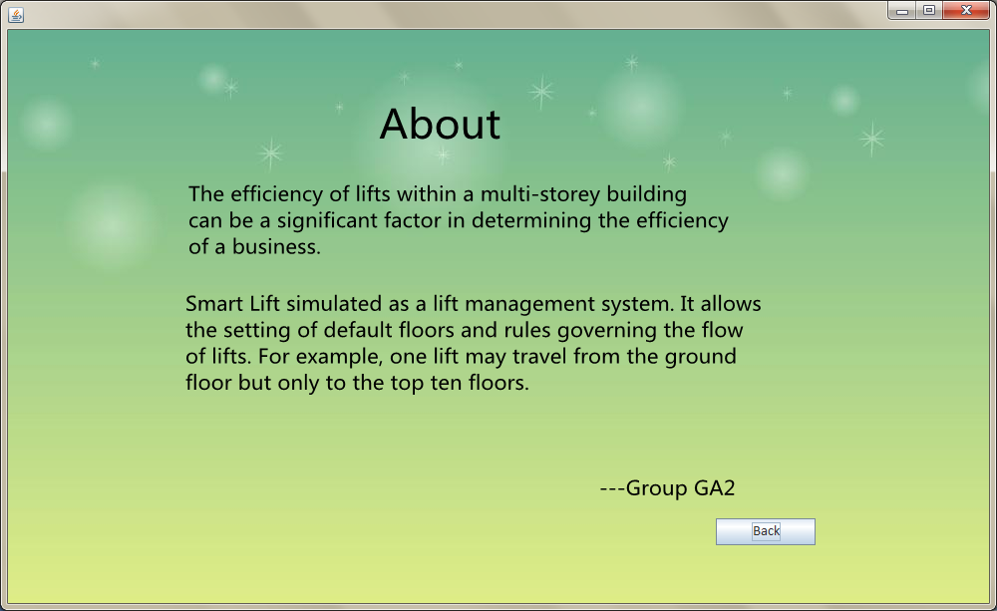

# Frequently Asked Question

* **Q: Who can use this software?**

**A:** The managers of a business building which want to create lift plan for their building. Smart lift will give them a good simulation to find whether their plan is suit for their building.

* **Q: How smart lift is useful for the manager?**

**A:** The smart lift will ask manager to input their building floors and lift number which can stand by their building data. Moreover, after simulation, the manager can get a report for this simulation summary.

*By Group GA2 - Yajuan Xu*