Ethics and Introduction

Virtual Turing Tumble
Level 4 solo project
Luke Gall

The aim of this experiment is to test the usability of the Virtual Turing Tumble web application. A usability test can not be performed by the creator of the application as it would give biased results, this is why user evaluation is required. I will give you some time to read the tutorial page before moving on with the tasks described. This experiment will take you no longer than 40 minutes. After completing the tasks, one of which is optional, you will be given a list of evaluation questions to answer. I will be collecting online response data which will be securely stored online and is password protected, no personal data will be stored.

I will be monitoring you during this experiment, please ask me any questions during this task. I will be taking anonymous notes on how easily you manage to complete the tasks.

Please remember that it is the web application, not you, that is being evaluated. You are welcome to withdraw from the experiment at any time, and any data you give will be discarded, without consequence. If you withdraw from the experiment early you will not be able to view the debrief about the purposes of the experiment. Do you agree to taking part in this evaluation?

If you have any further questions about the experiment, please feel free to contact
Luke Gall, Application Developer
2298070g@student.gla.ac.uk
Alice Miller, Project Supervisor
Alice.Miller@glasgow.ac.uk

Task 0 – Open website and have a (quick) read of the tutorial

Open the website using the following link - https://lukegall.github.io/Level-4-Solo-Project/home

Clicking the hamburger icon to the left of the Virtual Turing Tumble title will give you the side navigation bar. It should look similar to below.
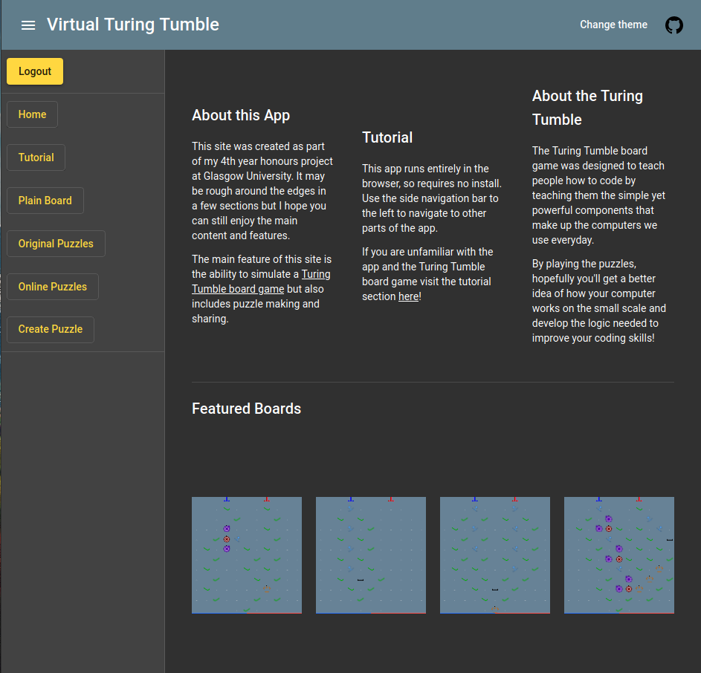

Click on the ‘Tutorial’ link in the sidenav to gain access to the tutorial page which will give some basic context to the game. Please have a quick read of the instructions for the game. The tutorial page looks below.
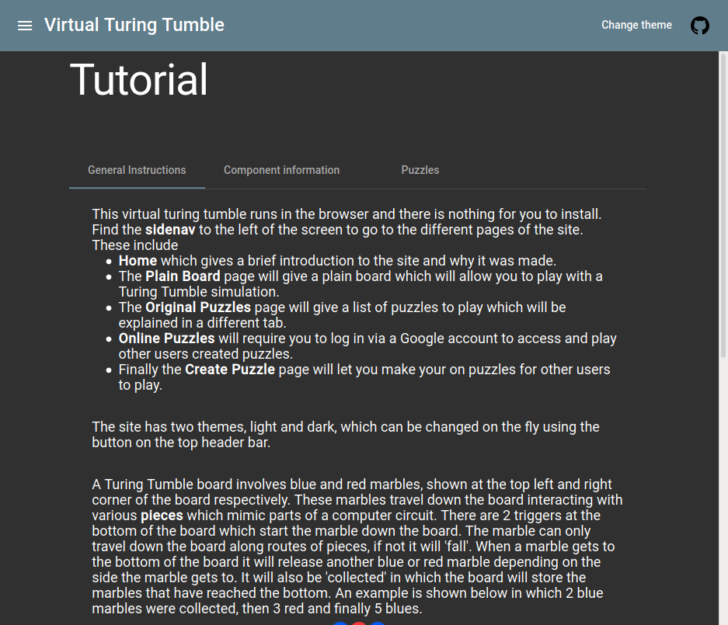

Task 1 – Creating an example on the plain board

Navigate to ‘Plain board’ and select a ‘Ramp’ piece. The page is shown below
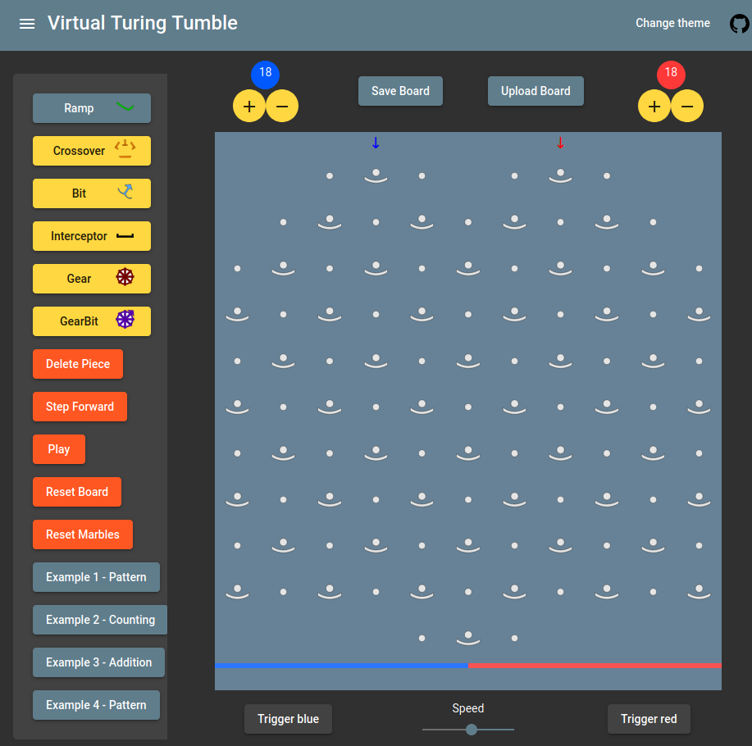

Add a ramp below the blue arrow on the board. Then trigger a blue marble to fall down. Notice the direction the marble goes and also notice that the marble ‘falls’ at the end as shown below. This indicates that the marble has fallen as it hasn’t reached a valid piece so stops travelling down the board.
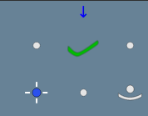

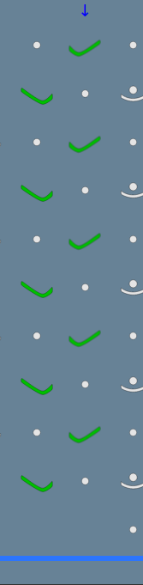
Fill in the rest of the board below.

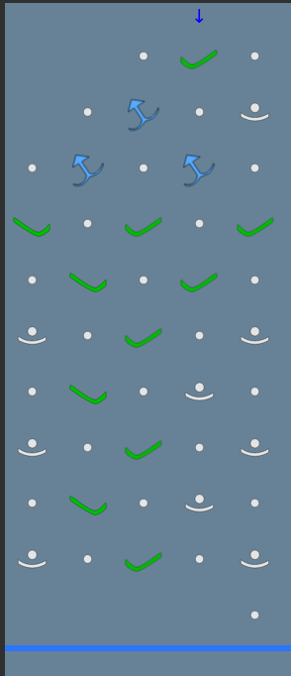

Now click blue marble again, let the marbles get to the end then pause execution.

Reset the board, then add a ‘Bit’ piece and add the pattern to the right to the board.

If you place the wrong piece, you can delete it.

Bits act as registers in a standard CPU, they can ‘store’ information based on the direction they point. Press ‘trigger blue’ and notice that bit’s will change direction once a marble passes through them which will change the direction the next marble will travel in.

Please click ‘GearBit’ and place GearBits so that they are ‘connected’ via Gears. Once connected change the direction of one of the GearBits. Create a pattern using the GearBits like the one below and watch the marble go down the board.

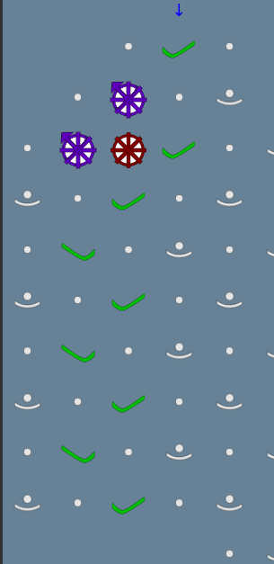

Task 2 – Example 3 and basic addition

Reset the board, ensure enough marbles are set up and click ‘Example 3’.

This will display a board which has 2 lines of bits on the left and right of the board. The bits will act as registers in this case and can be used to add two binary numbers together and display the result in the second line.

The bits are numbered on the right picture and represented the numbered register so the left line has 3 registers and the right line has 4. A bit is ‘On’ if it is pointing to the right therefore the left register equals (2^0 * 1) + (2^1 * 0) + (2^2 * 1) = 5.
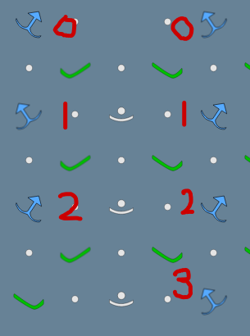

Trigger the blue marble, change the speed of execution and try stepping forward also.

At the end of the execution the marble will be caught by an ‘Interceptor’ component which will stop the marble execution in which the second line will display the addition of the two binary numbers.

Task 3 – Playing a puzzle

Navigate to the ‘Original puzzles’ page.

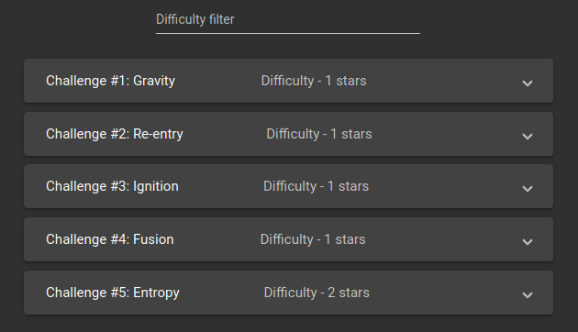

After getting to the page, filter the puzzles so only puzzles with difficulty 3 or 4 is visible.

Click on puzzle #15 and have a look at the three different tabs displaying information on the puzzle.

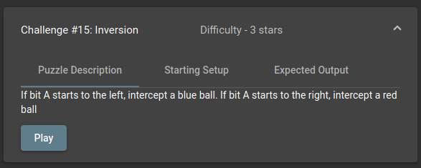

Now reset the difficulty filter and click and play puzzle #2: Re-entry.

Using the pieces available, try to complete the puzzle so that it matches the expected output.

If stuck at any time the ‘Show answer’ button can be clicked to display the answer. After triggering the blue marble and allowing all blue marbles to reach the bottom you will get a congratulations message.

Task 4 – (Optional) Creating a puzzle for other users

After logging into the site using the Anonymous login. Please only login using the anonymous login so the server doesn’t record your Google account during this experiment. You will now have access to ‘Online Puzzles’ and ‘Create Puzzle’, click on ‘Create Puzzle’ page.

The first stage to creating a puzzle is to place the starting pieces for the puzzle, these are the pieces that won’t be changed by the user but gives them an idea of what sort of puzzle it is. I also welcome you to come up with your own puzzle if you wish but you can also follow this example.

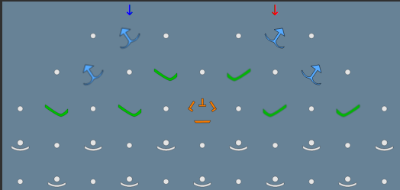

After making a starting set up, you can confirm these pieces by clicking ‘Confirm Set up’ which will lock these pieces for the starting set up of the puzzle.

After locking these pieces, it is time to add the remaining pieces that would work for a solution to your puzzle. Then add the required marbles then trigger and wait for the required marbles to reach the end. Once this is completed you can confirm the output. Please fill out a solution to your puzzle or copy the one below.

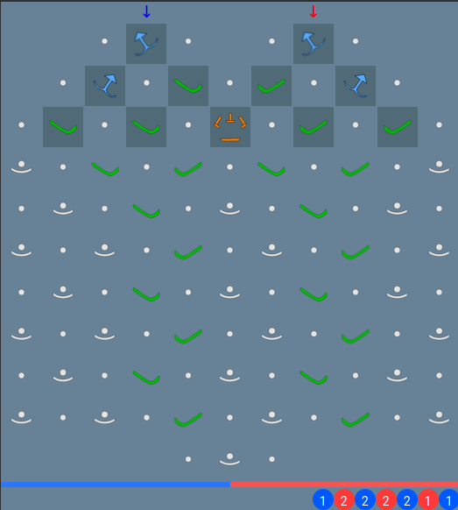

After confirming the output, a form will presented to fill out information about your puzzle before submission.

Evaluation

Please now fill out responses on the evaluation sheet asking you about your experiences using the app and if you have any suggestions to make the experience more enjoyable.

https://docs.google.com/forms/d/e/1FAIpQLSeJMnurFxU_n33EVp6nCr5Sf2dmulWghx1_FJYRSFmsGIbp5A/viewform?usp=sf_link

