Task 0 – Open website and have a (quick) read of the tutorial

Open the website using the following link - https://lukegall.github.io/Level-4-Solo-Project/home

Clicking the hamburger icon to the left of the Virtual Turing Tumble title will give you the side navigation bar. It should look similar to below.
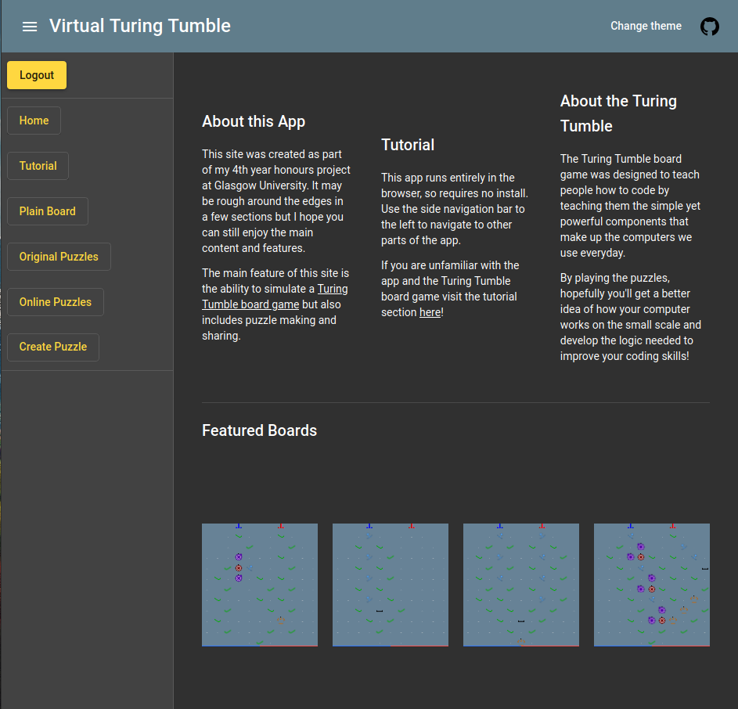

Click on the ‘Tutorial’ link in the sidenav to gain access to the tutorial page which will give some basic context to the game. Please have a quick read of the instructions for the game. The tutorial page looks below.
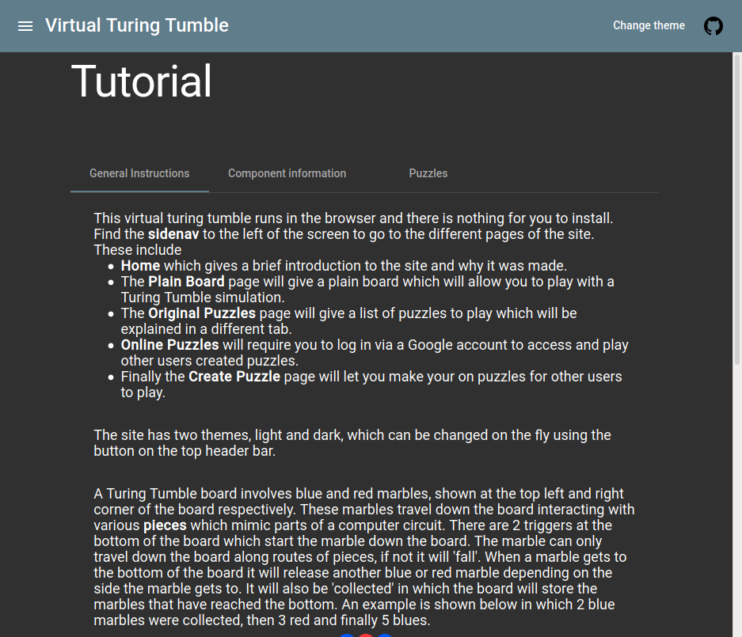

Task 1 – Creating an example on the plain board

Using the sidenav bar navigate to ‘Plain board’ and click on the ‘Ramp’ piece on the side selection bar. The page is shown below
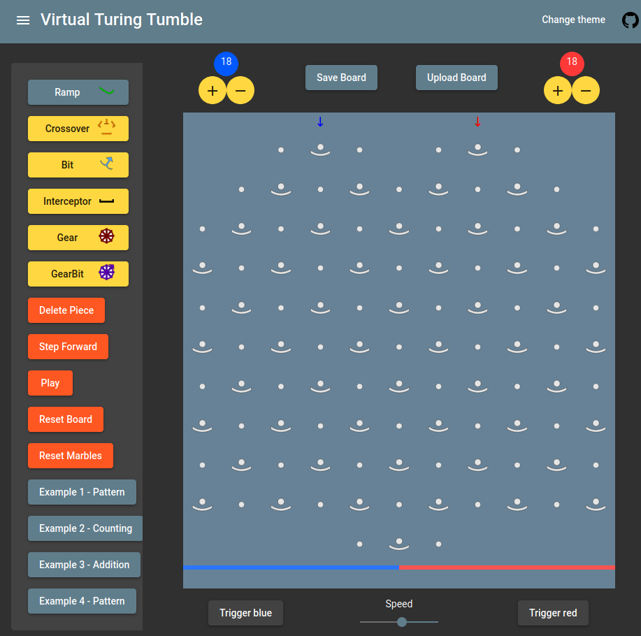

Click the ‘CompSlot’ below the blue arrow to place a ramp on the board. As shown below

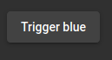

After adding the ramp click ‘Trigger blue’ to have the marble go down the screen. Notice the direction the marble goes and also notice that the marble ‘falls’ at the end looking like below. This indicates that the marble has fallen as it hasn’t reached a valid piece so stops travelling down the board.
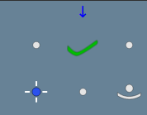

Fill in the rest of the board like below using the ‘Ramp’ piece. While ‘holding’ a Ramp piece, clicking on an already placed Ramp will change the direction of the Ramp.
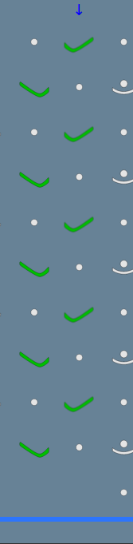

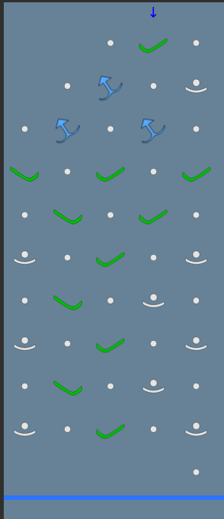

Now click ‘trigger blue’ again and notice that the marble now has a valid path to the end of the board and will trigger a new blue marble once it reaches the bottom. This can be paused or stopped by pressing ‘Pause’ or ‘Reset Marbles’ on the side bar.

Press ‘Reset Board’ to remove the pieces, then add click on the ‘Bit’ piece and add the pattern to the right to the board.

If you place the wrong piece at any point, adding a different piece to that slot will replace it or by clicking ‘Delete piece’ you can click on placed pieces to remove them.

Bits act as registers in a standard CPU, they can ‘store’ information based on the direction they point. Press ‘trigger blue’ and notice that bit’s will change direction once a marble passes through them which will change the direction the next marble will travel in.

Task 2 – Example 3 and basic addition

Using the side bar click on the ‘Example 3 – addition’ to get a pre-made patten onto the board.
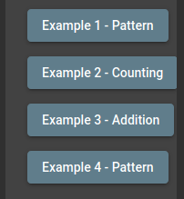

This will display a board which has 2 lines of bits on the left and right of the board. The bits will act as registers in this case and can be used to add two binary numbers together and display the result in the second line.
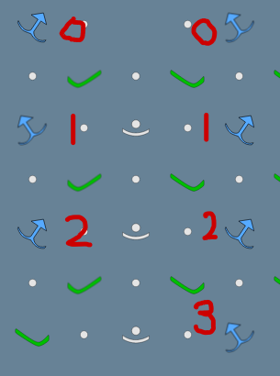

The bits are numbered on the right picture and represented the numbered register so the left line has 3 registers and the right line has 4. A bit is ‘On’ if it is pointing to the right therefore the left register equals (2^0 * 1) + (2^1 * 0) + (2^2 * 1) = 5.

At this stage you may need to add more marbles to the top of the board, to do this, click the plus sign next to the blue and / or red marbles so that this pattern works (20 is a safe bet)

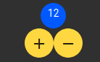

Then press the ‘trigger blue’ button and watch the marble go down the board, at this stage try ‘pausing’ and then ‘playing’ the execution of the board using the side bar.
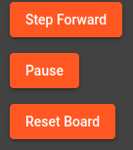

Try and change the speed of the execution by using the speed slider at the bottom of the board.
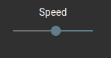

At the end of the execution the marble will be caught by an ‘Interceptor’ component which will stop the marble execution in which the second line will display the addition of the two binary numbers.

Task 3 – Playing a puzzle

After navigating to the ‘Original Puzzles’ page, it may take a few seconds to load these puzzles. But afterwards it should look like the following.
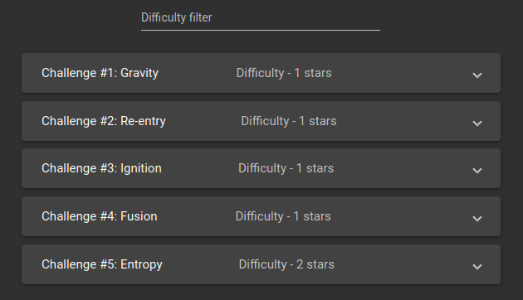

After getting to the page, add ‘3’ and ‘4’ to the difficulty filter at the top of the page.


Click on puzzle #15 and have a look at the three different tabs displaying information on ‘Puzzle description’, ‘Starting set up’ and ‘expected output’.

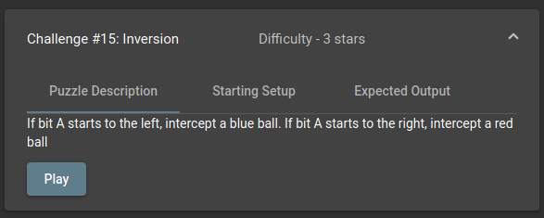

Now reset the difficulty filter by clicking the ‘X’s next to the numbers. Now click on puzzle #2 and click ‘play’

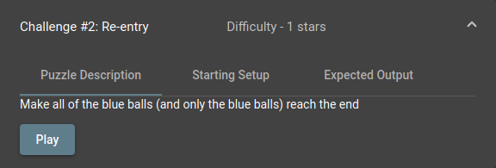

The puzzle will display the description of the puzzle which will give information of how to play the puzzle and what the output should be for this puzzle. The pieces which have a darker background are the ‘starting pieces’ these pieces can not be deleted or changed as they are required as part of the puzzle.

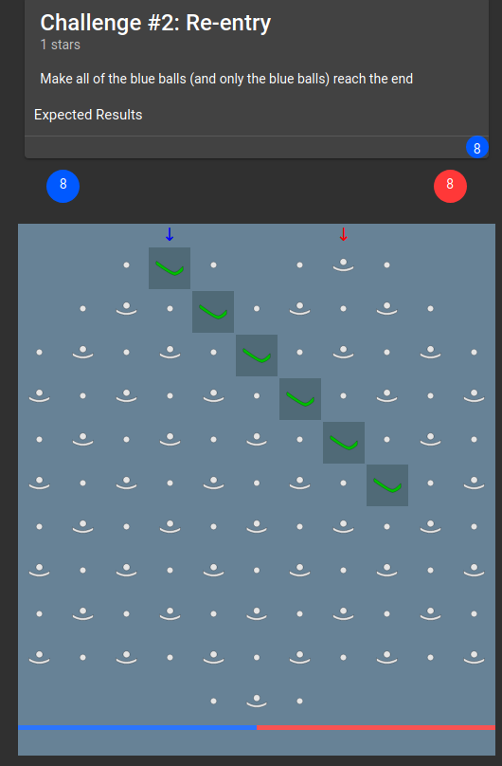

Using the pieces available conveyed by the number next to the pieces on the selection bar, try to complete the puzzle so that when the blue marble is trigged. Have a go at placing a ramp in an incorrect position and then delete it and re place it in the correct position.

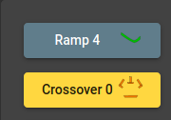

If stuck at any time the ‘Show answer’ button can be clicked to display the answer. After triggering the blue marble and allowing all blue marbles to reach the bottom you will get a congratulations message.

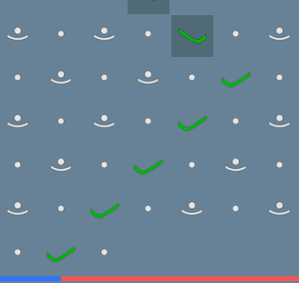

Task 4 – (Optional) Creating a puzzle for other users

After logging in the site using a Google account, you will now have access to ‘Online Puzzles’ and ‘Create Puzzle’, click on ‘Create Puzzle’ page.

The first stage to creating a puzzle is to place the starting pieces for the puzzle, these are the pieces that won’t be changed by the user but gives them an idea of what sort of puzzle it is. For example, you can give the following pieces as a starting set up for a puzzle. I also welcome you to come up with your own puzzle if you wish but you can also follow this example.

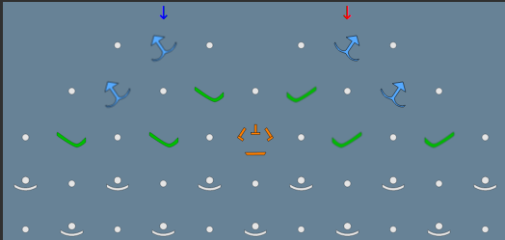

After making a starting set up, you can confirm these pieces by clicking ‘Confirm Set up’ which will lock these pieces for the starting set up of the puzzle.

After locking these pieces, it is time to add the remaining pieces that would work for a solution to your puzzle. After adding the pieces that would work as a solution to your puzzle, add the required marbles then trigger and wait for the required marbles to reach the end. Once this is completed you can select ‘Confirm Output’ which will save the solution pieces and the Expected output. Please fill out a solution to your puzzle or copy the one below.

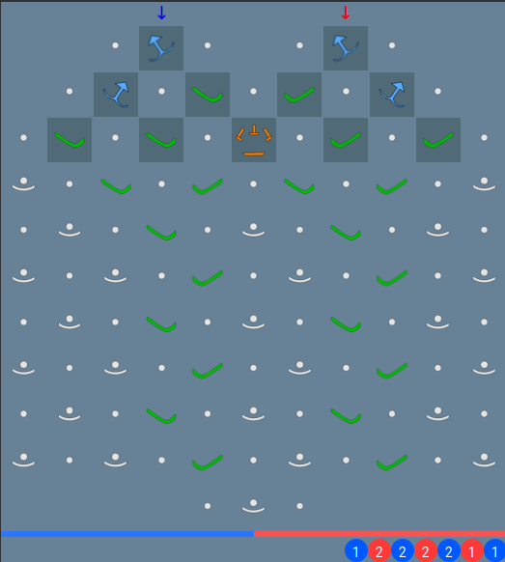

After confirming the output, a form will presented to fill out information about your puzzle before submission.

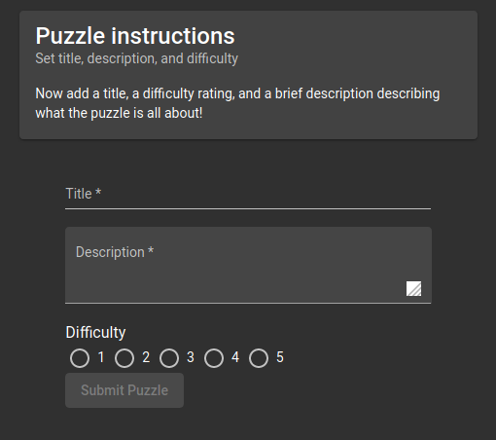

Evaluation

Please now fill out responses on the evaluation sheet asking you about your experiences using the app and if you have any suggestions to make the experience more enjoyable.

