AT3 Project Question 1

Programming III

Luke Gough

30003918

Contents

What data structures are you using? 1

Where are you using hashing techniques? 1

What sorting algorithm are you using how this is different from selection and bubble sort? 1

What search technique are you using? 1

What third party libraries are you using? 1

Where can I find the documentation for this? 1

A mock-up of the GUI. 1

What source control are you using? 1

What are your coding standards you are enforcing? 1

What tests are you going to run? 1

# What data structures are you using?

I am using a LinkedList to store the User objects in.



I am using List to store the userId’s in to display them to the User IDs list box.



I am using List’s in the Merge Sort methods.



# Where are you using hashing techniques?

The SaltGenerator uses RNGCryptoServiceProvider from System.Security.Cryptography to generate a salt.

The HashComputer uses SHA256 and SHA256CryptoServiceProvider from System.Security.Cryptography and the salt from SaltGenerator to generate a hash.

The PasswordManager class is used to generate or check the the password has using the SaltGenerator and HashComputer classes

# What sorting algorithm are you using how this is different from selection and bubble sort?

I am using Merge sort which is a Divide and Conquer algorithm which divides the supplied array in half, recursively calling itself until array size is the size of one element then sorts and merges the sub arrays.

Selection and Bubble sort use an iterative sorting algorithm

Bubble sort iterates over the array swapping element each time it sees a pair which is out of order and repeats until the whole array is sorted.

Selection sort iterates over the unsorted array finding the smallest unsorted element then adds it to the end of the sorted array and repeats until the all elements in the unsorted array have been added to the sorted array.

# What search technique are you using?

I am using a Recursive search which works by supplying a search item (userId) and recursively looking through the supplied LinkedList(users) until the item is either found or not then returns a(boolean) true or false.

# What third party libraries are you using?

I am using the third party library CSVHelper which allows me to easily export to a CSV file.

I am using the third party library StyleCop to enforce code standards.

# Where can I find the documentation for this?

The documentation for CSVHelper can be found [here](https://joshclose.github.io/CsvHelper/getting-started/).

The documentation for StyleCop can be found [here](https://github.com/DotNetAnalyzers/StyleCopAnalyzers/tree/master/documentation).

# A mock-up of the GUI.

## Server GUI

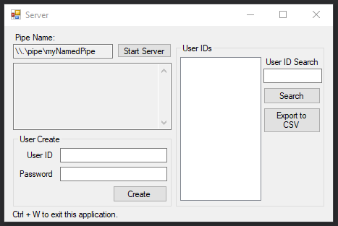

## Client GUI

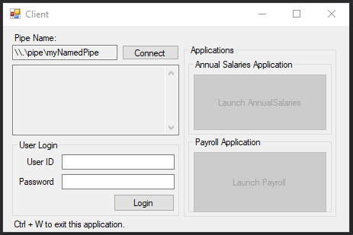

# What source control are you using?

I am using GitHub as my source control which can be found [here](https://github.com/LukeGough/Programming-III-Project).

There will be different branches for each version after a major implementation.

# What are your coding standards you are enforcing?

I am using StyleCop to enforce coding standards.

<https://github.com/StyleCop/StyleCop>

Enforced coding standards include standards such as:

* 
* 
* 
* 
* 
* 

Further standards can be found in the documentation [here](https://github.com/DotNetAnalyzers/StyleCopAnalyzers/tree/master/documentation).

# What tests are you going to run?

Testing will be further detailed in the testing document.

* Server and Client connection.
* User creation.
* User login.
* User search.
* Exporting to CSV.
* Close application with Ctrl + W.