**ABOUT WNTC**

**We need to cook is a fast-paced, text-based drug selling tycoon where you can go from rags to riches in mere hours.**

**HOW TO PLAY**

**Danger level indicator- The chance of being arrested by the police or being put in danger by a client**

**Seller level indicator- The degree of experience your character has selling drugs. The higher the level, the more expensive drugs you can sell.**

**Street level indicator- The strength and experience your player has on the street, the higher the level, the easier it is for you to win fights.**

**THE DRUGS**

**Crack cocaine- This is the highest selling drug in the game; for only level 10 sellers and up.**

**Cocaine- Second highest selling, hard to source level nine sellers and up.**

**Meth- Third highest selling, medium difficulty to source, level seven sellers and up.**



**Acid- Second lowest selling, easy to source, level five sellers and up**



**Weed- Lowest selling, easiest to source, level zero sellers and up.**



**THE BOSSES**

**Rico**

A former weed supplier that turns on you once you reach seller level five. He has a modified AK-47 that does double the damage of a regular AK.

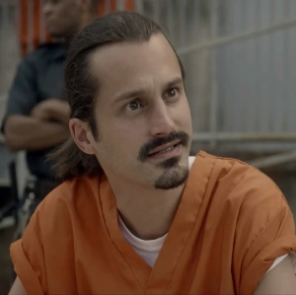

**Danny G**

A powerful enforcer for the game’s final boss, Big Don, who has a sawed of shotgun that does 300 damage. He has three minions working for him, who each have ak-47s.

**

**Donald Piccolo**

**A real estate developer with dealings in many other areas, D.P. is not the most powerful boss, but once beaten he makes for a powerful ally in fighting Antonio Guadelupe.**

**Antonio Guadelupe**

**Big D’s biggest rival, Antonio Guadelupe has become a formidable Narcotics dealer. Even his biggest rival, Big D, stays away from him due to his high intellect and influence.**

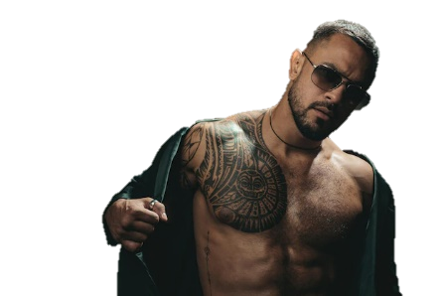

**Big D**

The racist, fat American idiot that makes your life miserable, Big D specialises in selling cocaine and attacks you when you become a big enough rival to challenge him (Seller level 10). He has ten minions, all with AK-47s, a massive machete dealing 500 damage and a private chopper with a mini gun dealing 1000 damage.  His famous catchphrase: “You can’t beat the D”.

**