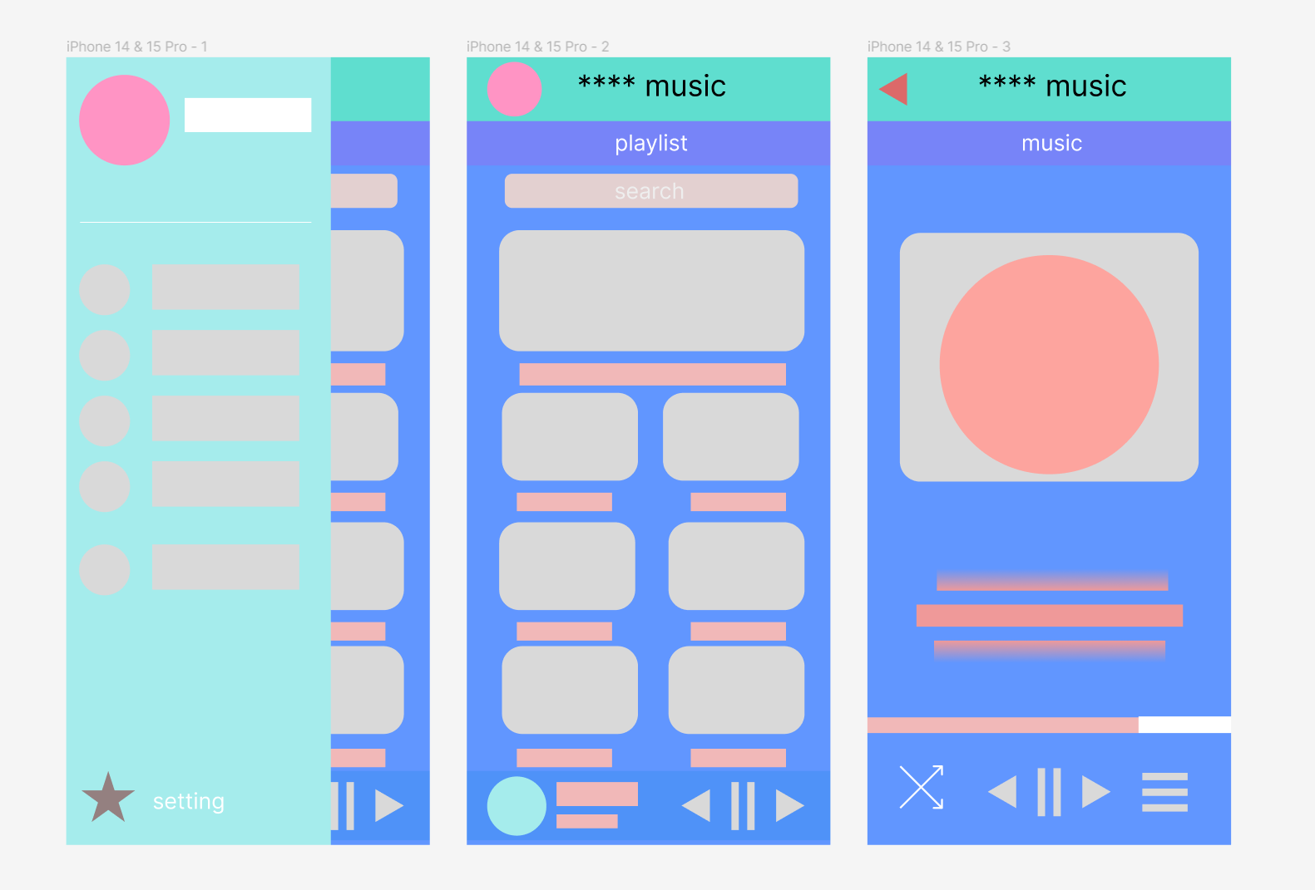https://www.figma.com/file/YYokjHD2Enm8BNzO4y20cr/Untitled?type=design&node-id=0%3A1&mode=design&t=ynFrJexWcAqkId8e-1