CS228: Probabilistic Graphical Models

Homework 5

Luke Jaffe

Due: 03/18/2017
Submitted: 03/18/2017

Problem 1: Bayesian Inference
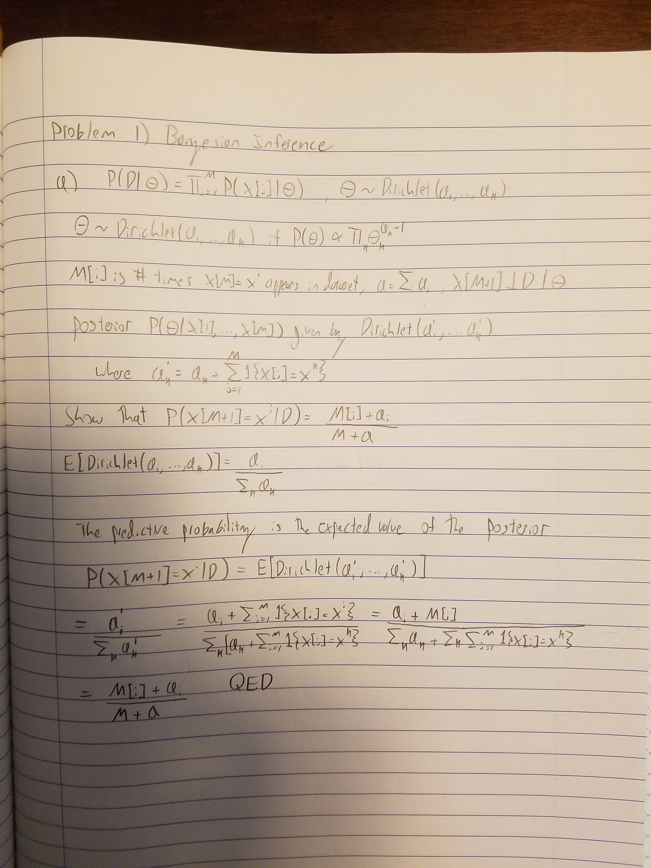
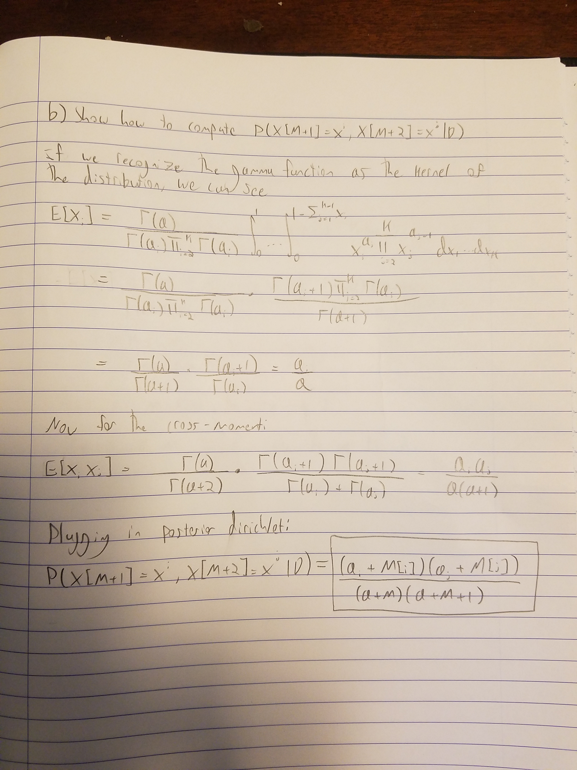

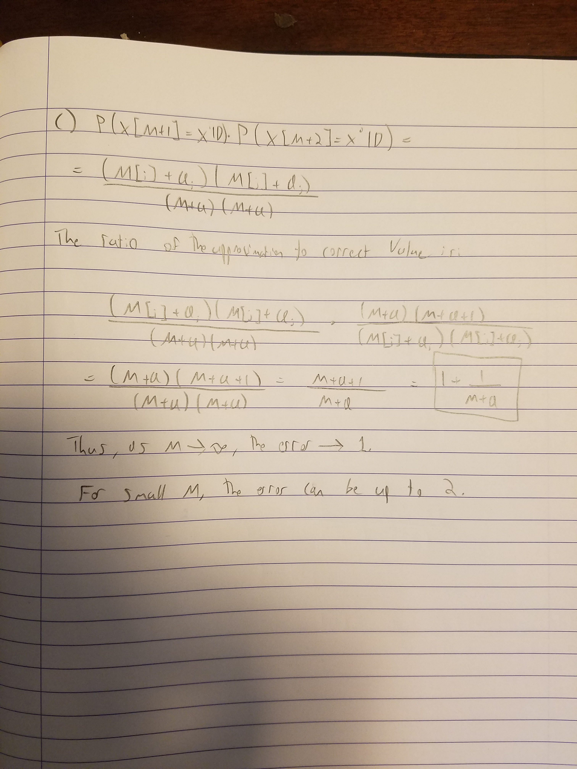
Problem 2: Programming Assignment

A) Gaussian mixture model

i. Parameter estimates:
MLE estimates for PA part A.i:
pi: 0.57
mu_0: [-0.99437209 -1.11730233]
mu_1: [ 1.04922807 0.98085965]
sigma_0: [[ 0.315455 0.29233619]
[ 0.29233619 0.8328346 ]]
sigma_1: [[ 0.79217671 0.20035059]
[ 0.20035059 0.25443312]]

ii. Parameter estimates:

MLE init:
{'pi': 0.58618066426826065, 'sigma_1': array([[ 0.72032607, 0.14375235],
[ 0.14375235, 0.30904765]]), 'sigma_0': array([[ 0.36106206, 0.30946665],
[ 0.30946665, 0.75617395]]), 'mu_1': array([ 0.98809485, 0.99678744]), 'mu_0': array([-1.04528972, -1.02646853])}

Rand init 1:
{'pi': 0.58469304369785646, 'sigma_1': array([[ 0.71692698, 0.14185481],
[ 0.14185481, 0.30804894]]), 'sigma_0': array([[ 0.36273897, 0.31211656],
[ 0.31211656, 0.76146101]]), 'mu_1': array([ 0.99144466, 0.99839573]), 'mu_0': array([-1.04272223, -1.02148551])}

Rand init 2:
{'pi': 0.58447227483326591, 'sigma_1': array([[ 0.71651377, 0.14162268],
[ 0.14162268, 0.30792467]]), 'sigma_0': array([[ 0.36305983, 0.3126073 ],
[ 0.3126073 , 0.76234312]]), 'mu_1': array([ 0.99190709, 0.99861054]), 'mu_0': array([-1.04229193, -1.0207145 ])}

That that the convergence criterion suggested in the problem statement was used, not the one in the starter code (absolute difference of eps).

All methods converged to the around the same log likelihood ~-2570, and arrived at roughly the same parameters. I had some runs where the rand inits arrived at wildly different parameters than the MLE init.

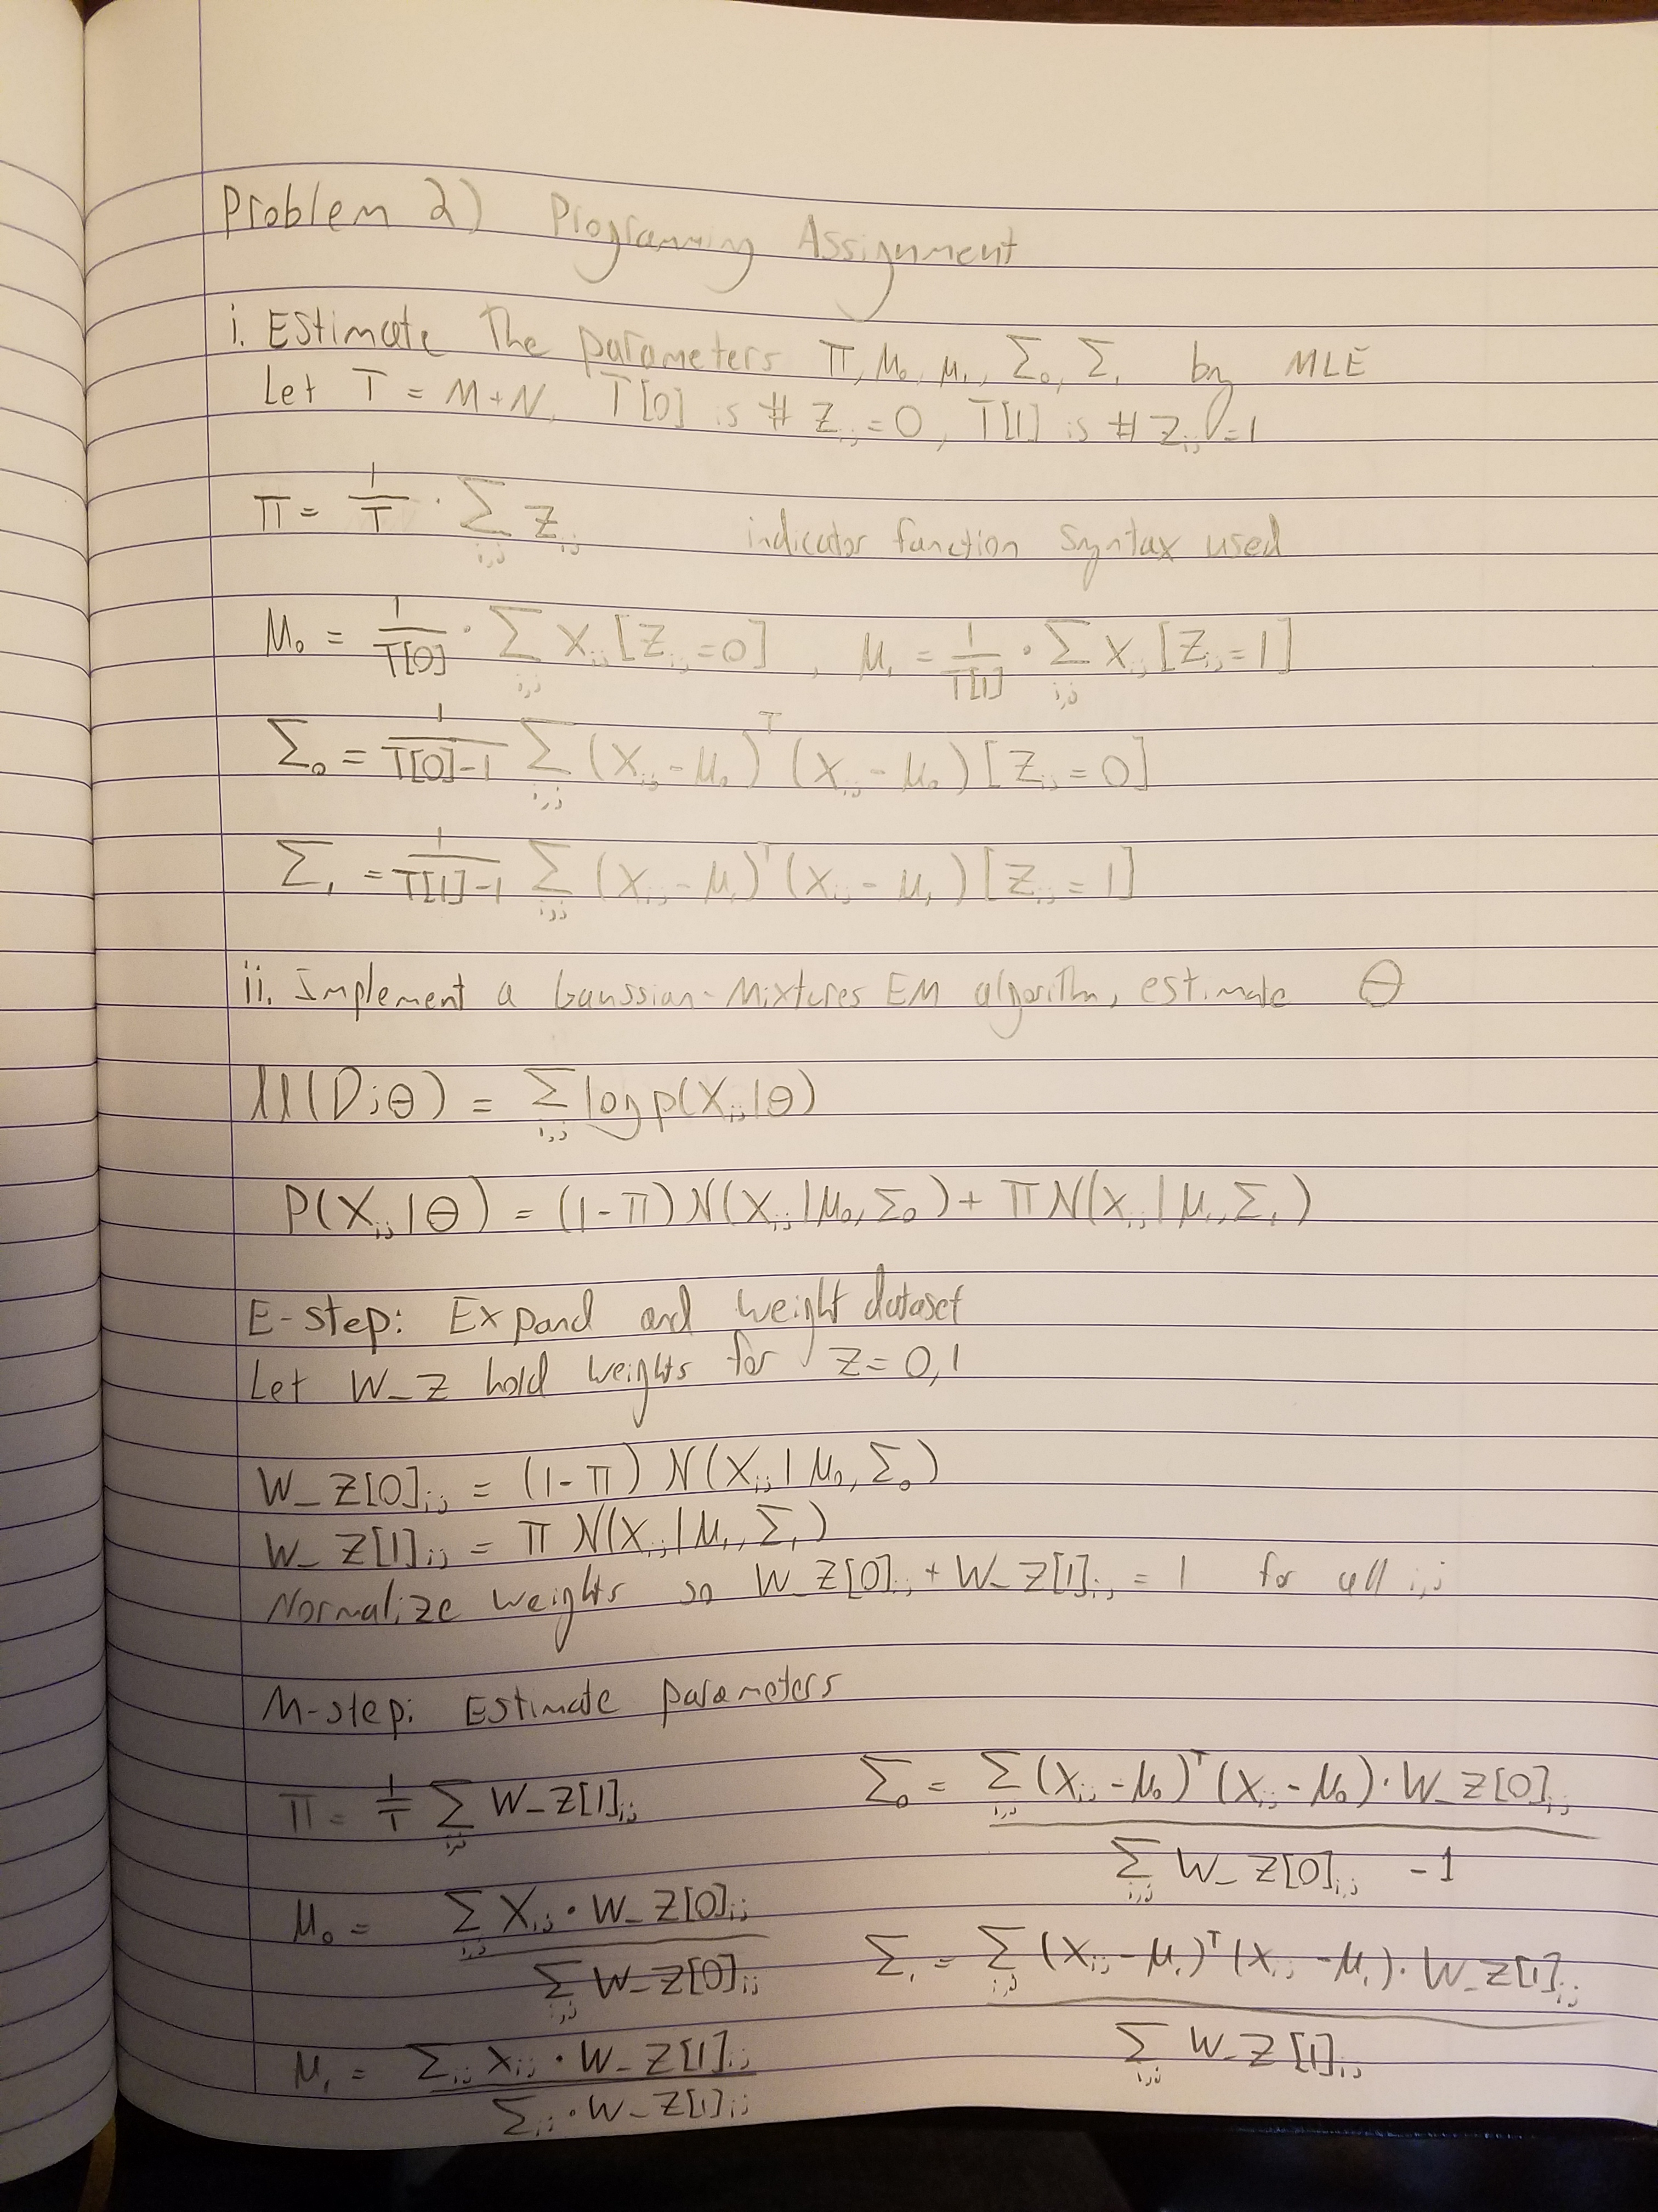

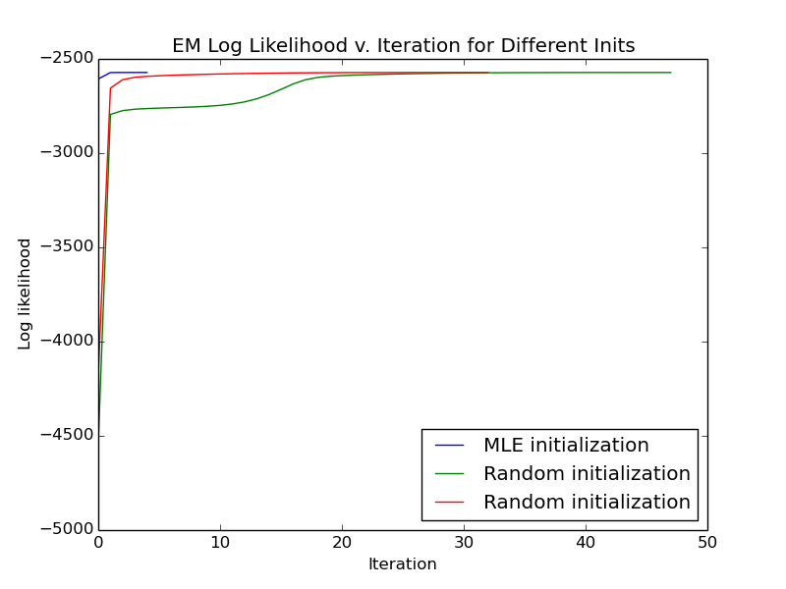

B) Geography-aware mixture model

i. Parameter estimates:
MLE estimates for PA part B.i:
MLE phi: 0.6
MLE lambda: 0.93

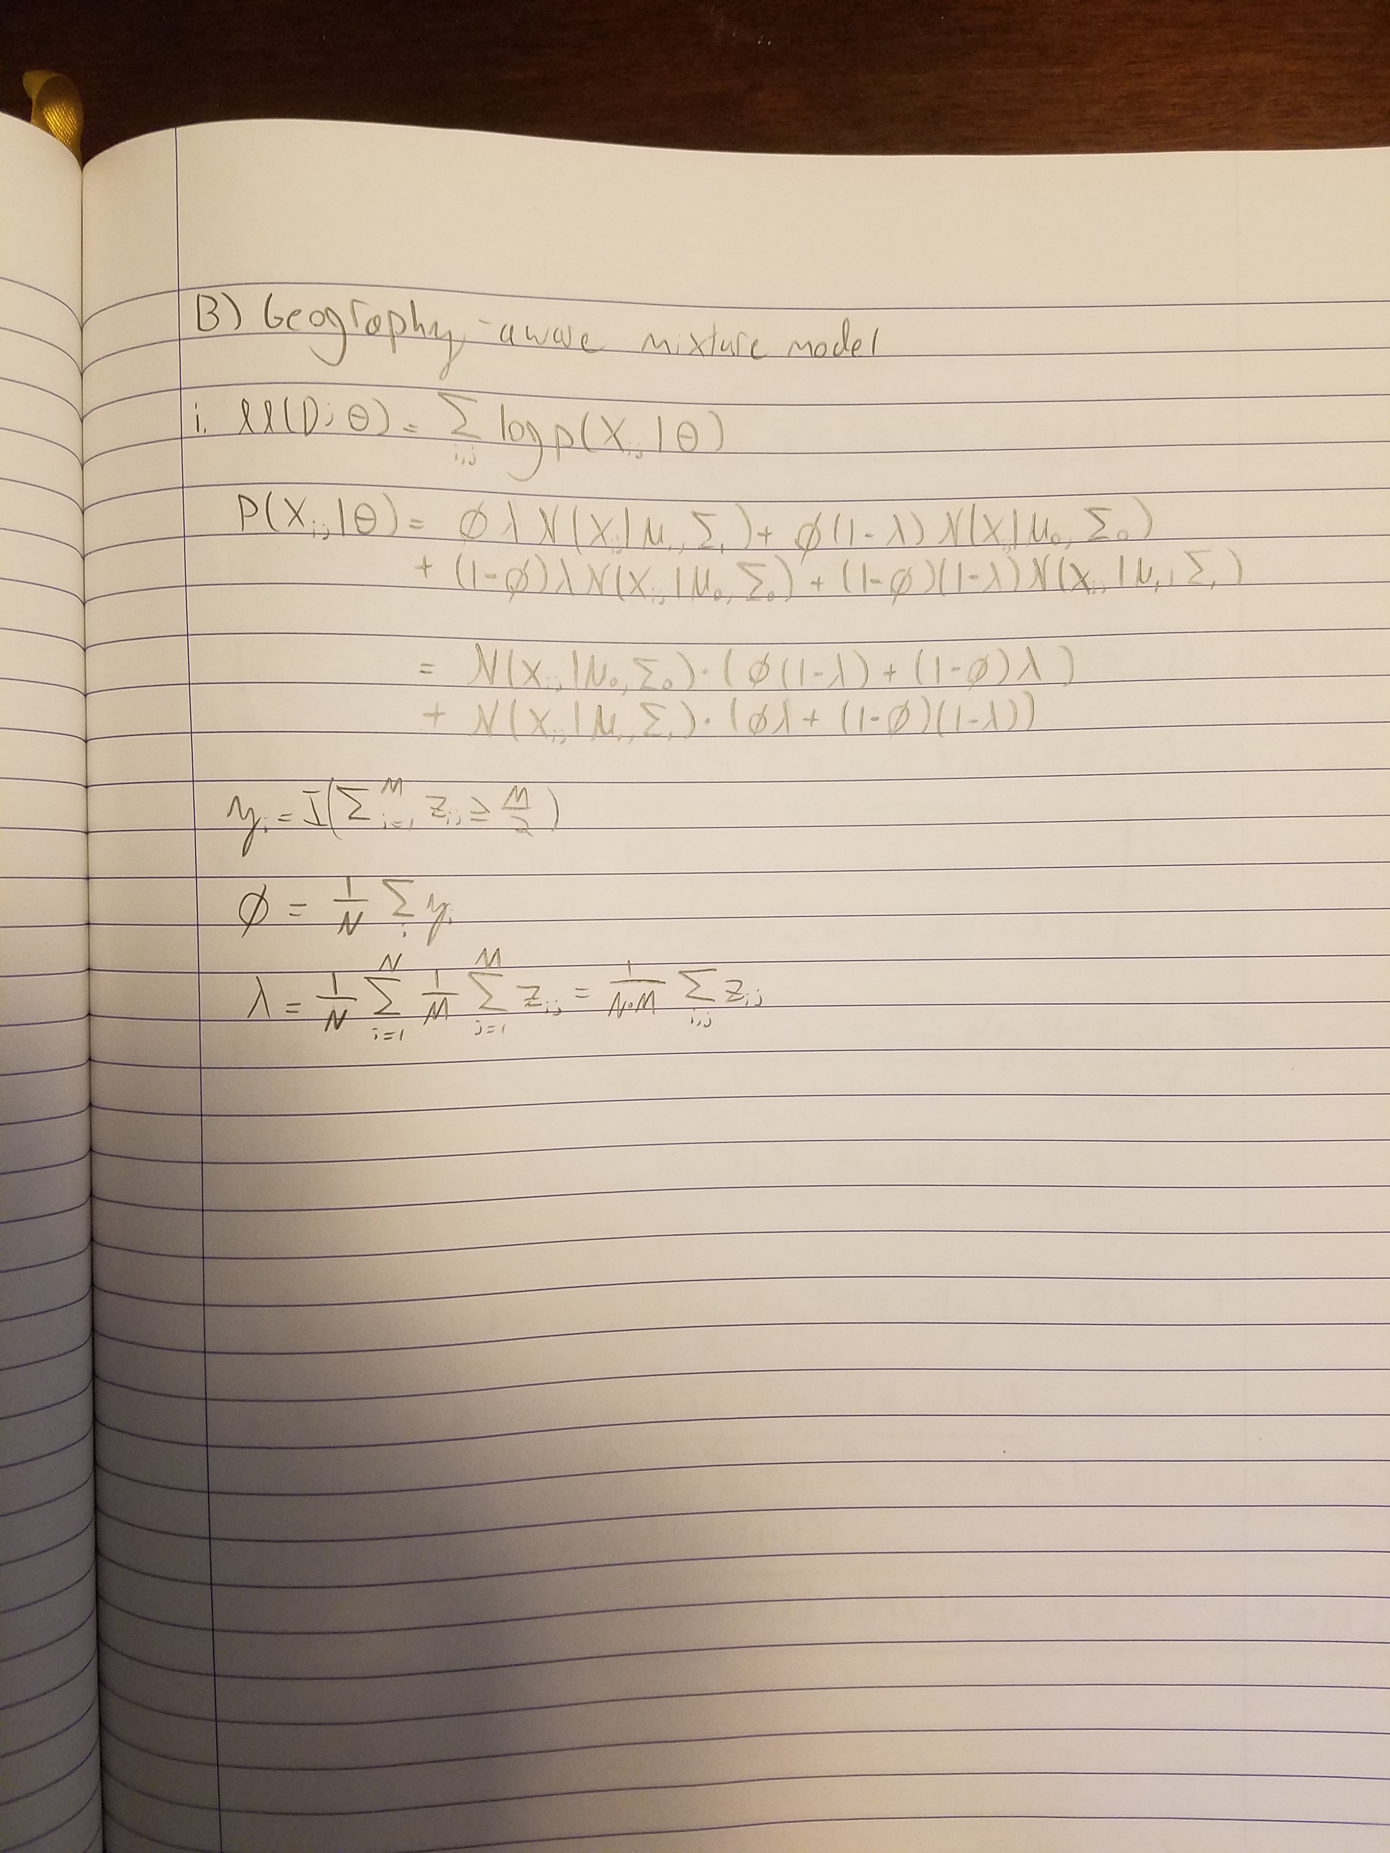
ii. * indicates marked for p > 0.5
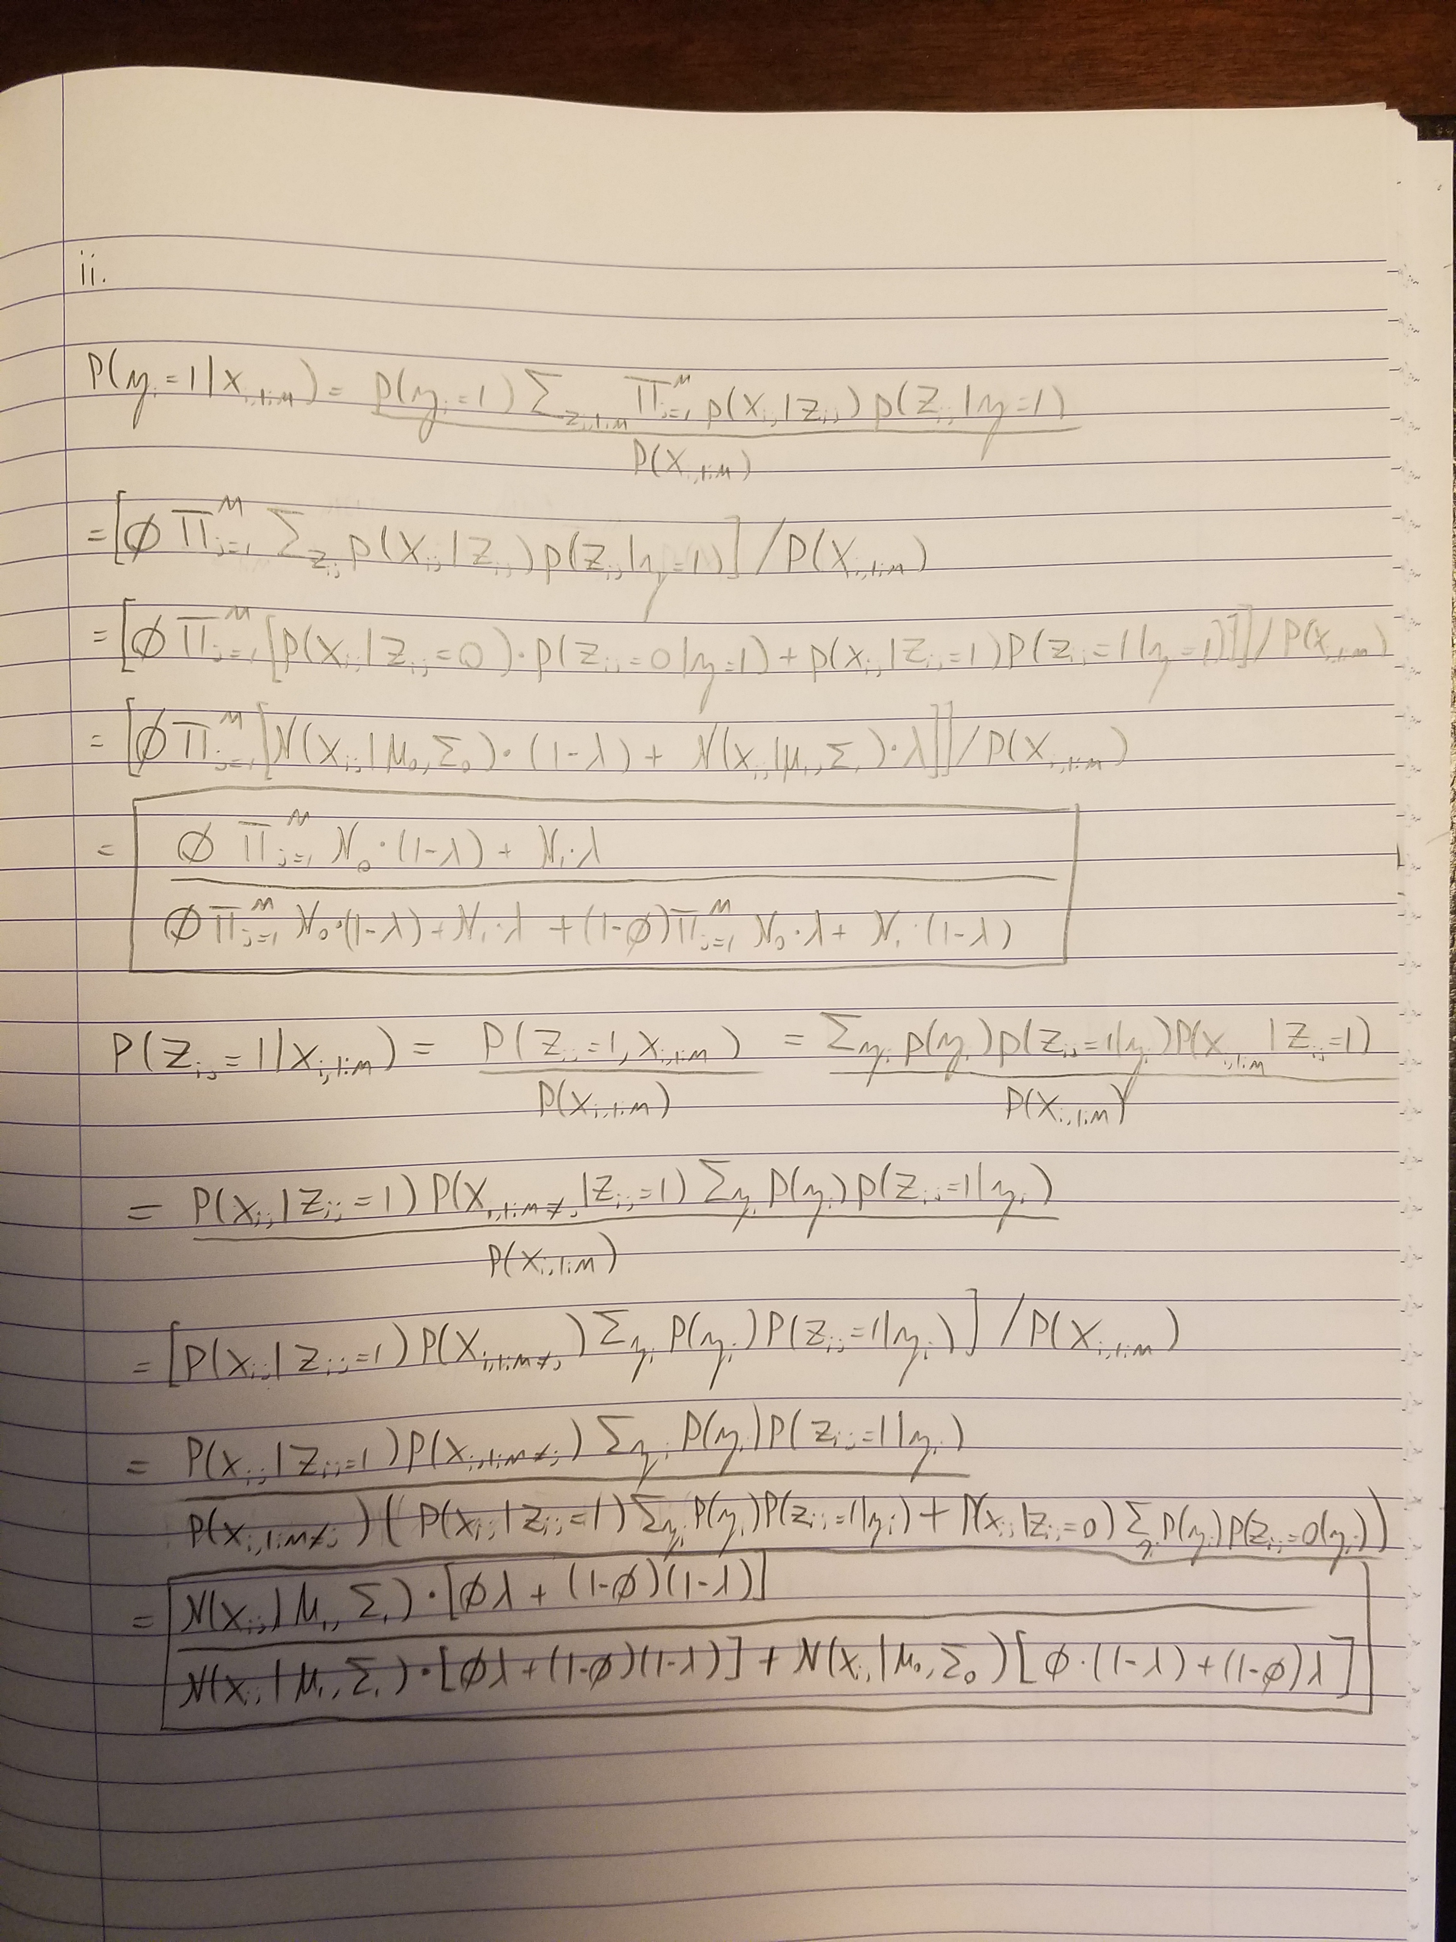
-------------------------
|Precinct |p(yi|xi,1:M) |
-------------------------
|* 0 | 1.000 |
|* 1 | 1.000 |
| 2 | 0.000 |
|* 3 | 1.000 |
| 4 | 0.000 |
|* 5 | 1.000 |
|* 6 | 1.000 |
|* 7 | 1.000 |
|* 8 | 1.000 |
|* 9 | 1.000 |
| 10 | 0.000 |
| 11 | 0.000 |
| 12 | 0.000 |
|* 13 | 1.000 |
|* 14 | 1.000 |
| 15 | 0.000 |
| 16 | 0.000 |
|* 17 | 1.000 |
|* 18 | 1.000 |
|* 19 | 1.000 |
| 20 | 0.000 |
|* 21 | 1.000 |
|* 22 | 1.000 |
| 23 | 0.000 |
|* 24 | 1.000 |
| 25 | 0.000 |
| 26 | 0.000 |
| 27 | 0.000 |
|* 28 | 1.000 |
| 29 | 0.000 |
|* 30 | 1.000 |
|* 31 | 1.000 |
|* 32 | 1.000 |
| 33 | 0.000 |
|* 34 | 1.000 |
| 35 | 0.000 |
|* 36 | 1.000 |
| 37 | 0.000 |
| 38 | 0.000 |
|* 39 | 1.000 |
| 40 | 0.000 |
|* 41 | 1.000 |
|* 42 | 1.000 |
| 43 | 0.000 |
|* 44 | 1.000 |
| 45 | 0.000 |
|* 46 | 1.000 |
| 47 | 0.000 |
|* 48 | 1.000 |
| 49 | 0.000 |

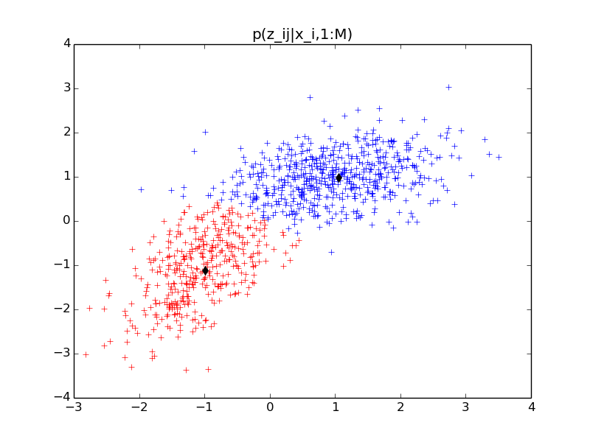

iii.
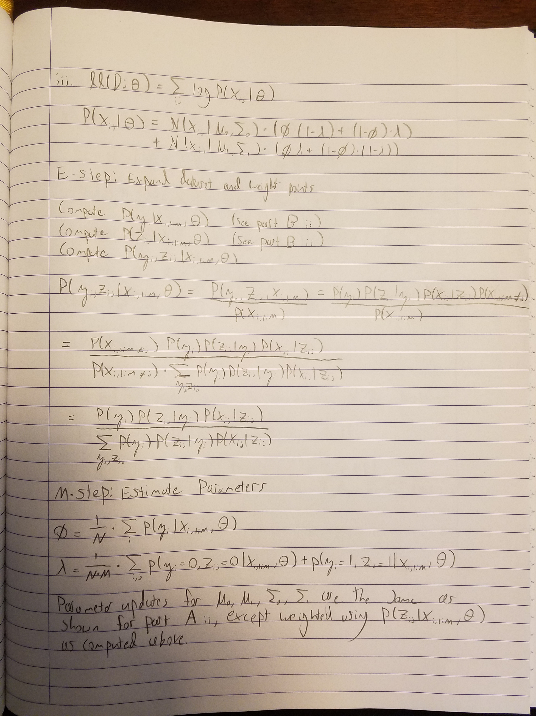

iv. Parameter estimates:

MLE init:
{'phi': 0.56000005452278112, 'sigma_1': array([[ 0.69270523, 0.12859102],
[ 0.12859102, 0.30099677]]), 'sigma_0': array([[ 0.38317011, 0.34278206],
[ 0.34278206, 0.81501996]]), 'mu_1': array([ 1.01946161, 1.01102893]), 'mu_0': array([-1.01584381, -0.97456872]), 'lambda': 0.93656267888912736}

Rand init 1:
{'phi': 0.0, 'sigma_1': array([[ 0.53861911, -0.04532715],
[-0.04532715, 0.00839436]]), 'sigma_0': array([[ 1.57358974, 1.22068669],
[ 1.22068669, 1.4939656 ]]), 'mu_1': array([-1.04553966, 0.65314159]), 'mu_0': array([ 0.15288455, 0.15693989]), 'lambda': 0.99479020426822873}

Rand init 2:
{'phi': 0.56013618371793228, 'sigma_1': array([[ 0.41309118, 0.38771891],
[ 0.38771891, 0.89215085]]), 'sigma_0': array([[ 0.66396172, 0.11593109],
[ 0.11593109, 0.29447559]]), 'mu_1': array([-0.9792153 , -0.91169995]), 'mu_0': array([ 1.05498714, 1.02379431]), 'lambda': 0.27571526114628297}
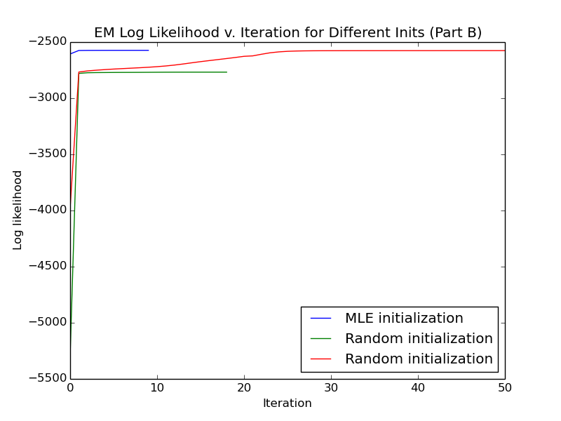
For this trial, neither random initialization reached the same parameter estimates as the MLE init. Only one of the random trials converged to the same log likelihood. Perhaps this EM is less stable since there are more parameters, would need to run more trials to test empirically.
v. * indicates marked for p > 0.5

-------------------------
|Precinct |p(yi|xi,1:M) |
-------------------------
|* 0 | 1.000 |
|* 1 | 1.000 |
| 2 | 0.000 |
|* 3 | 1.000 |
| 4 | 0.000 |
|* 5 | 1.000 |
|* 6 | 1.000 |
|* 7 | 1.000 |
|* 8 | 1.000 |
|* 9 | 1.000 |
| 10 | 0.000 |
| 11 | 0.000 |
| 12 | 0.000 |
|* 13 | 1.000 |
|* 14 | 1.000 |
| 15 | 0.000 |
| 16 | 0.000 |
|* 17 | 1.000 |
|* 18 | 1.000 |
|* 19 | 1.000 |
| 20 | 0.000 |
|* 21 | 1.000 |
|* 22 | 1.000 |
| 23 | 0.000 |
|* 24 | 1.000 |
| 25 | 0.000 |
| 26 | 0.000 |
| 27 | 0.000 |
|* 28 | 1.000 |
| 29 | 0.000 |
|* 30 | 1.000 |
|* 31 | 1.000 |
|* 32 | 1.000 |
| 33 | 0.000 |
|* 34 | 1.000 |
| 35 | 0.000 |
|* 36 | 1.000 |
| 37 | 0.000 |
| 38 | 0.000 |
|* 39 | 1.000 |
| 40 | 0.000 |
|* 41 | 1.000 |
|* 42 | 1.000 |
| 43 | 0.000 |
|* 44 | 1.000 |
| 45 | 0.000 |
|* 46 | 1.000 |
| 47 | 0.000 |
|* 48 | 1.000 |
| 49 | 0.000 |



